REHOTEQ
AI EDUCATION CURRICULUM
―――――――――――――――――――――――

Comprehensive Teacher's Lesson Note
Term Project and Revision
Junior Secondary 1 · First Term · Week 10

Field | Detail
Subject | AI Education and Digital Skills
Academic session | 2026/2027
Duration | 2 periods (40 to 45 minutes each, subject to the school timetable)
Document type | Comprehensive Teacher's Lesson Note
Curriculum status | Proposed curriculum for school pilot, review and consultation
Prepared by | Rehoteq Technologies (rehoteq.com)
Edition | First edition, November 2026

PROPOSED CURRICULUM NOTICE: This lesson note expands the Rehoteq AI Education Curriculum's proposed Junior Secondary 1, First Term, Week 10 scheme of work. It is offered for school pilot, review and consultation. It is not represented as an officially approved national syllabus, and it does not replace the current NERDC curriculum or any examination-board requirement.

1. Lesson Information
Field | Detail
Class | JSS 1
Subject | AI Education and Digital Skills
Term | First Term
Week | Week 10 of First Term
Topic | Term project and revision: showing what the class learned
Duration | 2 periods (40 to 45 minutes each)

2. Learning Outcome
By the end of the lesson, learners can:
- Build a small poster or chart that explains one idea from the term in their own words.
- Present the project to the class in two or three sentences.
- Answer revision questions from Weeks 1 to 9 with growing confidence.
- Identify their own strongest and weakest topics and say one step to improve each.

3. Weekly Scheme Content
Period | Scheme content
Period 1 | Project build: choose one term topic and make a poster or chart
Period 2 | Project presentations and whole-term revision quiz
Weeks 11 to 13 of the term are reserved for examinations, marking and results. Do not introduce new content during those weeks.

4. Materials and Preparation
- Chart paper or plain sheets, one per group of four.
- Colouring pencils or crayons, glue, old magazines or newspapers for cut-and-paste where available.
- The revision question list prepared on the board or on cards, covering Weeks 1 to 9.
- masking tape or board magnets to hang finished projects for a mini exhibition.
No-lab fallback: the project is paper-based by design and needs no computer. Revision can run as a team quiz with raised hands if cards are not available.

5. Period One: Introduce and Model
- Starter (5 minutes): walk the class back through the term on the board: computer and society, system unit, operating system, word processing, internet and email, what is AI, AI in Nigerian services, classification, collecting data.
- Teach (5 minutes): explain the project: each group picks ONE topic and makes a poster or chart that teaches it to a Primary 6 pupil. One clear picture, one short definition, three example items.
- Model (5 minutes): sketch a sample poster layout on the board: big title space, picture space, definition line, three examples.
- Build (25 minutes): groups plan, divide the work and start building. The teacher circulates and checks that every group's definition is in its own words, not copied.

6. Lesson Pictures
Show these pictures while teaching. Use each one to point back at the week it comes from before the class moves on.
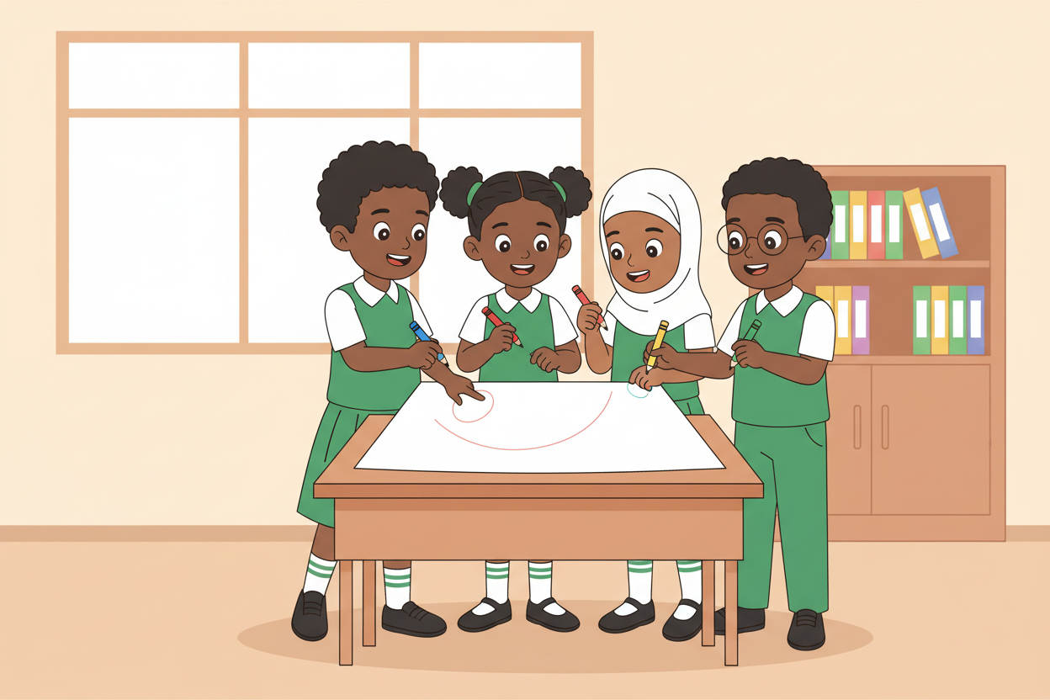
Picture 1. Groups work together: everyone owns a part of the poster, from title to examples.

Picture 2. A good poster teaches in one glance: a clear picture, a short definition and a few examples.

Picture 3. Presenting is part of the learning: each group explains its poster to the class in a few sentences.

Picture 4. The revision quiz brings the whole term together, one week at a time.

7. Period Two: Practise and Apply
- Presentations (20 minutes): each group presents for two minutes. The class asks one question per group; the group answers or says what it would check.
- Revision quiz (15 minutes): teams take turns answering one question per week from Weeks 1 to 9. Correct answers earn a point; the teacher restates the right answer after every turn.
- Self-check and close (10 minutes): each learner writes their strongest topic, their weakest topic, and one action for the weakest, then the class helps hang the posters for a mini exhibition.

8. Assessment and Evidence
- Evidence to collect: each group's poster or chart, each learner's presentation notes, and each learner's self-check paragraph.
Success looks like: every poster is self-explaining without the teacher, every presentation names its topic correctly, and every self-check names a real action.

9. Suggested Questions and Answer Guidance
1. Choose any topic from this term and explain it in two sentences. Expected response: any accurate two-sentence explanation of a Weeks 1 to 9 topic.
2. What makes a poster useful for teaching? Expected response: a clear picture, a short definition and a few correct examples, understandable at one glance.
3. Name one thing you learned this term that changed how you see computers. Expected response: any honest personal reflection tied to a real topic.
4. How do you plan to improve your weakest topic before the examination? Expected response: a concrete action, such as re-reading the note, redoing the activity or asking a classmate to teach it back.

10. Home Activity
Learners show their group's poster to someone at home and explain the topic in their own words; they note any question they could not answer and bring it to the revision before the examination week.

11. Inclusion
Groups are mixed-ability by design, and roles are divided so every learner owns a visible part: drawer, writer, checker or presenter, rotated so no one is stuck in one role. Learners who prefer speaking over drawing may lead the presentation, and the quiz accepts answers spoken or written.

12. Safety and Privacy
Poster content stays on the agreed class topics; learners do not paste or photograph personal details, home addresses or real names of relatives. Scissors and glue are used with the usual classroom care, and the exhibition wall keeps walkways clear.

13. Teacher Reflection
After the lesson, note what worked, which parts confused the class, which pupils need follow-up, and one change for next term.
Reflection notes
__________________________________________________________________________________________

14. Curriculum Alignment and Document Status
This note expands the Rehoteq AI Education Curriculum, a proposed curriculum for school pilot, review and consultation; not an officially approved national syllabus. It does not replace the current NERDC curriculum or examination-board requirements, and schools remain responsible for checking current NERDC requirements and their own calendar before implementation.

Prepared by Rehoteq Technologies (rehoteq.com). First edition, November 2026.

