Name: Reia Winola Merceline Menezes

MISIS: M00791121

Email: RM1661@live.mdx.ac.uk

Course: MSc Robotics

Module: PDE4433 – Machine Learning for Robotics

Assessment: Coursework 2

Professor: Dr. Maha Saadeh

Table of Contents

Introduction: 3

Dataset: 3

Preprocessing: 4

Train – Test split: 4

Class mapping and labels: 4

Machine Learning Model and Analysis: 5

Evaluation and Accuracy: 7

Future Improvements: 9

Conclusion: 9

YouTube Video Demonstration Link: 10

GitHub Repository Link: 10

References: 10

Table of Figures

Figure 1 shows the plates/ dataset Figure 2 shows the abudhabi_plates/ dataset 4

Figure 3 shows the class_names.json file 5

Figure 4 model summary output showing each layer and parameter count 6

Figure 5 .fit code section 7

Figure 6 This output shows the progression of training accuracy and validation accuracy. The model reaches high performance by epoch 7 and achieves perfect validation accuracy by epoch 6, maintaining it until the end of training. 8

Ticketless Parking System

## Introduction:

This project uses a machine learning model to automate access control through license plate recognition. Instead of using RFID tags or physical tickets, the system identifies Dubai number plates via a trained Convolutional Neural Network (CNN). A CNN model is trained exclusively on Dubai number plates to detect and verify authorized vehicles. Any image containing an Abu Dhabi plate is automatically denied access.

A simple GUI is created that simulates vehicle entry by uploading plate images. Access is granted, denied, or marked for payment based on recognition and entry time. In a robotics context, this system replaces manual checks with autonomous decision-making. Its output can be connected to physical actuators like boom barriers, making it a foundational module in intelligent robotic access control solutions.

Dataset:  
There are two image datasets used for this coursework. First is the ‘plates/’ folder which contains all the Dubai number plate images. There are a total of 10 classes, with each class containing 50 pictures. (Total: 500 images)

The second folder is ‘abudhabi_plates/’; this folder contains the Abu Dhabi number plate images. These have 5 classes, with each class containing 20 images (Total: 100 images). This dataset is used only during runtime to test denial or access.

All the images are pre-cropped and resized to ensure consistency while training the model.

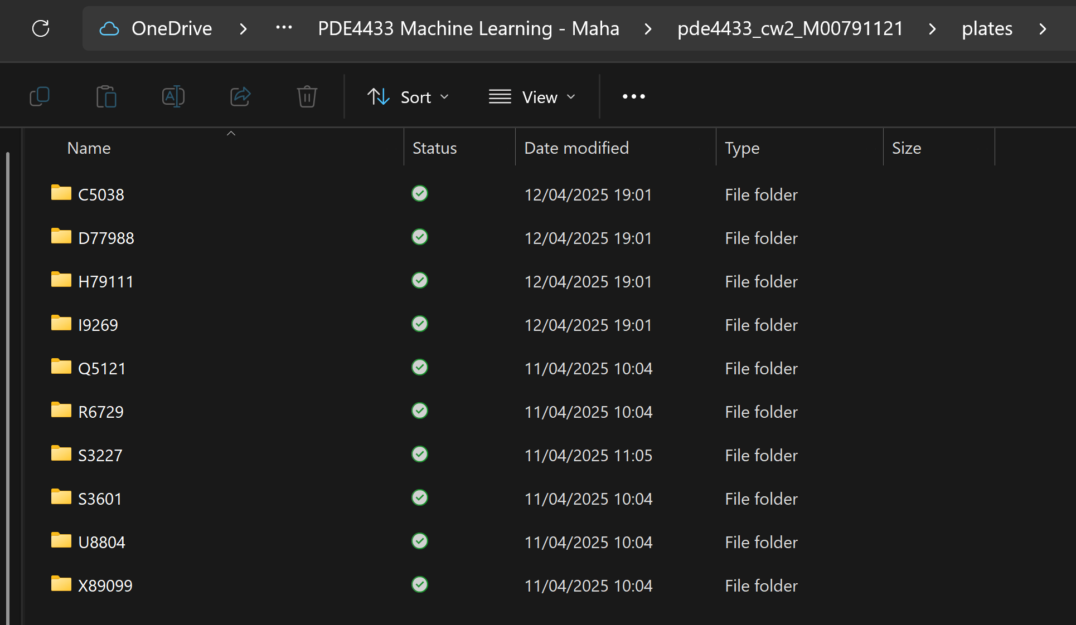

Figure 1 shows the plates/ dataset Figure 2 shows the abudhabi_plates/ dataset

## Preprocessing:

The images are resized to 224x224 pixels, and the pixels are normalized to [0,1] range using rescaling.

There is a data augmentation layer applied for better generalization; the following is included:

* Random flip
* Rotation (10%)
* Zoom ( b b%)
* Contrast adjustment (20%)

## Train – Test split:

A standard 80-20 split is applied for the Dubai plates dataset, where it was ensured that 400 images were used for training and 100 images were used for testing.

## Class mapping and labels:

The Dubai plate class names are extracted from the folder names automatically and are saved in a class_names.json file to maintain consistency during the prediction phase.

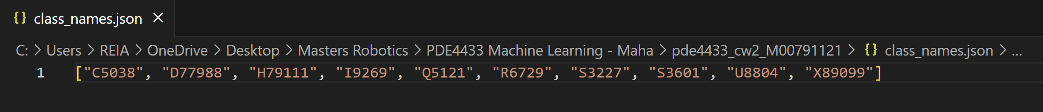

Figure 3 shows the class_names.json file

## Machine Learning Model and Analysis:

The model is a custom CNN classifier trained exclusively on Dubai plate images to distinguish between different known license plates.

Architecture Summary

* Input Layer: 224x224 RGB image
* Data Augmentation: Flip, rotation, zoom, and contrast
* Convolutional Layers:
  + Conv2D(32) → MaxPooling
  + Conv2D(64) → MaxPooling
  + Conv2D(128) → MaxPooling
* Fully Connected:
  + Flatten → Dense(128) → Dense(10 softmax)

Figure 4 model summary output showing each layer and parameter count

Training Configuration

* Loss Function: Sparse Categorical Crossentropy
* Optimizer: Adam
* Epochs: 15
* Metrics: Accuracy

Figure 5 .fit code section

## Evaluation and Accuracy:

The model was trained over 15 epochs using only Dubai license plate images. The training process shows a clear and stable improvement in both training and validation accuracy.

* Final Training Accuracy: 100%
* Final Validation Accuracy: 100%
* Final Loss: Approaches near zero
* Learning Trend: Consistent upward trend in accuracy with diminishing loss, indicating effective learning and near-perfect classification.

Figure 6 This output shows the progression of training accuracy and validation accuracy. The model reaches high performance by epoch 7 and achieves perfect validation accuracy by epoch 6, maintaining it until the end of training.

Performance Observations

* The model generalizes well within the Dubai dataset due to clean segmentation and augmentation.
* Misclassification may occur only if a new/unseen plate is introduced or confidence falls below the set threshold.

Abu Dhabi Filtering Logic

* Abu Dhabi images are never passed through the model.
* A filename-based check (e.g. "abudhabi" in path) denies them directly, keeping the logic efficient and lightweight.

## Future Improvements:

While the current system achieves high accuracy for Dubai plate classification and basic access control logic, several enhancements can further improve performance, scalability, and real-world deployment:

1. Expand Plate Dataset Coverage  
   Include more varied Dubai and Abu Dhabi plate styles (e.g., different fonts, weathered plates, night-time images) to improve robustness in uncontrolled environments.
2. Integrate OCR for Full Plate Text Extraction  
   Combine CNN classification with Optical Character Recognition (OCR) to read and verify full plate numbers, enabling personalized access and payment logic.
3. Real-Time Camera Feed Integration  
   Extend the GUI to support live feed detection instead of static uploads, simulating real-world gate surveillance systems.
4. Multi-City Access Control Logic  
   Expand classification to support plates from other emirates (Sharjah, Ajman, etc.) and assign different policies or rules for each.
5. Deploy to Edge Devices  
   Optimize the trained model for deployment on embedded systems like Raspberry Pi with camera modules for actual barrier control.

## Conclusion:

This project successfully demonstrates a ticketless parking access control system using machine learning for number plate classification. By training a CNN model exclusively on Dubai plates and incorporating GUI-based interaction, the system differentiates between Dubai and Abu Dhabi license plates with high accuracy, granting access only to eligible vehicles. The application simulates real-world scenarios such as timed exits, free parking windows, and payment prompts, all while maintaining a structured log of activity. This solution showcases how machine learning can streamline urban parking management, improve gate security, and reduce manual intervention cost-effectively.

## YouTube Video Demonstration Link:

<https://youtu.be/_i18kU271ZU>

## GitHub Repository Link:

<https://github.com/reiamenezes2004/pde4433_coursework2_m00791121.git>

## References:

* 1. Dataset: <https://www.kaggle.com/datasets/sheezawaheed/number-plate-dataset-of-uae-5-emirates?resource=download>