Name: Reia Winola Merceline Menezes

MISIS: M00791121

Course: BSc Honors Information Technology

Module: CST 3990 – Undergraduate Individual Project

Assessment: Final Report

Artefact: Parking Space Sharing Community (Web Based Mobile Application)

Supervisor: Mrs Chinnu George

I hereby confirm that the work presented here in this report and in all other associated material is wholly my own work.

This work is licensed under a Creative Commons Attribution-NonCommercialNoDerivatives 4.0 International License. See the details on the Creative Commons website: <https://creativecommons.org>

**Abstract**

Table of Contents

**Chapter 13**

Introduction3

Problem Definition4

Project Scope Aims4

Project Scope Objectives5

**Chapter 26**

Literature Review6

Background Study6

Comparative Analysis**9**

Functional Requirements**11**

Non – functional Requirements**13**

**Chapter 3**1**4**

Design1**4**

Hardware and Software Requirements1**4**

SDLC**15**

Methodology**16**

Design Diagram**17**

Use Case Diagram **18**

User Interface Requirements **19**

Wireframes**19**

**Chapter 422**

Implementation**22**

**Source Code22**

**Chapter 522**

Testing **22**

**Chapter 622**

Demonstration and Evaluation**22**

**Chapter 622**

Conclusion**22**

**Chapter 722**

Appendices**22**

**References23**

**Chapter 1: Introduction**

*Introduction:*

The widespread adoption of mobile phones and applications has led to a significant transformation in modern lives, affecting how people interact and move around their surroundings. Characterized by enduring patterns and continuous technological developments, these applications have successfully transformed smartphones into essential instruments suggestive of those used in the 19th-century industrial age.

Mobile applications, which are widely used for life management and available to most people globally through smart devices, serve a wide range of personal needs and interests, providing improved functionality on a wide range of mobile devices—including televisions—these apps have evolved into essential tools that help people accomplish a variety of chores quickly and easily. Mobile applications have revolutionized many aspects of contemporary life, impacting how people work, communicate, and engage with their environment. Examples of these impacts range from improving photo editing skills to helping people lose weight.

*Problem Definition:*

More parking places are needed, which makes what would seem like a straightforward task into a significant difficulty for drivers globally, leading to general annoyance and dissatisfaction. Even with meticulous planning and an early departure, finding a good parking spot still takes time because fewer spots are available, and competition for parking is severe. Because parking is so expensive, finding a place to park causes more problems than it solves. It also makes drivers worry about their financial stability. Moreover, the issue is worsened because many parking lots have more rigorous security regulations, which puts private vehicle owners at risk of injury, theft, and accidents—often without being held accountable.

Lack of parking impacts the environment, traffic flow, and individuals. Longer travel times, more pollution, and wasted energy from idle engines stalled in traffic are all consequences of increased traffic congestion brought on by several cars vying for parking spots. The environmental impact is increased by the energy used in these fruitless searches. In summary, the severe and pervasive problem of inadequate parking affects drivers in terms of financial repercussions, safety, and accountability.

*Project Scope - Aim:*

By creating an easy-to-use platform that connects consumers and parking spot owners, this application seeks to revolutionize the parking sector radically. Considering the inherent challenges that each party must overcome, the application aims to:

**For Users:**

* Simplify parking search: A thorough and user-friendly interface can avoid the hassle of finding a secure parking space.
* **Reduced parking costs:** To offer economically priced parking options, promote competition among parking space owners and allow access to empty places.
* - Strengthen safety and security: Prioritize safety by collaborating with local authorities and imposing strict procedures for parking space owners to verify their identities.

**For Renters:**

* **Make the most of unused resources: To generate extra income, immediately offer and rent out spare parking spaces to potential clients.**
* **Improve pricing strategy: Get innovative information regarding parking demand and adjust prices on the fly to maximize revenue.**
* **Enjoy a user-friendly experience: An owner dashboard makes managing listings, reservations, and payments easy.**

*Project Scope - Objectives:*

* Create an app that connects renters with individuals in need of a quick and secure parking spot. Launch it on iOS and Android.
* To enhance the user experience by adding necessary features including emergency services, renter evaluations and ratings, secure payment processing, in-app navigation to the reserved space, and a user-renter chat function.
* Ensuring user cars are safe through security monitoring to foster confidence and trust between users and renters.
* Adding a section for feedback and improvements to increase app usage over time.

**Chapter 2: Literature Review**

*Background Research: The Effects of Parking Scarcities in Urban Commercial Areas*

Drivers spend about 17–18 hours a year, according to McCoy (2017 USA Today), only trying to find a parking space in a garage, lot, or on the street. The amount of time not only affects the driver's wasted time but also impacts the environment. According to McCoy (2017), USA Today, simply circling an area while looking for parking wastes unnecessary fuel and increases emissions. The average estimate of fuel wasted by a driver annually is $345. Cost has always been essential to a person, whether for ordinary daily personal spending or transportation. However, parking fees are another additional expense associated with owning a car for a driver. Many drivers will either have someone sit in the car and wait for the driver to do their errand and return, or they will double park while keeping their hazard light on, suggesting they will be back shortly to avoid paying for parking.

Another common practice among drivers is to circle the neighbourhood several times before finding a parking space. If they're lucky, they may do this once or five times until someone already parked decides to leave and move on. Even though the drivers pay their parking penalties by using these avoidance techniques, this causes traffic congestion and makes it necessary for a parking inspector to issue parking fines because the driver will still be required to pay the fine. "Hunting for parking imposes costs on our pocketbooks that we often don't think about," stated Bob Pishue, an INRIX transportation analyst.

There are plenty of parking spots in cities. For example, research found that Philadelphia has 2.2 million parking spaces, compared to 1.85 million in New York

City.

The core of the problem is the traditional management of these places, which could be done more efficiently. Drivers get upset and waste too much time looking for a location since they often cannot quickly determine where spots are accessible. Because of trustworthy, real-time data, drivers cannot choose between surface lots, garages, or on-street parking.

Drivers who become frustrated with having to alternate between crowded lots and garages may choose to park illegally or quit the area, which would hurt the city in many ways.

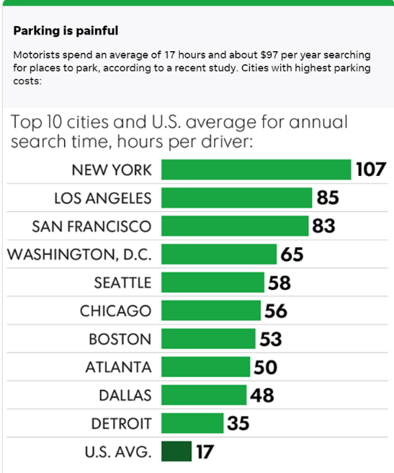The following graph displays the hours an average city driver spends looking for parking in ten American cities. The graph indicates that drivers in New York typically spend 107 hours a year attempting to locate a parking space in a big city. 63% of American drivers surveyed by McCoy (2017 USA Today) said they avoid driving to airports, shopping centres, recreation centres, and many other locations due to parking problems. The research also states that drivers frequently experience stress when finding a spot. According to a survey performed, "nearly 42% of the U.S. respondents said they missed an appointment, 34% abandoned a trip because of parking issues, and 23% experienced road rage," according to the article by Kevin McCoy.

Figure 1 shows a graph of the major American cities and the yearly time a vehicle spends searching for a parking space.

Along with the concerns of individual drivers and the environment, a lack of parking has a considerable damaging impact on the business climate of enterprises operating in urban commercial areas. After talking about the difficulties drivers encounter—such as missed deadlines, rising fuel costs, and financial strain on an individual basis—it is crucial to look at how these problems impact the nearby businesses.

According to Neal, A. PurpleCow (2020), employees' well-being and performance may decrease if there are no assigned parking spaces for employees at work. Posting a parking space for them demonstrates your concern and consideration for their needs regarding mobility. If compelled to park far from their place of business, employees may become agitated and gloomy; this is especially true if they are late for work. Enough parking spots can help reduce workers' concerns, boosting their output overall. A company's profitability is directly impacted by the satisfaction and well-being of its employees. Thus, parking issues need to be discovered and fixed.

Customers may select alternative businesses with easier parking when a reputable company does not offer accessible parking. Parking issues that drive away consumers directly impact a business's profitability and overall success.

Parking shortages adversely affect the economy more than just making driving more difficult. Businesses that function in urban commercial districts must recognize the critical role that easily accessible parking plays in sustaining foot traffic, fostering customer pleasure, and ultimately preserving a favourable profit margin. Managing parking issues becomes more than convenient for businesses looking to thrive in competitive urban environments.

Research indicates that customers are willing to pay extra for businesses prioritizing their security, comfort, and convenience—even if doing so means incurring higher costs. Ignoring the importance of accessible parking may have financial consequences and negatively impact customer happiness and loyalty. As a result, providing easy and safe parking becomes strategically crucial for companies trying to maximize earnings and maintain a positive reputation with their customers.

If drivers want to park conveniently for a day of shopping in the city center, it's crucial to let them know in advance if surface lots, garages, or on-street parking is available. Installing sensors on light posts allows for real-time monitoring of parking occupancy around the city, providing drivers with the data they need to make informed judgments when navigating these locations.

This real-time surveillance system is handy for cities during significant events. It allows for strategically managing properties, garages, or streets by establishing specific rules for price, length, and other necessary restrictions.

A city's revenue will eventually rise through successfully monetizing its current parking spots and installing an inexpensive parking management and guidance system. Drivers are more likely to pay for parking when they are sure they can locate a place fast and avoid going in circles. The fact that a state-of-the-art monitoring system keeps an eye on all areas helps drivers realize that paying for the valued public space and service is affordable.

Urban locations will always require additional parking controls as more people move there and these areas expand, necessitating more parking regulations. Achieving the general public's satisfaction is one of the most crucial objectives that cities may accomplish by devoting time and resources to implementing a solution that optimizes available space and streamlines the entire experience.