Project Sprint #1

The Solitaire game is described in CS449HomeworkOverview. You should read the description very carefully.

In this assignment, you aim to specify the requirements (i.e., user stories and acceptance criteria) of the target software that allows a human player to play a Solitaire game. These requirements will be fully implemented by the end of sprint 3. The minimum features include choosing the board size and type, starting a new game, making a move, determining if a game is over. The following is a sample GUI layout.

Board size
7
Board Type  - English  - Hexagon  - Diamond | 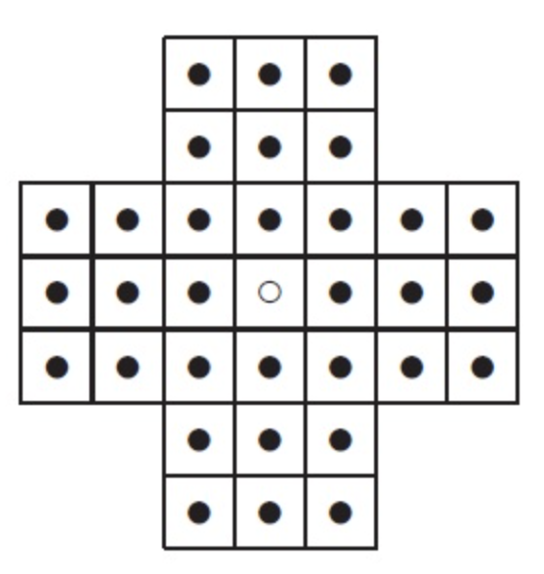 | New Game
Figure 1. Sample GUI layout of the first working program by the end of Sprint 3

Use the following tables to document your user stories and acceptance criteria.

You are required to use the free ChatGPT or another LLM to complete two user stories and two of their respective acceptance criteria. You must ensure that the generated user stories are correct and fix them if not. At the end of the submission, provide screenshots of your LLM prompts and answers, along with the description of errors the LLM made that you had to correct. Points will be deducted if no screenshots/description are provided.

For the other user stories and acceptance criteria, you are not required to use LLM.

- User Stories (3 points)

- User Story Template: As a <role>, I want <goal> [so that <benefit>]

ID | User Story Name | User Story Description | Priority | Estimated effort (hours)
1 | Choose a board size | As a player, I want to choose the size of the board so that I can play a game at the difficulty and length I prefer | High | 3
2 | Choose the board type | As a player, I want to choose the board type (English, Hexagon, or Diamond) so that I can play the board layout I like | High | 3
3 | Start a new game of the chosen board size and type | As a player, I want to start a new game so that I can play with the new settings in place | High | 2
4 | Make a move in a game | As a player, I want to move a peg, so that I can continue the game | High | 2
5 | A game is over | As a player, I want to be prompted the game is over, so that I can know im out of moves | High | 2

- Acceptance Criteria (AC) (12 points): Add/delete rows as needed.

User Story ID and Name | AC  ID | Description of Acceptance Criterion | Status (completed, toDo, inPprogress)
1. Choose a board size | 1.1 | AC 1.1 Valid Board Size accepted  Given: the game application is open and no game is in progress,  When: the player enters a valid board size (e.g., 7) in the board size field,  Then: the size is accepted and shown in the field, and it is used for the next new game | toDo
1. Choose a board size | 1.2 | AC 1.2 Invalid board size is rejected  Given: the game application is open and the player has previously chosen a valid board size,  When: the player enters an invalid board size (e.g., a negative number, zero, an even number, a non-numeric value, or a value below the minimum or above the maximum),  Then: the application shows an error message, and the previously chosen valid size stays in effect | toDo
2. Choose the board type | 2.1 | AC 2.1 Selecting a board type  Given: the game application is open and no game is in progress,  When: the player selects one of the board type options (English, Hexagon, or Diamond),  Then: only that option is shown as selected, and it is used for the next new game | toDo
2. Choose the board type | 2.2 | AC 2.2 Default board type.  Given: the game application has just been launched and the player has not yet selected a board type,  When: the player looks at the board type options,  Then: a default board type (English) is already selected, so a game can be started without an explicit selection | toDo
3. Start a new game of the chosen board size and type | 3.1 | AC 3.1 Start a new game with chosen settings  Given: the player has chosen a valid board size and board type  When: the player clicks the “New Game” button  Then: a board of the chosen size and type is displayed with every hole filled with a peg except the center hole, which is empty | toDo
 | 3.2 | AC 3.2 Restarting a game in progress  Given: a game is in progress and the player has chand the board size and/or type  When: the player clicks the “New Game” button  Then: the current game is discarded, and a fresh board with the new settings replaces it | toDo
 | 3.3 | AC 3.3 Start is blocked by an invalid setting  Given: the board size field contains an invalid value  When: the player clicks the “New Game” button  Then: no new game starts and an error message asks the players to enter a valid size | toDo
4. Make a move in a game | 4.1 | AC 4.1 Valid move  Given: a game is in progress and a peg has an adjacent peg next to it with an empty hole directly beyond it in the same line  When: the player moves that peg to the empty hole by jumping over the adjacent peg  Then: the jumping peg ends up in the empty hole, the jumped peg is removed, the original hole becomes empty, and the board display updates. | toDo
 | 4.2 | AC 4.2 Invalid move is rejected.  Given: a game is in progress  When: the player attempts an illegal move (e.g., moving to a filled hole, jumping over an empty hole, moving diagonally, moving more than one jump distance, or moving outside the board)  Then: the move is not made, the board stays unchanged, and the player is notified that the move is invalid. | toDo
 | 4.3 | AC 4.3 No moves after the game ends  Given: the game is over  When: the player attempts to move a peg  Then: the move is not made, and the board remains unchanged. | toDo
5. A game is over | 5.1 | AC 5.1 Game over when no moves remain.  Given: a game is in progress  When: the player makes a move after which no peg on the board has a valid move  Then: the game is declared over, and a message tells the player the game has ended because no moves are left. | toDo
 | 5.2 | AC 5.2 Game continues while moves remain.  Given: a game is in progress  When: the player makes a move after which at least one valid move still exists  Then: no game-over message is shown, and the player can keep playing | toDo
 | 5.3 | AC 5.3 Game over with a single peg left.  Given: a game is in progress,  When: the player makes a move that leaves exactly one peg on the board  Then: the game is declared over, and the message tells the player they have solved the puzzle | toDo

LLM Screen shots:
I found that the LLM did a good job. I couldn’t think of much other acceptance criteria that it did come up with. After review I was answers given by the LLM were good.
