ELEC 4700

Assignment 3

Monte Carlo/Finite

Difference Method

Student Name: Jeremy Schelhaas

Student Number: 100976020

Date: Feb 24, 2019

Table of Contents

Part 1: Monte Carlo with Applied Voltage on Boundary.……………………………………………..……..

Part 2: Finite Difference to Calculate Electric Field from Applied Voltage………

Part 3: Coupling Monte Carlo with Finite Difference…………..…..

Figures

Figure 1: Electric Field, Force and Acceleration in X and Y……………………………………

Figure 2: 2D Particle Trajectories…………………………………………………………..

Figure 3: Current Density…………………………………………

Figure 4: Density and Temperature Distributions…………………………………………………..

Figure 5: Voltage Distribution from Finite Difference …………………………………..

Figure 6: 2D Electric Field Quiver Plot…………………………………………………………………………

Figure 7: 2D Particle Trajectories with Finite Difference Voltage Distribution ……..

Figure 8: Density Distribution…………………………………………….

Part 1: Monte Carlo with Applied Voltage on Boundary

Going back to a previous problem, where there was a region 200nm wide by 100nm high with electrons travelling around in that region, those electrons were first simulated having no applied voltage to apply an electric field which would affect the velocity of those electrons. For the purpose of this experiment, an applied voltage was applied to study and understand how an applied voltage would affect the electrons’ movement.

If an applied voltage of 0.1V is applied to the left side of the region, where x = 0, an electric field is applied in the x direction. The magnitude of the electric field is calculated by dividing the voltage by the region the voltage is measured across, as seen below:

$$V=Ed \overset{→}{} E=\frac{V}{d}$$

Next, the force from the electric field can be calculated by dividing the electric field by the electronic charge of an electron, as shown below:

$$E=\frac{F}{q} \overset{→}{}F=Eq$$

Finally, the force being applied is divided by the effective mass of the electron in that region to produce the acceleration that all electrons are affected by, as shown below:

$$F=ma\overset{→}{}a=\frac{F}{m}$$

These calculations are shown in the figure below:

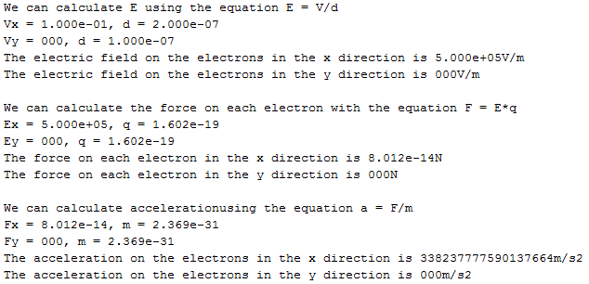

Figure 1: Electric Field, Force and Acceleration in X and Y

Now that the acceleration that each electron is affected by has been calculated, during the simulation, the velocities of each electron can be updated before the new position of each electron is calculated to account for the applied voltage. Since the voltage is applied only in the x direction, the electrons should have only their velocity in the x direction changed, but to be thorough, the updated velocity in the y direction will also be included. This will not change the outcome of the simulation, however, as there is no voltage being applied in the y direction to produce an acceleration in the y direction. The results of this simulation is shown below:

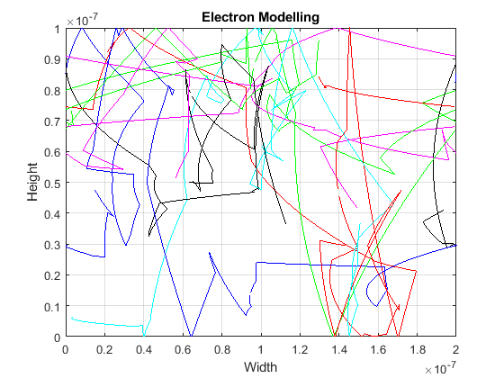

Figure 2: 2D Particle Trajectories

As shown above, the acceleration produced by the voltage manipulates the electrons so that they tend to move towards the right side of the region. Even if the electron scatters, the new velocity starts to arc towards the right side of the region.

Since electrons are moving throughout the region, a current will be produced. The current density can be calculated by determining the average velocity of all electrons in a direction, and multiplying that average by the electronic charge and concentration of electrons in the region. If we assume there are 1015 electrons per cm2, the current density for each time step can be determined, as the velocity of all electrons change every time step, and therefore the average velocity also changes. This is shown in the graph below:



Figure 3: Current Density

As done before, the density and temperature in the region can also be calculated. The density is determined by looking through the locations of all electrons and producing a histogram of this distribution. The temperature is calculated in essentially the same method, but instead of just determining where each electron is located, the velocity of each electron in a specific bin is taken to calculate the temperature in that bin. These distributions are shown below:

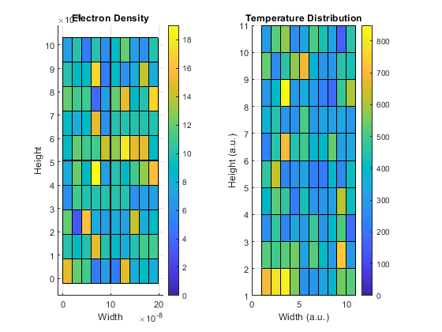

Figure 4: Density and Temperature Distributions

Part 2: Finite Difference to Calculate Electric Field from Applied Voltage

In another previous problem, a voltage was being applied on one side of a region, and Finite Difference Method was used to determine how that voltage would change and be affected by two regions of lower resistivity than the rest of the region. The two regions of lower resistivity are given coordinates identical to the problem mentioned in Part 1 above that was solved before, and the voltage was calculated with respect to this distribution. A mesh grid of nodes across the region was set up and the voltage at each node was calculated by producing a G matrix as before, but now, all voltages were affected by the resistivity of each node to produce an accurate voltage distribution. Next, matrix math was done to determine the voltage at each node, which was plotted and is shown below:

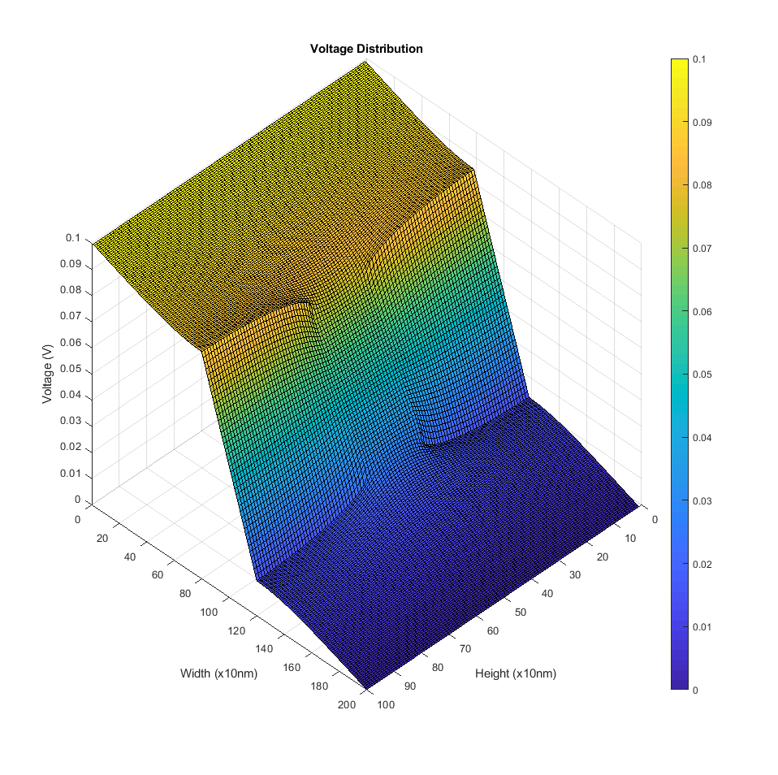

Figure 5: Voltage Distribution from Finite Difference

If the negative gradient of the voltage distribution shown above is taken, electric field vectors can be determined. Taking these vectors and plotting them in a quiver plot can show the direction and magnitude of the electric field at all nodes in the distribution. This is shown below:

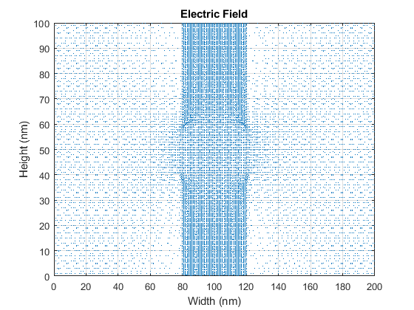

Figure 6: 2D Electric Field Quiver Plot

Part 3: Coupling Monte Carlo with Finite Difference

In Part 1 above, a voltage was applied to a region with electrons in it, and that voltage produced an acceleration for each electron in the region. In Part 2 above, a voltage was produced with an accurate representation of regions with different resistivity. As shown in Figure 6, the electric field in the region is not constant. Now, the voltage distribution produced in Part 2 will be coupled with the region in Part 1, so that the acceleration of electrons in the region in Part 1 is not just a constant acceleration, but dependent on the resistivity of the bottle-necks within the region. To do this, the voltage distribution must be calculated, such that an acceleration matrix can be produced based on the altered electric field in Part 2. This acceleration matrix will be used to determine the updated velocity of electrons at all nodes within the distribution, depending on the location of all electrons and updating them with the corresponding acceleration values. This updated velocity calculations will look similar to Figure 2, but now, there will be bottle-necks included in the region. This is shown below:

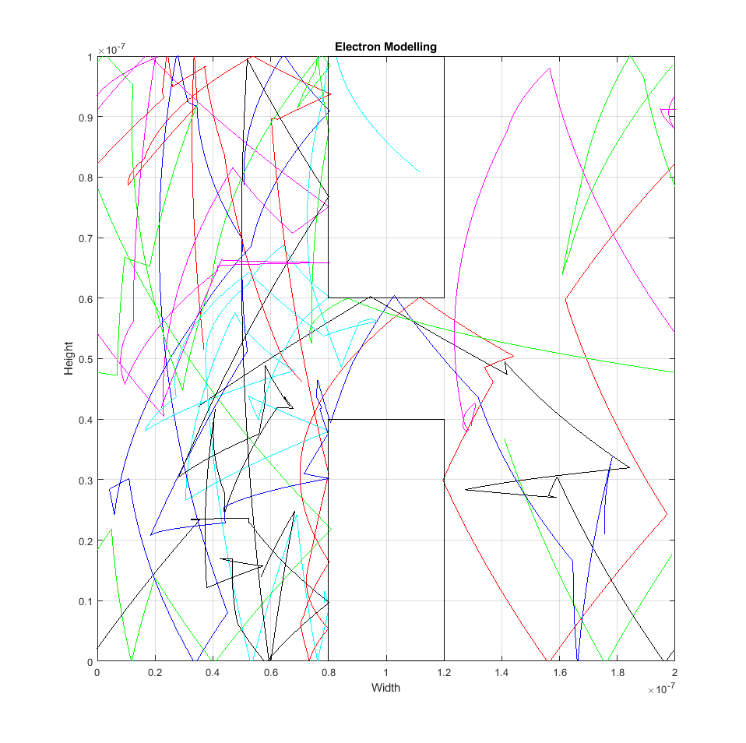

Figure 7: 2D Particles Trajectories with Finite Difference Voltage Distribution

As shown in the figure above, with the bottle-necks included, the velocities of all electrons are being updated with the applied voltage, but they are being “caught” on the left side of the region. The density of electrons in the region can again be determined as explained above, and this is shown in the graph below:

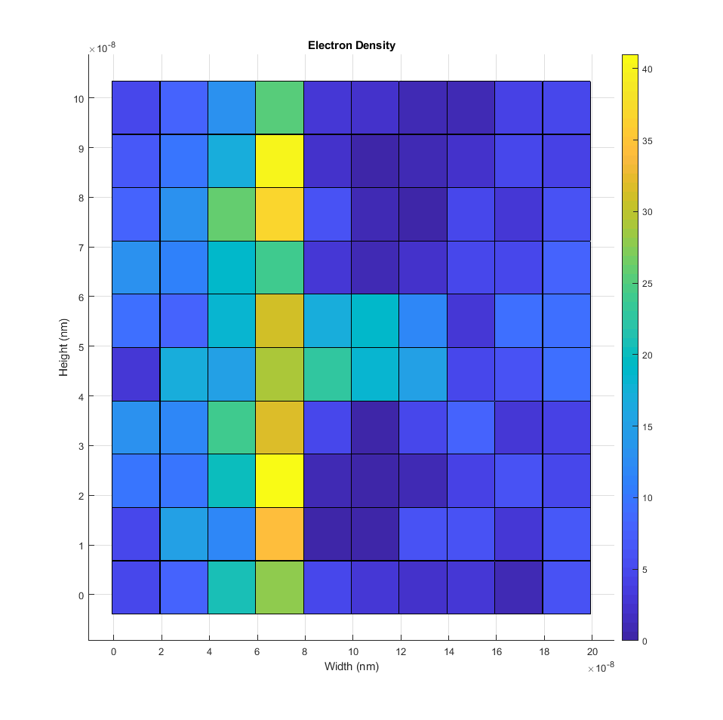

Figure 8: Density Distribution

As seen in the graph above, with the voltage being applied in the x direction, electrons are getting trapped on the left side of the region. Since boundary conditions are setup so that electrons will bounce off the top and bottom walls of the region, but travel through the left and right side of the region, the electrons seem to be “falling” from left to right and after they pass the right side of the region, they get “teleported” back to the left side and continue falling.

A possible next step in the implementation of this simulation to make it more accurate would be to implement collisions between electrons. The electric field produced by the electrons moving around as well as the velocity of each electron would give additional energy along with the energy of the electric field acting upon each electron. Whenever any electrons come close to each other and potentially collide, the velocity of those electrons could be affected based on the electric field and the other electron’s velocity at the time of impact. This would allow for more realistic movement of electrons in a region of a material.