ELEC 4700

Assignment 4

Circuit Modeling

Student Name: Jeremy Schelhaas

Student Number: 100976020

Date: April 7, 2019

Table of Contents

Part 1: Circuit MNA Modeling.………………………………………………………………..…………………………..……..3

Part 2: Transient Circuit Simulation……………………………………………………………………..……………………..5

Part 3: Circuit with Noise…………..…………………………………………………………………….………………………….7

Part 4: Non-linearity………………………………………………….…………………………………………………....…………8

Figures

Figure 1: Vin vs Vo and V3………………………………………………………………………………………………….……….3

Figure 2: G, C, b Matrices……………………………………………………………………………………………………..…….4

Figure 3: Frequency Response…………………………………………………………………………………………………...4

Figure 4: Perturbations in C…………………………………………………………………………………………………………5

Figure 5: FFT of Step Response…………………………………………………………………………………………………..6

Figure 6: FFT of Sin Function………………………………………………………………………………………………….......6

Figure 7: FFT of Gaussian Pulse ………………………………………………………………………………………………….7

Figure 8: Noise Response……………………………………………………………………………………………………………8

Figure 9: FFT Response……………………………………………………………………………………………………………….8

Figure 10: Noise Distribution………………………………………………………………………………………………………9

Part 1: Circuit MNA Modeling

Component stamps were created as separate functions in MatLab to add values to the respective cells in the G, C and b matrices respective of where the components are located in the circuit. Solving for the voltage matrix where $V=(G+sC)\backslash b$ gives the G, C and b matrices given in Figure 2, and the gain of the circuit in the DC response is given in Figure 1.



Figure 1: DC Gain

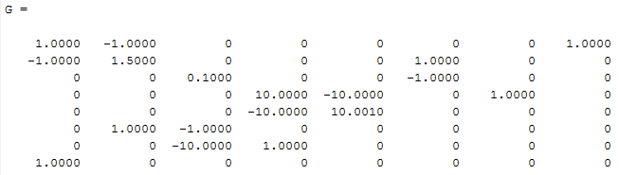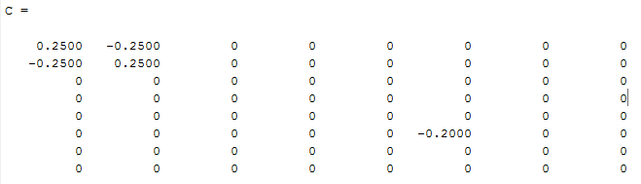



Figure 2: G, C, b matrices

Next the AC frequency response can be modelled, as shown in figure 3.



Figure 3: Frequency Response

Finally, random perturbations in the C matrix can be modelled, as shown in Figure 4.



Figure 4: Perturbations in C

Part 2: Transient Circuit Simulation

The circuit acts as a low pass filter with an amplifier. The low frequency responses will be amplified, while the high frequencies have no output.

A step response is shown in Figure 5, sinusoidal response in Figure 6 and Gaussian pulse in Figure 7.



Figure 5: Step Response



Figure 6: Sinusoidal Response



Figure 7: Gaussian Pulse Response

Part 3: Circuit with Noise

With the addition of noise in the circuit, the C matrix has been updated, as shown below:

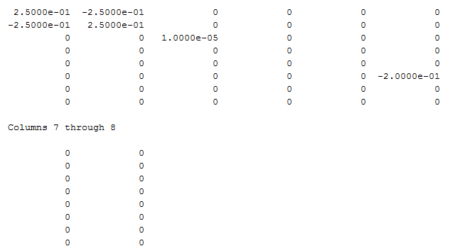

Figure 8: C Matrix

There is also a new FFT response, shown below:



Figure 9: FFT Response

There is also noise in the circuit now, so a distribution can be modelled:



Figure 10: Noise Distribution