**Appendix A: FluSight Website Instructions**

**Create an Account**

**Note: Each account is only able to submit one model per challenge. Teams submitting multiple models must register each under separate accounts.**

1. Go to <https://predict.cdc.gov/>
2. Click “Create Account” in the top right corner.
3. Fill in the fields and click “Register”.
4. You will see a new screen than says “Welcome! You will get an email shortly from [episupport@cdc.gov](mailto:episupport@cdc.gov) to have your account activated. You can also contact support should you encounter any problems.”

**Join a Project**

**Note: Teams must register for the national/regional and state FluSight challenges separately.**

1. Log into your account at <https://predict.cdc.gov/>
2. You should see a field to create a team for the FluSight project. Below is an image of the field for the state challenge. Another box, labeled FluSight 2019-2020, can be used to register for the national/regional FluSight challenge.

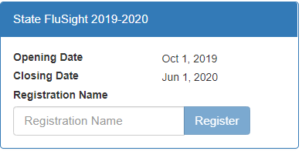

1. Enter your model name in the box labeled “Registration Name”. If your team is submitting multiple models for one challenge, please use the convention “TeamName_ModelName” as your model name.
2. Click “Register".
3. The system will notify us of your request to join the project.
4. We will approve your request with 2 business days. Send an email to [flucontest@cdc.gov](mailto:flucontest@cdc.gov) if you have any questions or concerns.

**Submit a Forecast**

1. Log into the website at <https://predict.cdc.gov/>
2. Click on “Go to project” under your team name in the FluSight box

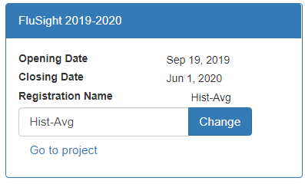

1. In the left menu bar, click on “Submit” to access the submission page

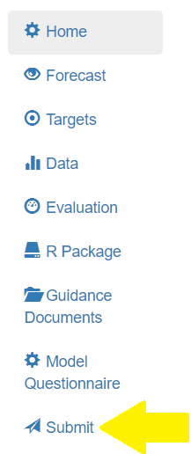

1. In the row for the week you are submitting (November 1st for the first submission), click “Upload CSV” and select your submission file.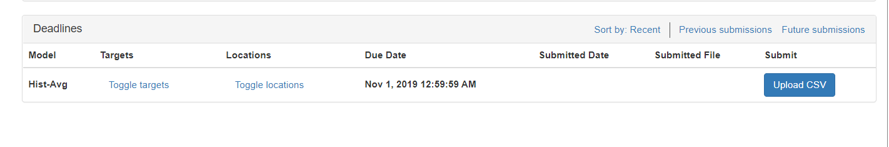
2. You should see “Processing…” and then “Sending…” appear next to the Upload button while your data are transmitted and the system checks to make sure your submission is valid.
3. If the submission is successful, you will see an “Open JSON” link next to the upload button. Clicking this will open the JSON file that your submission has been converted to that will eventually be used for visualizations on the webpage.
4. If your submission is not successful, an error message may popup explaining what rows/columns are out of agreement with a valid submission. Try to fix those errors and resubmit. Contact [flucontest@cdc.gov](mailto:flucontest@cdc.gov) if you experience technical issues with submitting.
5. Please also email your CSV to [flucontest@cdc.gov](mailto:flucontest@cdc.gov) until otherwise directed.