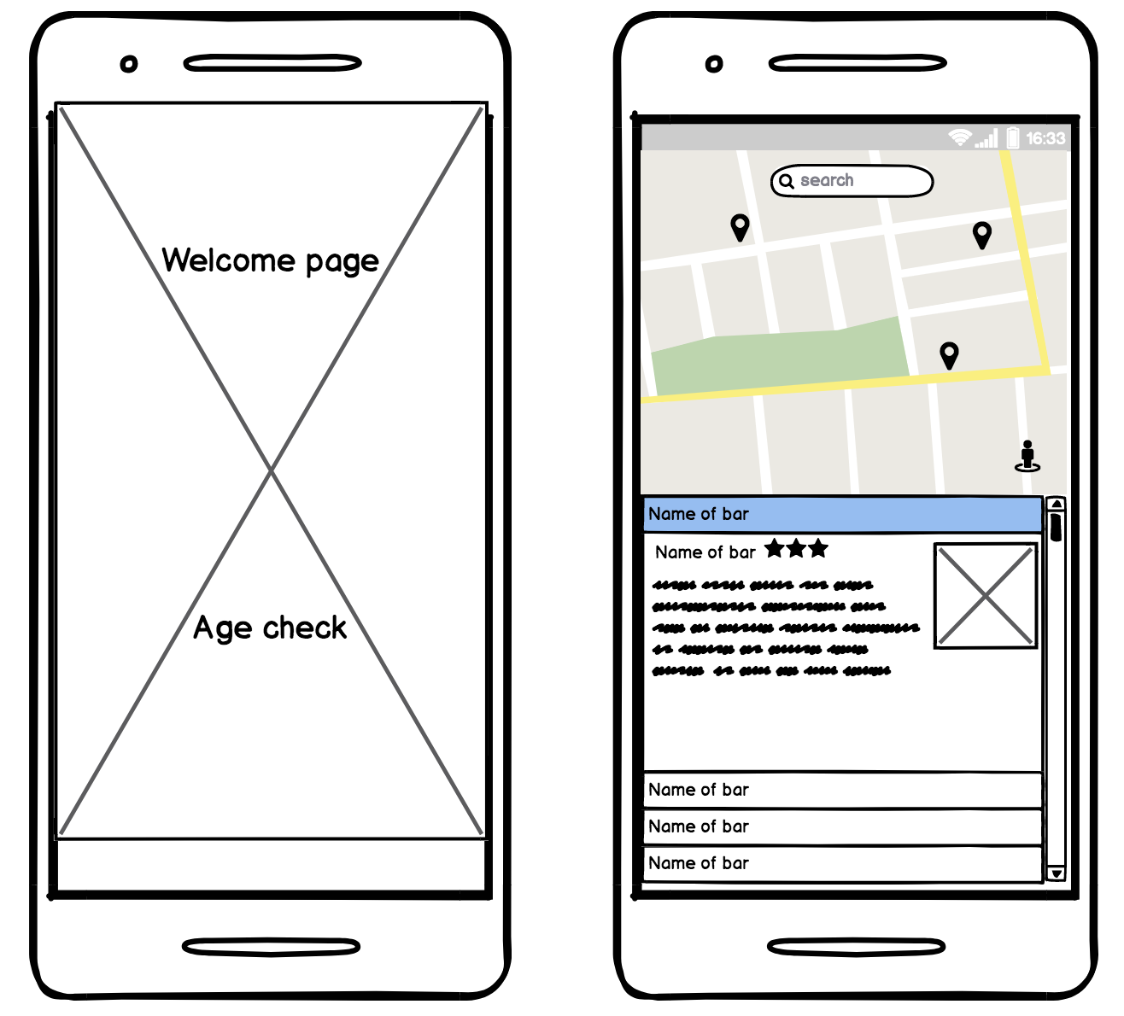

Welcome Page & Age Check

→ fades out to view of map with markers and list of nearby bars