# 5 Alternative Packaging Solutions for Sustainable Product Designers

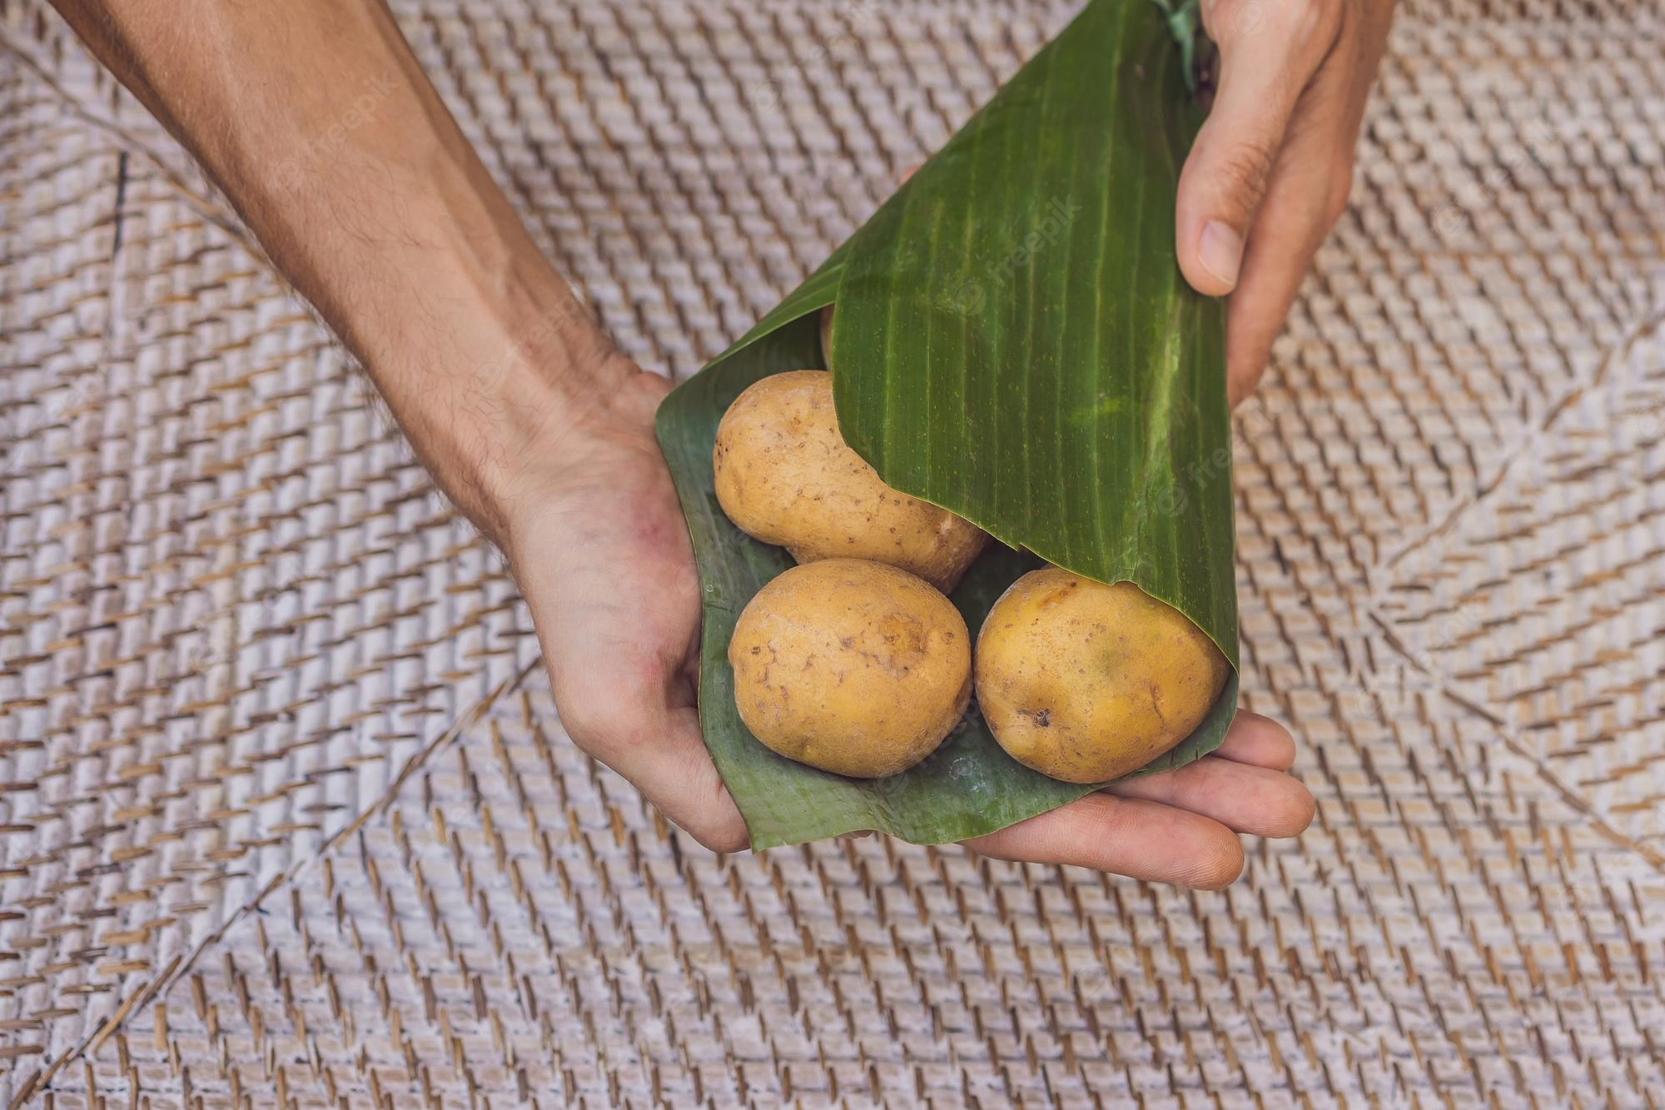

Image Source: FreeImages

‍

Newer and younger designers are becoming increasingly conscious of their role as responsible and accountable members of society. In response, many are shifting away from the flash and gimmickry they’re so often associated with, instead focusing on products that are not only beautiful but also have a positive impact on the world around them. This desire for more meaningful work has led to an increased focus on sustainability—not just in fashion or home decor but even in product design. In fact, there has been a surge in competitions centered around sustainable design such as PENDULUM’s New Materials Designers Award, which is dedicated to “new materials that change our lives through innovative applications in areas such as Artificial Intelligence, Smart Textiles & Wearable Technology, 3D Printing Applications, Digital Fabrication, Sustainable Materials & New Manufacturing Techniques.” Furthermore, there has been an increase in demand for designers who can create products responsibly from start to finish. This means ensuring a product operates at peak performance while using minimal energy, water and materials; as well as incorporating alternative packaging solutions.

## 1. Use the product itself as packaging

The most sustainable design is the one that doesn’t create waste at all. When designing packaging for a product, consider whether it makes sense to use the product itself as the packaging. Likewise, think about whether you can design a product in a way that makes it easy to repurpose. If you decide to make the product itself the packaging, think about whether it can be easily opened and recycled afterwards. If it needs to be repackaged for its destination, make sure there is an easy way for the consumer to open it. If you can’t find a way to make it work, it might be best to reconsider.

## 2. Make use of food-based packaging

Food-based packaging is an alternative packaging solution that has been growing in popularity for years. It is a type of packaging that uses natural substances such as fruits, vegetables, grains, grasses, wood fibres and cork to package products. There are a number of advantages to using food-based packaging, including the fact that it’s biodegradable, edible, renewable and sustainable. One of the biggest drawbacks to traditional packaging is that it isn’t usually fully biodegradable. In fact, many food and beverage products are packaged in materials that take decades or even centuries to decompose.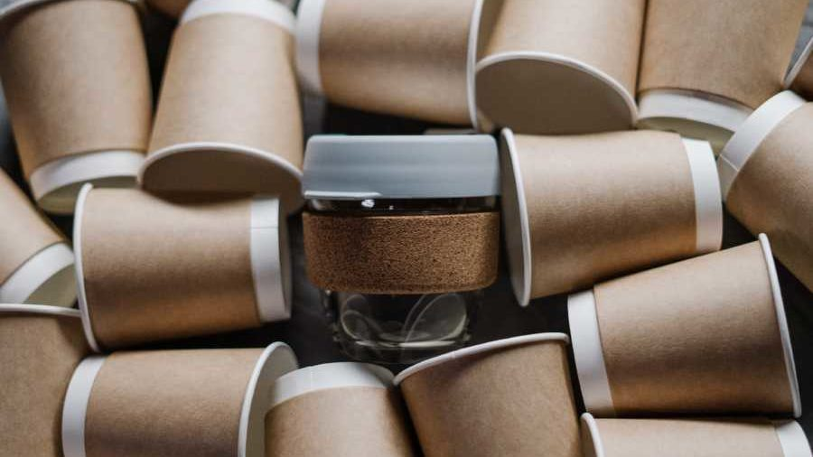

## 3. Grow your own packaging

Growing your own packaging is another alternative packaging solution that has seen an increase in popularity in recent years. Products and materials such as packaging made from mushrooms, barley and wheat are becoming more common. There are a number of advantages to growing your own packaging, including the fact that it is biodegradable, edible, renewable and sustainable. One of the major drawbacks to growing your own packaging is that it often takes longer to do than using traditional packaging materials. For example, it can take months to grow mushrooms as opposed to a few days to create a paperboard box using traditional methods.

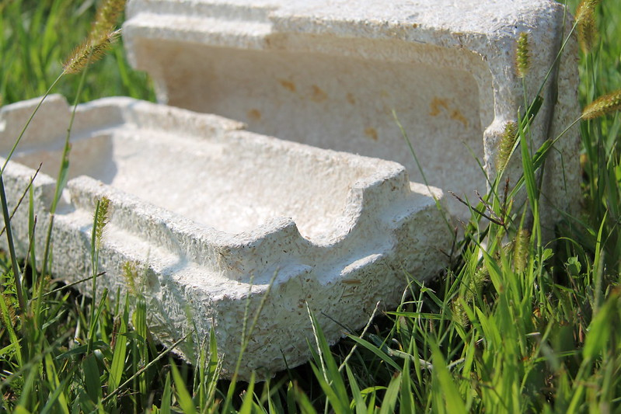

Photo by mycobond/https://www.flickr.com/photos/75778657@N06/6806712061

## 4. Utilize 3D printing

3D printing technology has grown immensely in popularity over the last decade. It has been used for everything from creating medical supplies to producing architectural models. More recently, it has been put to use in the packaging industry as well. There are a number of advantages to using 3D printed packaging, including the fact that it is fully recyclable, biodegradable and reusable. One of the major drawbacks to using 3D printed packaging is that it can be costly to produce. However, 3D printing is becoming increasingly affordable. Another potential issue is that the recycled materials used in 3D printing may not be the most sustainable option.

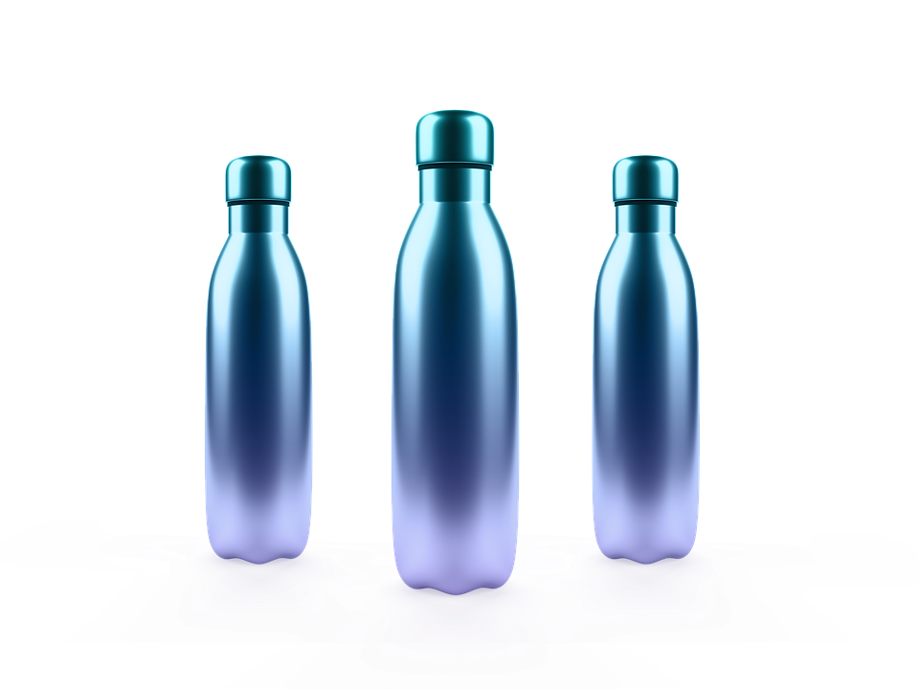

## 5. Create biodegradable, recyclable and compostable packaging

Biodegradable, recyclable and compostable packaging is a type of alternative packaging that has been growing in popularity in recent years. It is a type of packaging that uses sustainable materials such as soybean oil, starch, cornstarch, bagasse, eucalyptus, cork, hemp, paper and peat. One of the biggest advantages to using biodegradable, recyclable and compostable packaging is that it is sustainable. One of the major downsides, however, is that it is often more expensive than traditional packaging materials. One way to make biodegradable, recyclable and compostable packaging more affordable is to make it part of an entire product line.

## 6. Find other inventive solutions

Rather than focusing on finding the “next big thing” in packaging, consider other inventive solutions such as reusing existing materials, using fewer materials or using less packaging altogether. One of the biggest advantages to finding other inventive solutions is that they are often less costly than finding new and innovative packaging materials. One drawback to finding other inventive solutions is that it isn’t always possible to find materials that meet all of the necessary criteria. Finding packaging that is sustainable, safe and affordable isn’t always easy. One way to make finding other inventive solutions easier is to conduct research. You can read up on the latest developments in packaging and materials, as well as what industries are investing in sustainable packaging.

## 7. Conclusion

As the world becomes increasingly conscious of the impact of its actions, designers must do their part to create products with less impact on the environment. This can be achieved through the use of sustainable materials, biodegradable packaging, alternative shipping methods (such as drones) and more efficient usage of energy. It’s important to note that each of these solutions comes with its own set of challenges. Some of these solutions are more costly than others, and some require certain technological advancements in order to be viable. When selecting one of these solutions, it’s important to understand the positives and negatives of each so as to make an informed decision.