AUTHORIZED LAB WALKTHROUGH
Library
Service enumeration, SSH credential discovery, and Python-based privilege escalation
Platform: TryHackMe | Difficulty: Easy | Room: library

Reconnaissance
I began with Nmap default-script and service-version detection to identify reachable TCP services and collect initial HTTP metadata.
nmap -sC -sV <MACHINE_IP>
The scan identified 22/tcp running OpenSSH 7.2p2 and 80/tcp running Apache HTTP Server 2.4.18. The HTTP title identified the host as the Library machine, so I prioritized the web service for further enumeration.
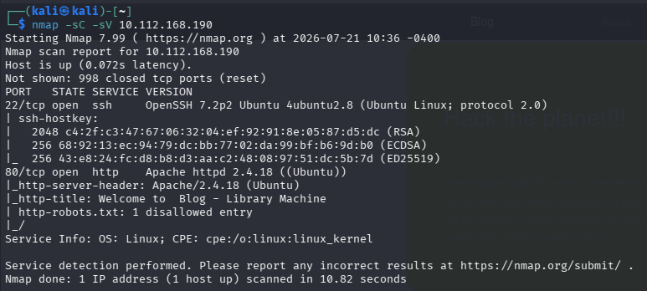
Evidence - Nmap identifies SSH on port 22 and HTTP on port 80.
Open services: 22/tcp (SSH) and 80/tcp (HTTP)

Web enumeration

robots.txt clue
The Nmap HTTP scripts reported a robots.txt file. I opened it in the browser and found an unusual user-agent value rather than a conventional crawler name.
http://<MACHINE_IP>/robots.txt
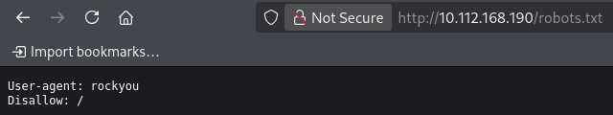
Evidence - robots.txt exposes the string rockyou.
The string rockyou strongly suggested the common rockyou password list. A username was still required before testing SSH credentials.

Username discovery
The web application displayed a blog post whose author line named meliodas. I treated this value as a candidate local account for the exposed SSH service.

Evidence - The blog post identifies meliodas as the author.
Candidate username: meliodas

Password-list verification
I checked the standard Kali Linux word-list directory and confirmed that rockyou was available as rockyou.txt.gz.
ls -l /usr/share/wordlists
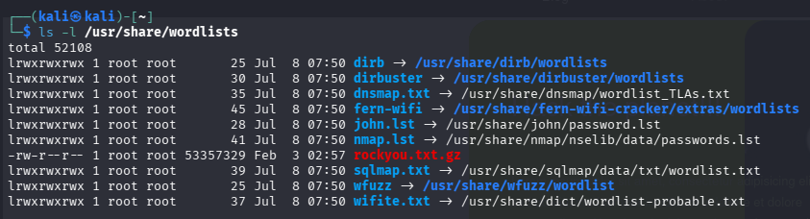
Evidence - rockyou.txt.gz is present in /usr/share/wordlists.
The Hydra build used in this session accepted the compressed list directly, as confirmed by the successful run below. On a system that requires plain-text input, the archive can instead be expanded with gzip -dk.

SSH credential discovery
Within the authorized lab scope, I tested the meliodas account against the password list with four parallel tasks.
hydra -l meliodas -P /usr/share/wordlists/rockyou.txt.gz -t 4 ssh://<MACHINE_IP>
Here, -l supplies one username, -P supplies the password-list file, and -t 4 limits Hydra to four concurrent tasks. The test returned one valid SSH credential pair.
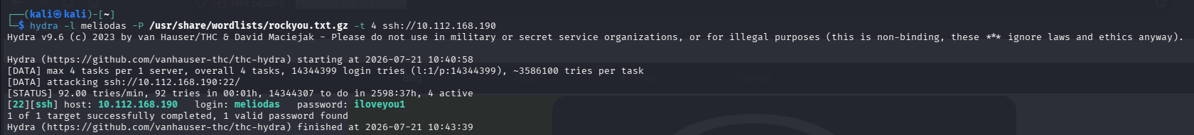
Evidence - Hydra identifies a valid password for meliodas.
Credentials: meliodas / iloveyou1

Initial access
I used the discovered credentials to establish an SSH session on the target.
ssh meliodas@<MACHINE_IP>
After accepting the host key and authenticating, I obtained a shell as meliodas on Ubuntu 16.04.6 LTS.
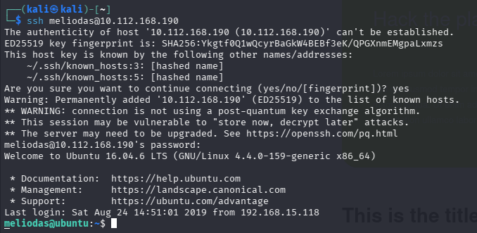
Evidence - Successful SSH login as meliodas.

User flag
I listed the user's home directory, located user.txt, and read the file.
ls -la
cat user.txt
Evidence - user.txt is read; the flag value is redacted for publication.
User flag: REDACTED

Privilege escalation

Confirming restricted access
An attempt to list /root as meliodas returned Permission denied, confirming that privilege escalation was required.
ls /root
Evidence - meliodas cannot access /root directly.

Reviewing sudo permissions
I inspected the sudo rules available to meliodas.
sudo -l
Sudo rule: (ALL) NOPASSWD: /usr/bin/python /home/meliodas/bak.py
The rule allowed a Python interpreter matching /usr/bin/python* to execute /home/meliodas/bak.py as root without a password. The file was owned by meliodas and writable, so its contents could be replaced before sudo executed it.
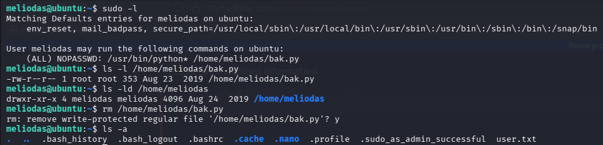
Evidence - sudo permissions and writable bak.py file.

Replacing the sudo-authorized script
I recreated bak.py with a short Python payload that replaces the interpreter process with a Bash shell. The -p option tells Bash to preserve its effective user ID.
echo 'import os; os.execl("/bin/bash", "bash", "-p")' > /home/meliodas/bak.py
Evidence - bak.py is replaced with a Bash-launching Python payload.

Obtaining a root shell
I executed the authorized script through the permitted Python interpreter.
sudo /usr/bin/python3 /home/meliodas/bak.py
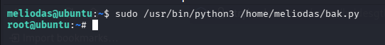
Evidence - The prompt changes from meliodas to root.
Privilege context: root

Root flag
With elevated privileges, I listed /root and read root.txt.
ls /root
cat /root/root.txt
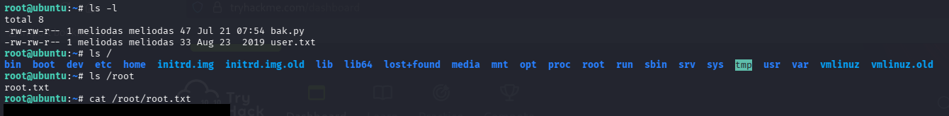
Evidence - root.txt is read; the flag value is redacted for publication.
Root flag: REDACTED

