AUTHORIZED LAB WALKTHROUGH
Pickle Rick
Web enumeration, command execution, and ingredient discovery
Spoiler warning: This writeup explains the complete solution path for the TryHackMe Pickle Rick room. The final room answers are redacted in this public version.
Platform: TryHackMe | Difficulty: Easy | Room: picklerick | Room URL: https://tryhackme.com/room/picklerick

Scope and environment
This write-up documents the solution path for the authorized TryHackMe Pickle Rick lab. The target address is represented as <MACHINE_IP> because the room assigns a temporary IP address each time the machine is deployed.

Reconnaissance
I began with a basic Nmap scan to identify reachable TCP services on the target.
nmap <MACHINE_IP>
The scan identified two open ports: 22/tcp for SSH and 80/tcp for HTTP. Because the challenge presents a web application, I prioritized the HTTP service for further investigation.
Evidence - Basic Nmap scan showing ports 22 and 80.
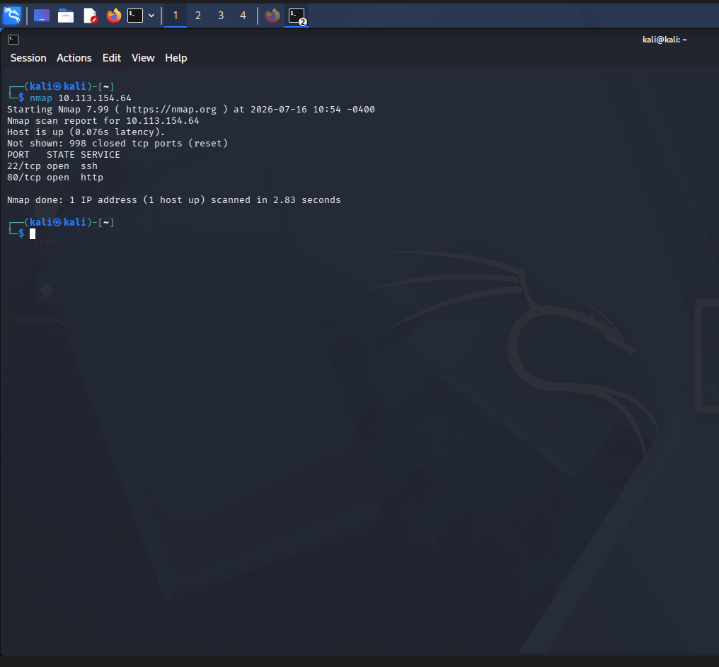

Web enumeration

HTML source inspection
I opened the web application and inspected the HTML source. A developer comment exposed a username that could be used for authentication.
Evidence - Username disclosed in an HTML comment.
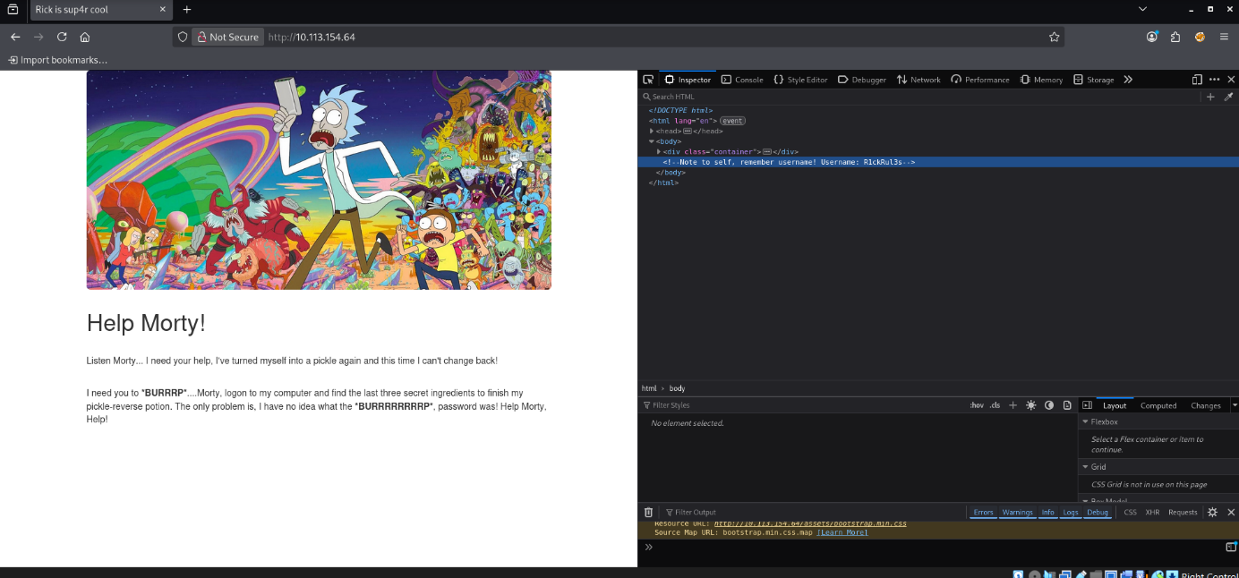
Username: R1ckRul3s

Directory enumeration
I used Gobuster with PHP, HTML, and TXT extensions to identify resources that were not linked directly from the home page.
gobuster dir -u http://<MACHINE_IP> -w /usr/share/wordlists/dirb/common.txt -x php,html,txt
Evidence - Gobuster directory enumeration results.
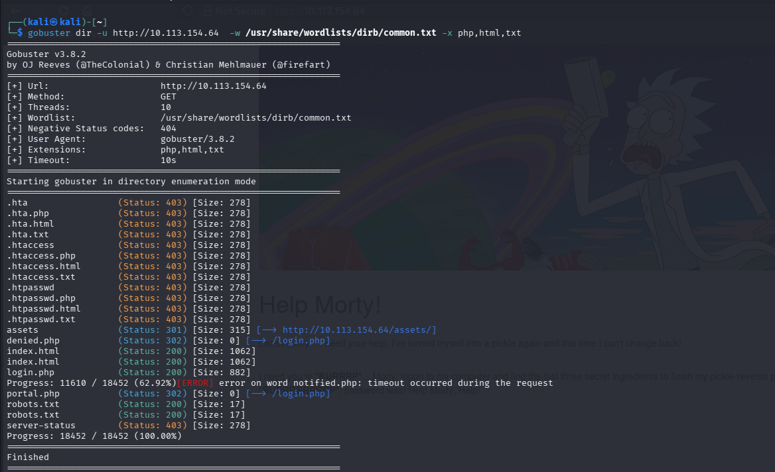
The results included login.php, robots.txt, and portal.php. The 302 redirect from portal.php to login.php indicated that the command portal required authentication.

Credential discovery in robots.txt
I inspected robots.txt before attempting to log in. Instead of normal crawler directives, the file contained a standalone string. I treated this value as a password candidate for the username discovered in the page source.
Evidence - robots.txt containing the password candidate.
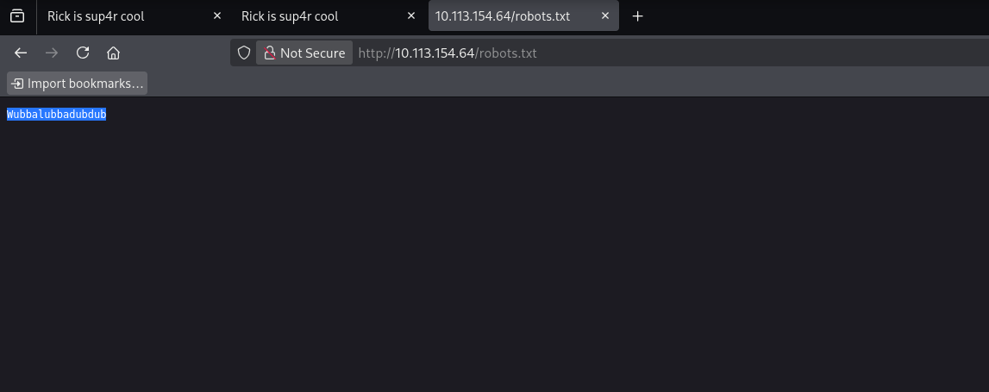
Password candidate: Wubbalubbadubdub

Authentication
I submitted the discovered username and password on login.php. Authentication succeeded and the application redirected me to the command panel at portal.php.
Credentials: R1ckRul3s / Wubbalubbadubdub
Evidence - Credentials entered on the portal login page.
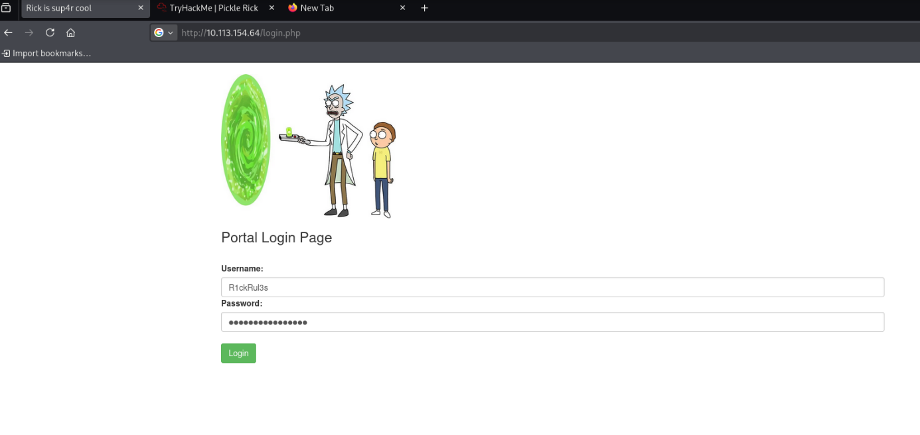

Command execution and the first ingredient
The authenticated portal accepted operating-system commands. I first listed the contents of the current web directory.
ls
Evidence - Listing the files in the web directory.
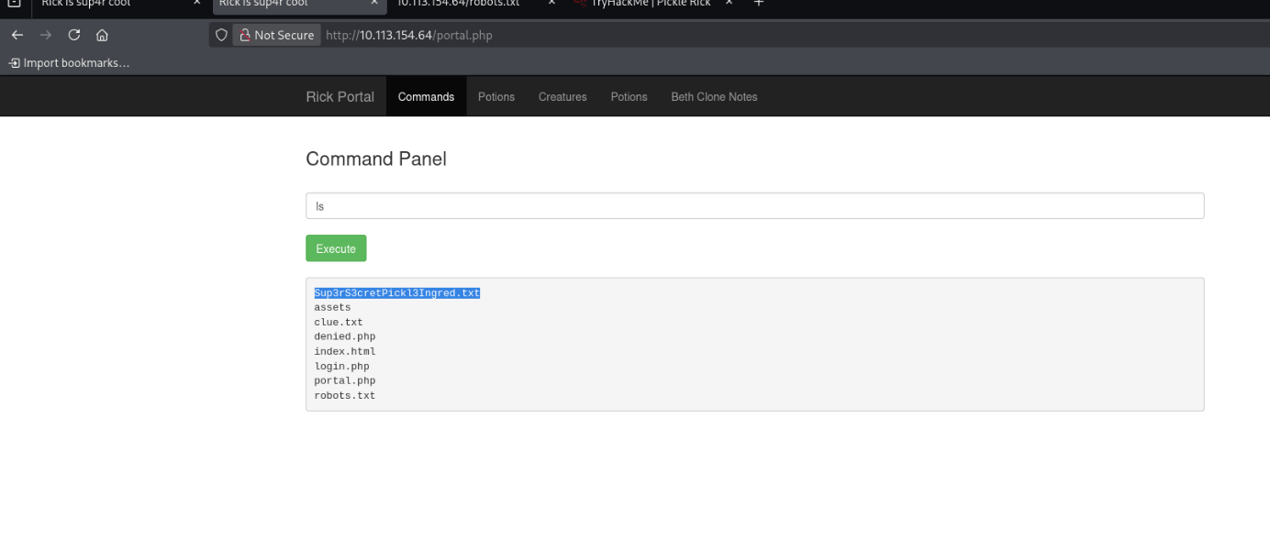
The listing revealed Sup3rS3cretPickl3Ingred.txt. I used less to display the contents of the file.
less Sup3rS3cretPickl3Ingred.txt
Evidence - Contents of Sup3rS3cretPickl3Ingred.txt.
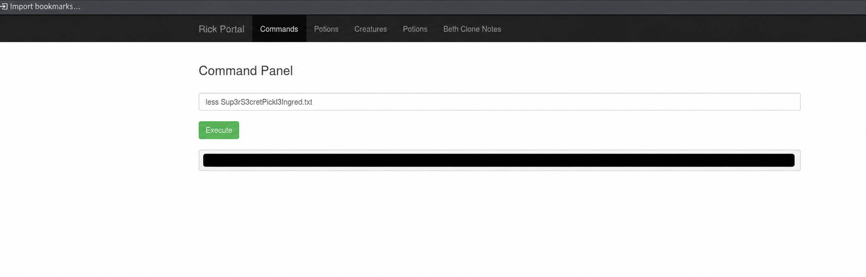
First ingredient: [REDACTED]

Locating the second ingredient
After finding the first ingredient in the web directory, I enumerated the root filesystem and then followed the user directories under /home.
ls /
Evidence - Root filesystem listing.
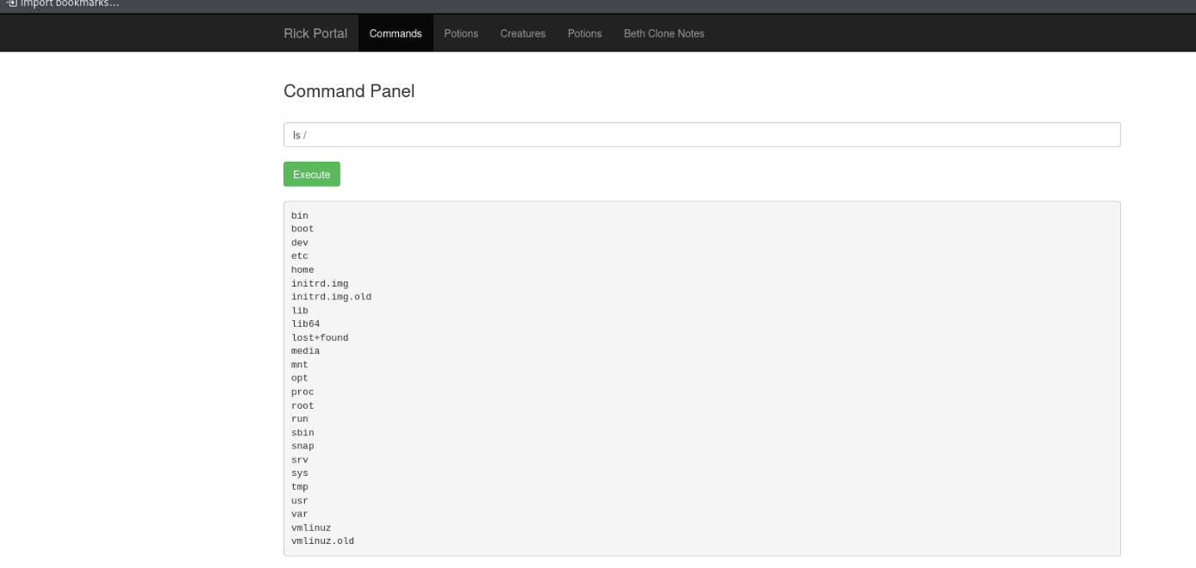
ls /home
Evidence - User directories under /home.
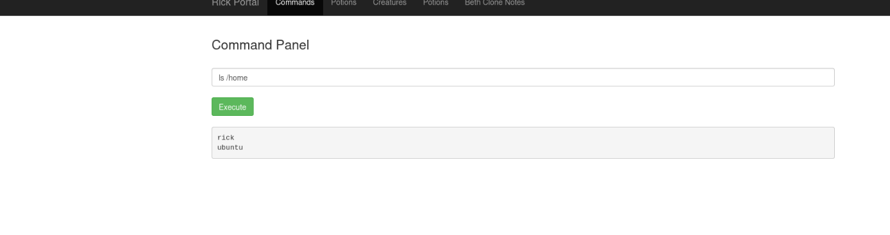
ls /home/rick
Evidence - The second ingredients file in /home/rick.
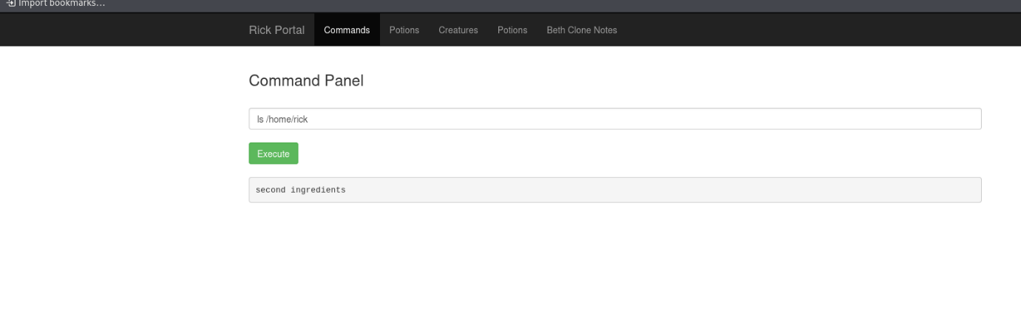
The filename contains a space, so I enclosed it in straight double quotes to ensure the shell treated the complete name as one argument.
less /home/rick/"second ingredients"
Evidence - Contents of the second ingredients file.
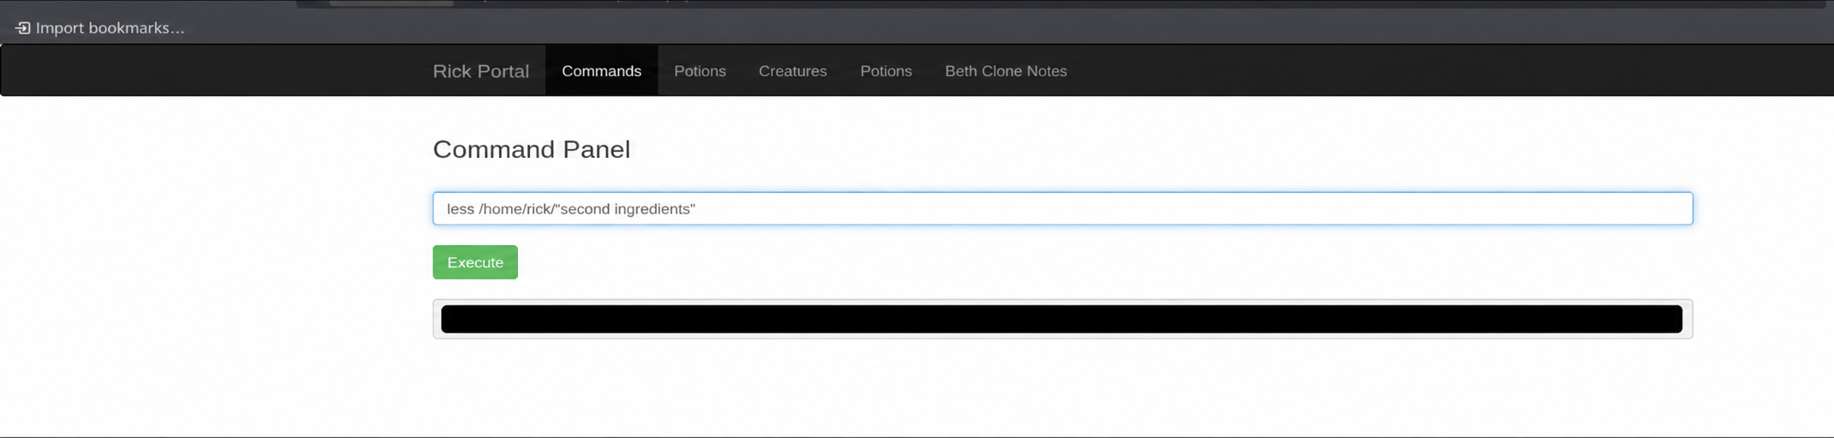
Second ingredient: [REDACTED]

Privilege context and the final ingredient
Before accessing /root, I checked which operating-system account was executing commands through the web portal.
whoami
Evidence - whoami confirms that portal commands run as www-data.
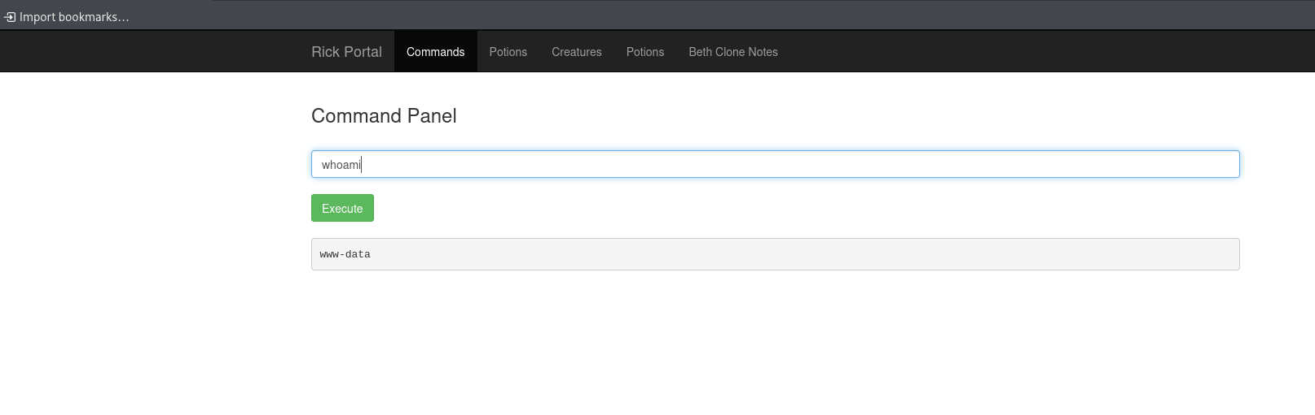
The output was www-data, confirming that commands were running as the restricted web-service account.
To determine whether the web-service account could execute commands with elevated privileges, I tested access to the root user's home directory using sudo ls /root. The command executed successfully without requesting a password, confirming that the account had excessive sudo privileges.
sudo ls /root
Evidence - Elevated listing of /root.
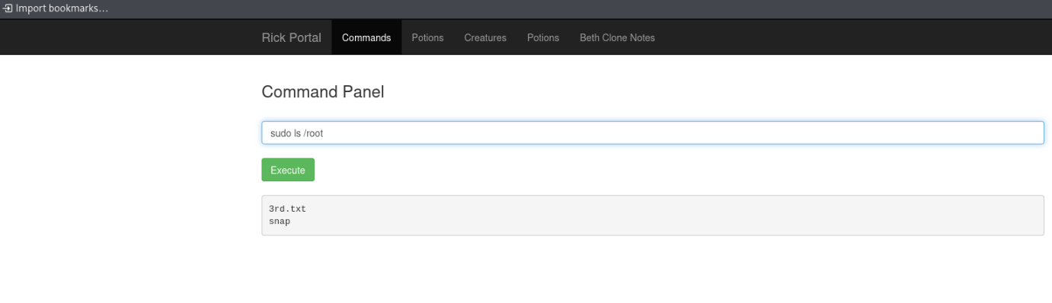
The directory contained 3rd.txt, so I read it with the same elevated privileges.
sudo less /root/3rd.txt
Evidence - Contents of /root/3rd.txt.
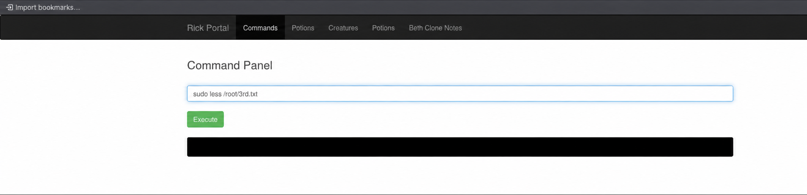
Final ingredient: [REDACTED]

Answer summary
The three room questions were answered in the same order in which the ingredients were discovered.
Question | Evidence location | Answer
First | Sup3rS3cretPickl3Ingred.txt (web directory) | [REDACTED]
Second | /home/rick/second ingredients | [REDACTED]
Final | /root/3rd.txt | [REDACTED]

