CSCI 4130/6905 - Information Retrieval

Programming Assignment: 01 – Response

1 Assignment Goal

Develop expertise in basic text preprocessing required for Information Retrieval (IR) applica-tions.

2 Problem Statement

Compute n gram frequencies for documents in a text corpus.

- Questions to Investigate Using the Corpus

  - Do all letters in the language occur with the same frequency? If not, which letter has the highest frequency? Which letter has the lowest frequency?

a : 731203
b : 139846
c : 185849
d : 400494
e : 1119617
f : 209239
g : 172048
h : 650743
i : 577691
j : 15946
k : 66676
l : 375313
m : 230032
n : 615091
o : 678136
p : 136173
q : 7552
r : 502402
s : 556863
t : 827161
u : 252211
v : 83829
w : 201292
x : 9160
y : 176040
z : 5525

‘e’ occurs the most.

- Does the Zipf’s law hold for Gutenberg corpus?
Yes

Log-log plot of the frequency of word occurrences versus their ranks is shown in Figure

Which unigrams occur more frequently?

[the] occurs unigram occurs the most
- Which bigrams occur more frequently?

[of the] bigram occurs the most.
- Which trigrams occur more frequently?

[of the lord] trigram occurs the most

- How did you test your program? How do you know that your program is working correctly?

We first tested the program by making a very small text file and made it read in uni-grams, bi-grams and n-grams. After that we calculated the frequency of the uni-grams bi-grams and n-grams. After that was correct we sorted the the frequencies and wrote the character counts for the text file to an output file. Once a small text file worked we tested it with a larger single text file and repeated. Then we had to make a list of all the corpus documents and read them in and calculated the same thing with all the files. Lastly we ran into the trouble of handling special characters in regular expressions and it messed with the n-gram list so we handled that. After the special characters were handled we tested the program again and it produced the correct output.

- Perform self-assessment using the following table:
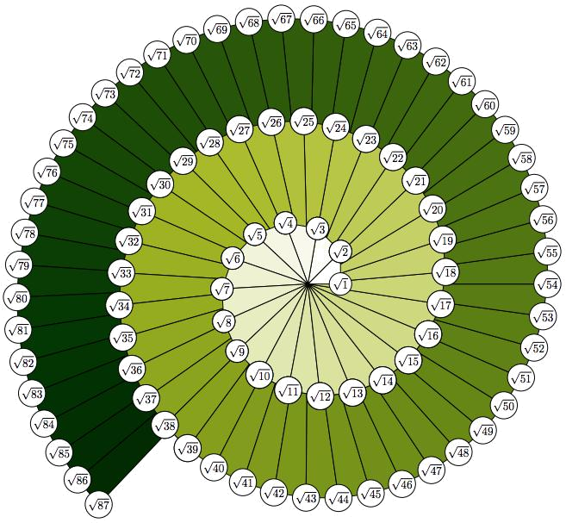

Figure 1: Distribution of letters in the English language

Unigram Name | Frequency
‘the’ | 133593
_{‘and’} | 95436
_{‘of’} | 71268
_{‘to’} | 48054
_{‘a’} | 33931
_{‘in’} | 33562
_{‘I’} | 29123
_{‘that’} | 28432
_{‘he’} | 25564
‘it’ | 21871

Table 1: Top ten frequently occurring unigrams

2

Figure 2: Log-log plot of word frequencies and their ranks for Gutenberg corpus

 | Bigram Name | Frequency
‘of the’ |  |  | 19145
‘in, the’ |  |  | 10245
‘and the’ |  |  | 8880
‘the lord’ |  |  | 6957
‘to the’ |  |  | 5412
‘all the’ |  |  | 3600
‘and he’ |  |  | 3575
‘to be’ |  |  | 3469
‘for the’ |  |  | 3049
‘shall be’ |  |  | 2791

Table 2: Top ten frequently occurring bigrams

3

Trigram Name | Frequency
‘of the lord |  | 1747
‘the son of’ |  | 1466
‘the children of’ |  | 1368
‘out of the’ |  | 1202
‘the house of’ |  | 917
‘saith the lord’ |  | 854
‘the lord and’ |  | 818
‘and I will’ |  | 764
‘and all the’ |  | 697
‘children of israel’ |  | 644

Table 3: Top ten frequently occurring trigrams

Task | Max Points | Points
 | Possible | Earned
Program compiles and runs | 30 | nn
Program seems to produce correct results | 20 | nn
Testing is done and test results are docu- | 20 | nn
mented
Appropriate data types are chosen for vari- | 10 | nn
ables
Variable names are self-explanatory | 10 | nn
Program code is commented appropriately | 5 | n
Self-assessment is performed | 5 | n
Total points | 100 | nnn

4

