Reimir Jashari
VERSION 1

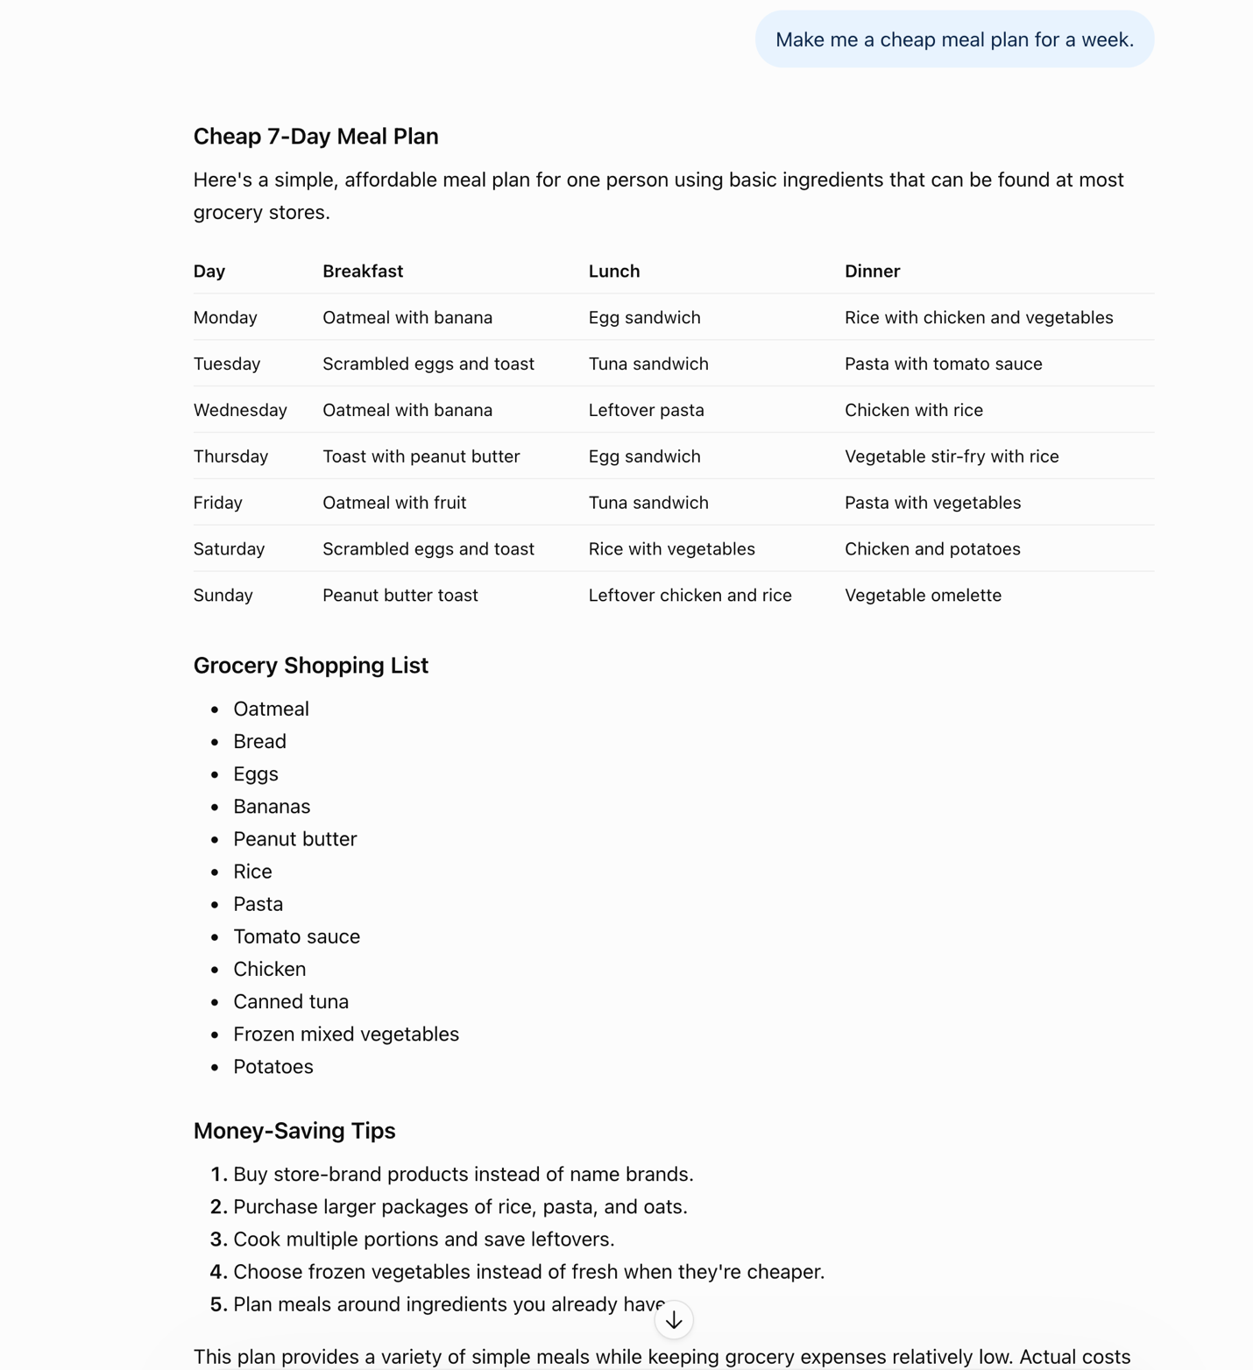

VERSION 2
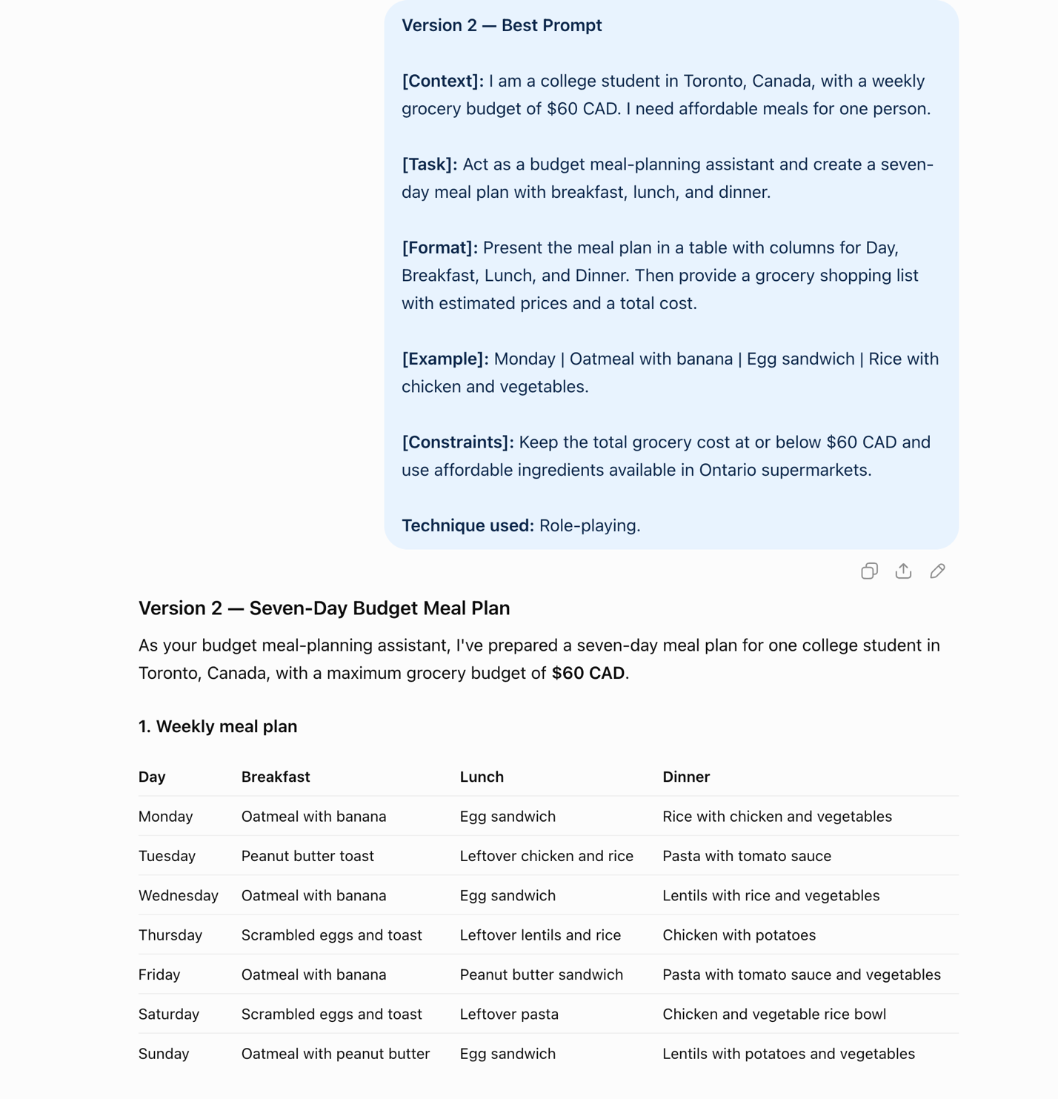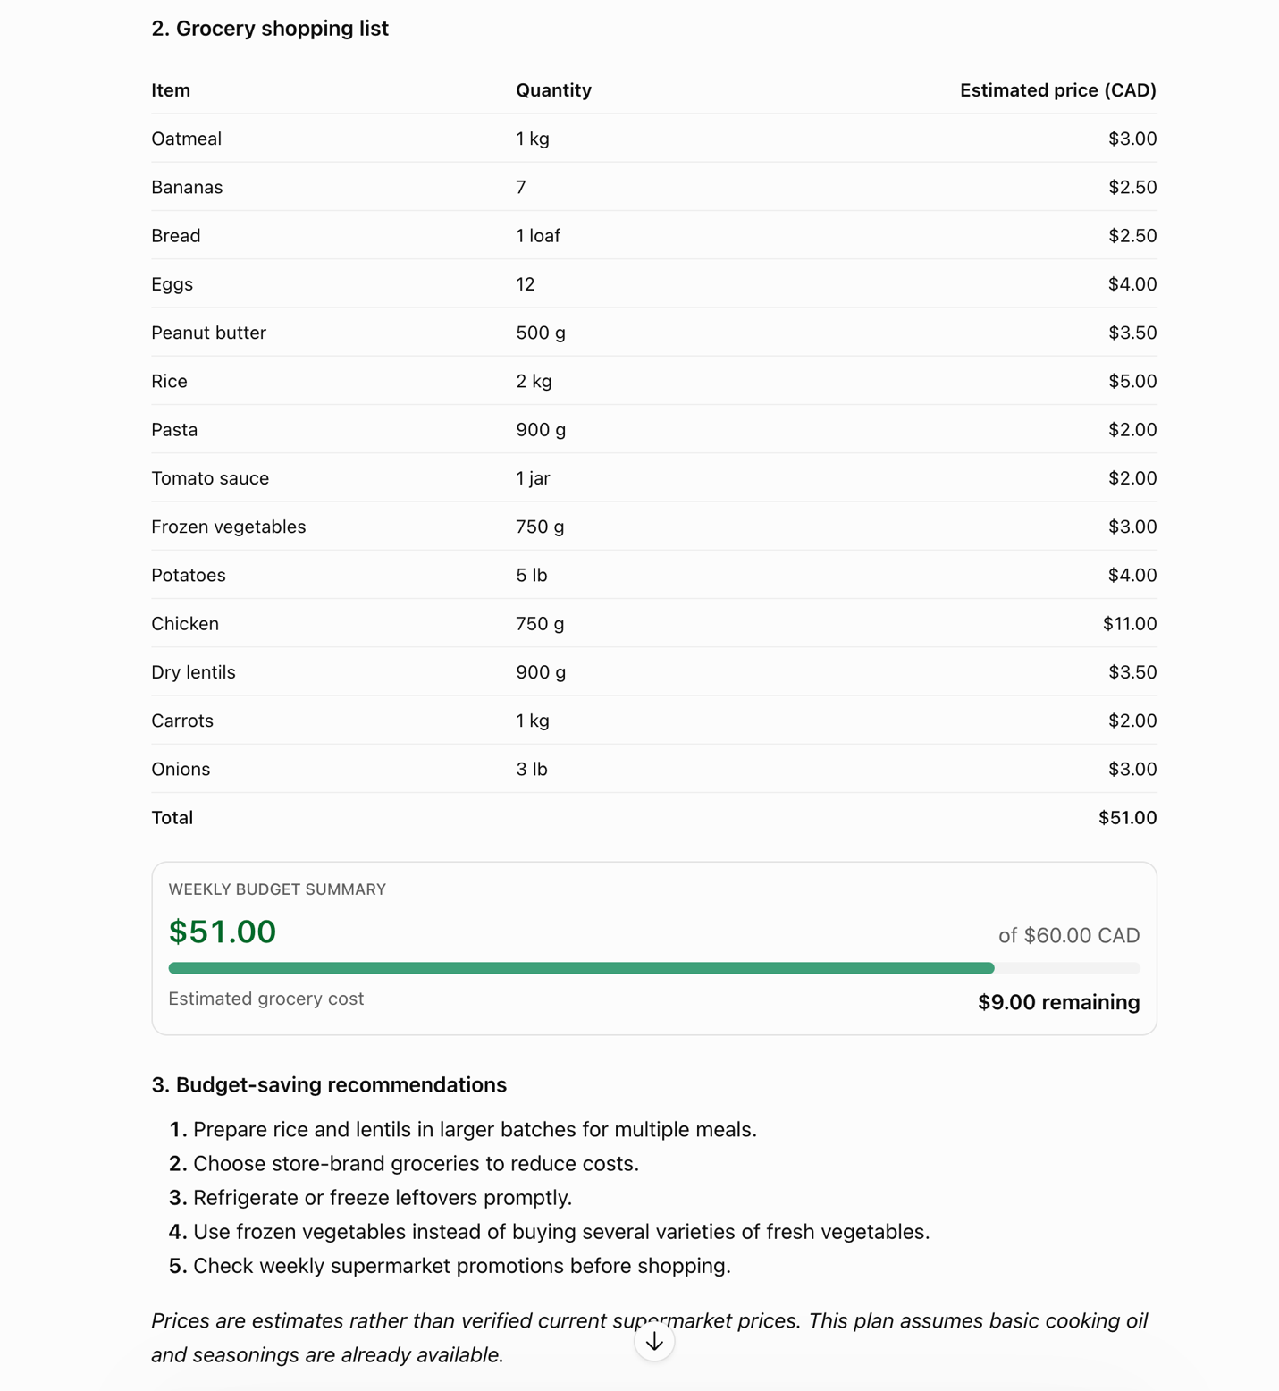

- PART 3: PEER REVIEW I RECEIVED
Reviewed by: ChatGPT (simulated peer review)
Check | ✓ / ✗
Context: Does it explain the situation? | ✓
Task: Is the action clear? | ✓
Format: Does it specify how the answer should look? | ✓
Example: Does it provide a sample? | ✓
Constraints: Does it set limits? | ✓
Technique: Is role-playing used correctly? | ✓
Suggestion from my reviewer:
The prompt could be improved by specifying how much time the student has available to prepare meals. For example, adding a maximum preparation time of 30 minutes per meal would make the meal plan more practical for a busy college student.

- Coffee Shop Interview Preparation Guide
Interview Question | Suggested Answer | Interview Tip
1. Tell me about yourself. | I'm a college student who is motivated, responsible, and eager to learn new skills. | Keep your introduction short and confident.
2. Why do you want to work at our coffee shop? | I enjoy interacting with people and want to develop my customer service skills. | Show genuine interest in the company.
3. How would you handle an unhappy customer? | I would stay calm, listen carefully, and try to resolve the issue professionally. | Emphasize patience and problem-solving.
4. How would you handle a busy rush? | I would stay organized, prioritize tasks, and communicate with my coworkers. | Highlight teamwork and working under pressure.
5. What are your strengths and weaknesses? | I'm reliable and willing to learn, but I'm working on becoming more efficient. | Be honest and explain how you're improving.

Task chosen: C2 — Prepare for your first job interview
Prompt 1: I am a college student preparing for my first part-time job interview at a coffee shop. List the five most common interview questions I should prepare for.
Prompt 2: Using the five interview questions you just listed, provide a short example answer for each question. Keep the answers professional but natural for someone with little work experience.
Prompt 3: Using the questions and example answers from your previous response, create a table with three columns: Interview Question, Suggested Answer, and Interview Tip. Keep the answers short and easy to remember.

- PART REFLECTION
Q1: What did your partner's feedback teach you about your prompt?
The feedback showed me that even when a prompt is clear, it can still be improved. Adding more specific constraints, like how much time I have to cook, can make the answer more useful.
Q2: Give one example of something you should not trust an AI to answer correctly, and explain why.
I would not fully trust AI to give me accurate grocery prices. Prices change often, and AI might use outdated information or make estimates. That's why it's important to check the prices myself.

