CS 410000 Computer Architecture
Homework 1
(Due: 2024-09-19 23:59)
110062272 盧思樺
Please evaluate your computer performance by executing the following benchmarks, and fill the blanks of table. In addition, basic hardware information of your computer has to be reported too. You can download the benchmark source code from eeclass, and re-compile them for your Linux system.

Compile Instructions
1) Change directories to “src” of benchmarks. (eq. SPEC2000_SS/CINT2000/164.gzip/src)
2) Make sure your gcc location in Makefile.defaults (eq. cc=gcc), and type "make",
3) Execute the “./run” script, and report your program elapsed time.

Reference machine information
Processor model | Intel(R) Core(TM) i5-8400 CPU @ 2.80GHz
Memory size | 32 GB
Operating system (OS) | Ubuntu 18.04.5 LTS

Benchmark | Execution time of your machine (second) | Execution time of reference machine (second) | Speedup of your machine w.r.t. reference machine
164.gzip | 0m0.650s | 0.564 | 0.87
175.vpr | 0m0.512s | 0.482 | 0.94
181.mcf | 0m0.069s | 0.072 | 1.04
Arithmetic mean |  |  | 0.91

Work station machine information
Processor model | AMD EPYC 7282 16-Core Processor
Memory | MemTotal: 263623900 kB
Operating system (OS) | CentOS Linux release 7.9.2009 (Core)

Snapshots of compilation results (including 164.gzip, 175.vpr, and 181.mcf). 3*5%
164
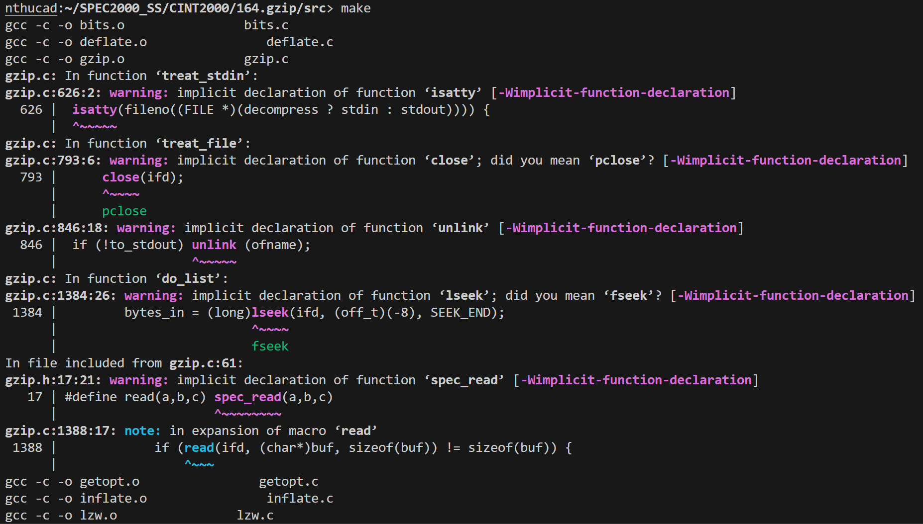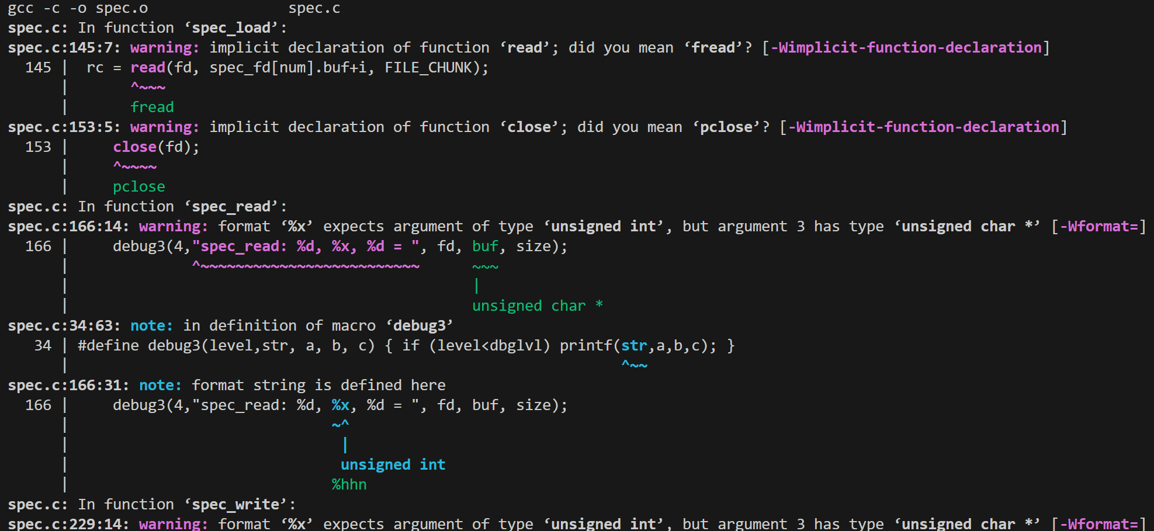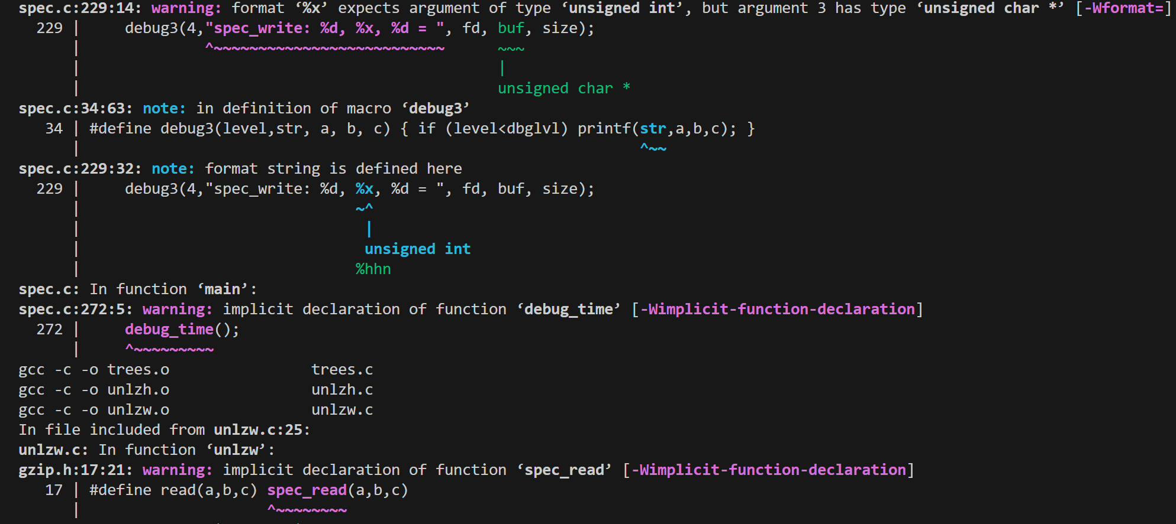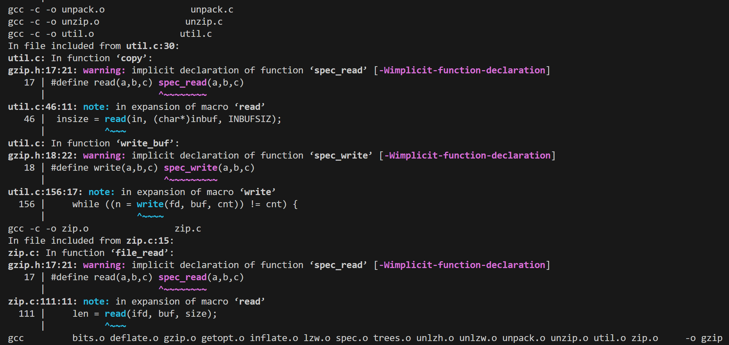

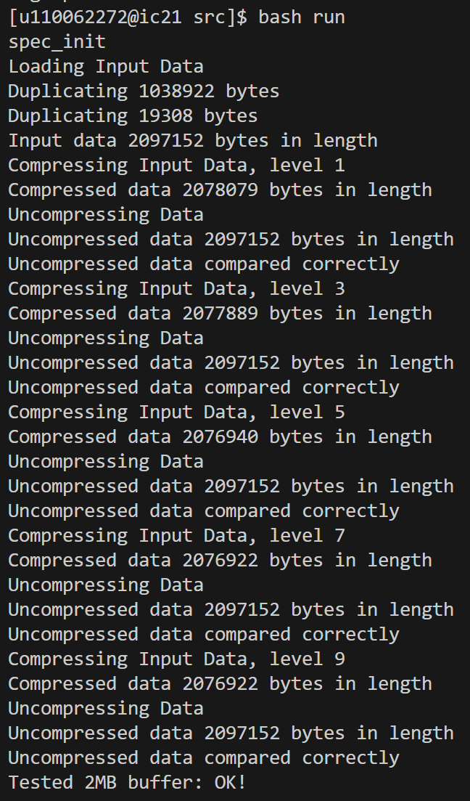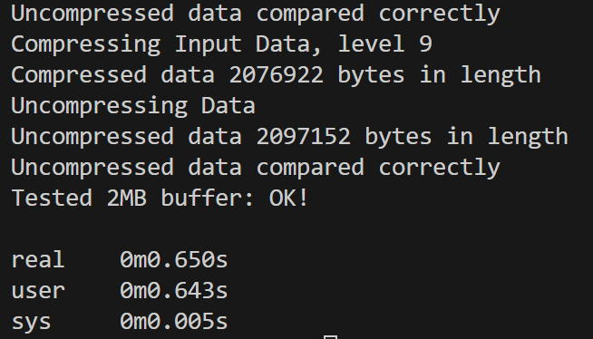
175

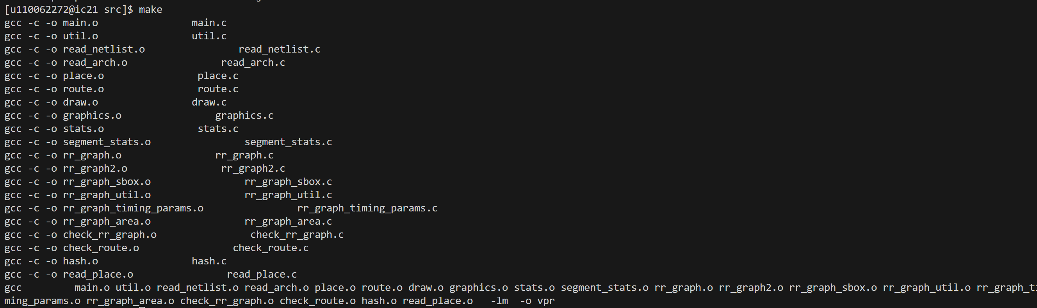
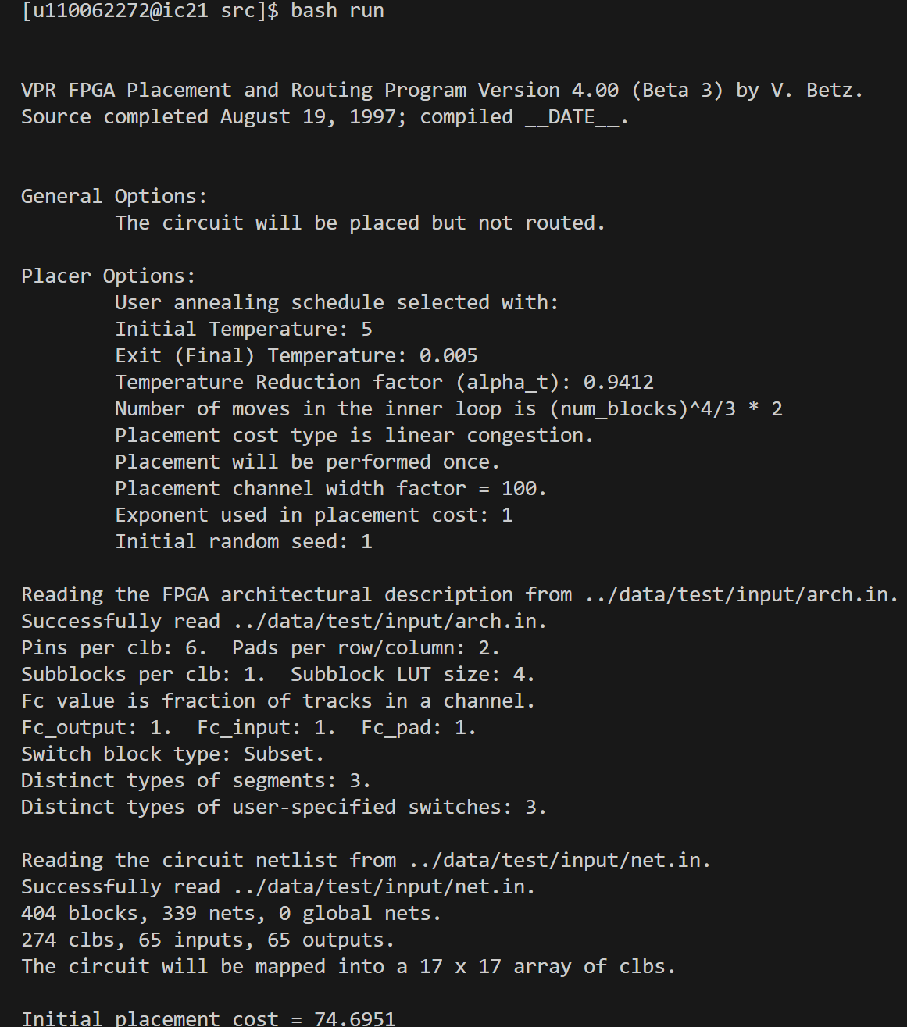
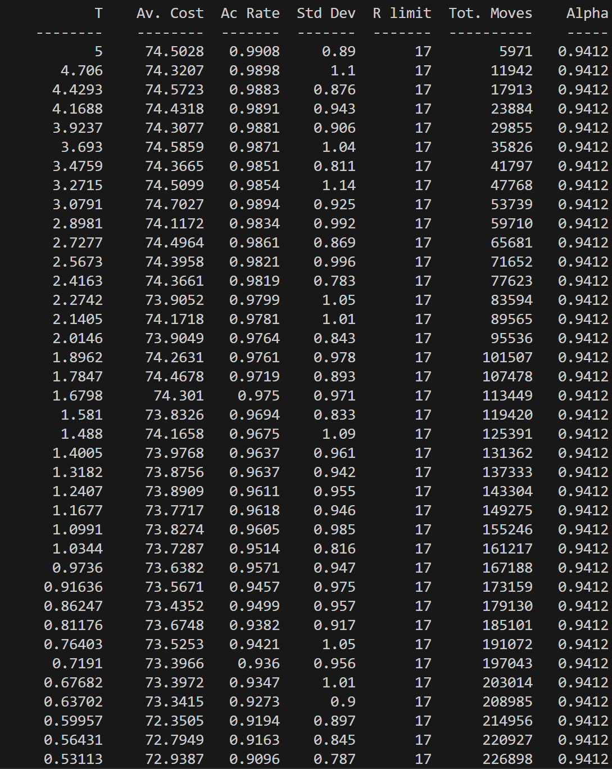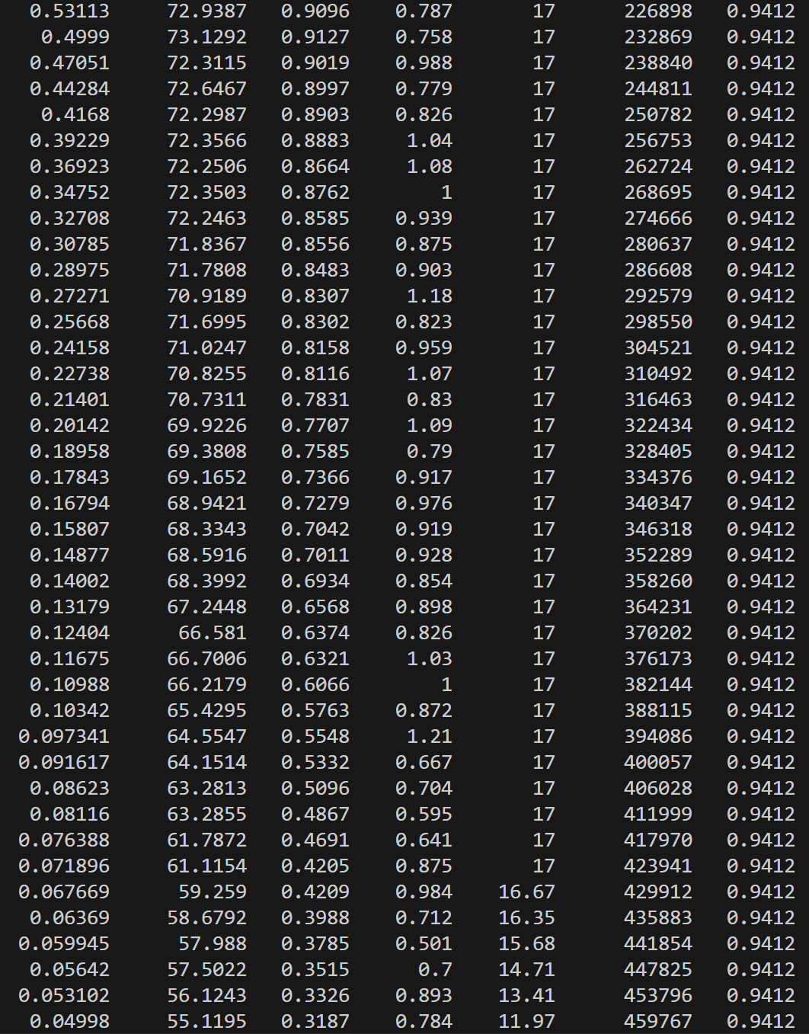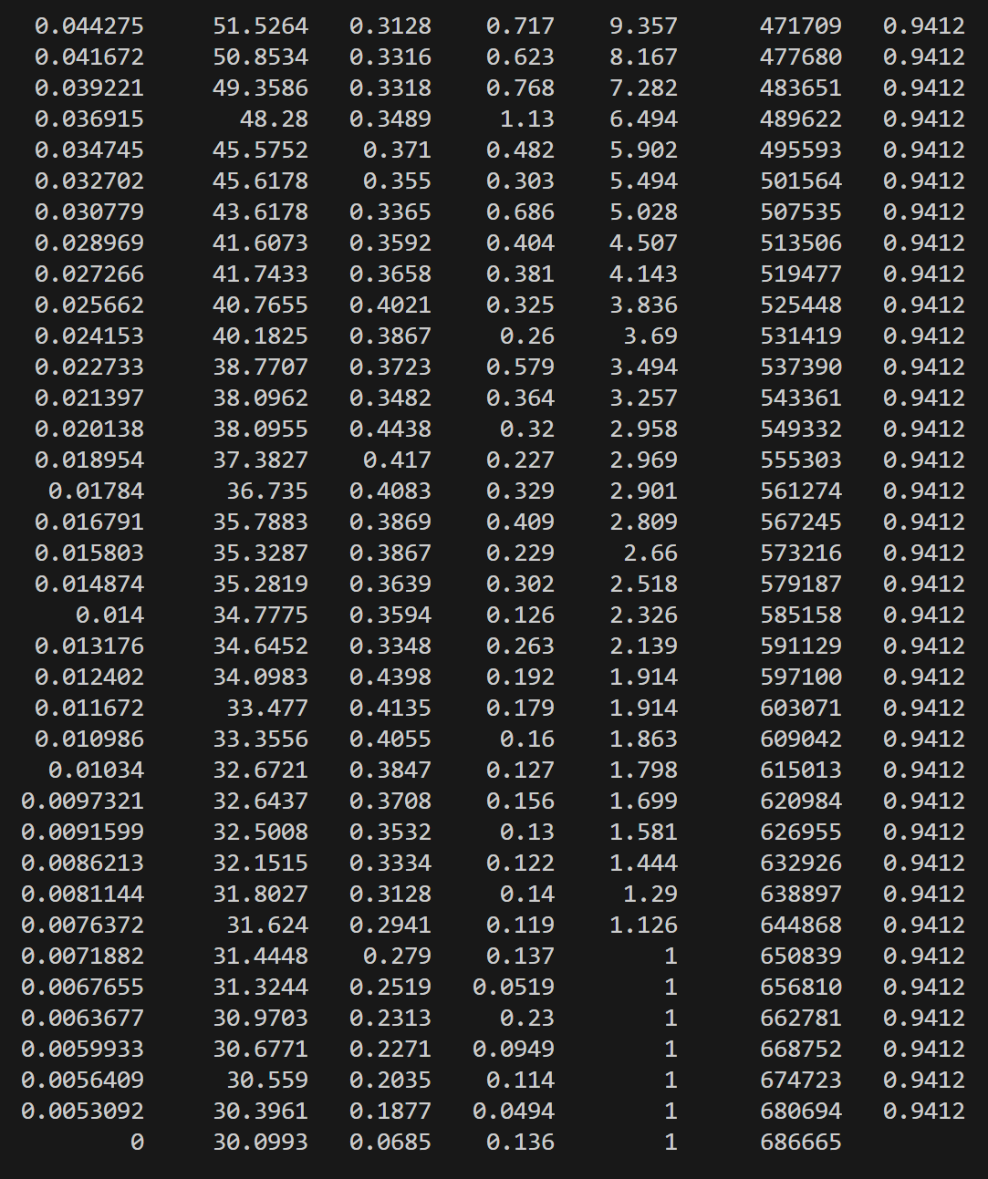
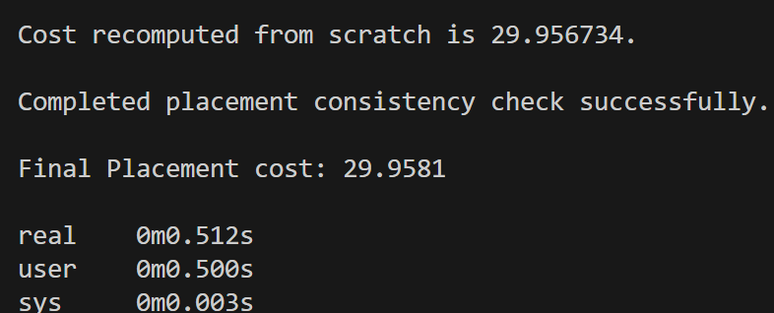
181
