Assignment3 Report
Name: 盧思樺
Institution (school): NTHU
Student ID: 110062272
Platform (Colab/Kaggle/Local): Colab
Python version: Colab
Operating system: Colab
CPU: None
GPU: T4 GPU
Remark: For ease of grading, you are encouraged to present data in textual form rather than as images.
- Train a RoBERTa-base model on the same dataset and report the performance of both BERT-base and RoBERTa-base models. (10%)
Results:
Model | Test Pearson Correlation | Test Accuracy
BERT-base | 0.8779 | 0.8699
RoBERTa-base | 0.8809 | 0.8758

  - Discuss the main differences between BERT and RoBERTa, and explain how these differences may affect performance. (5%)
Answer:
BERT and RoBERTa share similar Transformer architectures but differ in several key pre-training strategies. First, RoBERTa removes the Next Sentence Prediction (NSP) task used in BERT and trains solely with the Masked Language Modeling (MLM) objective. Second, RoBERTa applies dynamic masking, where mask patterns change every epoch, while BERT uses static masking. Third, RoBERTa is trained on a significantly larger corpus (160GB, roughly 10× BERT’s data) and for more training steps. Finally, BERT uses token_type_ids to distinguish sentence pairs, whereas RoBERTa omits this embedding during pre-training.
In our experiments, RoBERTa achieved slightly better performance (Pearson: 0.8809, Accuracy: 0.8758) compared to BERT (Pearson: 0.8779, Accuracy: 0.8699). This small improvement is consistent with expectations for a relatively small fine-tuning dataset (4,500 samples), where task-specific learning tends to diminish differences from pre-training. Since both models share a nearly identical architecture (~110M parameters, 12 Transformer layers), they exhibit similar capabilities in capturing semantic relationships between sentence pairs. These results suggest that RoBERTa’s enhanced pre-training benefits become less pronounced in low-resource fine-tuning scenarios, and both models are comparably effective for this semantic relatedness task.

- Train a GPT-2 model on the same dataset and evaluate its performance. (10%)
Results:
I also trained GPT-2 on the same dataset. The model achieved a test Pearson correlation of 0.8444 and a test accuracy of 0.8577, which is slightly lower than both BERT-base and RoBERTa-base.
Despite being a capable language model, GPT-2 shows weaker performance mainly due to its unidirectional (left-to-right) transformer architecture. Sentence-pair tasks such as semantic relatedness or textual entailment require understanding the relationship between two sentences using bidirectional context. BERT and RoBERTa can attend to both preceding and following tokens simultaneously, while GPT-2 can only attend to past tokens, limiting its ability to fully capture inter-sentence semantics.
Nevertheless, GPT-2 still achieves reasonable performance (≈85% accuracy), demonstrating that even decoder-only models can learn meaningful representations for sentence-pair tasks when properly fine-tuned, though they remain less effective than bidirectional encoders.

  - What are the main difference of BERT and GPT2? Discuss the main differences between BERT and GPT-2, and analyze how these differences influence their performance. (5%)
Answer:
BERT and GPT-2 differ primarily in architecture, training objectives, and context modeling.BERT is a bidirectional encoder trained with Masked Language Modeling (MLM), allowing it to attend to both left and right context simultaneously. In contrast, GPT-2 is a unidirectional (left-to-right) decoder-only model trained with causal language modeling, where each token can only attend to previous tokens.
These architectural differences strongly influence performance on sentence-pair tasks such as semantic relatedness or entailment. Because BERT’s bidirectional attention can model full contextual interactions between two sentences, it is better suited for understanding semantic relationships. GPT-2, however, must infer these relationships using only past-context attention, limiting its ability to fully capture bidirectional dependencies.

- Compare the performance of a multi-output learning model with BERT models trained separately on each sub-task. Does multi-output learning improve performance? Explain why or why not. (5%)
Answer:
Approach | Test Pearson | Test Accuracy
Multi-output Learning | 0.8779 | 0.8699
Separate Models | 0.8800 | 0.8689
The results show that separate training and multi-output learning perform almost equivalently, with only a negligible difference in Pearson correlation and accuracy. This indicates that neither approach is definitively better than the other for this task. Separate training allows each model to specialize in its objective, while the multi-output model benefits from shared semantic representations. Given the minimal performance gap, the choice between the two approaches largely depends on implementation preference.

- Why does your model fail to correctly predict some data points? Please provide an error analysis and introduce how do you improve your performance. (10%)
Answer:
For the error analysis, I examined batches with relatively high loss during the prediction stage and manually inspected the data points that the model failed to predict correctly. I found that many errors were caused by verbs or expressions that were rare or entirely absent in the training set, such as “shaved”. In other cases, the sentences contained multiple possible interpretations, leading to semantic ambiguity. These issues make it difficult for the model to achieve 100% accuracy.

- Anything that can strengthen your report. (5%)
Answer:
RoBERTa-base model result:
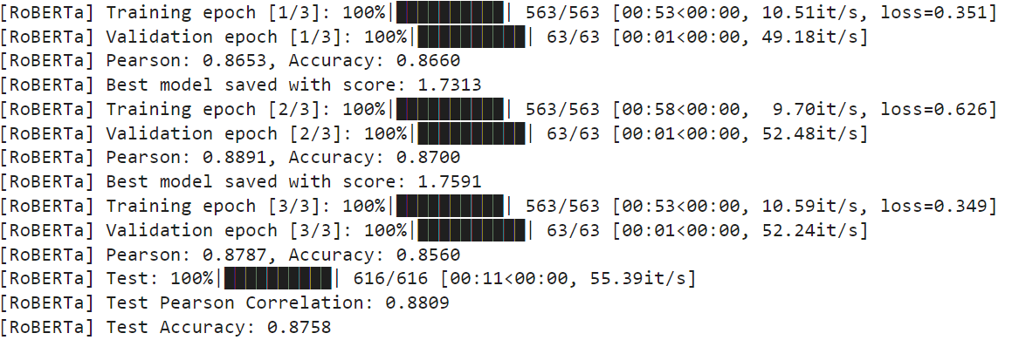
GPT-2 model result:
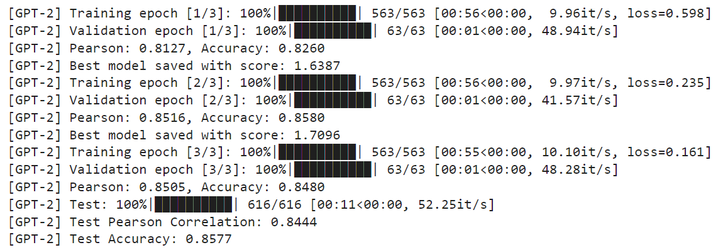

sub-task result:
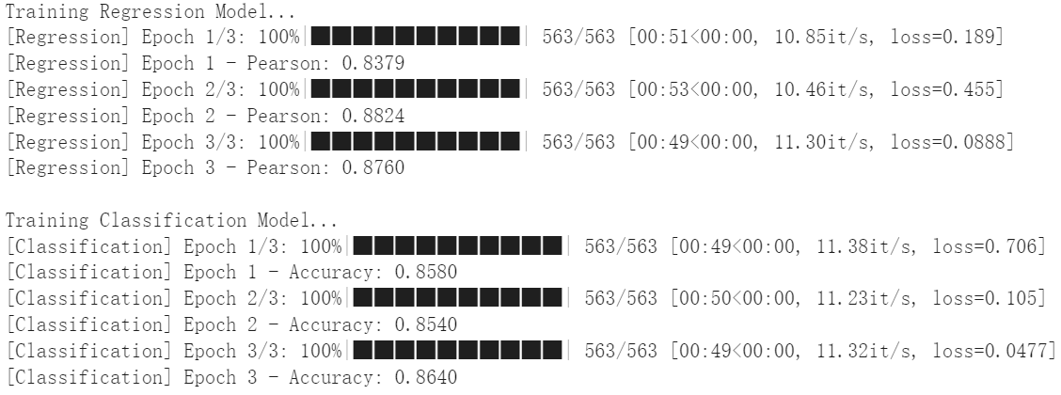

The screenshot of your testing logs and accuracy. (One Figure only) (10%)
