Assignment4 Report
Name:盧思樺
Institution (school): NTHU
Student ID:110062272
Platform (Colab/Kaggle/Local):Colab
Python version:Colab
Operating system: Colab
CPU:
GPU: T4 GPU
Remark: For ease of grading, you are encouraged to present data in textual form rather than as images.
- Please describe the details of your implementation for the RAG system (please tell us 1. What’s in your RAG system? 2. What’s your prompt? 3. What’s new in your code in comparison with the code from our lab course?) in this assignment. (5%)
Answer:
- My RAG system consists of three main components: (1) a knowledge base built from cat-facts.txt, where each line is transformed into a Document, and multiple preprocessing formats (original, lowercase, no punctuation, combined) are created to study how input format affects retrieval; (2) an embedding module using the HuggingFace model jina-embeddings-v2-base-en together with a Chroma vector store; and (3) an LLM component using Ollama’s Llama3.2:1b, combined with the retriever to form a complete RAG pipeline. The system includes data loading, embedding generation, retrieval (I ultimately use MMR with k=5), QA generation, and a full evaluation set measuring accuracy, recall@1, recall@5, and saving detailed logs in JSON.
- I use a two-part prompt consisting of a system message and a human message. The system prompt instructs the model to answer strictly based on the retrieved context, avoid hallucination, keep answers concise, and explicitly say “I cannot find the answer” when the context does not contain the required information. It also includes step-by-step reasoning guidance to help the model identify the relevant part of the context before answering. The human prompt simply feeds the question into this structure so that every query is always grounded in the retrieved documents.
- My implementation extends the lab example in several ways. First, I replace the small hand-written document set with a full cat-facts corpus and add multiple preprocessing formats for retrieval analysis. Second, I experiment with different retriever settings—including similarity, MMR, and similarity_score_threshold—and select MMR because it gives the best accuracy. Third, my prompt design is more task-specific, adding strict rules and reasoning instructions to make answers more reliable. Finally, I implement a full evaluation pipeline that compares predictions with ground truth, reports multiple recall metrics, analyzes errors, and exports all results to JSON for further study.

- Please provide analysis for the RAG performance using different prompts in generator model. (10%)
Answer:
In this assignment I experimented with three prompting strategies for the LLM component of the RAG system: persona prompting, few shot prompting, and chain of thought prompting. All three configurations used the same retriever setup with MMR and k=5, so Recall at 1 and Recall at 5 were identical across experiments. This means that any difference in accuracy is caused by how the LLM interprets the prompt and generates answers from the retrieved context rather than by changes in retrieval quality. Persona prompting yielded the highest accuracy because it encourages concise and context grounded responses. Chain of thought prompting produced slightly longer and more elaborate answers, which sometimes reduced the chance of matching the ground truth string. Few shot prompting performed the worst because the small model tended to imitate the example patterns instead of directly extracting the answer from the context. Overall the results show that prompting influences answer generation but does not affect retrieval performance. Below is the experiment result:
Persona:
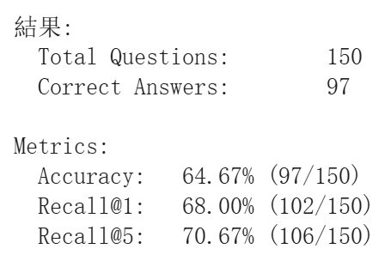
Few-shot:
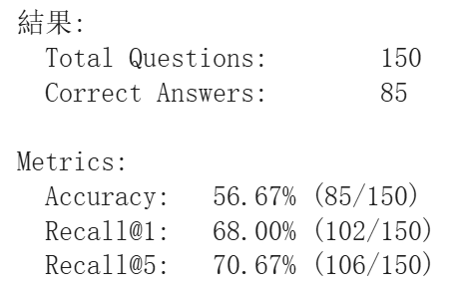
CoT:
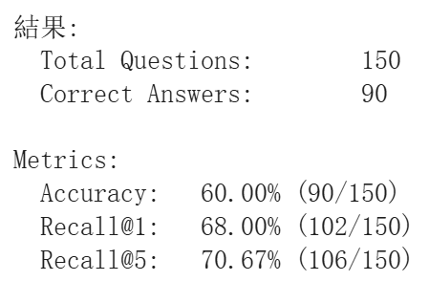

- Please analyze the RAG performance under different input data formats provided to the retriever. (10%)
Answer:
For this assignment I compared three input formats given to the retriever: Lowercase, No punctuation, and Normalization (lowercase + remove punctuation + remove spaces). All three settings use the same RAG pipeline (same embedding model, same MMR retriever with k=5, same LLM); only the text format differs.

- Lowercase: Accuracy is 62.67% (94/150), Recall@1 is 64.00%, and Recall@5 is 67.33%. This shows that simply lowercasing the corpus and queries already gives a reasonable baseline and makes the retriever slightly more robust to case differences between questions and documents.
- No punctuation: This setting achieves the best end-to-end accuracy, 67.33% (101/150), which is about +4.7 percentage points compared with the lowercase setting. Recall@1 (63.33%) and Recall@5 (66.67%) are very close to the lowercase case, so the retrieval quality is similar, but the LLM seems to benefit slightly from cleaner, less noisy context (commas removed) when generating the final answer. Overall, light normalization (removing commas and other punctuation while keeping word boundaries) brings the biggest gain.
- Normalization (lowercase + no punctuation + no spaces): Here the accuracy drops to 63.33% (95/150), and recall values also slightly decrease (Recall@1 = 62.67%, Recall@5 = 66.67%). This suggests that over-normalization hurts performance: once spaces are removed, words are concatenated (e.g., “cats are mammals” → “catsaremammals”), which breaks tokenization for the embedding model and makes the vector representations less meaningful. As a result, retrieval becomes a bit worse and the LLM has a harder time reading the context.
In summary, the experiments show that mild normalization such as removing punctuation can improve RAG performance, but aggressive normalization that destroys word boundaries (removing spaces) degrades both retrieval and QA accuracy. This also suggests that for embedding-based retrievers, case and commas are not the main problem; preserving clear word boundaries is much more important. Below is the experiment result.

Lowercase: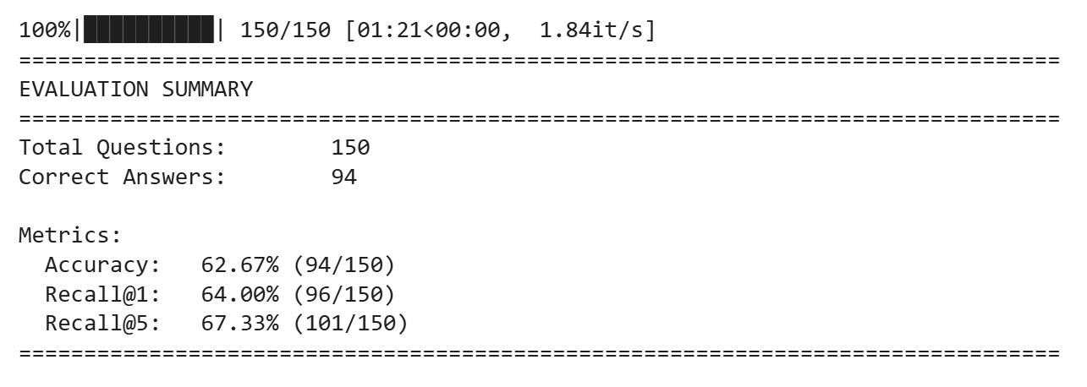
No punctation:
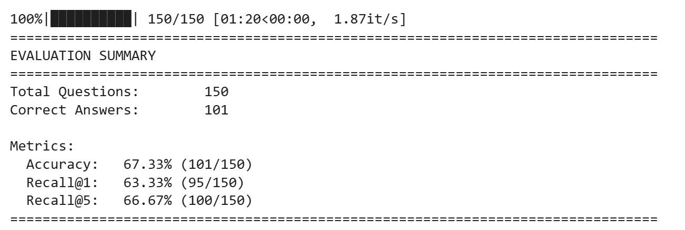

Normalization:
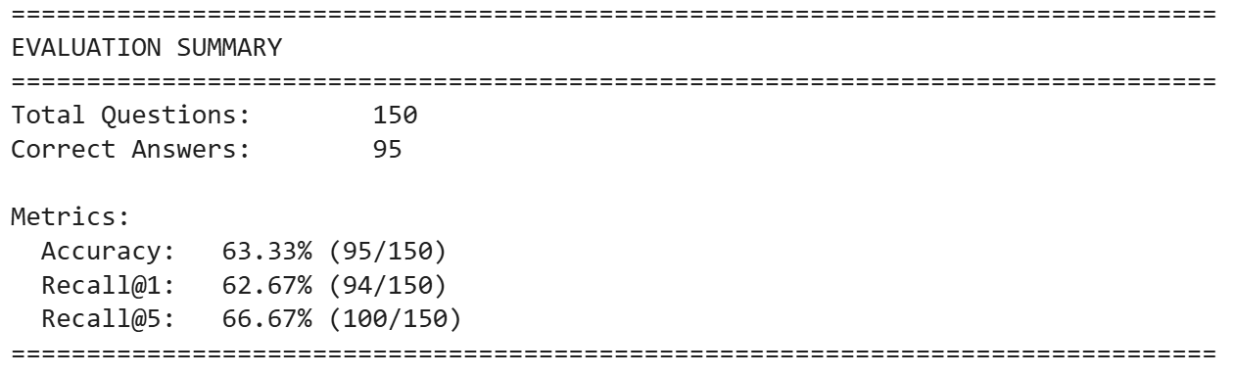

- Please provide analysis for the RAG performance using different input order of the retrieved documents to the generator model. (10%)
Answer:
In this experiment I evaluated how different input orders of the retrieved documents affect RAG performance. I compared the default order with two reordering strategies: reversing the retrieved list and randomly shuffling it. The results show that the overall accuracy remained relatively stable across conditions (60.67 percent for reversed and 63.33 percent for random), indicating that the LLM is still generally able to extract the correct answer somewhere within the provided context regardless of its position. However Recall at 1 changed dramatically. When the documents were reversed Recall at 1 dropped to only 2.67 percent because the correct supporting document was usually moved away from the first position. When the documents were randomly shuffled Recall at 1 increased to 21.33 percent but was still far below the default value since the correct document only occasionally appears first by chance. Recall at 5 remained unchanged at 70.67 percent across all conditions because reordering does not modify the set of retrieved documents but only their ordering. These results demonstrate that changing the document order does not affect retrieval quality but greatly influences which document the generator treats as primary. The model shows a strong positional bias and tends to rely heavily on the first document. Therefore placing relevant documents earlier improves reliability whereas reversing or randomizing the order pushes useful context away from the top and weakens the model’s grounding in the correct information.
Reversed:
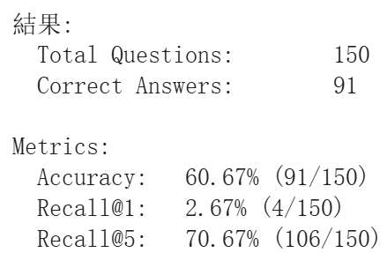
Random shuffle:
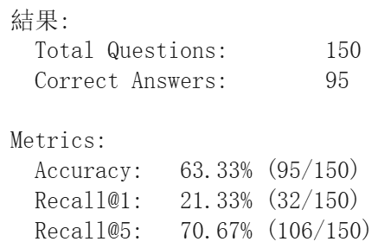

- Please analyze the generation performance of the model when counterfactual information is introduced into the input sequence of the generator. (10%)
Answer:
In my implementation, I did not change the retriever itself. For each query, I first call the retriever to obtain a list of documents. Then, based on the top-1 retrieved document, I generate a counterfactual version of that document: I modify numbers (e.g., ±5 or ±10), replace some key nouns with wrong but plausible alternatives, and flip phrases like “can”/“cannot”. This produces a sentence that looks reasonable but is actually wrong. I wrap this text as a new Document and insert it into the retrieved list (in my main experiment, at the beginning of the list), while keeping all original documents.
The generator then receives this modified document sequence as its context. When I run the evaluation without any counterfactual content, the model achieves 60.67% accuracy (91/150), with Recall@1 = 63.33% and Recall@5 = 66.67%. After inserting the counterfactual document into the context, the accuracy drops to 54.00% (81/150). Recall@5 remains almost unchanged at 66.00% (99/150), which means the correct document is still usually present somewhere in the top-5 results. However, Recall@1 falls sharply to 46.67% (70/150), showing that the first document the model sees is much more likely to be wrong once the counterfactual is added.

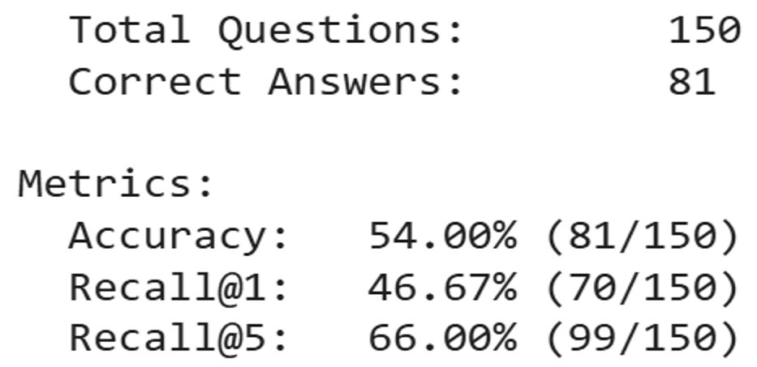
- Anything that can strengthen your report. (10%)
Answer:
In addition to the required experiments, I performed an ablation study on how different top-k retrieval settings influence overall RAG performance. I tested k = 1, 3, 5, and 10 while keeping all other components fixed (same embedding model, same MMR configuration, same LLM). The results show a clear pattern. When k is too small (k=1 or k=3), the retrieved context becomes very clean, but the system is less robust because missing the correct document in top-1 or top-3 directly limits the generator’s ability to find the answer. This leads to moderate accuracy around 62.67%. Increasing k to 5 significantly improves accuracy to 68.67%, the best among all tested values. This value of k provides a good balance: the correct supporting document is almost always included, while the amount of irrelevant or distracting information remains manageable for the small LLM.
However, when k increases to 10, accuracy no longer improves due to information overload. Although retrieval quality does not worsen and Recall@5 remains high, the generator must process almost twice as many sentences. For a small model like Llama 3.2 1B, this additional context introduces noise, weakens focus on the most relevant facts, and slightly reduces the model’s ability to extract concise answers. These findings reveal that RAG performance is not monotonically increasing with k; instead, there exists a practical “sweet spot” (k ≈ 5) where the trade-off between coverage and noise is optimized.

K=1
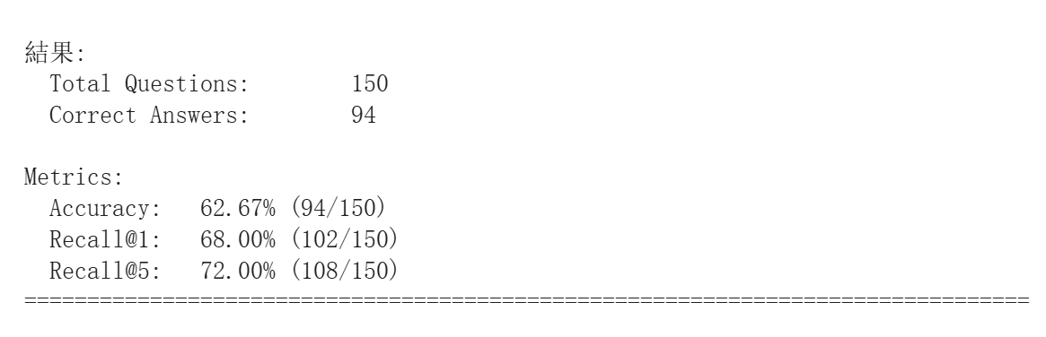
K=3

K=5
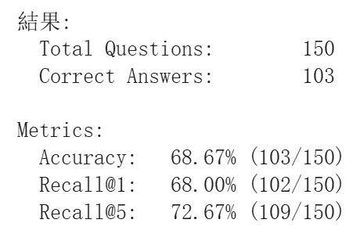
K=10
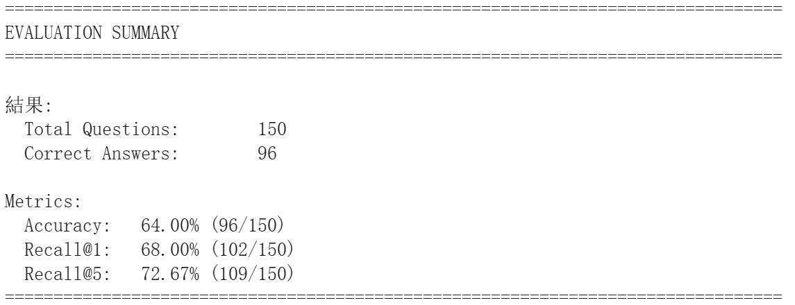
The screenshot of your testing logs and accuracy. (One Figure only)
