Biomolecular character of crossandra infundibuliformis
and insilico evolution of anticancer activity

ABSTRACT
PHYTOCHEMICAL ANALYSIS OF CROSSANDRA INFUNDIBULIFORMIS
ABSTRACT:
Crossandrainfundibuliformis,a significant horticultural plant in south indiathat is a member of the Acanthaceaefamily.It is often known that the majority of developing nations employ traditional medicine and medicinal herbs as a normative foundation for maintaining good health.The present study was aimed to perform the phytochemical analysis of Crossandra infundibuliformis and the purpose of the qualitative testing was to identify the presence of different phytochemical components using GC-MS.
A crucial computational method in structure-based drug discovery is molecular docking, which makes it possible to predict how small molecules (ligands) will interact with target proteins. Understanding molecular recognition, creating novel treatments, and improving lead compounds in drug development all depend on this method. Docking techniques assist in identifying promising candidates for additional experimental validation by modeling and analyzing the binding of possible drug molecules within a target protein's active site. By giving preference to molecules with strong binding affinities and advantageous interactions, the procedure drastically cuts down on the time and expenses involved with conventional drug discovery techniques.PyRx, a popular molecular docking tool, is used in this dissertation to explore the fundamentals, methods, and applications of molecular docking. The study describes the fundamental procedures for docking simulations, such as ligand and protein preparation, binding site identification, docking execution, and binding affinity analysis. Additionally, the dissertation divides docking methods into two categories: flexible docking, which takes into account the conformational changes of biomolecules to improve accuracy, and rigid docking, which treats the protein and ligand as inflexible molecules. Additionally covered are the role of algorithms in maximizing docking accuracy and the application of scoring functions in assessing binding strength.

INTRODUCTION

INTRODUCTION:
CrossandrainfundibuliformisL., a member of the Acanthaceae family, has long been used in the Belgaum area ofKarnataka,India, toalleviatemigraines.India,Bengal,Malaya,Sri Lanka, and Nepal are among its distributions locations.The plant is aphrodisiacal, and when crushed plant material is given to cattle,a dog will bite them.Crossandrainfundibuliformis flower have been shown to have a number of benefits, such as hepatoprotection and antibacterial qualities. Following the discovery of antibiotics in the 20th century, scientists have been developing a wide range of drugs to treat various infectious diseases. It is clear that pathogenic microbes and drugs that either hinder or kill them have coevolved as a result of "changing" nature. Resistance is therefore a major problem that the scientific community must deal with in order to create new medication formulations or formulations (combinations of two or more) to combat the potentially potent microorganisms. The scientific community is now investigating safe, effective, and non-toxic alternative medications to control the spread of resistant bacteria worldwide due to a discernible rise in the development of resistance against current medications.(Dave S1,Patel K1,Patel P2,Bhatpacharya I1,Gangwane A2 and Thakur A3,2021)
The many components of this plant are used to cure a variety of illnesses because of its medicinal properties. Numerous plant sections contain antimicrobial chemicals that have significant medicinal potential. In addition to successfully treating infectious disorders, they also lessen a number of the negative consequences that are frequently connected to synthetic antimicrobials.In male rats with ethanol-induced testicular toxicity, the flower extract of Crossandrainfundibuliformis exhibits aphrodisiac action.Medicinal plants may contain active ingredients that can treat a wide range of human illnesses. Numerous infectious disorders can be effectively treated with them.When tested against a few common bacterial and fungal diseases, the aqueous and methanol extracts of Crossandrainfundibuliformis flowers exhibit antibacterial activity. According to the research, Crossandrainfundibuliformis flower extracts have antifungal, antibacterial, and anticandidal properties.
Distribution:Crossandrainfundibuliformis, a member of the Acanthaceae family, is sometimes referred to as Firecracker flower and Unarmed Orange Nail Dye. This type of flowering plant is indigenous to Sri Lanka, Southern India (Malenadu and Kerala), and tropical nations.
Morphology: It is a one-meter-tall, upright, evergreen subshrub with glossy, wavy-margined leaves and fan-shaped blooms that can bloom at any time of year. The seeds are 4-orbicular with fimbriate scales, while the fruits are oblong capsules. The simple arrangement of the leaves is opposite or whorled, and they are clustered close to the inflorescence. It has a complete leaf edge and an elliptical shape with acute leaf bases and apexes. Typically, flowers have three to five asymmetrical petals. originate from spikes with four stalks and have a tube-like stem that is 2 cm long and is either apricot or coral red-colored.
Cultivation: Because it is a tropical plant, it cannot withstand frost or cold temperatures. It thrives in climates with temperatures around 30 degrees Celsius. It needs soil that drains well and is high in organic matter. Saline or alkaline soils are inappropriate since they promote chlorosis in plants.Use warm water to keep the soil slightly moist in the summer and less water in the winter since cold water causes shock, which kills plants. Use liquid fertilizer to feed the soil to combat the main Pratylenchusdelatterai and longidorus pests.
Novel medicinal molecules can be found in abundance in plants, and plant-based medications have significantly improved human health and wellbeing.A wealth of antibacterial compounds and strong, effective medications can be found in medicinal plants. Throughout India, Crossandrainfundibuliformis, a member of the Acanthaceae family, is widely used as a medicinal herb. One of the most popular types of plants for traditional medicine is this one. Numerous ailments, including fever, headache, appetite, pain, and wound healing, are treated with flower extract.The flower extract of Crossandrainfundibuliformis was found to possess larvicidal, hepatoprotective, antifungal, antioxidant, and antibacterial properties based on pharmacological tests. Although written records from early civilizations in China, India, and the Near East date back more than 5,000 years, the utilization of medicinal herbs to treat illness is undoubtedly an art as ancient as humanity. Plants like hollyback, which are still widely used in ethnomedicine worldwide, were utilized by Neanderthals 60,000 years ago in modern-day Iraq (Stockwell, 1988,et.,al). There is still much to learn about the potential of higher plants as a source for novel medications. Only a small portion of the estimated 2,50,000–5,00,000 plant species have undergone phytochemical investigation, and an even smaller portion have undergone biological or pharmacological screening. Therefore, any phytochemical analysis of a particular plant will only provide a very limited.(GalankiVasantha,DanabalaBhargavi,AdariYashodha,N Sharmila Roy,Sadeah Anjum Shiaik,2022)
The Crossandra flower is known to have anti cancer properties. The phytochemical compounds of Crossandra flower were analysed. Molecular Docking was performed between a disease causing protein and the analysed phytochemical compounds. Drug development and discovery heavily rely on the computational method known as "molecular docking," which predicts how a ligand will interact with a target protein. The principles, tools, and PyRx implementation of the docking methodology are the main topics of this section. The preparation, execution, and analysis of docking simulations to assess ligand-protein interactionsare highlighted in the study.
One popular computational method in structure-based drug design is molecular docking. It uses scoring functions to estimate the binding affinity and predicts the ligand's preferred orientation when bound to a protein.
DockingTypes:
Rigid Docking: Only translational and rotational movements are permitted by both proteins and ligands, which are regarded as rigid molecules.
Flexible Docking: The protein (and occasionally the ligand) istreated as flexible, accounting for conformational changes during binding.

REVIEW OF LITERATURE
REVIEW OF LITERATURE:
Crossandrainfundibuliformis, commonly known as Firecracker, is extensively utilized as a flowering potted plant and landscape option in Sri Lanka, and it is also highly sought after by several countries in Europe and Asia. Sri Lanka exports over 600000 rooted cuttings of C. infundibuliformis each year. Among the significant challenges faced in the monoculture of C. infundibuliformis is wilt caused by F. arysorum. This pathogen is one of the hardest to manage and can lead to the total destruction of the plant. The disease can impact the crop at any growth phase. Typical symptoms include the sudden wilting of leaves and petioles, no visible rot of the roots, and black internal discoloration affecting the xylem and pith.ManagingF. oxysporum’s impact on C. infundibuliformis is challenging due to the pathogen’s ability to survive in the soil for extended periods as chlamydospores or mycelium found in infected plant debris. Soil-borne antagonistic fungi, such as T. viride and T. harzianum, have been recognized as natural potential biological agents against F. oxysporum. It has been proposed that Trichoderma species isolated from the roots or rhizosphere of a particular crop may be more effectively adapted to that crop and thus more successful in controlling Fusarium species (Rubio-Perez etal., 2008).
As the pathogen resides in the soil, using chemical control methods is not cost-effective and can lead to environmental issues and groundwater contamination. In recent years, the emergence of resistance in the pathogen has rendered chemical fungicides less effective for managing Fusariumspecies.Trichoderma species are well-established as effective biological control agents against plant diseases caused by both soil-borne fungi and pathogenic fungi affecting less and fruits.Thesemycoparasites not only provide direct benefits such as protection against various plant pathogens in the rhizosphere, but also promote plant growth and trigger defenseresponses.They penetrate roots by secreting cellulolytic and proteolytic enzymes. Trichoderma species are opportunistic, virulent plant symbionts capable of colonizing plant roots through mechanisms akin to those used by mycorrhizalfungi. The colonization of roots by Trichoderma species often leads to improved root growth and development, increased crop productivity, enhanced resistance to abiotic stress, and better nutrient uptake and utilization. (V.Jegathambigai,R.S.W.Wijeratnam,andR.L.C.Wijesundera.,2009).
. Crossandrainfundibuliformis (Acanthaceae) is a significant plant in horticulture . It is prevalent in tropical regions like South India and Sri Lanka. The flowers of. C.infundibuliformis are commonly known as ‘Tropical flame’ or ‘Firecracker’ and have been utilized as hair adornments by the Puliyars tribal women.According to cancer registry data, it is projected that there will be approximately 8,00,000 new cancer cases in India annually.Insecticides are significant in the manner that food is cultivated and prepared in the present day. Insects, rodents, and bacteria have the ability to ruin crops and contaminate the food supplies consumed by people. As a way to manage this issue, insecticides were created. These products may be based on natural or chemical substances. There are different categories of insecticides available depending on the specific problem at hand. Without proper control measures, the grains can face destruction up to 100% of the stored commodity.
There are three species of Sitophilus, which include S. oryzae (wheat weevil), S. zeamais (maize weevil), and S. granarius (granary weevil). They are all considered the most significant pests of stored grain globally. S. oryzae can infest a variety of agricultural crop stores, including rice, wheat, corn, oat, barley, bean, nut, wild bird seed, rye, buckwheat, macaroni, starch, cereal products, and all forms of stored grains. S. oryzae is prevalent in warm and tropical regions around the world(E.Vadivel and V.P.Sunita,2016).
Wound healing is a process that is extremely significant in everyday life as we encounter numerous injuries and Wound healing.Various biological dressings and traditional medicines have been documented to exhibit wound healing properties. Nevertheless, none of these have proven to be entirely effective and devoid of negative side effects. Crossandrainfundibuliformis is believed to be one of the most dependable herbs that has shown a highly significant wound healing activity. The typical physiology of wound healing relies on low levels of reactive oxygen species and oxidative stress; excessive exposure to oxidative stress results in hindered wound healing. Antioxidants are theorized to assist in managing wound oxidative stress and thus promote faster wound healing .The cited antioxidant capability of Crossandrainfundibuliformis was the primary evidence and impetus for initiating this activity . There was also support from traditional medicine for wound healing activity concerning flowers(Rohit G and Verma.T.M.,2012)
Diabetesmellitus is a condition in which the homeostasis of carbohydrate, protein, and lipid metabolism is inadequately managed by the hormone insulin, leading to increased fasting and postprandial blood glucose levels. The primary chronic complications linked with diabetes include retinopathy, neuropathy, nephropathy, and atheroscleroticcoronary artery disease as well as peripheralatheroscleroticvasculardisease. Recent estimates suggest that the global population is nearing the center of a diabetes pandemic. By 2020, it is expected that the total number of individuals afflicted with diabetes will reach 3. 7 million. Conversely, traditional medicinal plants have been effectively employed since ancient times by both practitioners and non-professionals to manage diabetes and its related complications, offering an exciting opportunity for the development of alternative treatment methods for diabetes.Herbal medications are commonly prescribed, even when their active biological components are not identified, because of their efficacy, reduced side effects, and relatively low price.This plant is also well-known for its aphrodisiac effects and for its anti-inflammatory action; it is referred to as a sparkler because when the dried pod of the plant comes into contact with water, it bursts open like a sparkler, hence these plants were given this name. The study aims to investigate the anticancer effects of the ethanol extract of the flowersofC. infundibuliformis. Additionally, an effort was made to evaluate the antioxidant potential of this plant in order to establish a relationship with the decrease in oxidative stress linked to diabetes(GalankiVasantha ,A. Venkatesham ,C. H. Dayakar.,2020).
Phytochemical Screening and Constituents:
Common Phytochemicals:
Studies have identified the presence of saponins, terpenoids, and tannins in Crossandrainfundibuliformis extracts.
Specific Compounds:
Saponins: Present in both acetonic and chloroformic extracts.
Tannins: Present in both acetonic and chloroformic extracts.
Anthraquinones: Present in acetonic extracts.
Other Phytochemicals:
Carbohydrates: Present in the ethanolic extract.
Proteins: Present in the ethanolic extract.
Terpenoids: Present in the flower extract.
Extracts:
Studies have used various extracts, including aqueous, ethyl acetate, acetone, chloroform, and propane extracts.
Biological Activity:
Many of the identified compounds exhibit antipathogenic properties, including antifungal and antibacterial activities.
Traditional Uses and Potential Applications:
Traditional Medicine:
Crossandrainfundibuliformis has been used in traditional medicine for treating various ailments.
Antimicrobial Activity:
The plant extracts have shown antimicrobial activities against bacteria and fungi.
Antioxidant Activity:
Some extracts exhibit antioxidant activity.
Other Potential Applications:
The plant extracts have also shown potential for use in treating male sexual disorders.

MATERIALS AND METHODS
MATERIALS AND METHODS:
ANALYSIS:

FIGURE1:Flow chart of anti-cancer activity of crossandrainfundibuliformis

COLLECTION OF PLANT SAMPLES:
The yellow colour flowers of Crossandrainfundibuliformis were gathered and carefully separated from the plant,then were thoroughly washed to remove excess impurities in the flower.
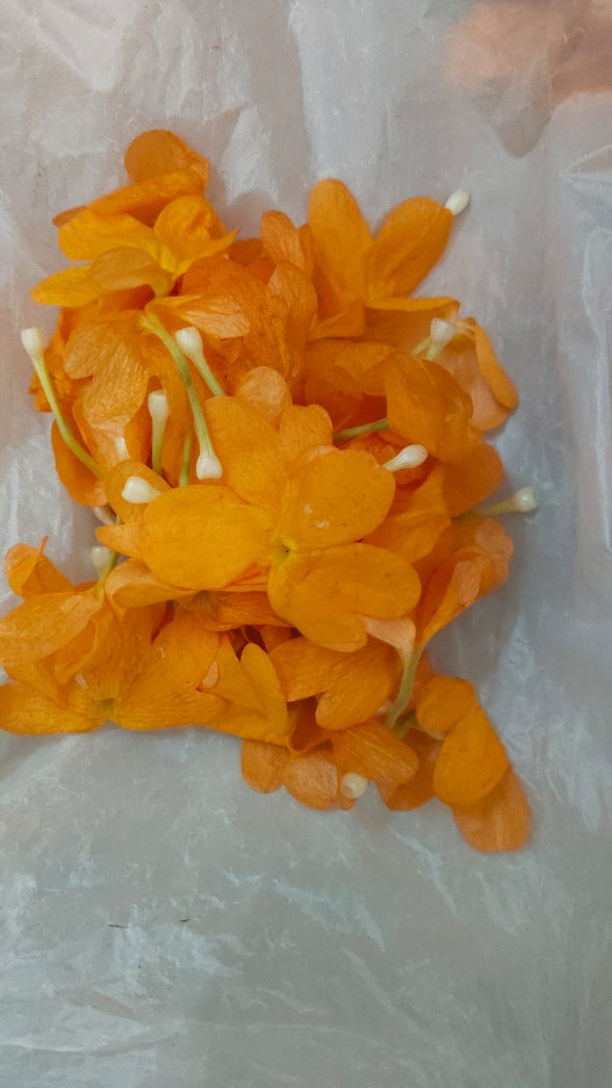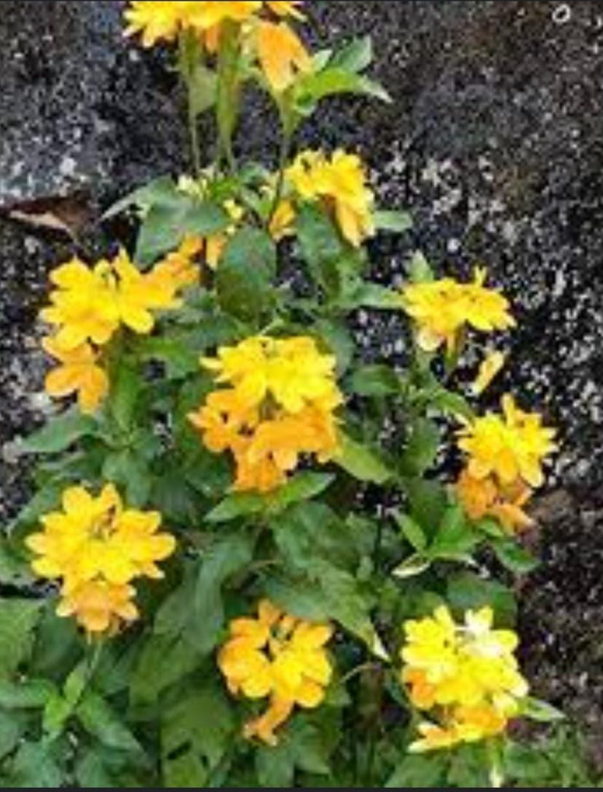
FIGURE 3:YellowCrossandrainfundibuliformis flower

SAMPLE PREPARATION:
The Crossandrainfundibuliformis flower were ground into a powder in a mechanical grinder after being shade-dried. The plant's powder was extracted using the solvent ethanol by maceration. For the further research, an ethanol extract of Crossandrainfundibuliformis flowers was utilised.Figure 4 and 5 are dried and grinded of Crossandrainfundibuliformis flowers are given below.
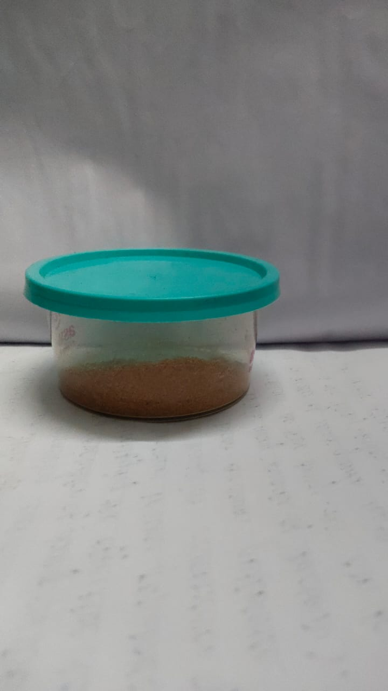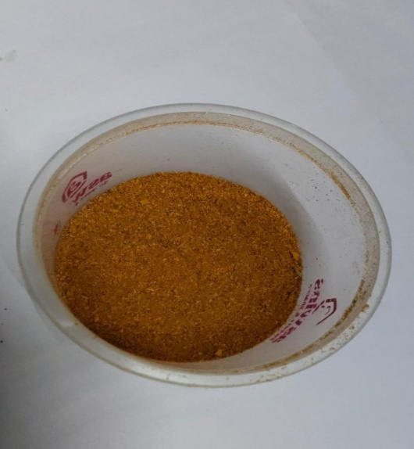
FIGURE 4 Powdered sample of
CrossandraInfundibuliformis FIGURE 5
PRILIMINARY PHYTOCHEMICAL TEST:
To identify potential phytochemical components, the ethanolic extract of Crossandrainfundibuliformisflowers was examined the anticancer activity.
1.TEST FOR SAPONINS:
In a test tube, 0.5 g of the plant extract was mixed with water before being brought to a boil. The observation of frothing was interpreted as early proof that the saponin was present.
2.TEST FOR TANNINS:
In a test tube, 0.5 g of extract was added to 10 ml of water and filtered. After adding a few drops of 0.1% ferric chloride, the colouration was checked for brownish green or blue-black.
3.TEST FOR ANTHRAQUINONES:
A dry test tube was filled with approximately 0.5 g of extract, 5 ml of chloroform, and agitated for 5 minutes. The filtrate was shaken with an equal volume of 10% ammonia solution after the extract had been filtered. Anthraquinones can be identified by the ammonical layer's pink, violet, or red colouration.
4.TEST FOR AMINOACID:
To 2ml of the sample, 2ml of Ninhydrin reagent was added and kept in a water bath for 20 minutes. The emergence of a purple color indicated the presence of amino acids in the sample.
5.TEST FOR TRI-TERPERIODS:
5ml of every extract was combined with 2ml of chloroform and 3ml of concentrated H2SO4 to create a monolayer of reddish-brown coloration at the interface, indicating a positive result for the terpenoids.
6.TEST FOR TRIPLE SUGAR:
To 2 ml of extract, 2 drops of Molisch’s reagent were added and mixed thoroughly. 2 ml of concentrated H2SO4 was added along the sides of the test tube. A reddish violet ring formed at the boundary of the two layers right away, indicating the presence of carbohydrates.
GC-MS ANALYSIS:
GC-MS is a unique analysis technique used for identification and quantification which is limited to analytes that are not only volatile and thermally labile but can also withstand the harsh partitioning conditions of the gas chromatograph . A representative spectral output of all the ascertainable compounds from the empirical sample is displayed by this technique. The Gas-chromatography device has an injection port from where the process is initiated by injecting the sample to that port. After this, evaporation and separation of the components take place one by one and finally this equipment identifies the components present in the corresponding sample. A specific spectral pick is produced for each component which is recorded on a paper chart electronically.
GC-MS analysis of Crossandrainfundibuliformis extracts reveals the presence of various phytochemicals, including alkaloids, flavonoids, saponins, tannins, and terpenoids, supporting the plant's traditional medicinal uses.
Here's a more detailed breakdown of the phytochemical analysis and GC-MS findings:
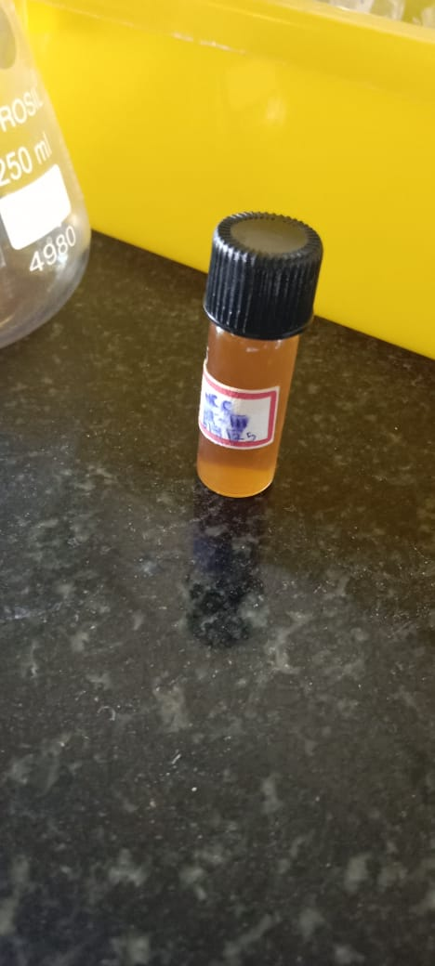
FIGURE 6:Crossandrainfundibuliformis extract for gc-ms.

MOLECULAR DOCKING:
Target Protein Preparation: Extraneous molecules (water, ions) are eliminated, and the protein's three-dimensional structure is obtained from databases such as the RCSB PDB.
Ligand Preparation: Energy minimization is done after the ligand's chemical structure has been obtained from PubChem.
Grid Box Selection: To limit docking calculations, a search space is established around the binding site.
The docking algorithm computes binding affinities by docking the ligand into the protein's active site.
interpretation of the Results: To forecast binding efficiency, docking scores, hydrogen bonding interactions, and molecular interactions are examined.
PyRx-Based Molecular Docking
For molecular docking studies, PyRx is an open-source virtual screening program that combines AutoDock and AutoDock Vina. It automates docking calculations and streamlines the preparation of ligands and proteins.

Steps in PyRx Docking:
- Loading Protein and Ligand:
The protein structure is obtained from the RCSB PDB database and imported into PyRx in PDB format. The protein retrieved for this docking procedure was 5tdn, the abnormal expression level of this protein is known to cause cancer, breast cancer to be more specific. It was downloaded in PDB format. The ligand structure is either retrieved from databases like PubChem or drawn using molecular editing tools like ChemDraw, then saved in SDF format. The small compound also called as ligand we retrieved from the GCMS results. The following ligands were obtained from the results.
These small compounds which were extracted from Crossandra yellow flowers is known to have anti-cancer properties and it is said to have been served as a potential treatment option for breast cancer. The ligandsare converted into PDBQT format using the Open Babel feature in PyRx, which ensures compatibility with AutoDock Vina.
2)Setting the Grid Box:
The grid box is defined to cover the active site of the protein, allowing the ligand to search for optimal binding positions.The dimensions and centre of the grid box are adjusted based on prior knowledge of the binding site or using blind docking for unknown binding pockets.
3)Analyzing Docking Results:
The docking results are displayed as a list of binding affinities (in kcal/mol), where lower values represents a stronger binding.The best ligand pose is selected based on its binding energy and favorable molecular interactions.The docking complex is visualized using molecular visualization tools like PyMOL or Discovery Studio to analyze hydrogen bonding, hydrophobic interactions, and spatial orientation within the binding pocket.Key interactions such as hydrogen bonds, π-π stacking, and hydrophobic interactions are noted to understand the ligand's binding mechanism.

RESULT AND DISCUSSION

RESULT:
PRELIMINARY PHYTOCHEMICAL TEST:
S NO | TEST | OBSERVATION | RESULT
1. | Amino acid | Purple colouration was observed | Presence of amino acid
2. | Saponins | Frothing was observed | Presence of saponins
3. | Tannins | Brownish greenish colour observed | Presence of tannin
4. | Tri terpenoids | Monolayer reddish blown in interface is not observed | Absence of tri terpenoids
5. | Anthraquinones | Ring was observed | Presence of anthraquinones
6. | Triple sugar | Reddish violet ring was not observed at boundaries of two layer | Absence of carbohydrates
TABLE 2:phytochemical analysis observation.

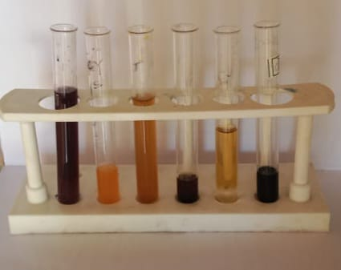
FIGURE 7:Result for the phytochemical test.

S no | Compound number | Gc-ms compounds from plants with flower
1. | Compound1 | Benzene, ethoxy-
2. | Compound 2 | Furo[2,3-c]pyridine, 2,3-dihydro-2,7-dimethyl-
3. | Compound 3 | 13-Docosenamide, (Z)-
4. | Compound 4 | 1-Adamantylamine, N-tert-butyldimethylsilyl-
5. | Compound 5 | Pentanenitrile,3-(Hydroxymethyl)-
6. | Compound 6 | 7-nitro-4,5-dihydro-1,4-benzoxazepin-3(2h)-one
7. | Compound 7 | Tetrasiloxane, decamethyl-
8. | Compound 8 | Formic acid phenyl ester
9. | Compound 9 | 2-Ethylformanilide
10. | Compound 10 | 13-Docosenamide, (Z)-
11. | Compound 11 | 1-Propene, 2-(3-methylphenyl)-1-phenyl-, (Z)-
TABLE 3:ligands from the gc-ms extract.

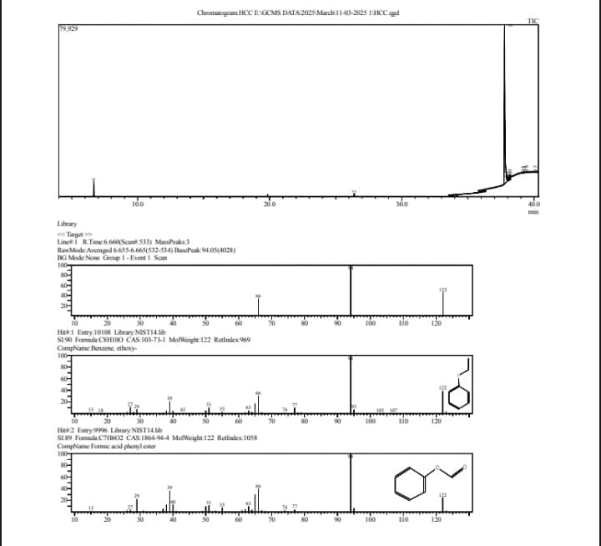

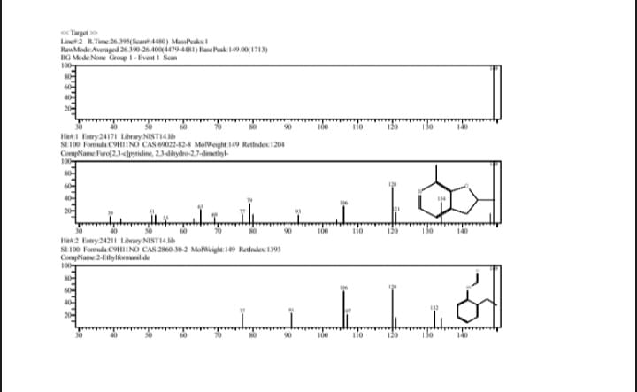

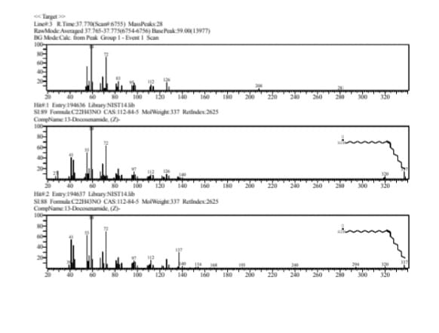

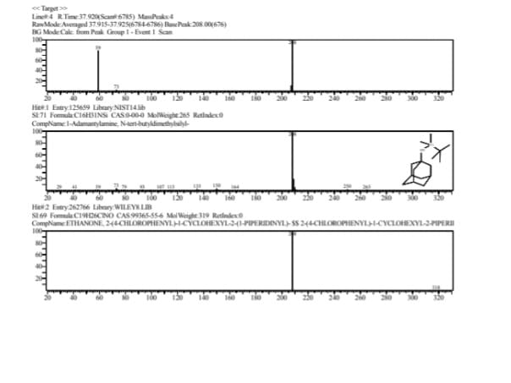
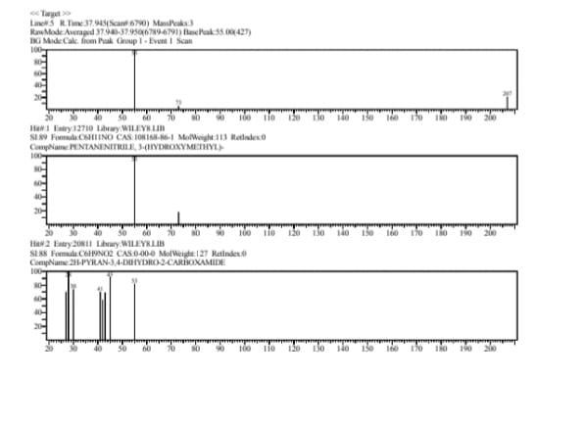
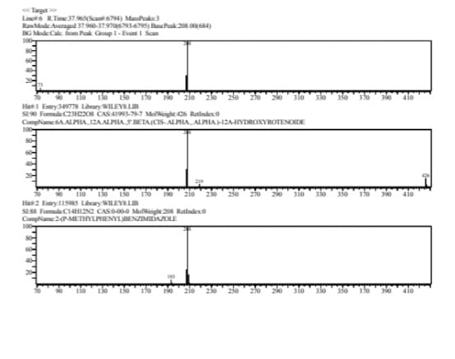

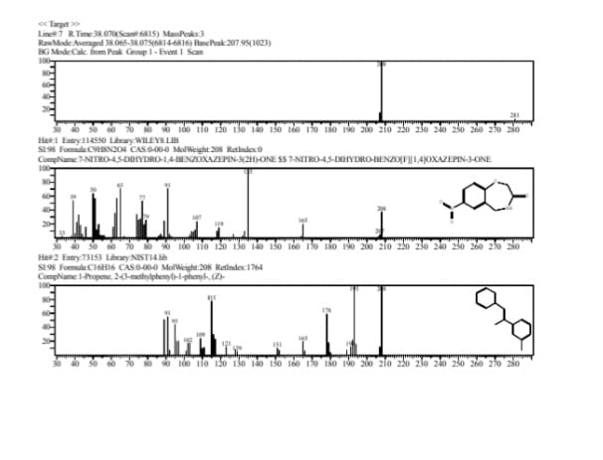
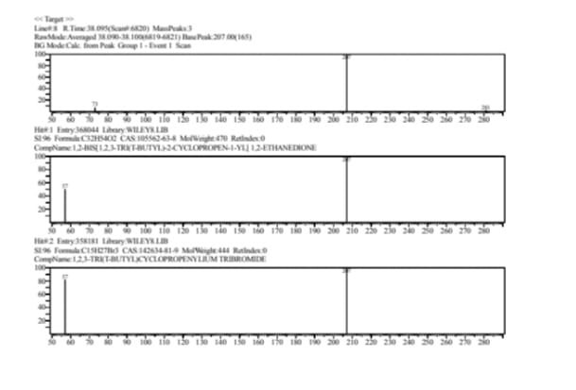

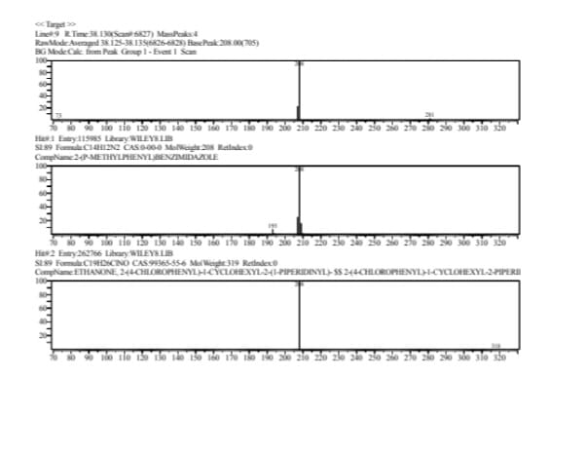
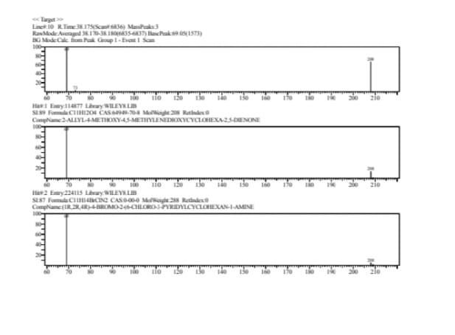

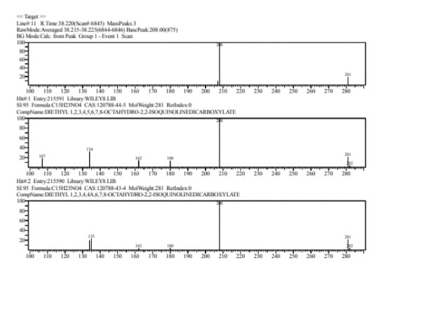

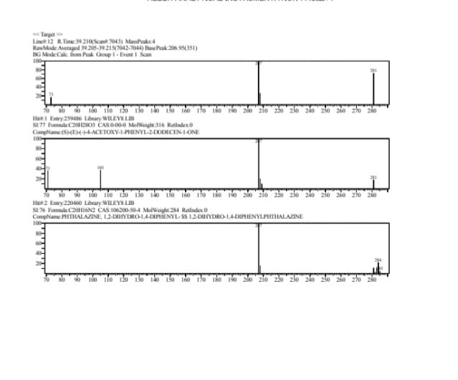
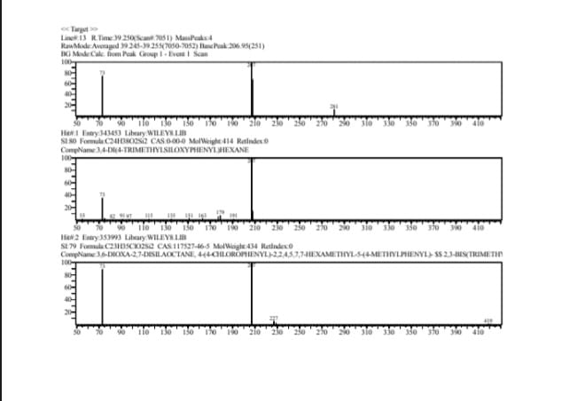
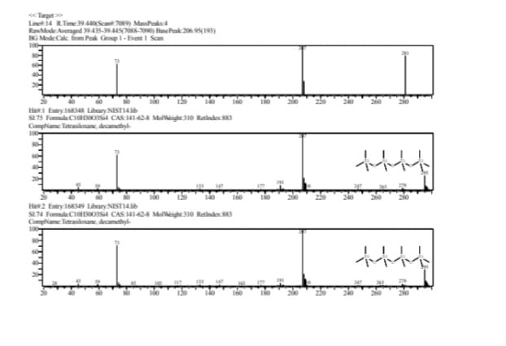

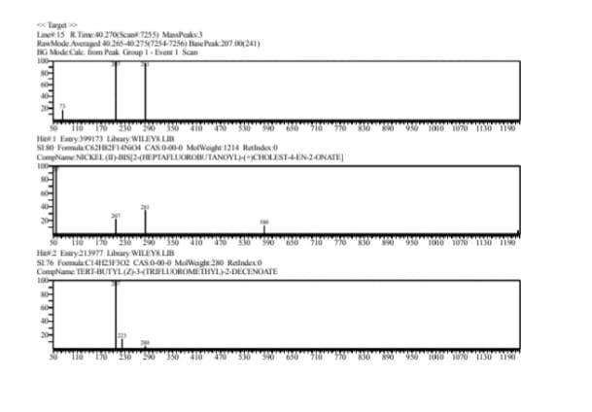
Docking result:
S.NO | Ligands | Binding Affinity
1. | 1-Propene | -5.2
2. | 7-nitro-4,5-dihydro-1 | -4.8
3. | n-(2-ethylphenyl) formamide | -4.1
4. | 2,7-dimethyl-2 | -3.8
5. | Phenyl Formate | -3.7
6. | SCHEMBL7922642 | -3.6
7. | PHENETOLE | -3.6
8. | ERUCAMIDE | -3.2

The protein BRCA1, which is a disease causing protein for breast Cancer, was docked against the small compounds which was obtained from GCMS result. The top scoring ligands are presented in the table above. The ligand 1-propene has the highest binding affinity among the other small compounds. It has the highest binding affinity of -5.2 and the rsmd/ub value and rsmd/lb value is 0. The picture above is the structure of BRCA1 protein (2cp_model2).

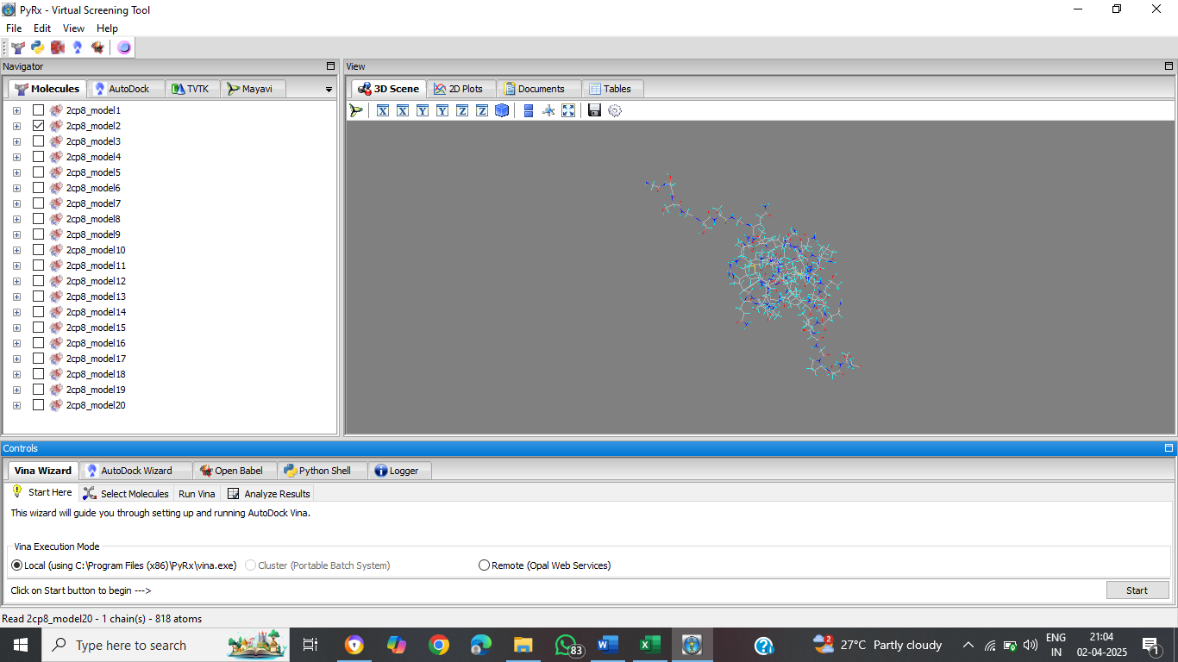

DISCUSSION:
Plants are a significant source of new natural chemicals. Despite the availability of many approaches, the identification of therapeutically occurring compounds remains the best source of new structural kinds. In the United States, natural goods account for about 25% of all prescription pharmaceutical sales, followed by structurally modified natural products at 25% and 119 defined medications that are still commercially generated from higher plants, 74% of which are ethnobotanical. Phytochemical and pharmacological studies have been conducted on only a small portion of the several hundred thousand plant species that are found across the world. Therefore, focussing on the many phytochemical components that have been investigated from various extracts of Crossandrainfudifuliformis was the aim of the current study.
The phytochemical analysis of C. infundibuliformis aqueous, ethyl acetate, acetone, chloroform, and propane extracts . Phytochemical screening revealed that all of the crude extracts contained steroids. Tri-terpenoids were only present in the acetone and propane extracts; they were absent from the other extracts. Aqueous and propane extracts include tannins, unlike other extracts. Triple sugar, proteins, and amino acids are absent from all five extracts. Anthraquinones were only present in the aqueous extract; the other extracts were absent. Heart glycosides can be found in extracts of acetone, chloroform, and propane. The many medicinal applications of the plant could be ascertained using this information.
There are several hundred thousand plant species globally, but only a minor fraction has been studied in terms of phytochemistry and pharmacology. Consequently, the current study aimed to examine the diverse phytochemical components from extracts of Crossandrainfundififormis.The sample, Crossandrainfundibuliformiswas subjected to extraction using ethanol as the solvent. The consistency of the resulting extract was observed as semi-solid, indicating a substance that has characteristics between liquid and solid states. The extract displayed a unique brown colour, implying the existence of particular compounds or pigments within the extractive material. These recorded parameters not only offer a detailed understanding of the extract’s physical properties but also provide valuable insights into the potential bioactive compounds found in Crossandrainfundibuliformis that could be important in various uses.In general, the analysis of phytochemicals identifies the existence of multiple active and non-active compounds that provide the medicinal benefits. The components such as tannins, saponins, amino acid were significantly detected during the present study.

CONCLUSION

CONCLUSION:
There are numerous plant species globally, with only a limited fraction having undergone both phytochemical and pharmacological examination. Phytomedicine provides significant benefits, including wide-ranging antimicrobial properties attributed to the variety of phytochemicals found in plant extracts.Qualitative analysis has revealed the existence of steroids, triterpenoids, flavonoids, phenolic compounds, and tannins, indicating a diverse chemical composition that may hold pharmacological importance. Consequently, the current study aimed to explore the different phytochemical constituents from extracts of Crossandrainfundibuliformis.
This study reveals the presence of Amino acid,Tannin,Saponin in Crossandrainfundibuliformis.Additionly,the phytochemical examination via GC-MS showed the identification of several compounds, among Benzene, ethoxy-,Furo[2,3-c]pyridine, 2,3-dihydro-2,7-dimethyl-,13-Docosenamide, (Z)-,1-Adamantylamine, N-tert-butyldimethylsilyl-,pentanenitrile, 3-(hydroxymethyl)-,6a.alpha.,12a.alpha.,5’.beta.(cis-.alpha.,.alpha.)-12a-hydroxyrotenoide,7-nitro-4,5-dihydro-1,4-benzoxazepin-3(2h)-one,1,2-bis[1,2,3-tri(t-butyl)-2-cyclopropen-1-yl] 1,2-ethanedione,2-(p-methylphenyl)benzimidazole,2-allyl-4-methoxy-4,5-methylenedioxycyclohexa-2,5-dienone,diethyl 1,2,3,4,5,6,7,8-octahydro-2,2-isoquinolinedicarboxylate,(s)-€-(-)-4-acetoxy-1-phenyl-2-dodecen-1-one,3,4-di(4-trimethylsiloxyphenyl)hexane,tetrasiloxane, decamethyl-,nickel (ii)-bis[2-(heptafluorobutanoyl)-(+)cholest-4-en-2-onate] and others. these compounds play a role in the plant’s potential therapeutic benefits.
Docking studies were performed using PyRx, to evaluate the biological activity of phytochemicals. The phytochemicals identified from GC-MS analysis were docked against specific target proteins related to Breast Cancer. The docking scores were analyzed to determine the strongest binding candidates.
In this study, we analyzed six single nucleotide polymorphisms (SNPs) in the SDHB gene, each of which results in an amino acid substitution that may influence the function of the SDHB protein. These variations, including p.Ser239Cys (S239C), p.Ser163Pro (S163P), p.Ile127Leu (I127L), p.Asn106Ser (N106S), p.Ala102Thr (A102T), and p.Arg90Gln (R90Q), could potentially alter the structural and functional integrity of SDHB, a key component of the mitochondrial complex II. Given the critical role of SDHB in cellular respiration and tumor suppression, these mutations might be associated with pathogenic conditions such as hereditary paragangliomas, and other cancerous predispositions.

SNP variations in Breast Cancer

S.no | SNP(variations) | Gene(Protein change)
1 | NM_003000.3(SDHB):c.716C>G (p.Ser239Cys) | SDHB  (S239C)
2 | NM_003000.3(SDHB):c.487T>C (p.Ser163Pro) | SDHB  (S163P)
3 | NM_003000.3(SDHB):c.379A>C (p.Ile127Leu) | SDHB  (I127L)
4 | NM_003000.3(SDHB):c.317A>G (p.Asn106Ser) | SDHB  (N106S)
5 | NM_003000.3(SDHB):c.304G>A (p.Ala102Thr) | SDHB  (A102T)
6 | NM_003000.3(SDHB):c.269G>A (p.Arg90Gln) | SDHB  (R90Q)

REFERENCES

REFERENCE:
- Remya S. B. , Rakeshkumar JattAndAnoopa John L. WORLD JOURNAL OF PHARMACEUTICAL AND MEDICAL RESEARCH,2023
- S. SelvakumarJournal of Chemical and Pharmaceutical Research, 2015
- RohitGundamaraju and T. Mohan VermaInternational Journal of Pharmaceutical Sciences and Research ,2012
- Galanki Vasantha, A. Venkatesham, C. H. Dayakar International Journal of Green Pharmacy,2020
- V.Jegathambigai, R.S.W.Wijeratnam, and R.L.C.WijesunderaAsian Journal of Plant Pathology,2009
- Jency S , Jeya SundaraSharmila D and Patrick Gomez M Indian Journal Of Natural Sciences,2013
- Baby Joseph, S Sujath, J Jemima Shalin, A PalavesamInt J Biol Med Res 2 (3),2011
- G Madhumitha, A Mary Saral, B Senthilkumar, A SivarajAsian Pacific Journal of Tropical Medicine 3 (10),2010
- Kumar G Satheesh, G Sadhana Reddy, Syed KhundmeerMujahid, T AshwiniAsian Journal of Research in Pharmaceutical Science 8 (4), 2018
- Kumar G. Patil,V.Jaishree,H. N. PoornachandraTejaswiAmerican Journal of Plant Sciences,Vol.5 No.9,2014
- R Tejaswi, Zehra Salma and G AdityaInternational Journal of Chemical Studies,2020
- N. Sharmila,N. GomathiInternational Journal of Phytomedicine,vol3.no.2,2011
- Bharath Kumar S, Kesavardhini K, Deepika M, Rahul R, Subasri S, Dr A M Ramachandran International Journal of Creative Research Thoughts (IJCRT),volume 12,2024
- Prajwal Chavhan, Pranali D. Shahare, Dr. Mohammad Tauqeer Sheikh, Pranali S. Kalambe, 5Yashwant D. NakhateInternational Journal of Creative Research Thoughts (IJCRT),volume 11,2023
- S. Selvakumar,Gangatharan. S and M.R.K. Rao. Research Journal of Pharmacy and Technology,volume9,2016
- Hari VishvaP,Abdul Azim A,VanithaM,Ganesan S and Gokulnath K, Corresponding Author:: Hari Vishva P, Al International Journal of Research and Development in Pharmacy & Life Sciences,Vol 8(5),2022
- V. Manivasagan, K. Bhavani, R. Swathy, N. G. Ramesh babuInternational Journal for Research Trends and Innovation,volume 4,2019.
- Özkan Oktay E, Kaman T, Karasakal ÖF, Enisoğlu Atalay V. "In Silico Prediction and Molecular Docking of SNPs in NRP1 Gene Associated with SARS-COV-2." Biochemical Genetics, 2023
- SamJ, Sundara Sharmila DJ, Gomez P. Journal of Chemical and Pharmaceutical Research, 2013
- Vadivel E, Panwal SV. Journal of Chemical and Pharmaceutical Research, 2016
- Dave S,PatelK,PatelP,BhattacharyaI,GangwaneA,ThakurA Annals of the Romanian Society for Cell Biology,2021
- GalankiVasantha,DanabalaBhargavi,AdariYashodha,N Sharmila Roy,Sadeah Anjum ShiaikUGC Care Group1 Journal,2022
- Beese, S., & Sarvanan, S. S. (2020). Studies on effect of plant growth regulators on plant growth and flower yield of crossandra (Crossandrainfundibuliformis L.) var. Arka ambara.International Journal of Chemical Studies, 8(3), 2703-2706.
- Bhosale, P. B., Kadam, M. B., Katwate, S. M., & Pawar, B. G. (2018). Evaluation of different genotypes of crossandra.International Journal of Applied Research, 4(3), 178-180..

.

