Screenshot:

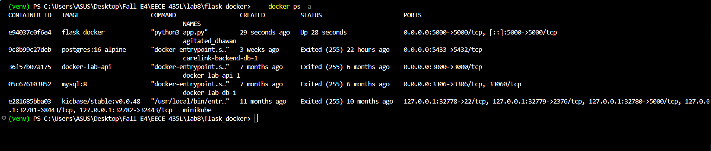
docker ps -a lists all containers, running and stopped. My flask_docker container is Up, running python3 app.py, with port 5000 on my machine mapped to port 5000 in the container.
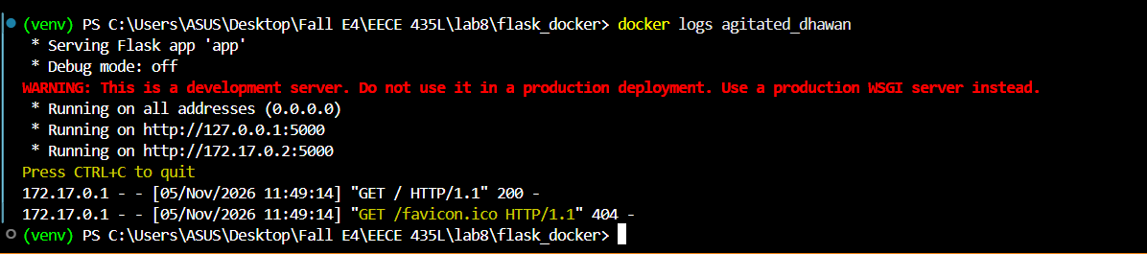
docker logs shows what the container printed. Flask started on port 5000 and GET / returned 200, so the Hello World page loaded (the favicon 404 is just the browser asking for a tab icon).
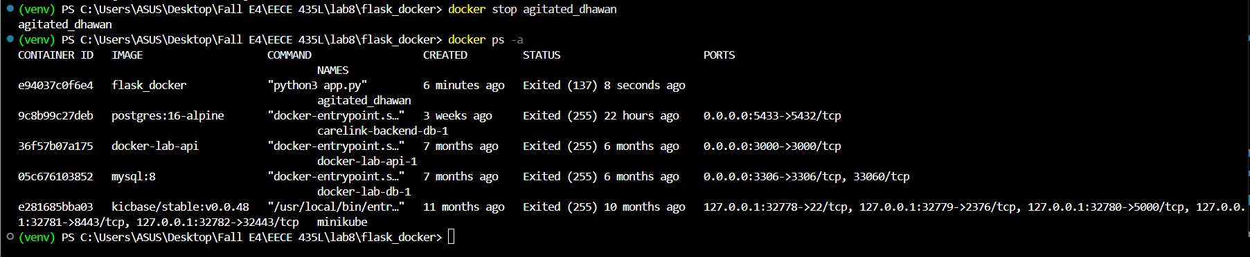
docker stop stops the running container. Running docker ps -a again shows its status changed from Up to Exited; the container still exists and can be restarted with docker start.
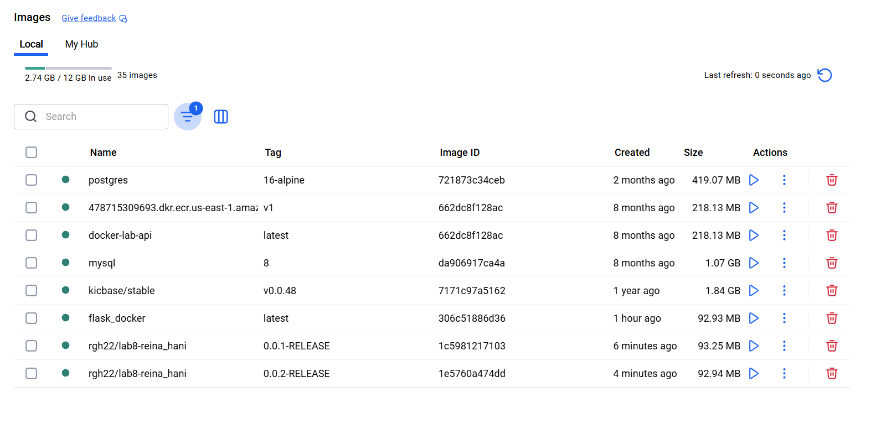
Docker Desktop shows both images I built: tag 0.0.1-RELEASE (Lab 5 API on port 5000) and tag 0.0.2-RELEASE (get_users API on port 3000). Docker tags can't contain a colon, so I used a dash.
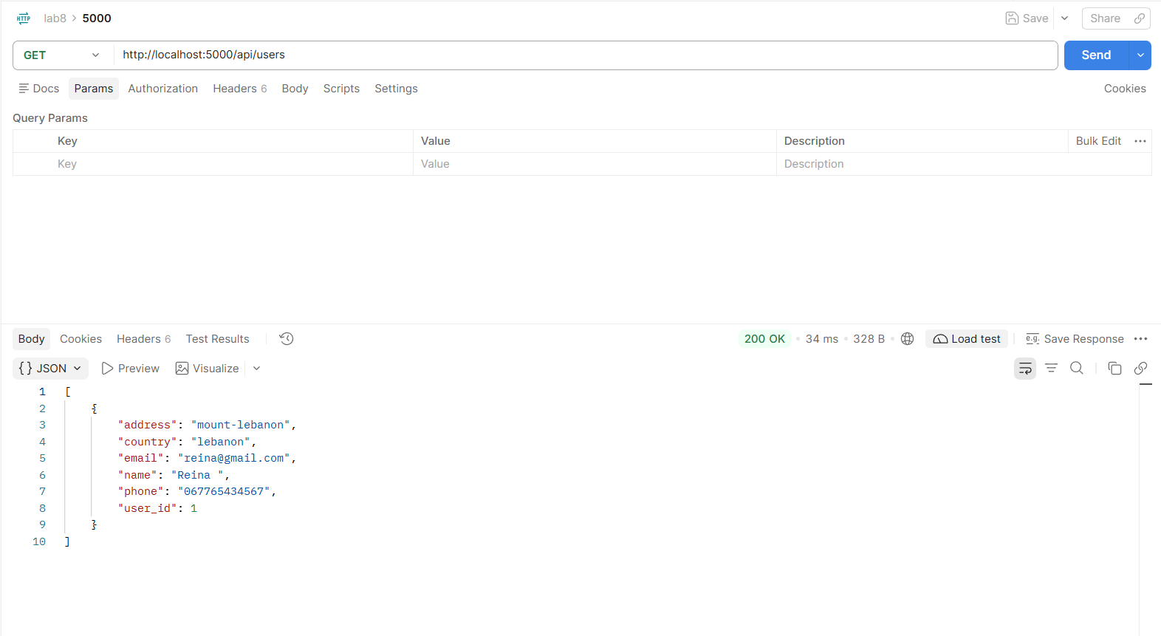
The 0.0.1-RELEASE container runs my Lab 5 API on port 5000. Calling GET http://localhost:5000/api/users in Postman returns 200 OK with the full list of users from the database.
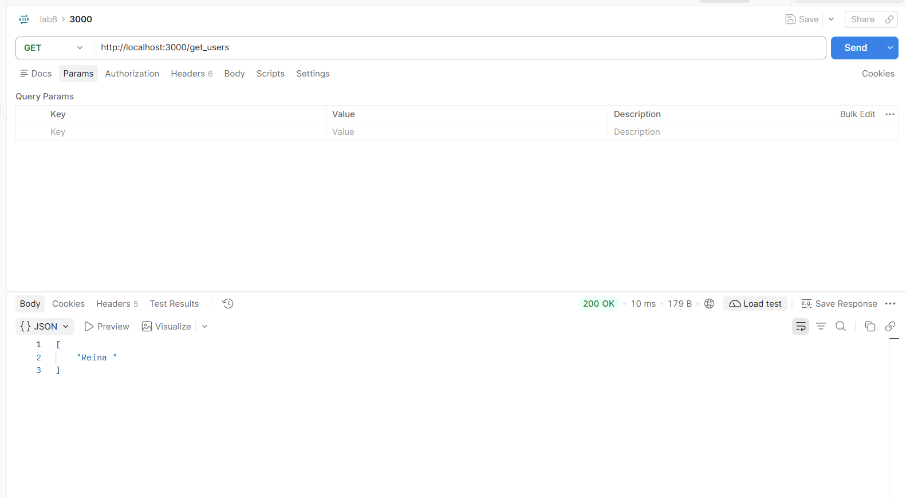
The 0.0.2-RELEASE container runs on port 3000. Calling GET http://localhost:3000/get_users returns 200 OK with a list of just the names of all the users in the database.

