Assessing the Role of Age and Cumulative Smoking Exposure in Lung Cancer Risk
Saraa Al-Jawad
Authors
Saraa Al Jawad
Author affiliations
- College of Public Health, University of Georgia, Athens, GA, USA.
- Another Affiliation, Athens, GA, USA.
- Yet another Affiliation.
$*$ These authors contributed equally to this work.
$∧$ Corresponding author: some@email.com
$†$ Disclaimer: The opinions expressed in this article are the author’s own and don’t reflect their employer.

1. Summary/Abstract
Write a summary of your project.
It is recommended to use a structured abstract with Background/Methods/Results/Discussion sections.
I will just draft summary about the purpose of this project Still In progress
Lung cancer remains one of the leading causes of cancer-related mortality worldwide, with age and smoking exposure recognized as major risk factors. Understanding how these factors contribute to lung cancer risk is essential for improving prevention strategies and risk assessment. In this study, we examine the relationship between age, cumulative smoking exposure, and lung cancer risk using a structured data analysis approach in R. Exploratory data analysis will be performed to evaluate distributions, trends, and potential associations among variables, followed by statistical modeling to assess the independent and combined effects of age and smoking exposure on lung cancer outcomes. This analysis aims to determine whether increasing age and greater cumulative smoking exposure are associated with elevated lung cancer risk and to assess the relative strength of these factors.

2. Introduction

2.1 General Background Information
Provide enough background on your topic that others can understand the why and how of your analysis
Summary intro_draft IN PROGRESS
Lung cancer is one of the leading causes of cancer-related mortality worldwide and remains a major public health concern. Despite advances in screening and treatment, lung cancer often presents at advanced stages, leading to poor prognosis and high mortality rates. Identifying and understanding key risk factors is therefore essential for prevention efforts and early risk assessment.
Age and smoking exposure are well-established risk factors for lung cancer. Risk increases with age due to cumulative biological changes and prolonged exposure to environmental carcinogens. Smoking exposure, particularly cumulative exposure over time, is strongly associated with lung cancer development and is considered the primary preventable risk factor. Examining these variables together allows for a clearer understanding of how they both contribute to disease risk.

2.2 Description of data and data source
Describe what the data is, what it contains, where it is from, etc. Eventually this might be part of a methods section.
The data used in this project were obtained from a publicly available dataset related to lung cancer risk factors. The dataset contains individual-level observations including demographic information and smoking-related variables relevant to lung cancer outcomes. Key variables that will be used in this analysis include age, cumulative smoking exposure, and lung cancer status.

2.3 Questions/Hypotheses to be addressed
The primary research question of this analysis is whether age and cumulative smoking exposure are associated with lung cancer risk.This project seeks to examine how lung cancer risk varies across different age groups and levels of smoking exposure.
The main hypotheses are: 1. Increasing age is associated with a higher risk of lung cancer. 2. Greater cumulative smoking exposure is associated with an increased risk of lung cancer. 3. Smoking exposure contributes more strongly to lung cancer risk than age when both factors are considered together.

3. Methods
Describe your methods. That should describe the data, the cleaning processes, and the analysis approaches. You might want to provide a shorter description here and all the details in the supplement.
Still In progress_this is just simple draft of planned analysis no details yet

3.1 Planned analysis approach
The analysis will begin with exploratory data analysis to examine the distributions of key variables and identify potential patterns or relationships between age, smoking exposure, and lung cancer status. Summary statistics and simple visualizations will be used to better understand the data and assess data quality.
Following exploratory analysis, statistical modeling approaches will be applied to evaluate the association between age, smoking exposure, and lung cancer risk. Models will be used to assess the independent and combined effects of these predictors on lung cancer outcomes. Additional variables in the dataset may be considered in extended analyses as the project progresses, particularly in later stages of the course when multivariate and machine learning methods are introduced.

3.2 Schematic of workflow
Sometimes you might want to show a schematic diagram/figure that was not created with code (if you can do it with code, do it). Figure 1 is an example of some - completely random/unrelated - schematic that was generated with BioRender. We store those figures in the assets folder.

Figure 1: A figure that is manually generated and shows some overview/schematic. This has nothing to do with the data, it’s just a random one from one of our projects I found and placed here.

3.3 Data acquisition
As applicable, explain where and how you got the data. If you directly import the data from an online source, you can combine this section with the next.

3.4 Data import and cleaning
Write code that reads in the file and cleans it so it’s ready for analysis. Since this will be fairly long code for most datasets, it might be a good idea to have it in one or several R scripts. If that is the case, explain here briefly what kind of cleaning/processing you do, and provide more details and well documented code somewhere (e.g. as supplement in a paper). All materials, including files that contain code, should be commented well so everyone can follow along.

3.5 Statistical analysis
Explain anything related to your statistical analyses.

4. Results

4.1 Exploratory/Descriptive analysis
Use a combination of text/tables/figures to explore and describe your data. Show the most important descriptive results here. Additional ones should go in the supplement. Even more can be in the R and Quarto files that are part of your project.
Table 1 shows a summary of the data.
Note the loading of the data providing a relative path using the ../../ notation. (Two dots means a folder up). You never want to specify an absolute path like C:\ahandel\myproject\results\ because if you share this with someone, it won’t work for them since they don’t have that path. You can also use the here R package to create paths. See examples of that below. I generally recommend the here package.
Table 1: Data summary table.
skim_type | skim_variable | n_missing | complete_rate | factor.ordered | factor.n_unique | factor.top_counts | numeric.mean | numeric.sd | numeric.p0 | numeric.p25 | numeric.p50 | numeric.p75 | numeric.p100 | numeric.hist
factor | Gender | 0 | 1 | FALSE | 3 | M: 4, F: 3, O: 2 | NA | NA | NA | NA | NA | NA | NA | NA
numeric | Height | 0 | 1 | NA | NA | NA | 165.66667 | 15.97655 | 133 | 156 | 166 | 178 | 183 | ▂▁▃▃▇
numeric | Weight | 0 | 1 | NA | NA | NA | 70.11111 | 21.24526 | 45 | 55 | 70 | 80 | 110 | ▇▂▃▂▂

4.2 Basic statistical analysis
To get some further insight into your data, if reasonable you could compute simple statistics (e.g. simple models with 1 predictor) to look for associations between your outcome(s) and each individual predictor variable. Though note that unless you pre-specified the outcome and main exposure, any “p<0.05 means statistical significance” interpretation is not valid.
Figure 2 shows a scatterplot figure produced by one of the R scripts.
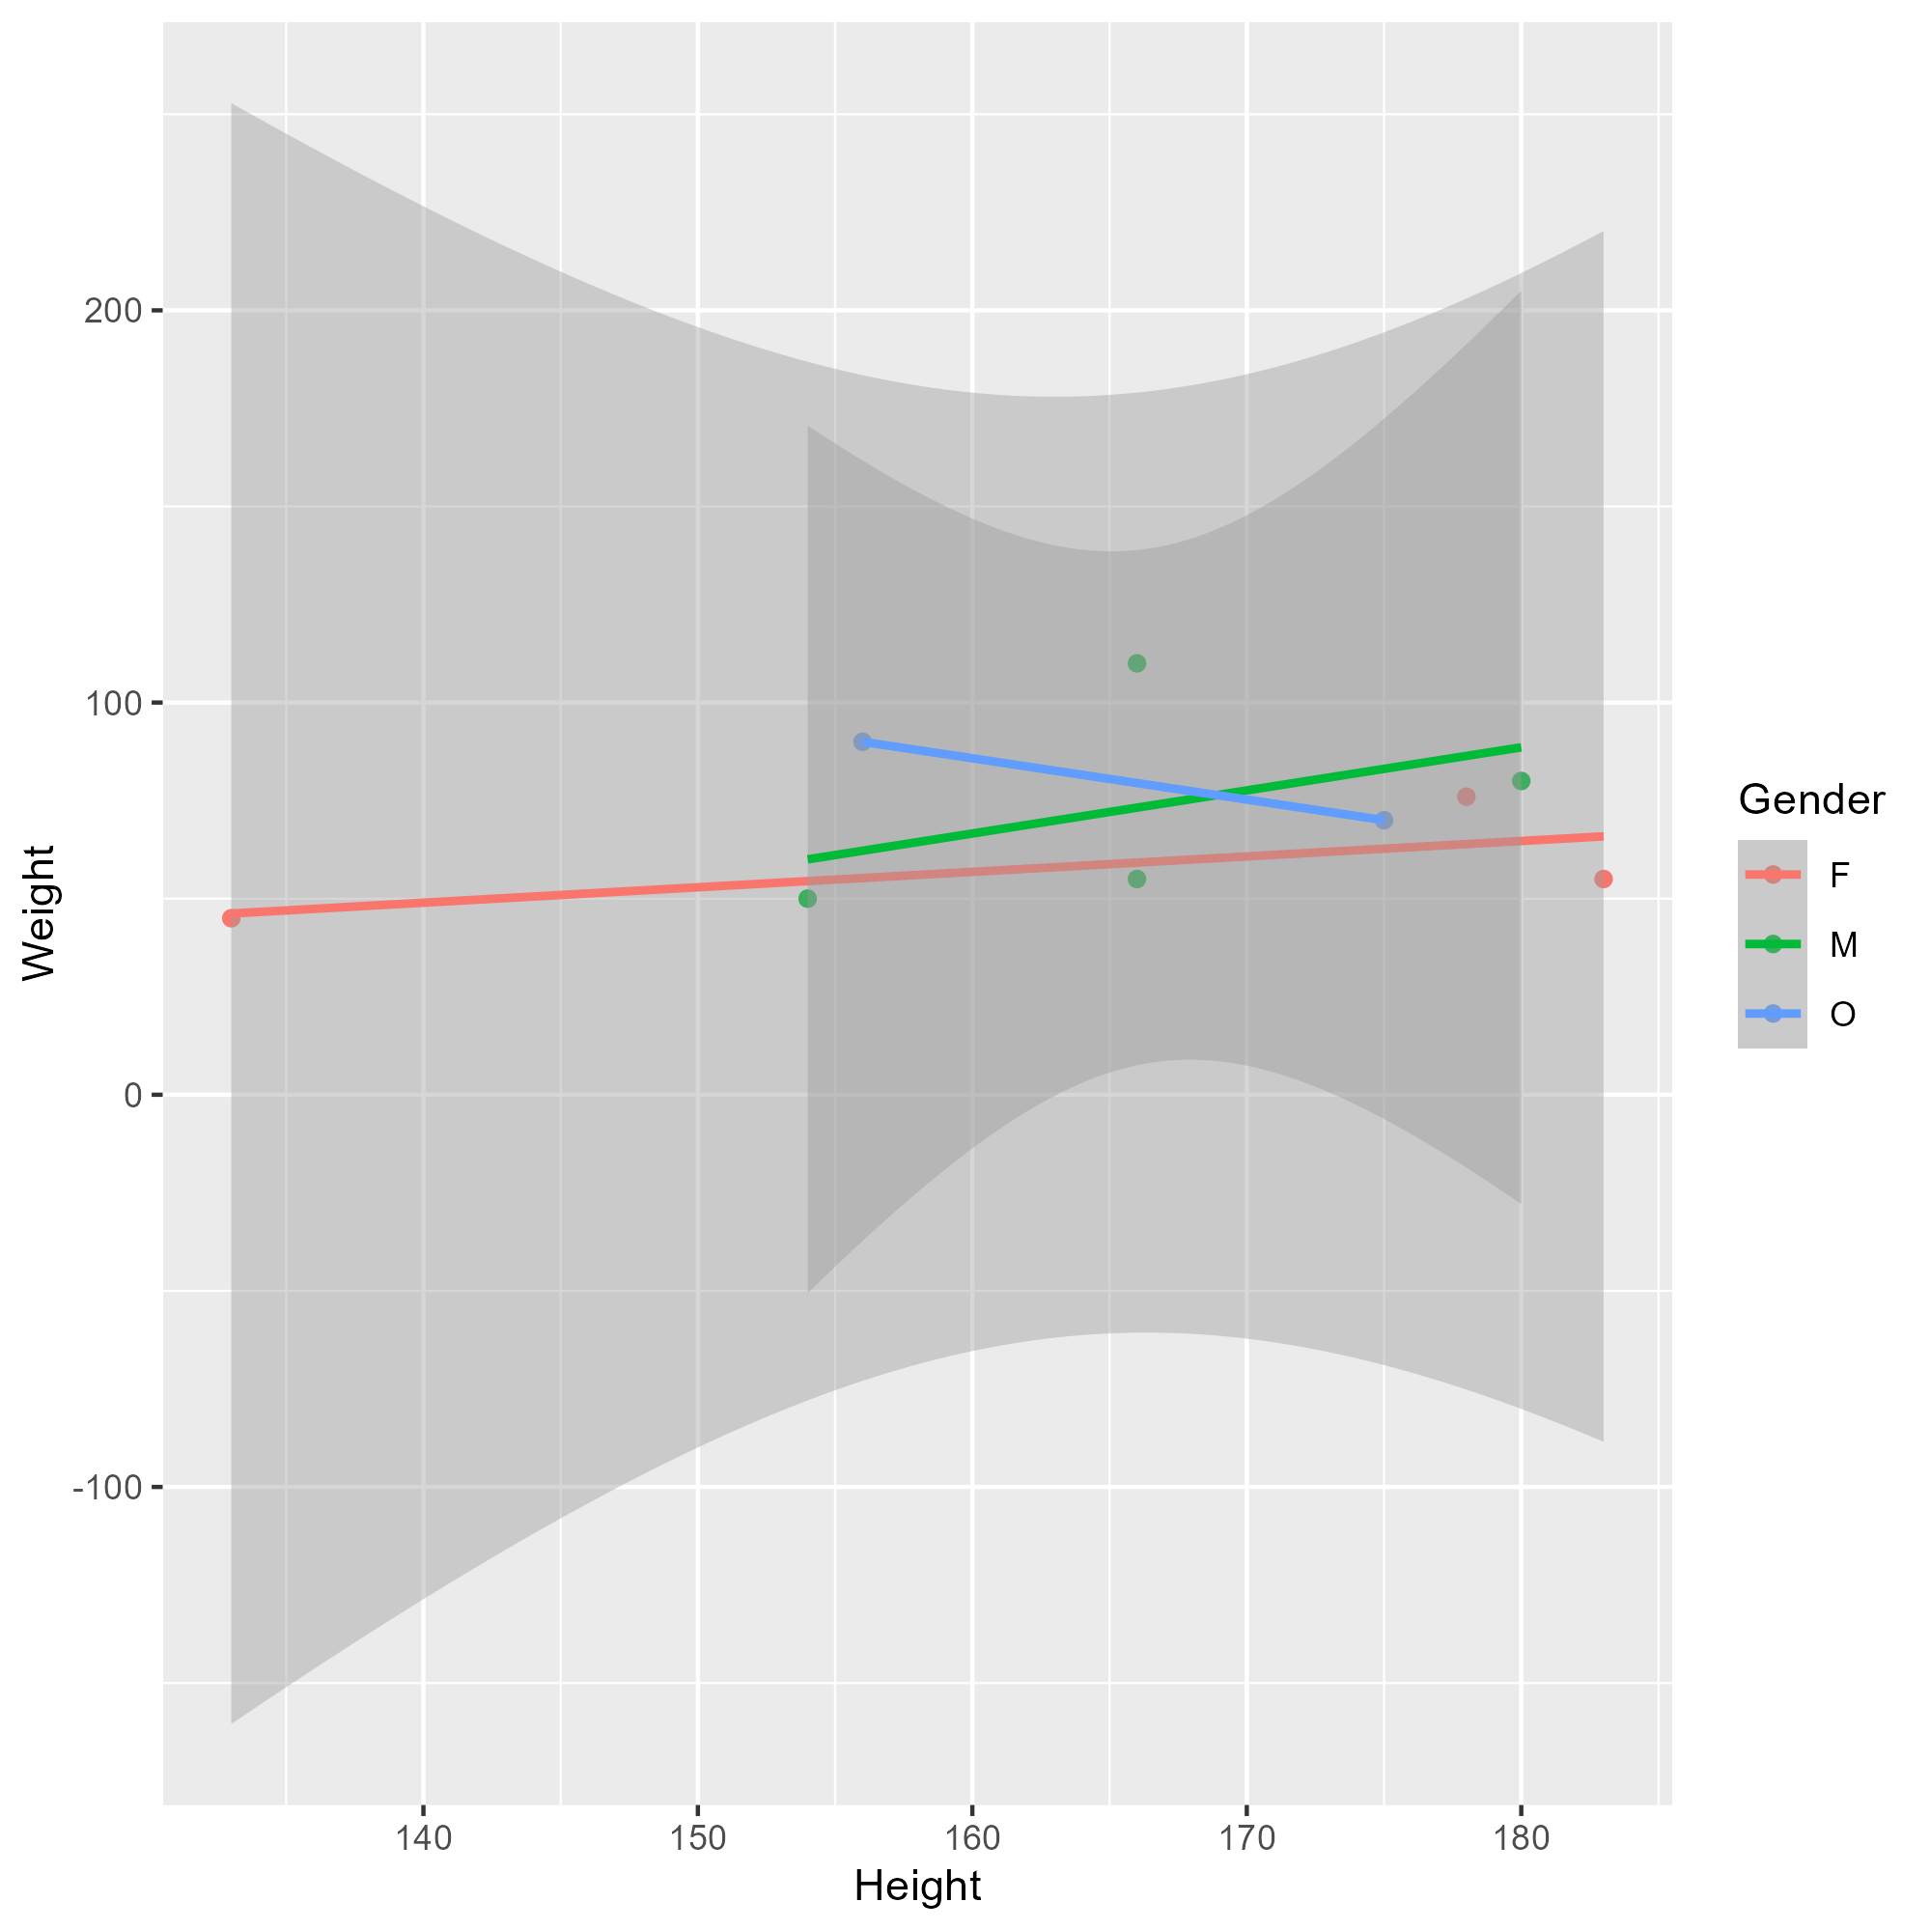
Figure 2: Height and weight stratified by gender.

4.3 Full analysis
Use one or several suitable statistical/machine learning methods to analyze your data and to produce meaningful figures, tables, etc. This might again be code that is best placed in one or several separate R scripts that need to be well documented. You want the code to produce figures and data ready for display as tables, and save those. Then you load them here.
Example Table 2 shows a summary of a linear model fit.
Table 2: Linear model fit table.
term | estimate | std.error | statistic | p.value
(Intercept) | 149.2726967 | 23.3823360 | 6.3839942 | 0.0013962
Weight | 0.2623972 | 0.3512436 | 0.7470519 | 0.4886517
GenderM | -2.1244913 | 15.5488953 | -0.1366329 | 0.8966520
GenderO | -4.7644739 | 19.0114155 | -0.2506112 | 0.8120871

5. Discussion

5.1 Summary and Interpretation
Summarize what you did, what you found and what it means.

5.2 Strengths and Limitations
Discuss what you perceive as strengths and limitations of your analysis.

5.3 Conclusions
What are the main take-home messages?
Include citations in your Qmd file using BibTeX, the list of references will automatically be placed at the end
This paper (1) discusses types of analyses.
These papers (2,3) are good examples of papers published using a fully reproducible setup similar to the one shown in this template.
Note that this cited reference will show up at the end of the document, the reference formatting is determined by the CSL file specified in the YAML header. Many more style files for almost any journal are available. You also specify the location of your BibTeX reference file in the YAML. You can call your reference file anything you like.

6. Supplementary materials
The raw data used in this analysis are stored in the project repository under data/raw-data/.

7. References
1. Leek JT, Peng RD. Statistics. What is the question? Science (New York, N.Y.). 2015;347(6228):1314–1315.
2. McKay B, Ebell M, Billings WZ, et al. Associations Between Relative Viral Load at Diagnosis and Influenza A Symptoms and Recovery. Open forum infectious diseases. 2020;7(11):ofaa494.
3. McKay B, Ebell M, Dale AP, et al. Virulence-mediated infectiousness and activity trade-offs and their impact on transmission potential of influenza patients. Proceedings. Biological sciences. 2020;287(1927):20200496.

