SE 6367 Software Testing, Validation and Verification
(Executive Master’s Program)

Spring 2013

Homework 2 (in-class exercise)
Total points: 100

Due: March 9 (Saturday)

Follow the instructions in Chapter 2 of the χSuds User's manual. You should see Figure 2-34, the coverage summary by-type, on your screen after executing wordcount.17.

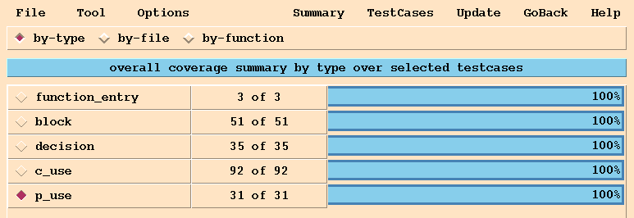

Please print out the entire screen (not just Figure 2-34) and submit a paper copy in class.

