SE/CS 6367 & SYSM 6310: Software Testing

Quiz 4: Code Coverage Testing and Tool Support

Due: 06/04/Thursday (11:59:59 pm Dallas time)
(No late submission will be accepted.)

Submit your solution to Mr. Linghuan Hu <linghuan.hu@utdallas.edu>

Refer to the following code and its control flow graph.

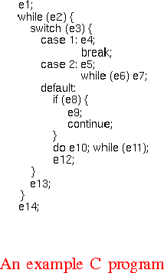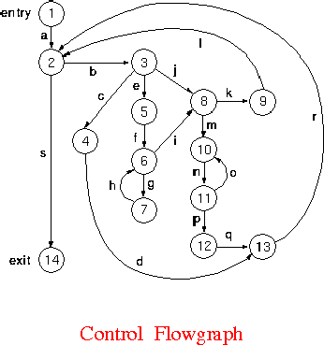

- Does node 4 or node 12 predominate node 13?
An answer without any explanation receives zero points.

- Does node 9 postdominate node 8?
An answer without any explanation receives zero points.

