Analysis of the Evolution of the Upper Tropospheric Cyclonic Vortex of December 1995 over Southeastern South America Based on Isentropic Potential Vorticity
Reinaldo Haas
Department of Physics / Center for Physical and Mathematical Sciences
Federal University of Santa Catarina (UFSC), Florianópolis - SC, Brazil
Contact: reinaldo.haas@ufsc.br
ABSTRACT
During the last two weeks of December 1995, a synoptic baroclinic disturbance crossed the Andes Cordillera and evolved into a long-lived Upper Tropospheric Cyclonic Vortex (UTCV) that propagated anomalously northeastward along the southern and southeastern coast of Brazil. The system induced widespread extreme precipitation episodes, flash floods, and substantial socio-economic damage. In this study, the dynamic and thermodynamic lifecycle of the UTCV is investigated within the framework of Ertel Isentropic Potential Vorticity (IPV thinking) using the high-resolution ECMWF Reanalysis v5 (ERA5, 0.25° × 0.25°) and NOAA GridSat-B1 calibrated geostationary infrared observations. Our diagnostic results demonstrate that: (1) baroclinic coupling between an upper-level tropopause fold (q ≥ 1.5 UVP at 400 hPa) and a shallow boundary-layer cyclonic IPV anomaly dammed west of the Chilean coast pre-conditioned the initial intensification; (2) during Andean transit, the vortex axis tilted eastward before realigning vertically on the lee side into an equivalent barotropic column, inducing regional lee cyclogenesis associated with the Northwestern Argentine Low (BNOA; minimum sea level pressure of 989.6 hPa at 29.5°S, 66.5°W on 20/12 18 UTC); (3) upon reaching Southeastern South America (SESA), coastal re-intensification on 22/12 (peak 400 hPa IPV of 2.79 UVP) was maintained by low-level moisture convergence and an equivalent potential temperature (θe) tongue (341–343 K at 925 hPa); and (4) the anomalous northeastward displacement from 35.5°S to 24.3°S between 21 and 28 December was dynamically sustained by upper-tropospheric barotropic instability across 300–100 hPa, where the meridional gradient of absolute vorticity Q_y = β - d²ū/dy² reversed sign (crossing zero at ~28.8°S), satisfying Kuo's necessary instability condition.
Keywords: Upper Tropospheric Cyclonic Vortex; IPV Thinking; Lee Cyclogenesis; Barotropic Instability; Flash Floods; ERA5.
RESUMO
Durante as duas últimas semanas de dezembro de 1995, um distúrbio baroclínico de escala sinótica transpôs a Cordilheira dos Andes e evoluiu para um Vórtice Ciclônico de Altos Níveis (VCAN) de longa duração que se deslocou de forma anômala para nordeste ao longo do litoral Sul e Sudeste do Brasil. O sistema provocou episódios generalizados de precipitação extrema, inundações bruscas e severos prejuízos socioeconômicos. Neste trabalho, o ciclo de vida dinâmico e termodinâmico do VCAN é investigado sob o arcabouço da Vorticidade Potencial Isentrópica de Ertel (pensamento VPI) utilizando a reanálise de alta resolução ECMWF ERA5 (0,25° × 0,25°) e observações infravermelhas calibradas do satélite geoestacionário NOAA GridSat-B1. Os resultados diagnósticos revelam que: (1) o acoplamento baroclínico entre uma dobra de tropopausa em altos níveis (q ≥ 1,5 UVP em 400 hPa) e uma anomalia rasa de VPI ciclônica na camada limite represada a oeste da costa chilena pré-condicionou a intensificação inicial; (2) durante a travessia andina, o eixo vertical do vórtice inclinou-se para leste antes de se realinhar verticalmente a sotavento em uma coluna barotrópica equivalente, induzindo ciclogênese a sotavento associada à Baixa do Noroeste Argentino (BNOA; pressão ao nível médio do mar de 989,6 hPa em 29,5°S, 66,5°W em 20/12 18 UTC); (3) ao alcançar o Sudeste da América do Sul (SESA), a reintensificação costeira em 22/12 (pico de VPI em 400 hPa de 2,79 UVP) foi sustentada pela convergência de umidade em baixos níveis e por uma língua de temperatura potencial equivalente (θe de 341–343 K em 925 hPa); e (4) o deslocamento anômalo para nordeste de 35,5°S para 24,3°S entre 21 e 28 de dezembro foi sustentado dinamicamente por instabilidade barotrópica na alta troposfera entre 300 e 100 hPa, onde o gradiente meridional de vorticidade absoluta Q_y = β - d²ū/dy² inverteu de sinal (cruzando o zero em ~28,8°S), satisfazendo o critério necessário de instabilidade de Kuo.
Palavras-chave: Vórtice Ciclônico de Altos Níveis; Pensamento VPI; Ciclogênese a Sotavento; Instabilidade Barotrópica; Inundações Bruscas; ERA5.
1. INTRODUCTION
Extratropical and subtropical cyclonic disturbances in the midlatitudes of the Southern Hemisphere exert a dominant control over synoptic weather patterns, precipitation distribution, and severe convective outbreaks (Bjerknes and Solberg, 1922; Charney, 1947; Eady, 1949). In South America, upper-tropospheric cut-off lows and Upper Tropospheric Cyclonic Vortices (UTCVs, commonly designated as VCANs in South American literature) represent high-impact synoptic phenomena capable of causing catastrophic flash floods, prolonged storm surges, and landslides (Gan and Rao, 1994; Reboita et al., 2009; Iwabe et al., 2010).
Historically, cyclone analysis relied heavily on multi-level isobaric charts and Sutcliffe-Trenberton quasi-geostrophic diagnostic equations. However, the formulation of Ertel's Potential Vorticity theorem (Ertel, 1942; Rossby, 1940) and its modern revitalization into Isentropic Potential Vorticity (IPV) by Hoskins et al. (1985) established the paradigm known as 'IPV thinking' (Thorpe, 1985; Davis and Emanuel, 1991). By consolidating dynamic vorticity and thermodynamic stratification into a single conserved tracer under adiabatic, frictionless conditions, IPV analysis offers an intuitive and invertible framework to examine tropopause folds, vortex-vortex interactions, and baroclinic amplification.
Between December 10 and 31, 1995, an exceptional UTCV developed over the southeastern Pacific, traversed the high topography of the Andes Cordillera, and produced an unusually persistent cyclonic disturbance over Southeastern South America (SESA). Rather than progressing eastward or southeastward toward the South Atlantic along standard storm tracks (Ambrizzi and Pezza, 1999), this system executed an anomalous northeastward trajectory spanning four Brazilian states (Rio Grande do Sul, Santa Catarina, Paraná, and São Paulo) and generated record-breaking rainfall episodes and flash floods (Haas, 2002).
Despite the severity of this event, previous investigations lacked high-resolution reanalysis datasets to unravel the complex interaction between the Andes barrier, boundary-layer thermodynamics, and upper-level shear instability. In this paper, we employ the 0.25° ECMWF ERA5 reanalysis and NOAA GridSat-B1 calibrated geostationary observations to provide a rigorous, dynamically consistent diagnosis of the formation, Andean transit, coastal re-intensification, and anomalous northward displacement of this remarkable vortex.
2. LITERATURE REVIEW
Classical baroclinic instability theory demonstrates that cyclonic development requires vertical wind shear and an westward-tilted vertical axis with height (Charney, 1947; Eady, 1949). In the IPV conceptual framework, this configuration corresponds to an upper-tropospheric positive (cyclonic) IPV anomaly located upshear (west) of a low-level warm thermal disturbance (Hoskins et al., 1985; Hirschberg and Fritsch, 1991). The cyclonic circulation induced by the upper IPV anomaly advects warm, moist air poleward, creating an effective positive low-level IPV anomaly. In return, the low-level thermal perturbation induces cyclonic circulation aloft, reinforcing the upper vortex in a self-amplifying mutual feedback loop.
The massive barrier of the Andes Cordillera (mean elevation exceeding 4,000 m between 20°S and 35°S) drastically alters transient baroclinic waves entering South America (Gan and Rao, 1994; Seluchi and Saulo, 2012). Numerical sensitivity experiments by Orlanski et al. (1991) and Funatsu et al. (2004) showed that orographic vortex compression on the windward slope followed by rapid vertical stretching on the lee side triggers orographic lee cyclogenesis over western and central Argentina. This lee cyclogenesis frequently manifests through the amplification of the Northwestern Argentine Low (BNOA; Seluchi and Saulo, 2012), a thermal-orographic low centered east of the Andes.
Once displaced toward the subtropical South American coast, long-lived vortices can interact with maritime boundary-layer air masses. Reboita et al. (2009) and Iwabe et al. (2010) examined quasi-stationary cyclones off the southern coast of Brazil, highlighting the role of middle-tropospheric vorticity advection, warm thermal advection, and atmospheric blocking in impeding normal zonal evacuation. Furthermore, when horizontal wind shear is pronounced, the flow can satisfy Kuo's (1949) necessary condition for barotropic instability, allowing synoptic vortices to extract kinetic energy directly from the upper-tropospheric subtropical jet.
3. MATERIALS AND METHODS
Atmospheric diagnostics were computed using the Fifth Generation ECMWF Atmospheric Reanalysis (ERA5; Hersbach et al., 2020). ERA5 data were acquired on a regular 0.25° × 0.25° horizontal grid spanning the domain 0°–60°S and 90°W–30°W at 6-hourly synoptic intervals (00, 06, 12, and 18 UTC) from December 10 to 31, 1995. The vertical domain comprises 12 standard isobaric levels: 1000, 925, 850, 700, 600, 500, 400, 300, 250, 200, 150, and 100 hPa. Surface parameters include mean sea level pressure (msl), 2-meter air temperature (t2m), sea surface temperature (sst), surface pressure (sp), and surface geopotential (z). To avoid fictitious isobaric extrapolation beneath the steep Andean orography, lower isobaric levels and vertical cross-sections were masked wherever pressure exceeded local surface pressure (p > sp).
Calibrated infrared (11 µm) window brightness temperatures from the GOES-8 geostationary satellite were obtained from the NOAA National Centers for Environmental Information (NCEI) GridSat-B1 climate data record (Knapp et al., 2011).
In hydrostatic pressure coordinates, Ertel's Potential Vorticity is formulated as:
P = -g (ζ_p + f) (∂θ / ∂p)
where g = 9.80665 m s⁻² is gravitational acceleration, f = 2Ω sin(φ) is the Coriolis parameter (Ω = 7.292115 × 10⁻⁵ rad s⁻¹), ζ_p = (∂v/∂x)_p - (∂u/∂y)_p is relative vorticity evaluated along isobaric surfaces, and θ = T (1000/p)^0.286 is potential temperature. In the Southern Hemisphere, where f < 0 and ∂θ/∂p < 0 in a statically stable atmosphere, Ertel PV values are algebraically negative. In alignment with Southern Hemisphere conventions in potential vorticity literature (Haas, 2002), we define cyclonic Isentropic Potential Vorticity as:
q ≡ -P × 10⁶ [PVU or UVP, 10⁻⁶ m² K kg⁻¹ s⁻¹]
Under this sign convention, positive values (q > 0) unambiguously designate cyclonic vorticity in both hemispheres. Stratospheric air is demarcated by q ≥ 1.5 UVP, which defines the dynamical tropopause.
Equivalent potential temperature (θe) at lower tropospheric levels is computed using Bolton's (1980) formulation. To assess upper-level barotropic instability, the meridional gradient of absolute vorticity was evaluated from the layer-mean zonal wind (ū) between 300 and 100 hPa:
Q_y = β - (d²ū / dy²)
where β = (2Ω cos φ) / a and a = 6.371 × 10⁶ m. Kuo's (1949) theorem dictates that a change of sign of Q_y within the domain represents the necessary condition for barotropic instability.
4. RESULTS AND DISCUSSION
4.1 Vortex Genesis over the Southeastern Pacific
Between December 10 and 14, 1995, the synoptic precursor to the UTCV originated over the southeastern Pacific Ocean (40°–50°S, 100°–80°W). The vortex developed from the anticyclonic roll-up and equatorward fracture of a cold front whose polar segment advanced rapidly eastward while its subtropical branch remained retarded west of the coastline (Gan and Rao, 1994).
Calibrated GOES-8 infrared brightness temperatures from NOAA GridSat-B1 (Figure 1) capture the distinct morphological evolution of the vortex core. On December 14 at 18 UTC (Figure 1a), an incipient spiral of cyclonic cloudiness is centered near 32°S, 82°W. By December 19 at 18 UTC (Figure 1b), the system had evolved into a fully organized cut-off vortex centered near 35°S, 80°W, characterized by an expansive clear-sky eye indicative of strong upper-level subsidence and stratospheric intrusion.
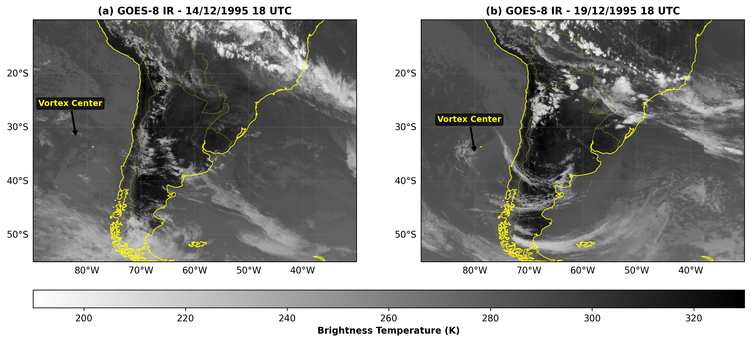
Figure 1. Calibrated GOES-8 infrared (11 µm) brightness temperature (K) from the NOAA GridSat-B1 climate data record for: (a) 14/12/1995 18 UTC (incipient vortex formation over the southeastern Pacific); and (b) 19/12/1995 18 UTC (mature cut-off cyclonic vortex prior to Andean crossing). Arrows indicate the vortex core. Coastlines and international borders are shown in yellow.
4.2 Pre-Andean Baroclinic Coupling
Prior to impinging upon the Andes Cordillera, the vortex experienced notable baroclinic amplification between December 17 and 19 over the eastern Pacific. Figure 2 presents a vertical cross-section along 35°S at 18 UTC on December 18, 1995, depicting Ertel cyclonic IPV (q, shaded) and isentropes (black contours).
The cross-section reveals an intense upper-tropospheric stratospheric extrusion (tropopause fold) characterized by q ≥ 1.5 UVP descending from the stratosphere down to the 400–500 hPa layer near 88°W, with peak core values reaching ~4.6 UVP. Downstream, along the Chilean coastal margin between 78°W and 74°W, a shallow boundary-layer cyclonic IPV anomaly (values up to ~1.0–1.2 UVP) is clearly evident below 850 hPa, dammed against the steep western flank of the Andes.
The upper-level cyclonic anomaly was positioned upshear (west) of the low-level coastal anomaly. This westward vertical tilt with height enabled mutual baroclinic amplification (Hoskins et al., 1985; Hirschberg and Fritsch, 1991). The cyclonic circulation associated with the descending tropopause fold induced warm, moist northerly advection along the coast, which intensified the low-level thermal and cyclonic anomaly, while the lower anomaly in turn enhanced poleward warm advection east of the upper trough. This mutual baroclinic coupling pre-conditioned the vortex into a robust coherent structure before it encountered the mountain barrier.
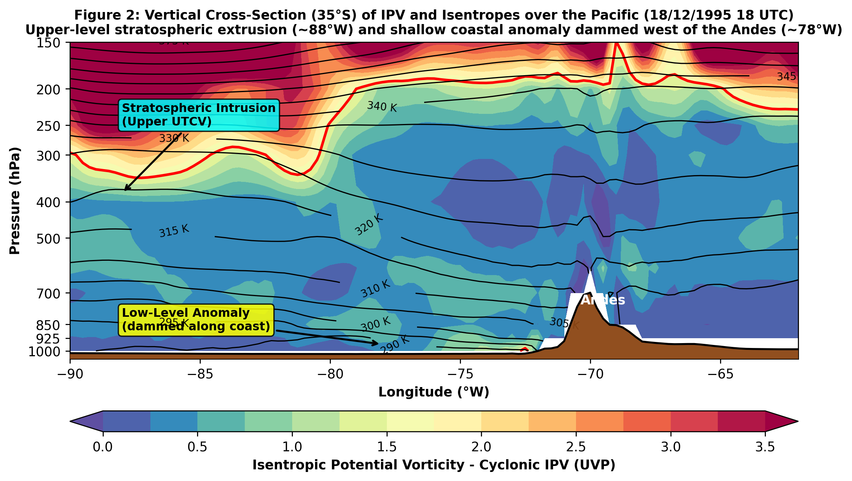
Figure 2. Vertical cross-section along 35°S of Ertel Isentropic Potential Vorticity (q in UVP, shaded) and potential temperature (isentropes in black contours, interval 5 K) on 18/12/1995 at 18 UTC from ERA5 reanalysis. Shading highlights the upper-level tropopause fold (q ≥ 1.5 UVP) near 88°W and the shallow coastal IPV anomaly below 850 hPa dammed west of the Andes (~78°W). Topography is masked in gray below surface pressure.
4.3 Andean Transit and Lee Cyclogenesis
Between December 20 and 22, the UTCV crossed the Andes Cordillera. The structural evolution of the vortex during mountain transit is illustrated by vertical cross-sections along 27.5°S at 20/12 00 UTC and 22/12 00 UTC (Figure 3).
On December 20 at 00 UTC (Figure 3a), as the system approached the mountain crest, the vertical axis of the vortex exhibited a pronounced westward tilt with height. The upper-tropospheric IPV anomaly (q > 2.0 UVP) remained centered west of 70°W between 400 and 250 hPa, while downstream at the surface, the initial stages of orographic vortex stretching were underway. By December 22 at 00 UTC (Figure 3b), following complete Andean crossing, the vortex axis transitioned into a nearly upright, equivalent barotropic vertical alignment between 62°W and 58°W, extending from the middle troposphere down to 850 hPa.
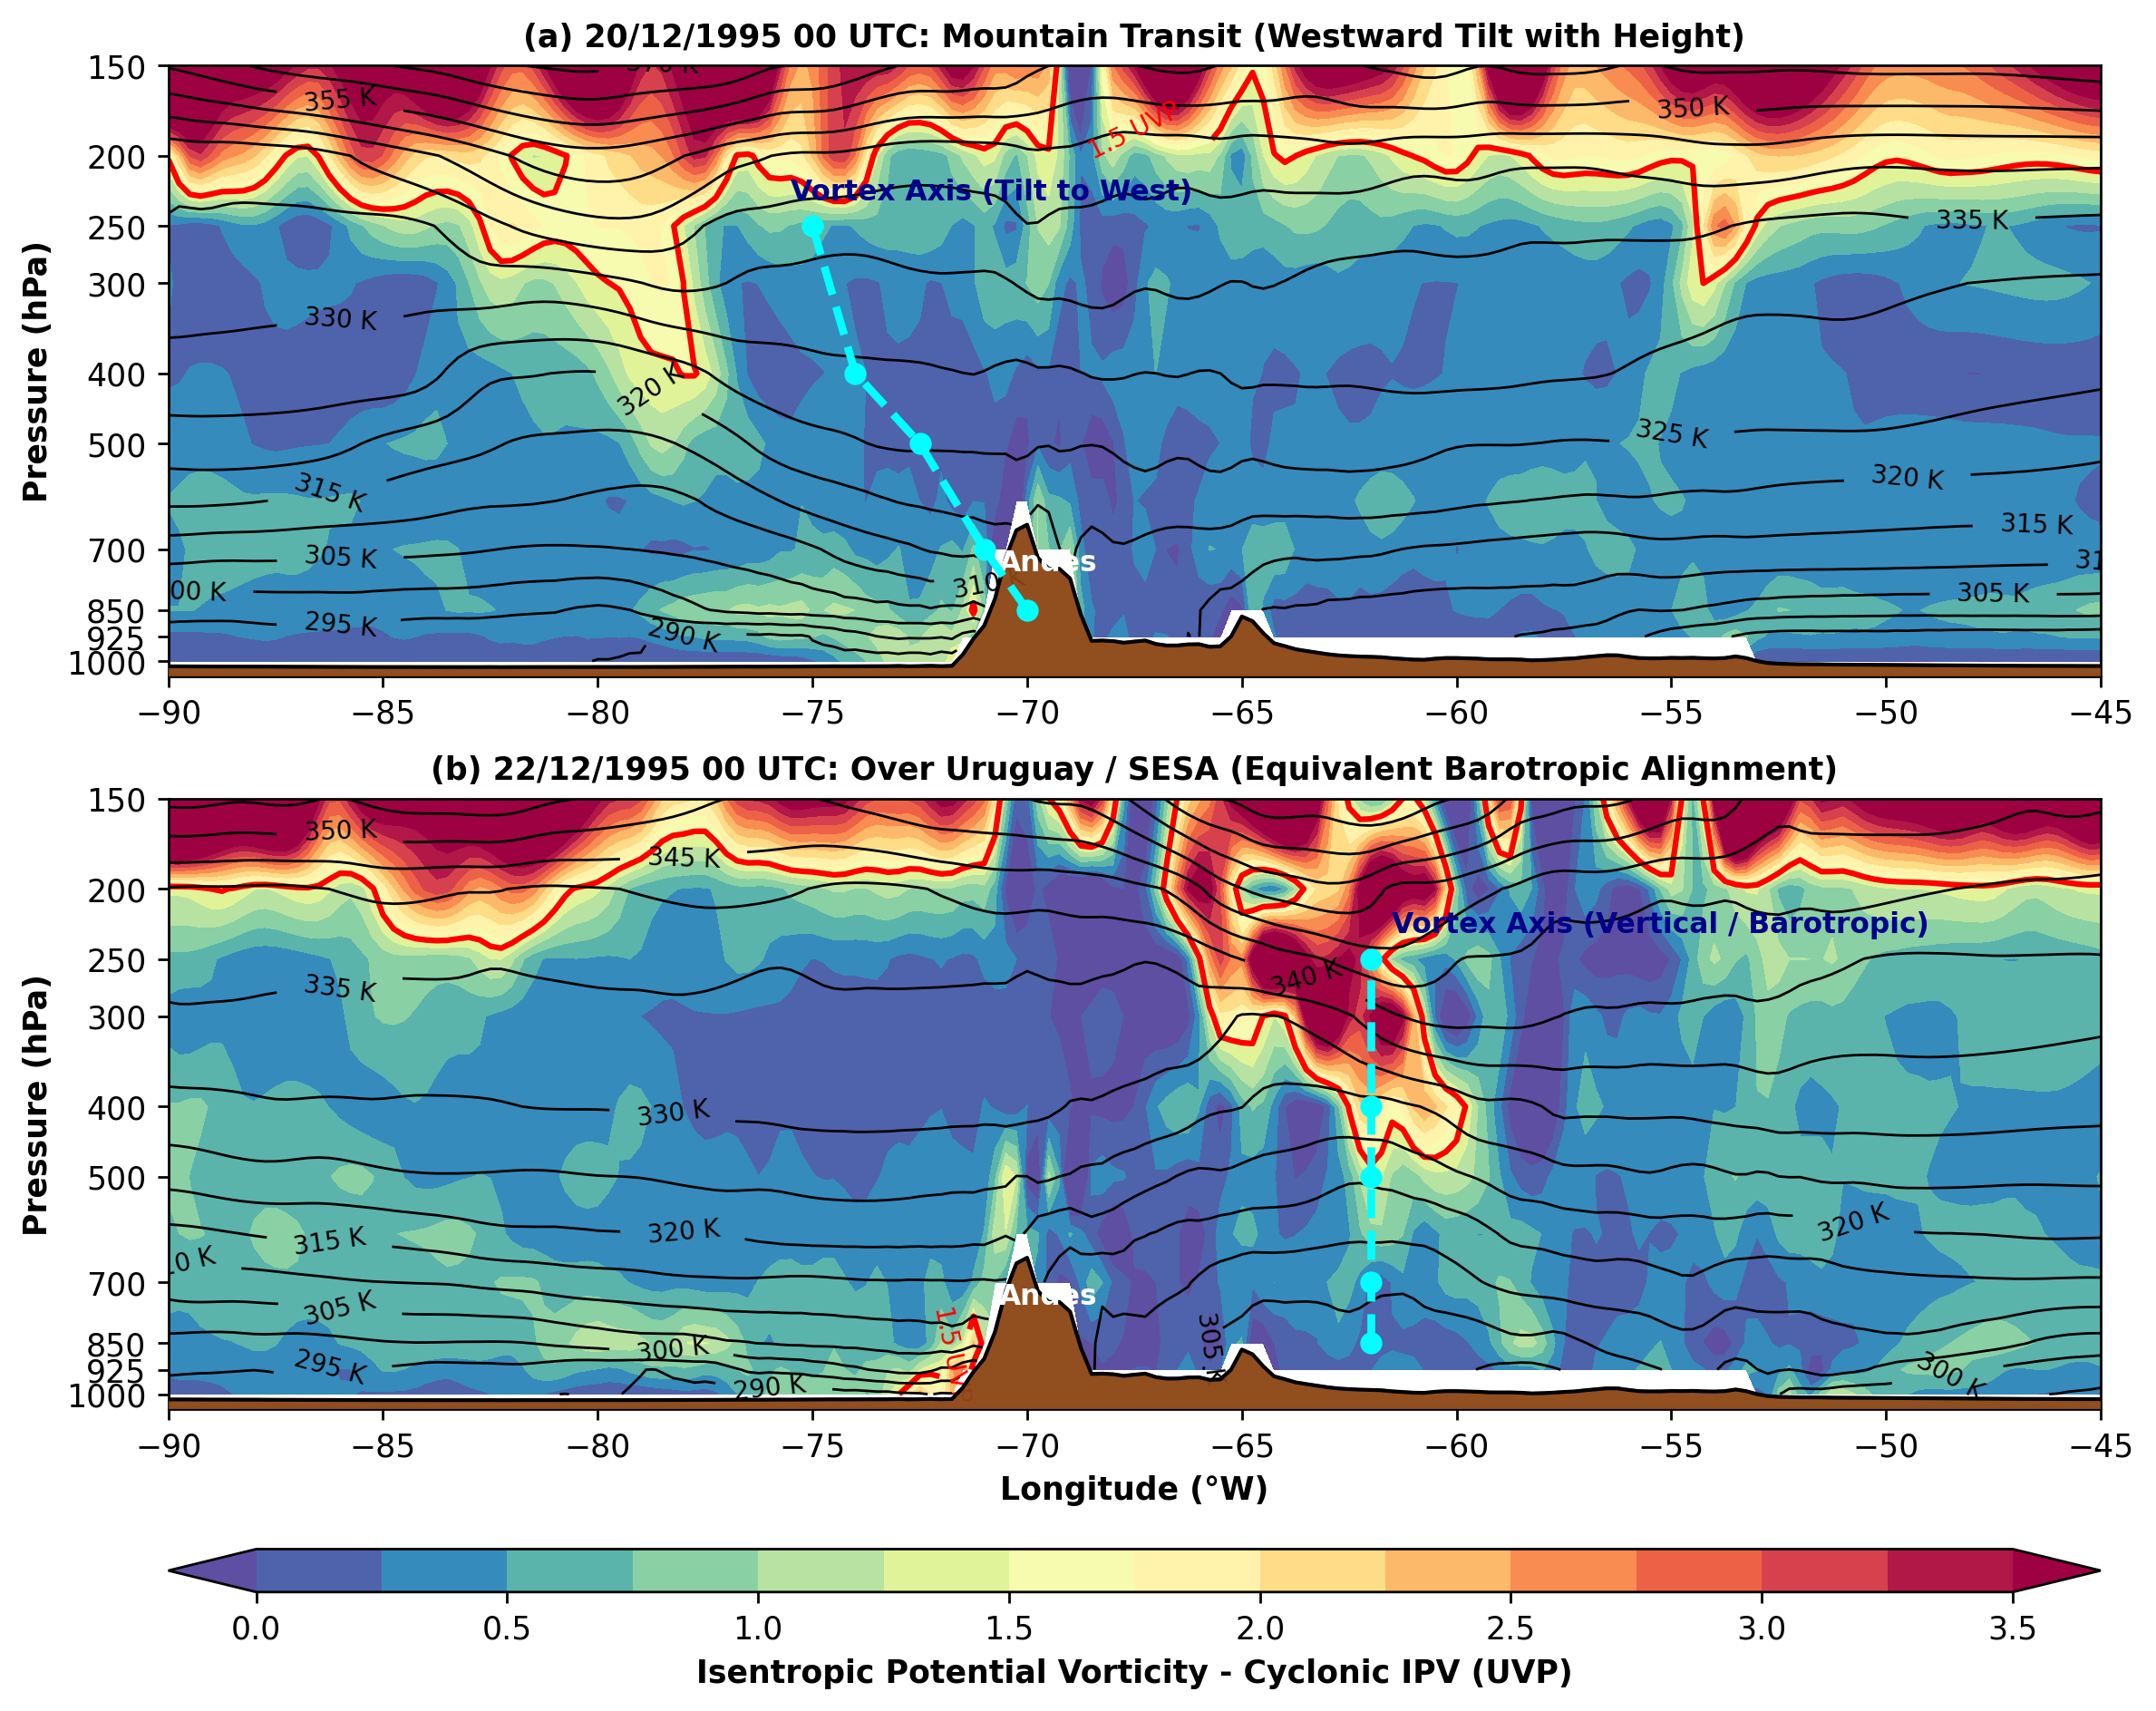
Figure 3. Vertical cross-section along 27.5°S of Ertel Isentropic Potential Vorticity (q in UVP, shaded) and isentropes (black contours, interval 5 K) from ERA5 reanalysis for: (a) 20/12/1995 00 UTC (westward tilt during Andean approach); and (b) 22/12/1995 00 UTC (upright, equivalent barotropic alignment downstream of the Andes). The dashed red line marks the cyclonic vortex axis. Topography is masked in gray below surface pressure.
The corresponding surface pressure evolution is documented in the synoptic sequence of Mean Sea Level Pressure (SLP) from ERA5 (Figure 4). On December 21 at 00 UTC (Figure 4a), intense lee cyclogenesis is evident across northwestern and central Argentina. The regional minimum SLP of 989.6 hPa occurred at 29.5°S, 66.5°W in La Rioja/Catamarca at 18 UTC on December 20, corresponding to a pronounced thermal-orographic Northwestern Argentine Low (BNOA; Seluchi and Saulo, 2012). At Mendoza (32.89°S, 68.84°W), SLP reached a local trough minimum of 995.7 hPa at 18 UTC on December 20, rising to 1005.2 hPa by 00 UTC on December 21 as the cold front swept eastward. Although this pressure drop was vigorous, it did not satisfy the classical 'meteorological bomb' threshold for this latitude (Sanders and Gyakum, 1980), which requires a 24-hour geostrophically normalized deepening rate exceeding 1 Bergeron (~17.5 hPa/24 h at 30°S).
As the upper-level vortex tracked east of the Andes, a secondary surface low developed over Uruguay, reaching 1003.3 hPa on December 22 at 00 UTC (Figure 4b). Over the subsequent days, this surface low gradually filled to 1008.0 hPa by December 25 (Figure 4c) and dissipated completely by December 29 (Figure 4d), while the upper-level vortex remained remarkably active aloft.
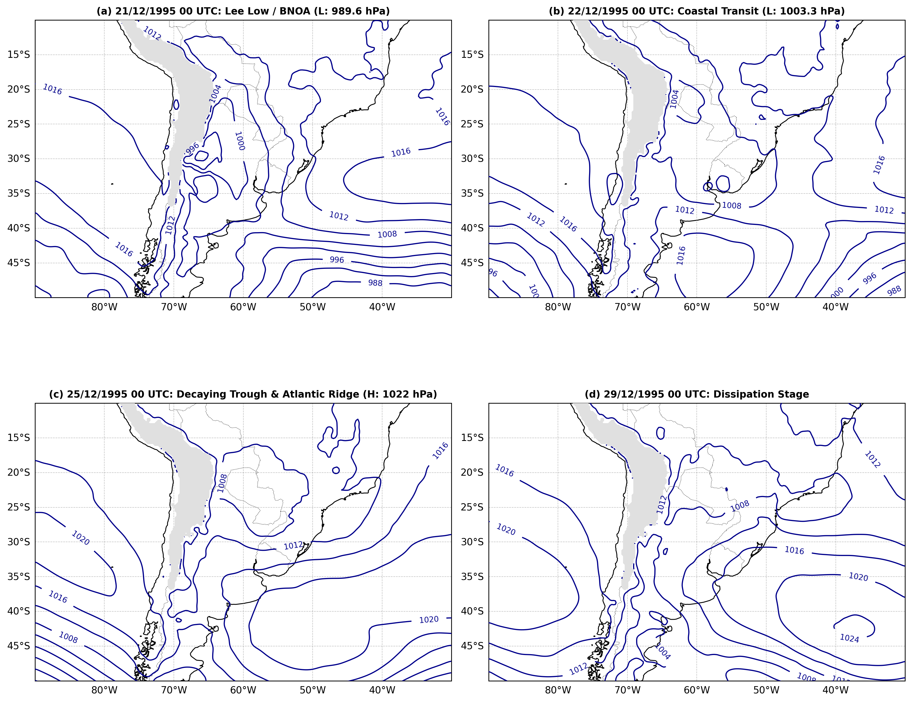
Figure 4. Mean Sea Level Pressure (hPa, black contours, interval 4 hPa) from ERA5 reanalysis across key synoptic stages: (a) 21/12/1995 00 UTC (lee cyclogenesis over western/northwestern Argentina; local SLP at Mendoza is 1005.2 hPa); (b) 22/12/1995 00 UTC (surface cyclone over Uruguay at 1003.3 hPa); (c) 25/12/1995 00 UTC (decaying coastal trough, Uruguay low filled to 1008.0 hPa); and (d) 29/12/1995 00 UTC (dissipation phase). Topography above 2000 m is masked in gray.
4.4 Coastal Re-intensification and Moisture Inflow over SESA
A central puzzle of the December 1995 UTCV was its prolonged vigor and devastating precipitation over Southeastern South America (SESA) despite the filling of the surface low. Figure 5 depicts the Ertel cyclonic IPV (q) and geopotential height at 400 hPa on December 22 at 00 UTC.
On December 22 at 00 UTC, the 400 hPa cyclonic vortex reached its peak intensity over SESA, with core IPV attaining 2.79 UVP centered at 31.5°S, 62.0°W. The dynamical tropopause (q = 1.5 UVP, bold red contour) extended across northern Argentina, Uruguay, and western Rio Grande do Sul, embedded within a closed cyclonic geopotential depression (minimum height ~7180 m). Cyclonic winds around the vortex periphery exceeded 35 m s⁻¹.
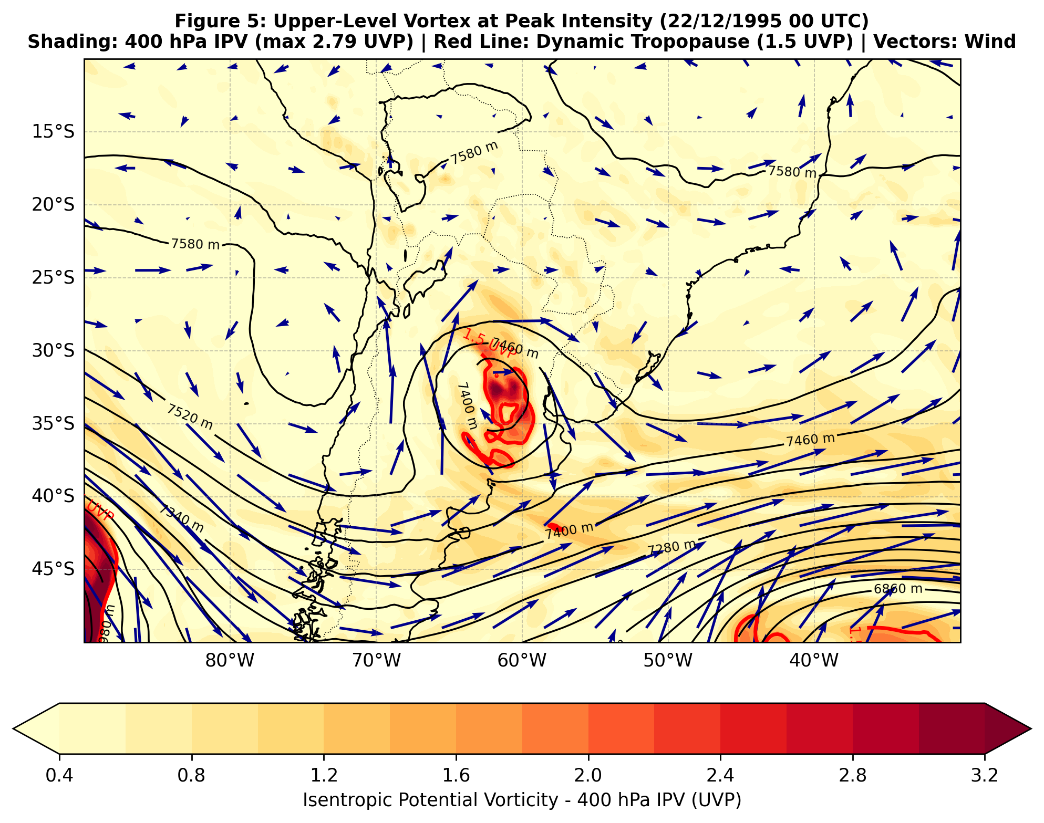
Figure 5. Ertel Isentropic Potential Vorticity (q in UVP, shaded) and geopotential height (black contours, interval 40 gpm) at 400 hPa on 22/12/1995 at 00 UTC from ERA5 reanalysis. The bold red line denotes the dynamic tropopause (q = 1.5 UVP). Vectors represent horizontal wind (m s⁻¹). Peak cyclonic IPV over SESA reaches 2.79 UVP.
The sustained convective activity and heavy precipitation along the Brazilian coast were governed by thermodynamic boundary-layer forcing. Figure 6 examines the lower-tropospheric structure at 925 hPa on December 23 at 00 UTC. An intense maritime tongue of high equivalent potential temperature (θe between 341 and 343 K; Figure 6b) was advected from the tropical Atlantic into the coastal sectors of Santa Catarina, Paraná, and Rio Grande do Sul by strong southeasterly/easterly maritime winds (10–15 m s⁻¹).
Under IPV theory, this high-θe tongue acts dynamically as an effective positive lower-boundary IPV anomaly (Hoskins et al., 1985). Although intermediate levels (850–600 hPa) exhibited lower PV values (precluding a single unbroken vertical 'tower' of stratospheric IPV), the strong low-level warm/moist advection directly below the diverging eastern flank of the upper-level vortex forced persistent synoptic-scale ascent, triggering catastrophic localized rainfall episodes and flash floods (Haas, 2002).
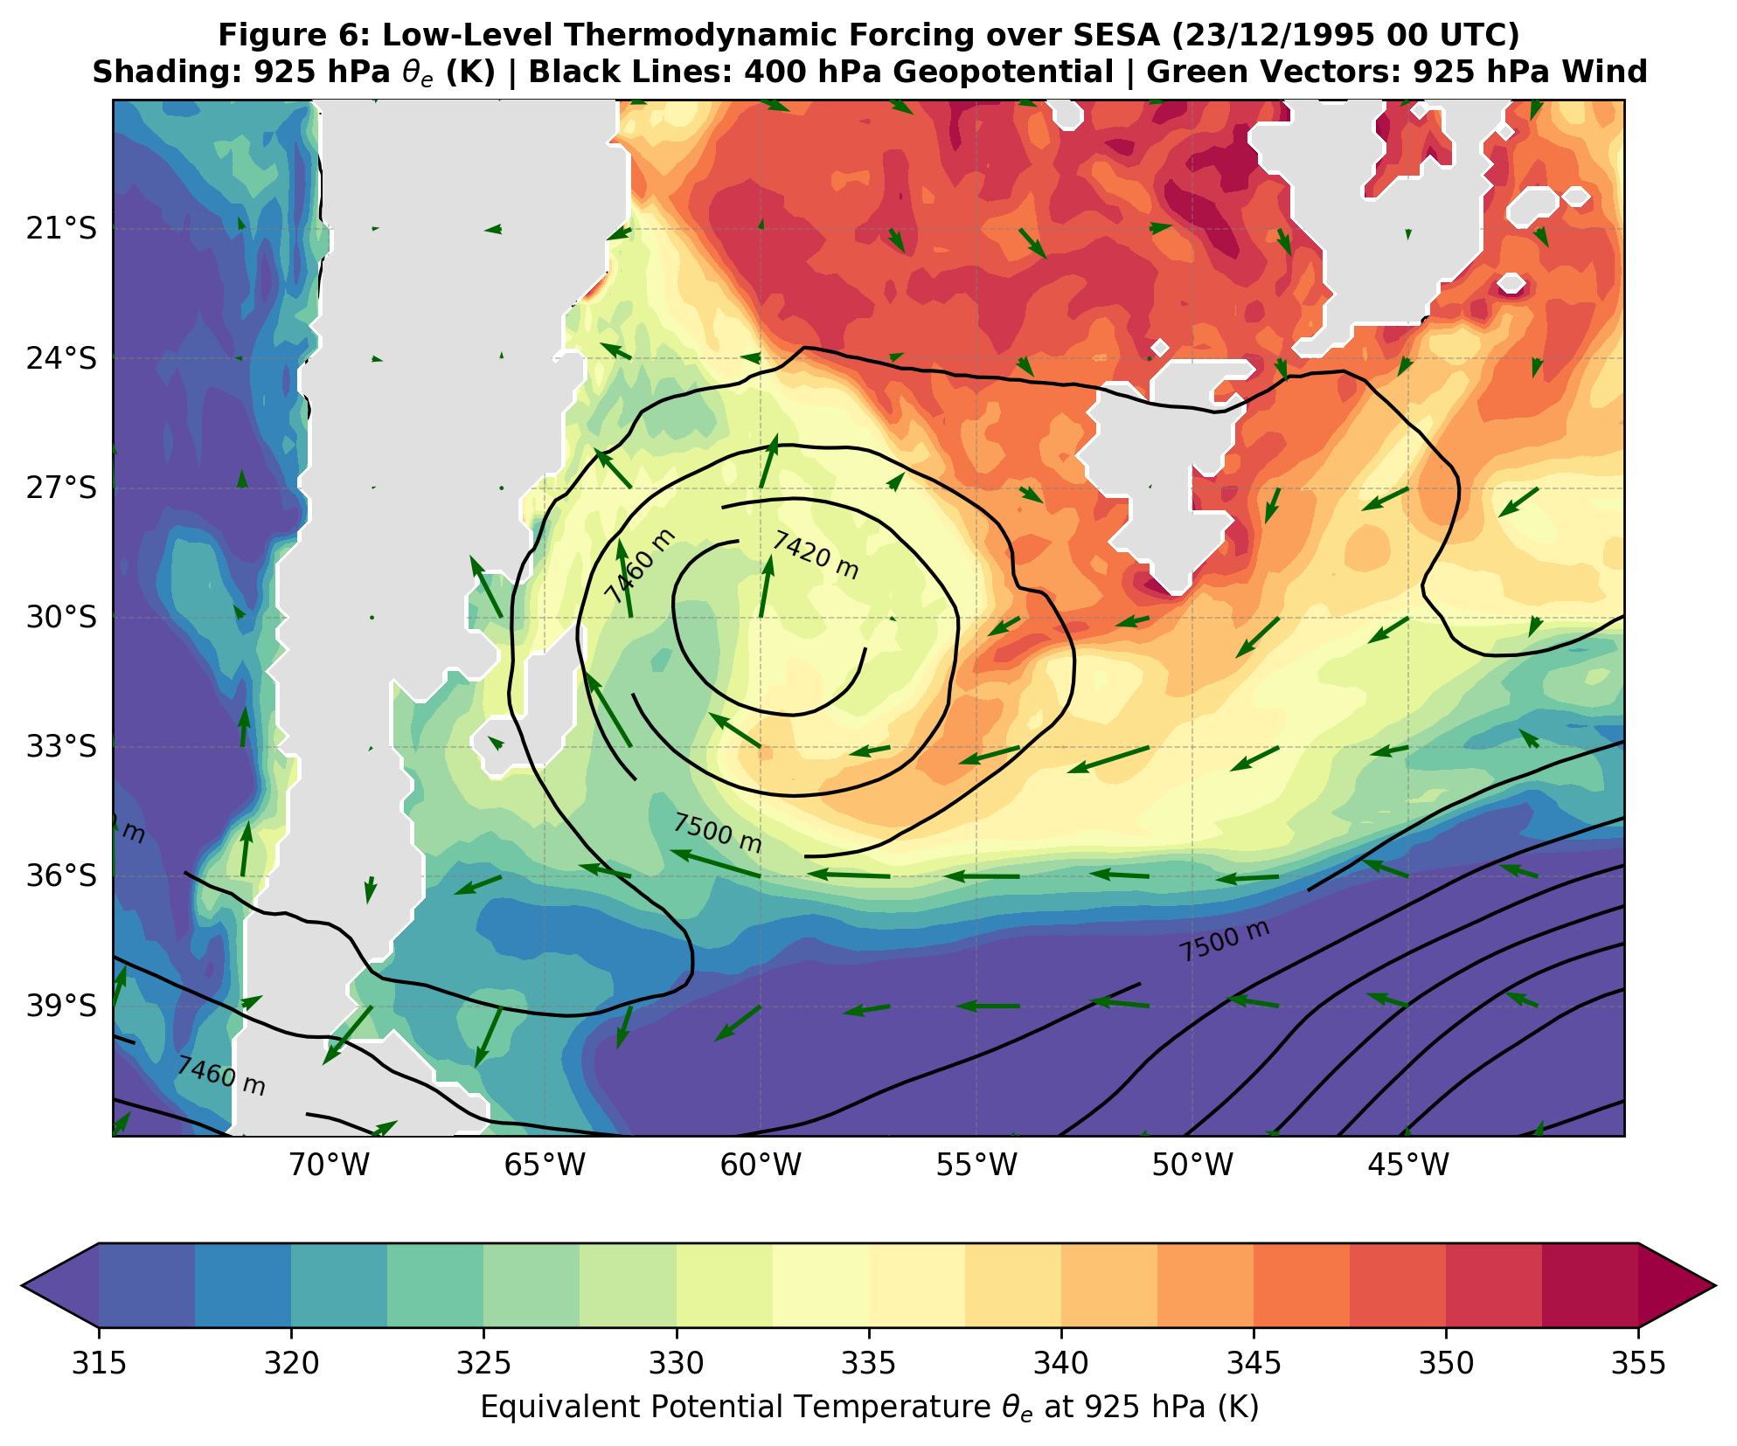
Figure 6. Lower-tropospheric thermodynamic and dynamic forcing on 23/12/1995 at 00 UTC from ERA5 reanalysis: (a) 925 hPa Ertel IPV (q in UVP, shaded) with horizontal wind vectors (m s⁻¹) and overlaid 400 hPa IPV contours (dashed magenta, 1.5 and 2.0 UVP); (b) 925 hPa equivalent potential temperature (θe in K, shaded and black contours, interval 2 K) highlighting the warm/moist maritime plume (mean 341–343 K) advected into the subtropical coast.
4.5 Anomalous Northeastward Trajectory and Barotropic Instability
From December 22 onwards, rather than following the climatological midlatitude path toward the east-southeast (Ambrizzi and Pezza, 1999), the UTCV underwent a sharp equatorward deflection, propagating slowly northeastward across southern Brazil toward the subtropics.
To examine the physical mechanism responsible for this unusual trajectory, barotropic instability diagnostics were computed across the upper-tropospheric jet layer (300–100 hPa layer mean, averaged between 70°W and 40°W). Figure 7 displays the 1D meridional profiles of zonal wind ū(y) and the absolute vorticity gradient Q_y(y) = β - d²ū/dy² on December 24 at 00 UTC, alongside the time-latitude Hovmöller evolution of Q_y from December 20 to 31.
On December 24 (Figure 7a,b), the subtropical jet was characterized by an intense westerly core (ū ~ 42 m s⁻¹) near 45°S and strong easterly/weak westerly flow to the north. This intense meridional horizontal wind shear created a pronounced local maximum in d²ū/dy² that overwhelmed planetary beta (β). Consequently, Q_y reversed sign, crossing zero at 28.8°S. According to Kuo (1949), the reversal of the meridional gradient of absolute vorticity within the fluid domain is the necessary condition for barotropic instability.
The Hovmöller diagram (Figure 7c) demonstrates that the condition Q_y ≤ 0 (demarcated by the bold black zero line) persisted continuously between 25°S and 32°S from December 21 to 28. Under barotropic instability, the synoptic perturbation extracts kinetic energy directly from the horizontal shear of the mean zonal jet. This energy extraction prevented the vortex from decaying rapidly as it propagated into the subtropics where planetary vorticity |f| diminishes, allowing the vortex to maintain its structural coherence.
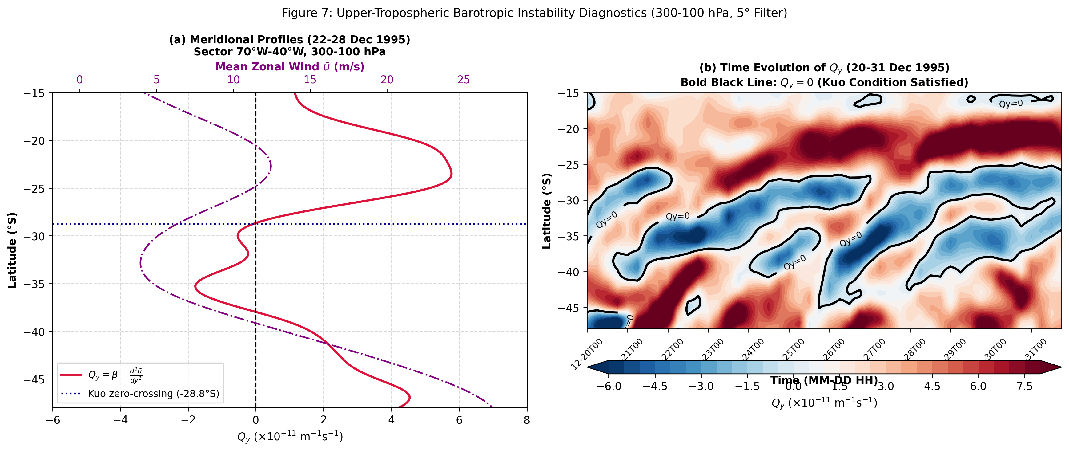
Figure 7. Upper-tropospheric barotropic instability diagnostics (300–100 hPa layer mean, 70°W–40°W) from ERA5 reanalysis: (a) Meridional profile of mean zonal wind ū (m s⁻¹) on 24/12/1995 00 UTC; (b) Meridional gradient of absolute vorticity Q_y = β - d²ū/dy² (10⁻¹¹ m⁻¹ s⁻¹) on 24/12/1995 00 UTC, showing sign reversal (zero crossing at 28.8°S); and (c) Time-latitude Hovmöller diagram of Q_y (10⁻¹¹ m⁻¹ s⁻¹) from 20 to 31 December 1995. The bold black line marks the zero contour (Q_y = 0), delineating the continuous fulfillment of Kuo's necessary instability condition.
The trajectory and intensity of the vortex center were objectively tracked in ERA5 using the 400 hPa geopotential anomaly field (z₄₀₀' = z₄₀₀ - z̄₄₀₀(φ)) with a constrained local search radius (~5.5°). As depicted in Figure 8a, the vortex center moved smoothly from 35.50°S, 69.00°W on December 21 at 00 UTC to 24.25°S, 54.00°W on December 28 at 12 UTC, progressing northeastward across Argentina, Uruguay, Rio Grande do Sul, Santa Catarina, and Paraná.
Figure 8b tracks the temporal evolution of the central geopotential anomaly (minimum reaching -153.6 m on December 22 at 00 UTC) and the maximum cyclonic IPV within the vortex core. The vortex sustained stratospheric IPV values (q > 1.5 UVP) continuously from December 21 through December 23, peaking at 5.66 UVP during the immediate post-Andean transition on 21/12 12 UTC and maintaining values of 2.79–3.37 UVP over SESA. Even during its subtropical decay phase between December 24 and 28, core IPV remained resilient (0.7–1.0 UVP), confirming that upper-level barotropic energy extraction sustained the cyclonic core long after surface dissipation.
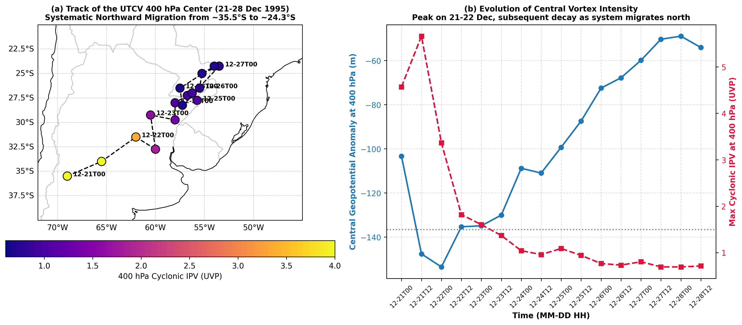
Figure 8. Objective tracking and intensity evolution of the UTCV at 400 hPa from 21 to 28 December 1995: (a) Trajectory of the vortex center (tracked via geopotential anomaly z₄₀₀') colored by maximum cyclonic IPV (UVP); and (b) Time series of central geopotential anomaly (gpm, left axis, blue line) and core maximum cyclonic IPV (UVP, right axis, crimson line). Source: ERA5 Reanalysis.
5. CONCLUSIONS
The extraordinary lifecycle, orographic transition, and anomalous northeastward propagation of the December 1995 Upper Tropospheric Cyclonic Vortex (UTCV) over Southeastern South America was comprehensively analyzed using the ERA5 reanalysis and NOAA GridSat-B1 satellite observations under the framework of Isentropic Potential Vorticity (IPV thinking). The principal conclusions are:
1. Baroclinic pre-conditioning over the Pacific: Before crossing the Andes, the descending stratospheric tropopause fold (q ≥ 1.5 UVP, core ~4.6 UVP at 400 hPa) coupled with a shallow boundary-layer cyclonic IPV anomaly dammed west of the Chilean coast (~78°W, below 850 hPa). The resulting westward vertical tilt facilitated mutual baroclinic amplification prior to mountain encounter.
2. Andean transit and lee cyclogenesis: Mountain transit induced severe vertical compression followed by lee stretching, causing the vortex axis to tilt eastward before recovering an upright equivalent barotropic column east of the Andes. This triggered intense regional lee cyclogenesis, with the thermal-orographic Northwestern Argentine Low (BNOA) reaching 989.6 hPa at 29.5°S, 66.5°W on 20/12 18 UTC, and local pressure at Mendoza dropping to a trough minimum of 995.7 hPa (1005.2 hPa at 21/12 00 UTC). While vigorous, the system did not satisfy the meteorological bomb criterion.
3. Coastal re-intensification over SESA: Upon reaching the subtropical coast on 22/12, 400 hPa cyclonic IPV reached a secondary peak of 2.79 UVP. Concurrently, maritime easterly flow advected a moist equivalent potential temperature tongue (θe = 341–343 K at 925 hPa) inland. This low-level thermodynamic perturbation coupled with upper-level divergence to sustain prolonged vertical motion and torrential rainfall episodes along the southern Brazilian coast.
4. Upper-level barotropic maintenance and northward track: The unusual northeastward trajectory from 35.5°S to 24.3°S was dynamically governed by upper-tropospheric barotropic instability across 300–100 hPa. Strong horizontal wind shear in the northern flank of the jet caused the meridional gradient of absolute vorticity Q_y = β - d²ū/dy² to reverse sign (crossing zero at ~28.8°S), satisfying Kuo's necessary instability condition continuously between December 21 and 28. This enabled the vortex to extract kinetic energy from the mean jet, preserving its coherent structure during its subtropical transit.
ACKNOWLEDGMENTS
The author expresses sincere gratitude to the National Council for Scientific and Technological Development (CNPq - Conselho Nacional de Desenvolvimento Científico e Tecnológico) for financial and research support. Grateful acknowledgment is also extended to the European Centre for Medium-Range Weather Forecasts (ECMWF) for providing the ERA5 reanalysis data and to the NOAA National Centers for Environmental Information (NCEI) for the GridSat-B1 satellite records.
REFERENCES
Ambrizzi, T.; Pezza, A. B. (1999). Cold waves and the propagation of extratropical cyclones and anticyclones in South America. Revista Geofísica, 51, 45-67.
Bjerknes, J.; Solberg, H. (1922). Life cycles of cyclones and the polar front theory of atmospheric circulation. Geofysiske Publikasjoner, 3(1), 1-18.
Bolton, D. (1980). The computation of equivalent potential temperature. Monthly Weather Review, 108(7), 1046-1053.
Charney, J. G. (1947). The dynamics of long waves in a baroclinic westerly current. Journal of Meteorology, 4(5), 135-163.
Davis, C. A.; Emanuel, K. A. (1991). Potential vorticity diagnostics of cyclogenesis. Monthly Weather Review, 119(8), 1929-1953.
Eady, E. T. (1949). Long waves and cyclone waves. Tellus, 1(3), 33-52.
Ertel, H. (1942). Ein neuer hydrodynamischer Wirbelsatz. Meteorologische Zeitschrift, 59, 277-281.
Funatsu, B. M.; Gan, M. A.; Rao, V. B. (2004). A case study of orographic cyclogenesis over South America. Atmósfera, 17(2), 91-113.
Gan, M. A.; Rao, V. B. (1994). The influence of the Andes Cordillera on transient disturbances. Monthly Weather Review, 122(6), 1141-1157.
Haas, R. (2002). Simulações da chuva orográfica associada a um ciclone extratropical no litoral sul do Brasil. Tese de Doutorado, Instituto de Astronomia, Geofísica e Ciências Atmosféricas, Universidade de São Paulo (IAG/USP), 168 pp.
Hersbach, H. et al. (2020). The ERA5 global reanalysis. Quarterly Journal of the Royal Meteorological Society, 146(730), 1999-2049.
Hirschberg, P. A.; Fritsch, J. M. (1991). Tropopause undulations and the development of extratropical cyclones. Part II: Diagnostic analysis and conceptual model. Monthly Weather Review, 119(2), 518-550.
Hoskins, B. J.; McIntyre, M. E.; Robertson, A. W. (1985). On the use and significance of isentropic potential vorticity maps. Quarterly Journal of the Royal Meteorological Society, 111(470), 877-946.
Iwabe, C. M. N.; Reboita, M. S.; Camargo, R. (2010). Estudo de caso de uma situação atmosférica entre 12 a 19 de Setembro de 2008 similar à do Evento Catarina. Revista Brasileira de Meteorologia, 25(3), 369-386.
Knapp, K. R.; Ansari, S.; Bain, C. L.; Bourassa, M. A.; Dickinson, M. J.; Khalid, A.; Levinson, D. H.; Bravo, N.; Magnusdottir, G. (2011). Globally gridded satellite observations for climate studies (GridSat-B1). Bulletin of the American Meteorological Society, 92(7), 893-907.
Kuo, H. L. (1949). Dynamic instability of two-dimensional nondivergent flow in a barotropic atmosphere. Journal of Meteorology, 6(2), 105-122.
Orlanski, I.; Katzfey, J.; Menendez, C.; Marino, M. (1991). Simulation of an extratropical cyclone in the Southern Hemisphere: Model sensitivity. Journal of the Atmospheric Sciences, 48(21), 2293-2312.
Reboita, M. S.; Iwabe, C. M. N.; da Rocha, R. P.; Ambrizzi, T. (2009). Análise de um ciclone semi-estacionário na costa sul do Brasil associado a bloqueio atmosférico. Revista Brasileira de Meteorologia, 24(4), 407-422.
Rossby, C.-G. (1940). Planetary flow patterns in the atmosphere. Quarterly Journal of the Royal Meteorological Society, 66(Suppl.), 68-87.
Sanders, F.; Gyakum, J. R. (1980). Synoptic-dynamic climatology of the 'bomb'. Monthly Weather Review, 108(10), 1589-1606.
Seluchi, M. E.; Saulo, A. C. (2012). Baixa do Noroeste Argentino e Baixa do Chaco: características, processos e sua influência sobre o tempo na América do Sul. Revista Brasileira de Meteorologia, 27(1), 49-60.
Thorpe, A. J. (1985). Diagnosis of balanced vortex structure using potential vorticity. Journal of the Atmospheric Sciences, 42(4), 397-406.

