**Summary of Training Record (for a two-week period)**

|  |  |  |
| --- | --- | --- |
| **Brief Description of Experience** | **From** | **To** |
| Literature study | 18-May | 22-May |
| Model Anti-sway crane system in MATLAB Simulink | 25-May | 29-May |
| Lab Safety Training | 26-May | 26-May |
|  |  |  |
|  |  |  |
|  |  |  |
|  |  |  |
|  |  |  |
|  |  |  |
|  |  |  |

**Comments by Organization Supervisor:**

______________________________________________________________________________________________________________________________________________________________________________________________________________________________________________________________________________________________________________________________________________________________________________________________________

Signature : ________________

Name : ________________

Designation: ________________

Date : ________________

**Training Record**

**(Elaborate on training outlined in summary)**

In the first two weeks, initial literature review was done in order to understand the motivation and current status of anti-sway crane controllers in the industry. The swaying angle of the load has been a well-known control problem in seaports and manufacturing industry. It has attracted numerous solutions; yet still require continuous effort to develop a reliable and applicable for future portable sea ports. Anti-swaying is now mostly conducted manually by a crane operator, even though many assistive technologies for anti-sway are available in the market. Anti-sway crane control is not an easy and straightforward task due to its underactuation, coupled dynamics, and presence of uncertainties in its working environment.

From our observation, there are at least three approaches that have been taken to address the problem, namely:

1. Open-loop control scheme by input shaping
2. Closed-loop control scheme with sway-angle estimator and feedforward controller
3. Closed-loop control scheme by disturbance observer and robust controllers

The variables in each approach were taken into account because many of the research papers are dealing with only a particular situation. Next, we define the container transfer process from the simplest stage by eliminating wind disturbance, length of rope variation, and container mass variation. The governing equations of the system were derived by using Langrangian equations of motion. And then we build the model of the system using MATLAB Simulink.

Organization Supervisor’s Initial: Dr. Chen Silu

NTU Tutor’s Initial: Assoc Prof Murukeshan Vadakke Matham

**Summary of Training Record (for a two-week period)**

|  |  |  |
| --- | --- | --- |
| **Brief Description of Experience** | **From** | **To** |
| Creation of initial anti-sway simulations in MATLAB Simulink | 02-June | 12-June |
|  |  |  |
|  |  |  |
|  |  |  |
|  |  |  |
|  |  |  |
|  |  |  |
|  |  |  |
|  |  |  |
|  |  |  |

**Comments by Organization Supervisor:**

______________________________________________________________________________________________________________________________________________________________________________________________________________________________________________________________________________________________________________________________________________________________________________________________________

Signature : ________________

Name : ________________

Designation: ________________

Date : ________________

**Training Record**

**(Elaborate on training outlined in summary)**

An open-loop control by input shaping method was designed and tested in MATLAB Simulink. The actuator’s input (trolley’s speed) will be given pre-defined as a function of initial and final state to achieve minimum transfer time while keeping the sway-angle under a tolerable range. This method was firstly developed from the experience of skilled crane operators and can be verified by a few simple equations. Theoretically this method will succeed as our simulation study had confirmed. However due to the lack of feedback, the application in real-time is limited to very small disturbance environment i.e. indoor crane operations.

Another control scheme consisting of a position controller and sway-angle feedforward compensator was built with MATLAB Simulink. A conventional PD (proportional-derivative) controller was assigned as position controller which takes in reference position from reference trajectory generator block and outputs desired velocity to the plant. In order to suppress undesirable swaying of the load, another velocity term which is proportional to the estimated sway angle is added based on superposition. The reference trajectory must be feasible in terms of the actuator’s constraints. Results showed satisfactory position tracking and the compensator is able to suppress sway angle significantly.

Organization Supervisor’s Initial: Dr. Chen Silu

NTU Tutor’s Initial: Assoc Prof Murukeshan Vadakke Matham

**Summary of Training Record (for a two-week period)**

|  |  |  |
| --- | --- | --- |
| **Brief Description of Experience** | **From** | **To** |
| Design of physical scaled-down testbed | 15-June | 26-June |
| Assembly of frame | 22-June | 26-June |
|  |  |  |
|  |  |  |
|  |  |  |
|  |  |  |
|  |  |  |
|  |  |  |
|  |  |  |
|  |  |  |

**Comments by Organization Supervisor:**

______________________________________________________________________________________________________________________________________________________________________________________________________________________________________________________________________________________________________________________________________________________________________________________________________

Signature : ________________

Name : ________________

Designation: ________________

Date : ________________

**Training Record**

**(Elaborate on training outlined in summary)**

We proposed to build a scaled down crane model as a test-bed. The proposed design is very simple consisting of aluminum frame as support, belt linear guide, one motor for trolley’s transverse motion, and another motor as a hoisting mechanism. A few parts which were not standard parts, have to be designed with specific dimensions using Solidworks. The standard parts are purchased from Misumi company.

One drawback of the design is that, because we are using string to suspend the load, sway angle verification cannot be easily measured (encoders at the trolley cannot be implemented). Common practice is to use the costly vision-based sensor. One paper has presented an alternative to measure the sway angle is by using an inclinometer. I proposed to use a high resolution ultrasonic sensor and by its geometry, sway angle can be calculated. However, the idea has not being verified.

Organization Supervisor’s Initial: Dr. Chen Silu

NTU Tutor’s Initial: Assoc Prof Murukeshan Vadakke Matham

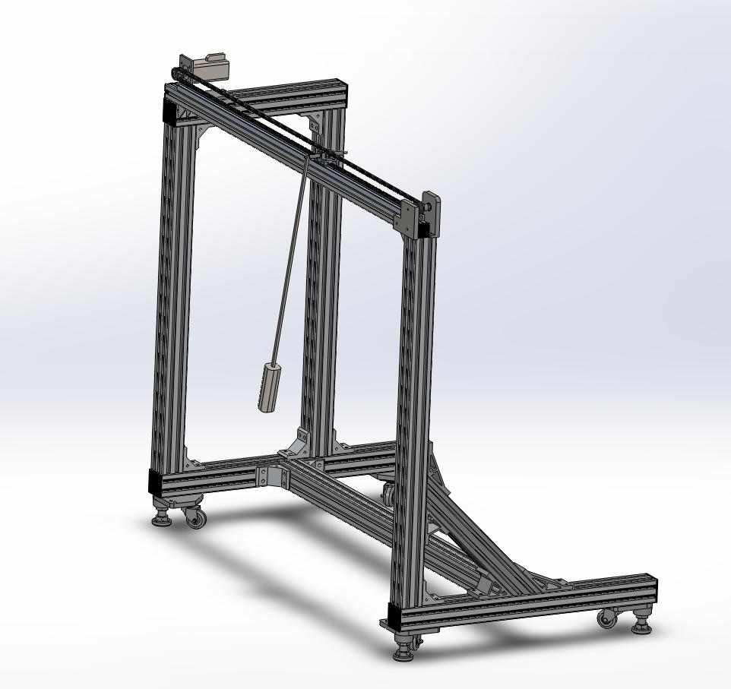

**Summary of Training Record (for a two-week period)**

|  |  |  |
| --- | --- | --- |
| **Brief Description of Experience** | **From** | **To** |
| Assembling electronics and cables | 29-June | 03-July |
| Literature study on State-observers | 06-July | 10-July |
|  |  |  |
|  |  |  |
|  |  |  |
|  |  |  |
|  |  |  |
|  |  |  |
|  |  |  |
|  |  |  |

**Comments by Organization Supervisor:**

______________________________________________________________________________________________________________________________________________________________________________________________________________________________________________________________________________________________________________________________________________________________________________________________________

Signature : ________________

Name : ________________

Designation: ________________

Date : ________________

**Training Record**

**(Elaborate on training outlined in summary)**

During these weeks, the mechanical parts were sent to fabrication or purchased. I spent my time in preparing the electrical components eg. motor drivers, motion interface, power cables, as well as getting introduced to LABView software.

In the practice, the usage of state observer or disturbance observer is very crucial because of the uncertain conditions of the seashore environment and absence of satisfactory sensors. There are two common types of state observers namely: Luenberger’s observer and Gopinath’s observer. To my knowledge, Gopinath’s observer is more complicated to be understood and hence has a more powerful representation that Luenberger’s observer. Basically Luenberger’s observer has some similarity with the stochastic Kalman filter.

Organization Supervisor’s Initial: Dr. Chen Silu

NTU Tutor’s Initial: Assoc Prof Murukeshan Vadakke Matham

**Summary of Training Record (for a two-week period)**

|  |  |  |
| --- | --- | --- |
| **Brief Description of Experience** | **From** | **To** |
| Progress Evaluation | 13-July | 13-July |
| Simulation on my own control scheme | 14-July | 16-July |
| Report Writing | 20-July | 23-July |
| End Project Presentation | 24-July | 24-July |
|  |  |  |
|  |  |  |
|  |  |  |
|  |  |  |
|  |  |  |
|  |  |  |

**Comments by Organization Supervisor:**

______________________________________________________________________________________________________________________________________________________________________________________________________________________________________________________________________________________________________________________________________________________________________________________________________

Signature : ________________

Name : ________________

Designation: ________________

Date : ________________

**Training Record**

**(Elaborate on training outlined in summary)**

Since the early weeks, my intention is to try developing a controller which may be implemented in real time system. Instead of controlling both trolley’s position and sway angle to indirectly control load’s position, I thought that it must be possible to control payload’s position directly. A block to estimate payload’s position is developed with trolley’s position and sway angle as an input. The payload’s position is taken as a feedback to the position controller instead of trolley’s position. The result shows that the payload is able to track the reference trajectory closely even in the presence of wind gust. On the other hand, the trolley keeps on oscillating around the reference trajectory at the initial and endpoint with relatively high speed. However, this trolley’s high speed may not be practically achievable. In order to lower down trolley’s speed to a reasonable boundary, we must decrease travelling velocity which contradicts the idea of rapid transfer. Hence, the middle solution is reasonable and can be compared with other control schemes.

During the final 2-weeks, we completed a few requirements towards the end of our Industrial Orientation. Firstly, our progress is being evaluated by Prof. Murukeshan. Then we prepare our report for both SIMTech and NTU as well as a presentation is done among Mechatronics research group in SIMTech.

Organization Supervisor’s Initial: Dr. Chen Silu

NTU Tutor’s Initial: Assoc Prof Murukeshan Vadakke Matham