Reinelle Jan C. Bugnot September 24, 2018
Progress Report 1
Groupmates: Nicolo Ramirez and Francis Laboguin

Handwriting Recognition Canvass using Neural Network

The first week of our project development primarily encompassed discussions and the solidification of our game plan as well as the review of related literature/projects that we could cite so as to not have to start from absolute scratch. As stated in our methodology flowchart, the group will begin working on the two functions, namely, the canvass and the handwriting recognition algorithm, separately; and then integrate afterwards. I am tasked to create the recognition algorithm—which I employed using a simple neural network.
So far, I have managed to create a simple handwriting recognition system in Octave 4.1.4 (which uses a similar language as Matlab). This is shown in Fig. 1. The machine learning algorithm was trained with 50 iterations using the free database of 30,000+ handwritten digits from the Modified National Institute of Standards and Technology (MNIST, http://yann.lecun.com/exdb/mnist/). The finished algorithm takes in 400 inputs describing the brightness of every pixel in a 20x20 pixel image of a handwritten sample. The algorith has an accuracy of 95.52%.
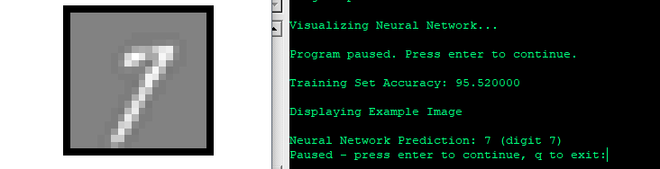

Fig.1. Test image of a '7' (left). Accuracy level of the NN algorithm and the prediction for the test image (right)
In light of this, our next agenda is to progress individually on our tasks, i.e., the canvass for my groupmates, and this algorithm for mine. As for my next task, I will begin studying on how to convert this matlab code into the C++ language, or perhaps write the matlab code to C++ directly—depending on how effective the code converter I find is. This, for me, will be the trickiest part of my task in our project.

