Reinelle Jan C. Bugnot October 15, 2018
Progress Report 4
Groupmates: Nicolo Ramirez and Francis Laboguin

Handwriting Recognition Canvass using Neural Network

This week, our progresses are centered around our individual tasks of slowly creating the structure of our algorithms; however, we are slowly trying to figure out how to integrate with each other's progresses. Francis has a baseline development accomplished using the wxWidget and Nicolo is slowly progressing in the development of the writing canvas. The primary challenge we are experiencing as a group is adapting with the C++ syntax in writing our codes.
The progress for this week has been quite significant, particularly in the extraction of the free mnist data from http://yann.lecun.com/exdb/mnist/ which is a collection of a total of 70,000 20x20 px grayscale images of handwritten digits (60k for training, 10k for testing). The images are originally stored in IDX format (.idx1-ubytes) which is a non-standard file format; therefore, cannot be opened by simple image viewing softwares. A code was written in python primarily using the function ord() which is a function that returns the integer representing the Unicode code point of the character when the argument is a unicode object, or the value of the byte when the argument is an 8-bit string . The training data and the training labels are then extracted to a seperate .txt file. Contingent to whatever our group eventually decides, the images are temporarily converted to binary by setting a threshold of 0.5. The result is written in a .txt file, a snippet is shown below.
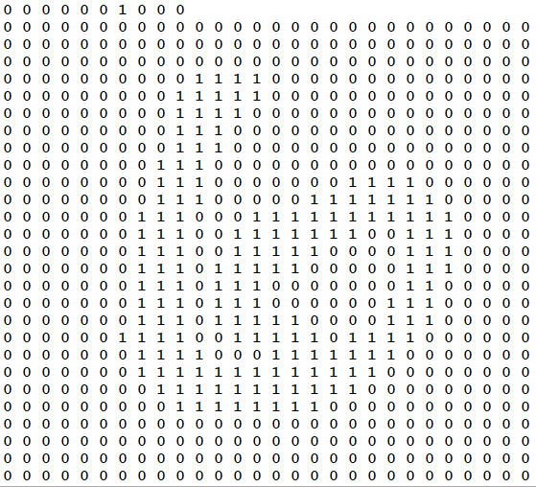
Fig. 1 The binary representation of the digit '6'. The label is a vector of zeros wherein the index of only '1' identifies the digit (top). The image is represented by a 400-dimensional array of 0's (none-written) and 1's (written). The array is formatted in order to visualize the digit '6'.
Having done this, I might be able to eventually integrate with Nicolo and FB's work, depending on how I progress in the writing of the learning algorithm. As a group, as soon as we are able to make the writing functionality work, we will then test if we can output the pixel data in a format compatible with the reading algorithm.

