Kyle Reinholt

OOAD – HW2

2/15/19

1.

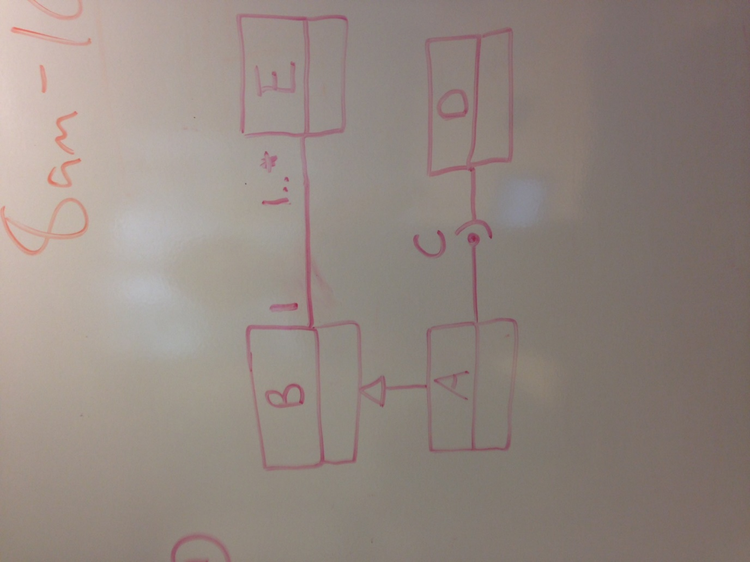2.

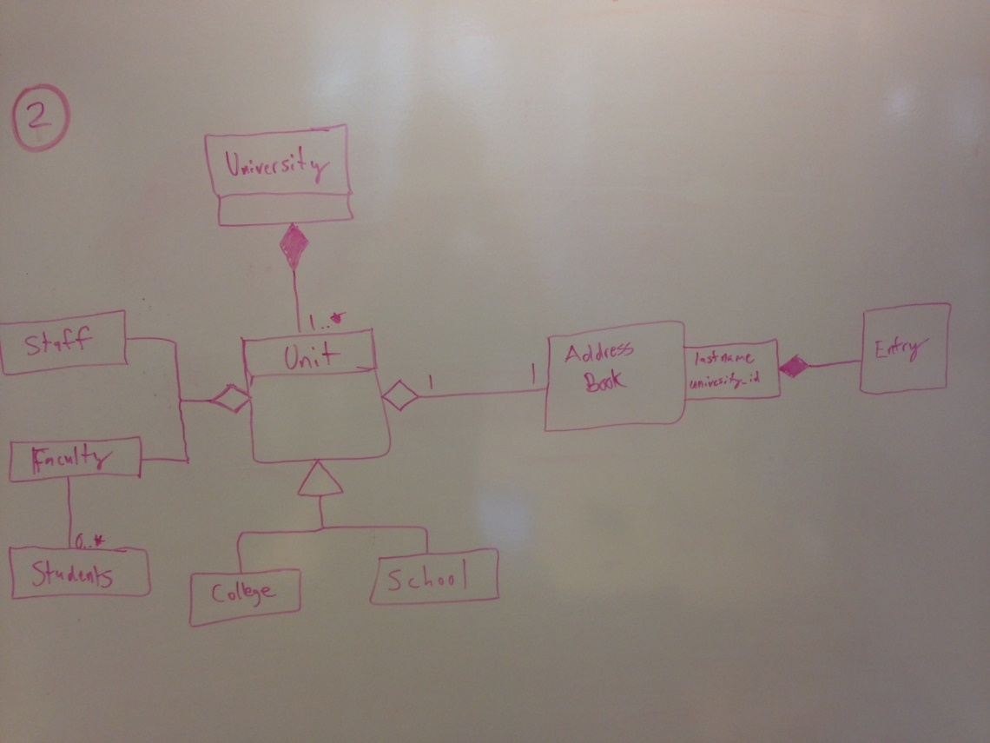3.

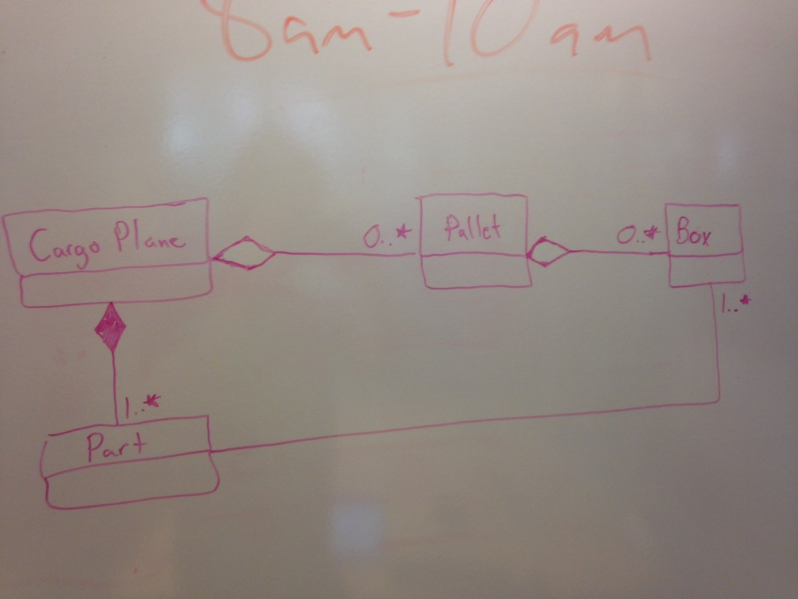4. The answer is no. For D to access B through C, B would have to implement C. Since A is a subclass of B, we could access some similar features of B. If everything about B were completely public we could access B from anywhere.

5. The engineer has violated the “Design by Contract” constraint. The main reason we use inheritance is to reduce the amount of code reuse. The repercussions this has is that now we must implement a getArea() method specific to the other shape subclasses and this somewhat defeats the purpose of inheriting in the first place.