OsSim User's Manual

Table of Contents

Topic Page #
------------------------------------------------------------------------------------------------------
1. Overview of the OS 1
2. Summary of Commands 2
3. Detailed Description of Each Command 3
- help 3
- history 4
- date 4
- version 4
- directory 5
- alias 6
- batch 6
- quit 7
4. Summary of Error Messages 8
5. Index 9

OVERVIEW OF OsSim
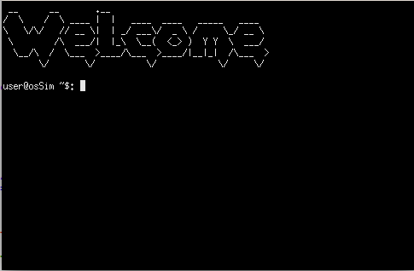
-----------------------------------------------------------

The name of this OS simulator hints at its purpose. OsSim stands for “Operating System Simulator”. The purpose of OsSim is to create an implementation of an operating system using a high level programming language. OsSim is a command line version of an operating system that allows you type in commands to navigate through the file system and perform jobs. It has the same functionality as a graphical user interface that you are used to, however, you just have to learn the commands inside this operating system in order to do tasks. Luckily, this manual explains exactly how to use OsSim. Command line interfaces will be a little rough at first, but once you learn how to operate the system using it, you will fall in love with the command line and never use a graphical interface again.

----------------------------------------------------------

SUMMARY OF COMMANDS

As OsSim is now, here are all of the commands that the system will recognize:

================================================================================Command | Summary
================================================================================help | Display a list of all commands in the system
-------------------------------------------------------------------+-------------------------------------------------------------------history | Display a list of all of the user input received
-------------------------------------------------------------------+-------------------------------------------------------------------date | Show the current date and time to the user
-------------------------------------------------------------------+-------------------------------------------------------------------version | Displays the current version of the OsSim you are on
-------------------------------------------------------------------+-------------------------------------------------------------------directory | Prints a list of all files in the OsSim directory
-------------------------------------------------------------------+-------------------------------------------------------------------alias <old command> <new command> | This allows you to rename commands
-------------------------------------------------------------------+-------------------------------------------------------------------
batch <filename.ext> | Run multiple commands from a file at once -------------------------------------------------------------------+------------------------------------------------------------------quit | Exit OsSim
================================================================================

DETAILED DESCRIPTION OF EACH COMMAND

Command Syntax - - - - > Description
================================================================================
help - - - - > This command displays a help menu containing a brief descprition of each command along with the syntax for the command.

Question: When do I use the help command?
Answer: Whenever you forget a command or need to review the syntax for that command.

Example of use:

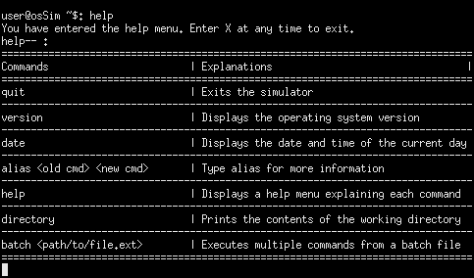

Command Syntax - - - - > Description
================================================================================
history - - - - > This command displays a list of all of the commands the user has input into the system. The user can cycle through each command by pressing enter. It outputs the command in order from most
recent to least recent.

Question: When do I use the history command?
Answer: Whenever you want to see what commands you have used during your OsSim session.

Example of use:

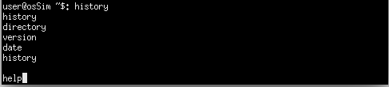
Command Syntax - - - - > Description
================================================================================
date - - - - > This command displays the current date and time to the user.

Question: When do I use the date command?
Answer: Whenever you want to see what day it is or you need to know the time.

Example of use:

Command Syntax - - - - > Description
================================================================================
version - - - - > This command displays the current version of the OsSim you are using

Question: When do I use the version command?
Answer: Whenever you want to see what version of OsSim you are using.

Example of use:

Command Syntax - - - - > Description
================================================================================
directory- - - - > This command displays all of the folders and files from the OsSim root directory. It displays 10 files at time. You can press enter to display the next 10 files in the event there is 10 or more folders or files in the directory.

Question: When do I use the directory command?
Answer: Whenever you want to see want to see a list of files and folders in the OsSim root directory.

Example of use:

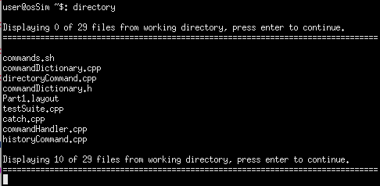

Command Syntax - - - - > Description
================================================================================
alias <old command> <new command> - - - - > Alias changes an old command to a new command.

Question: When do I use the alias command?
Answer: When you want to change a command to a new name with the old commands functionality.

Example of use:

Command Syntax - - - - > Description
================================================================================
batch <filename.ext> - - - - > The batch command reads in a file from the root OsSim directory and executes all of the commands in the file. Each command in the file should be separated by the '/' character. For example (contents of batch file): history / date / version
After the command executes, it will display a message notifying the user how many commands were successfully executed.

Question: When do I use the batch command?
Answer: When you want to execute a list of commands the you have saved in a file, you can use the batch command to read in the file and it will automatically execute each command.

Example of use:

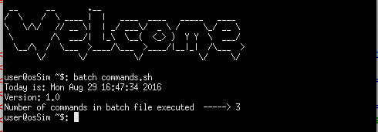

Explanation of Error Messages

Error Message - - - - > Description
================================================================================
' ' is an invalid command - - - - > Whenever the user inputs a command that is invalid, the system will inform you when this happens.

