User manual

Software manual for Room Reservation System (RRS)

Error 420, inc: Denny Hood, Kyle Reinholt, Courtney Purtell, Michael Adedigba, Trevor Walker

CS 410 – Software Engineering

-Table of Contents-

1. Introduction – What is the Room Reservation System?
   1. Purpose
   2. Compatibility
2. The User Interface
3. Administrators
   1. Privileges
   2. Approving Reservations
4. A tour of RRS
   1. The login screen
   2. Building selection
   3. Date selection
   4. Time selection
   5. Room selection
   6. Other pages
5. Sources

-Introduction-

What is the room reservation system?

The Purpose

Room Reservation System is a piece of software created by Error 420, inc. to fulfill the requirements of a college software engineering mastery course. Room Reservation System (abbreviated RRS) is a flexible piece of software that fulfills any campus’ needs for universal consolidation of room occupancy statuses throughout various buildings or properties. In other words, you will always know when somebody will be using a room anywhere on campus!

Compatibility

RRS functions properly on any platform that has access to a web browser. For maximum functionality, the following platforms have been tested for RRS compatibility.

Known/Tested platforms:

-Apple Safari

-Google Chrome

-Internet Explorer

-RRS User Interface-

What do all of these buttons do?

The labelled picture and explanations below will help to demonstrate what you will see on a typical RRS webpage.

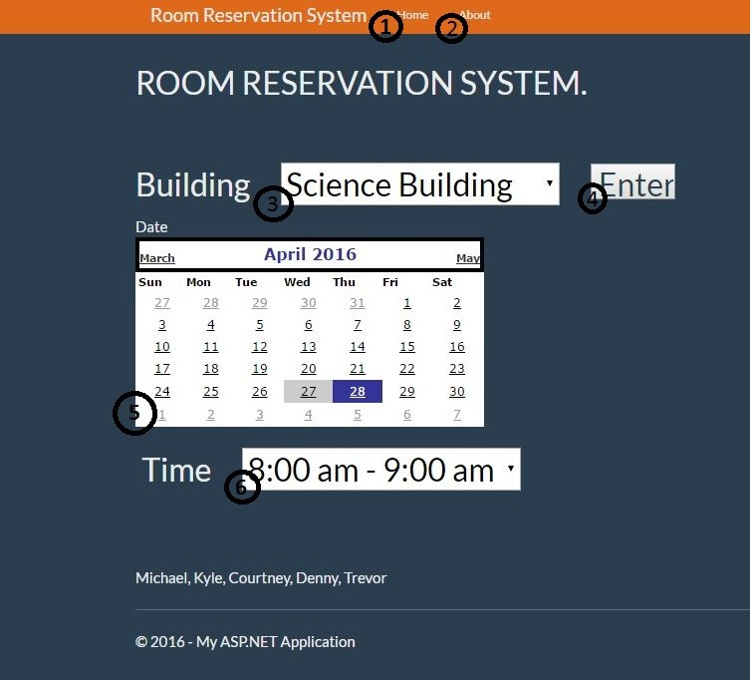

1. The Home button takes you to the RRS homepage, where you can access RRS functions.
2. The about button will take you to the RRS readme page.
3. A drop-down menu. Click on this to pull up a menu of various options.
4. Buttons can be clicked to perform various functions, usually entering a selection.
5. The integrated calendars allow you to select a date when prompted.
6. RRS operates off of the standard AM/PM timekeeping method.

-Administrators-

What is the difference between a standard user and an administrator?

Administrator Privileges

An administrator is a user that is designated as the head of a set of rooms or buildings. Administrators are necessary for the process of room reservation. They are the only users that are required to log in. Administrators can reserve rooms at will, as well as cancel reservations that were put in place at an earlier time.

Approving Reservations

When a non-administrator user wishes to reserve a room, they must send an email to an administrator so that they can handle the request. The emails for the administrator(s) in charge of each specific room is listed on the rooms table. When the administrator approves the request, the room will be listed as reserved and unavailable in the rooms table.

-A Tour of RRS-

What can each page do?

The following section will give a short synopsis of the functionality of each of the primary pages you will encounter when using RRSDB.

The Login Screen

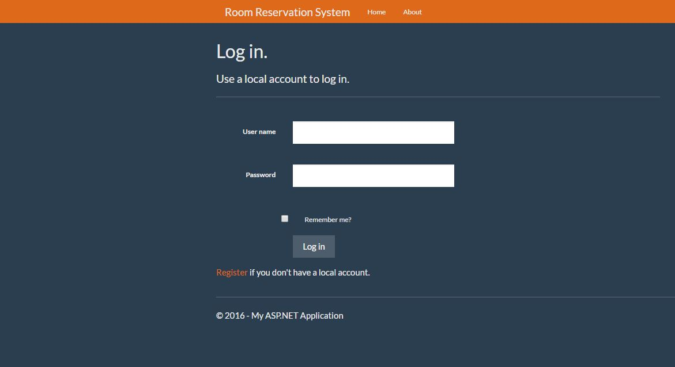

The login screen is where administrators can log in. Enter the user name and password in the designated fields and press log in. There is also a registration link below the login button so users can register.

Building Selection Screen

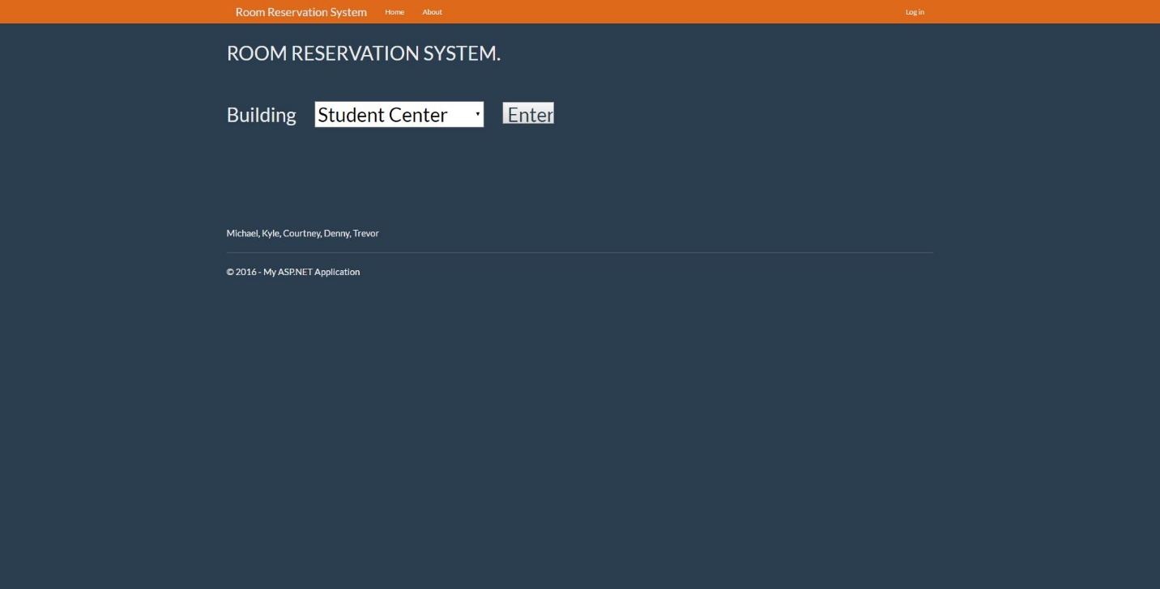

This screen is what you will see as RRS’ ‘home’ screen. To start the process of checking on or reserving rooms, use this screen’s drop-down menu to select the building you wish to check on, and then press enter.

Date Selection

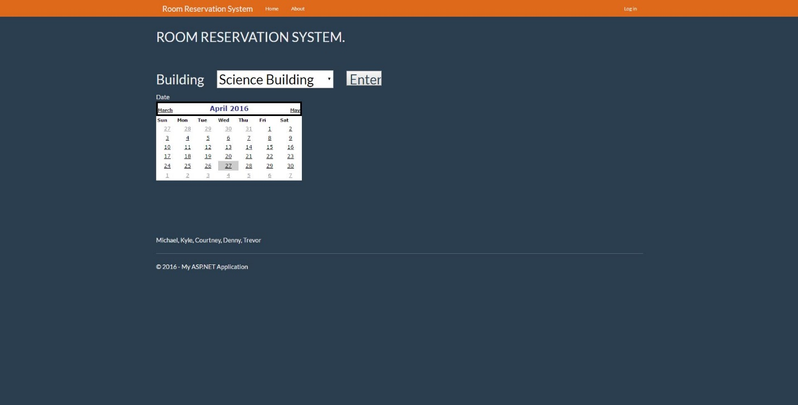

After choosing a building, the calendar tool will appear. Select the date that you would like to check on. Your selection will be highlighted in blue and RRS will proceed to the next screen.

Time Selection

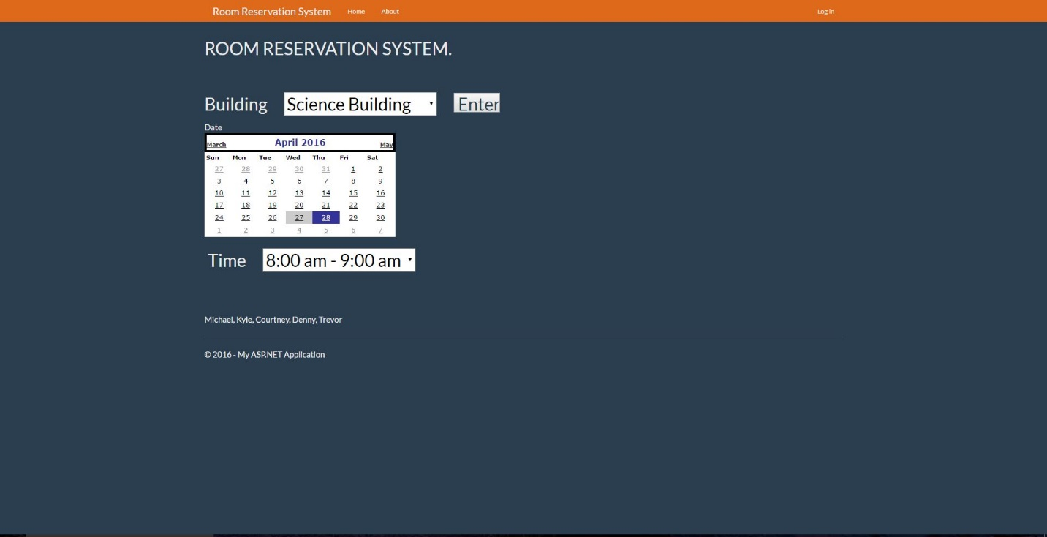

The next screen in sequence will allow the user to select a time range that they wish to check on. These 3 pieces of information are all that RRS needs to determine which rooms suit your search. Selecting a timeframe and pressing enter will launch the room search and bring you to the next screen.

Room Selection

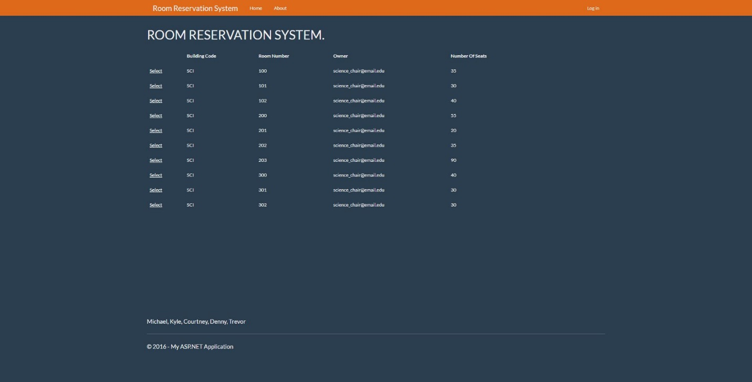

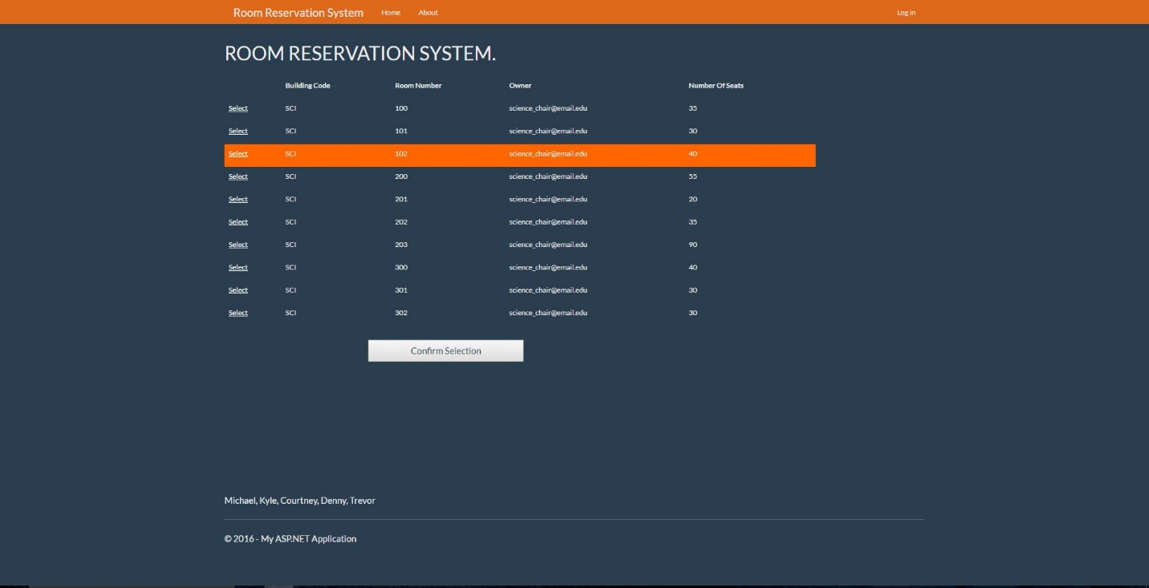

This screen displays the table of rooms that meet your search parameters. From here, a standard user can see if a room is available or booked, and an administrator (the second of the pictures) can select a room to reserve or cancel. Press home to exit this page.

Sources and Acknowledgements

Room Reservation System was created by Error 420, inc. working out of Concord University. The team consists of Kyle Reinholt, Michael Adedigba, Trevor Walker, and Courtney Purtell, led by Project Manager Denny Hood, under the supervision of Professor Lonnie Bowe.

Credit to the following programs:

-Python 3 & IDLE

-Microsoft Visual Studio

-SQLite