| Project Proposal | *Jan 27, 2022* |
| --- | --- |
| XFit Exercise Web App | **CAPSTONE PROJECT** |

*By Reiniel Fernandez, Javier Herdocia, Mario Orellana, and Gustavo Zapata*

# Overview

XFit is a web application that will help users plan workout routines according to the availability of equipment they have at home. Our application will help users find and learn new exercises that they can apply at home in addition to organizing weekly routines that can help them find a satisfying and consistent exercise pattern that works best for them.

Users may struggle to understand what kind of exercises they can perform with equipment and finding out which ones they could use can be time consuming and confusing, especially for beginners. Even experienced users who primarily workout at home could struggle to organize their routines at home.

XFit offers a convenient and efficient way of allowing users to find what type of exercises they can do based on the equipment they currently have in their possession. Each exercise will have a description and example of how they can be done and will be also filtered for users who are either experienced or beginners to help them have a more comfortable experience using the application.

# Objective

Many applications similar to XFit provide guidance to users on what exercises they can do, but they fail to provide needed customization options to users who may not have specific types of equipment at home. They also may present beginning users with more difficult to perform exercises that could risk them injuring themselves.

XFit will filter exercises from an existing database of available exercises based on User profile configurations. Users who are beginners and have only dumbbells for example, will see exercises that meet User specifications in which they can add to a weekly checklist routine and customize each exercise.

Our objective is to create a fitness tracker app that users can use to dedicate themselves to a weekly workout routine. They will have an easier time to keep track of useful exercises of which users can add to their routine and keep them logged as guidance. This will achieve our goal to make the app useful to beginners starting out and for experienced users.

# Environment

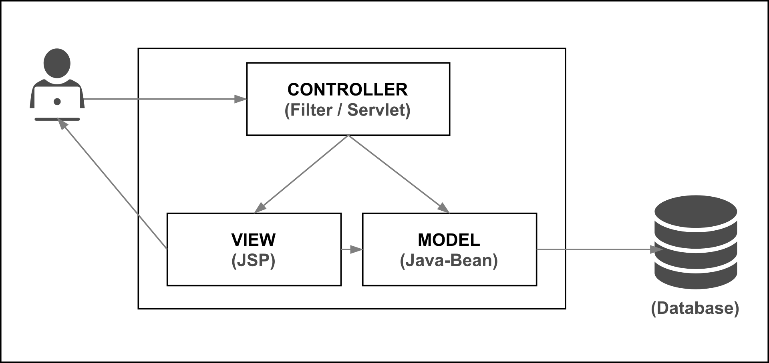

* The languages XFit will be developed with includes:
  + Java
  + MySQL
  + Tomcat Apache
* The type of charts expected to be used:
  + Class diagram UML
  + Use case diagrams
  + Architectural Diagram
  + ER Diagram
  + Domain Model
  + Site Map
  + Site Mockup
  + Sequence Diagrams
* Netbeans

# 

# Implementation

The type of SDLC model we will be using will be an Agile methodology. The development will be broken up into 3 sprints that will cover the scope of this application.

System extensions:

* Java.Sql
* Javax.servlets
* Tomcat Apache
* JSTL

# Deliverables

* Project Management Plan
* Responsibility Matrix
* SRS
* SDS

# Features

## ***Users***

* New Users choose to register, and must fill out a profile.
* Existing Users login using their UserName OR Email and password.
* User configures profile
  + User Name
  + Password
  + Email
  + Weight/Height
  + Equipment
  + Experience

## 

## Main Page

* On the main page, users can choose whether to view all existing exercises or choose “Planner” to customize routines.
* By choosing “Exercises”, Users can scroll through the database consisting of all available exercises unfiltered.

## Exercises

* Each exercise on the list and on the weekly planner will include a variety of attributes.
* A description of the exercise and what parts of the body it works on the most.
* A suggested stretching before the given exercise.
* A diagram of how the exercise is performed describing the steps.
* The suggested difficulty of the exercise.
* Equipment needed for the exercise.

## Planner

* By choosing “Planner”, User can customize weekly workout routine by clicking the day
* Exercise options come from an existing database from which user can choose from
* Exercise options available to add to routine are filtered based on what equipment the user has on their profile.
* Exercises are also filtered based on the user's experience level they configured on their account settings.
* In addition, users can create a custom exercise that may not be available in the database of exercises.
* Users can customize reps and cycles within each exercise.
* Users can check off each day which exercises they’ve completed.
* Daily Summary will be presented to the user based off of exercises completed in the day.
* Daily summary will include amount of calories lost based on completed exercises