**–––––––––––––––––––––––––––––**

Software Requirements Specification

**for**

**XFit Exercise App**

**Version 1.0**

**Prepared by**

**Reiniel Fernandez**

**Javier Herdocia**

**Mario Orellana**

**Gustavo Zapata**

**Group 3**

**2022-01-29**

# Table of Contents

**Table of Contents** **2**

**Revision History** **4**

**1. Introduction** **5**

1.1 Purpose 5

1.2 Scope 5

1.3 Definitions/Abbreviations 6

1.4 References 6

1.5 Technologies 6

1.6 Overview 6

**2. Overall Description** **7**

2.1 Use-Case Model 7

2.2 Activity Diagram 8

2.3 Web Architecture diagram 9

2.4 ER Diagram 10

2.5 Architecture Diagram 10

2.6 Data Dictionary 11

2.6.1 User 11

2.6.2 Exercise 11

2.6.3 FavoriteExercise 11

2.6.4 Plan 12

2.6.5 Muscle 12

2.6.6 ExerciseMuscle 12

2.6.7 Equipment 12

2.6.8 ExerciseEquipment 13

2.6.9 UserEquipment 13

2.6.10 Image 13

2.6.11 ExerciseImage 13

2.6.12 EquipmentImage 13

2.7 Assumptions and Dependencies 14

**3. Specific Requirements** **15**

3.1 Use-Case Reports 15

3.1.1 Use Case 1: Logging in as User 15

3.1.2 Use Case 2: Creating New Account 16

3.1.3 Use Case 3: Viewing available Exercises 19

3.1.4 Use Case 4: Configuring User Account 21

3.1.5 Use Case 5: Adding Exercise to a day in the Planner 24

3.1.6 Use Case 6: User Adding Custom Exercise 25

3.1.7 Use Case 7: Editing Custom Exercise 27

3.1.8 Use Case 8: Logging out 29

3.1.9 Use Case 9: Today’s Workout 30

3.2 Class diagram 31

3.3 Supplementary Requirements 31

# 

# Revision History

| **Name** | **Date** | **Reason For Changes** | **Version** |
| --- | --- | --- | --- |
| Javier Herdocia | 1/27/2022 | Initial Draft | 1.0 |
| Javier Herdocia | 3/2/2022 | Rough draft | 1.1 |
| Javier Herdocia | 3/21/2022 | Revision | 1.2 |
| Javier Herdocia | 4/7/2022 | Final | 2.0 |

# 1. Introduction

## 1.1 Purpose

To create a product to provide guidance to users on a convenient and efficient way of allowing users to find what type of exercises they can do as well as create and plan workout routines based on the equipment they currently have in their possession. The users who will use this application will be users who are either experienced athletes or beginners who have just started working out, as well as users who are only looking to lose weight through fitness.

## 1.2 Scope

* New users will be able to register and fill out a profile upon starting the application for the first time.
* Existing users will be able to sign in using their Email and password
* Users are able to change the content in their profile such as:
  + User Name
  + Password
  + Email
  + Weight/Height
  + Equipment
* Will list each exercise for the user and will have a weekly planner that will include a variety of attributes that the user can customize
* Will suggest the user to stretch first before exercise.
* Will display the equipment needed for specific workout routines.
* Planner will allow users to customize the workout routines for the day or week depending upon preference.
* Users will be able to customize reps and cycles within the exercises they plan to do.
* Users will be able to create an exercise that may not be available in the database.
* Users can check off completed exercises in today's exercise feature.
* Each application featured exercise will contain detailed information and guidance with text and pictures on how to perform a given exercise.
* A daily summary will display the number of exercises they have completed in the current day.

## 1.3 Definitions/Abbreviations

* HTTP - HyperText Transfer Protocol
* HTML - HyperText Markup Language
* JSP - Java Server Pages
* NavBar - Navigation Bar
* DB - Database
* ER - Entity Relation
* PK - Primary Key
* FK - Foriegn Key
* CK - Composite Key
* JPA - Java Persistence API

## 1.4 References

* SRS_Sample.doc

## 1.5 Technologies

* Java
* Servlets/JSP
* Apache Tomcat
* JPA (Hibernate)
* MariaDB (SQL)
* VSCode
* Docker
* Git

## **1.6 Overview**

XFit is a web application that will help users plan workout routines according to the equipment they have at their home. The application will help users find and learn new exercises that they can apply at home in addition to organizing weekly routines that can help them find a satisfying and consistent exercise pattern that works best for them. Each exercise will have a description and example of how they can be done and will also be filtered for users who are either experienced or beginners who are just starting out.

# 

# 2. Overall Description

Xfit is a web page executing on a web server and it is connected to a database of exercises in order to create workout routines and consistent exercise patterns. XFit accepts and processes requests from end users and system administrators, besides the local server database (that holds the exercises). The system is expected to have a Web user Interface for customers.

## 2.1 Use-Case Model

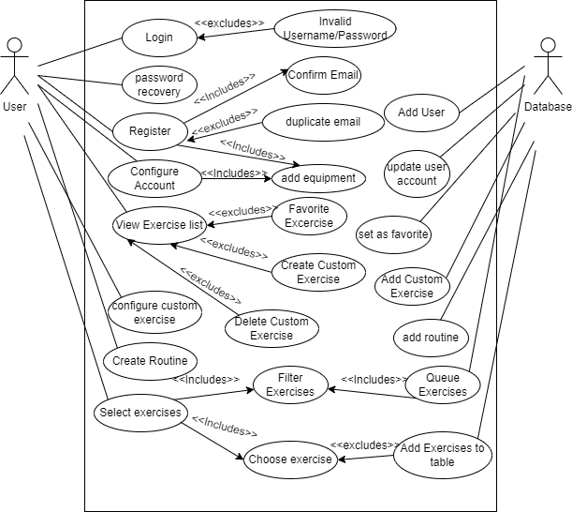

## 2.2 Activity Diagram

## 2.3 Web Architecture diagram

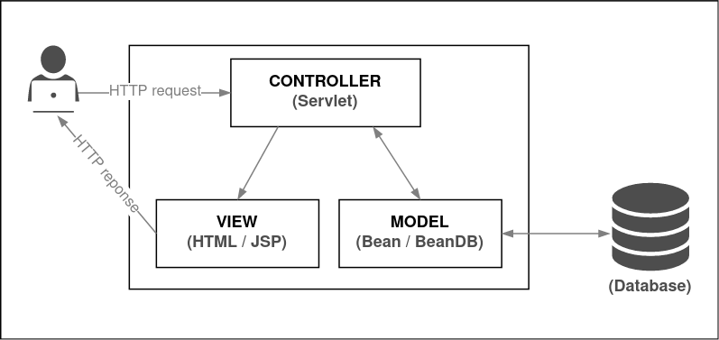

## 2.4 ER Diagram

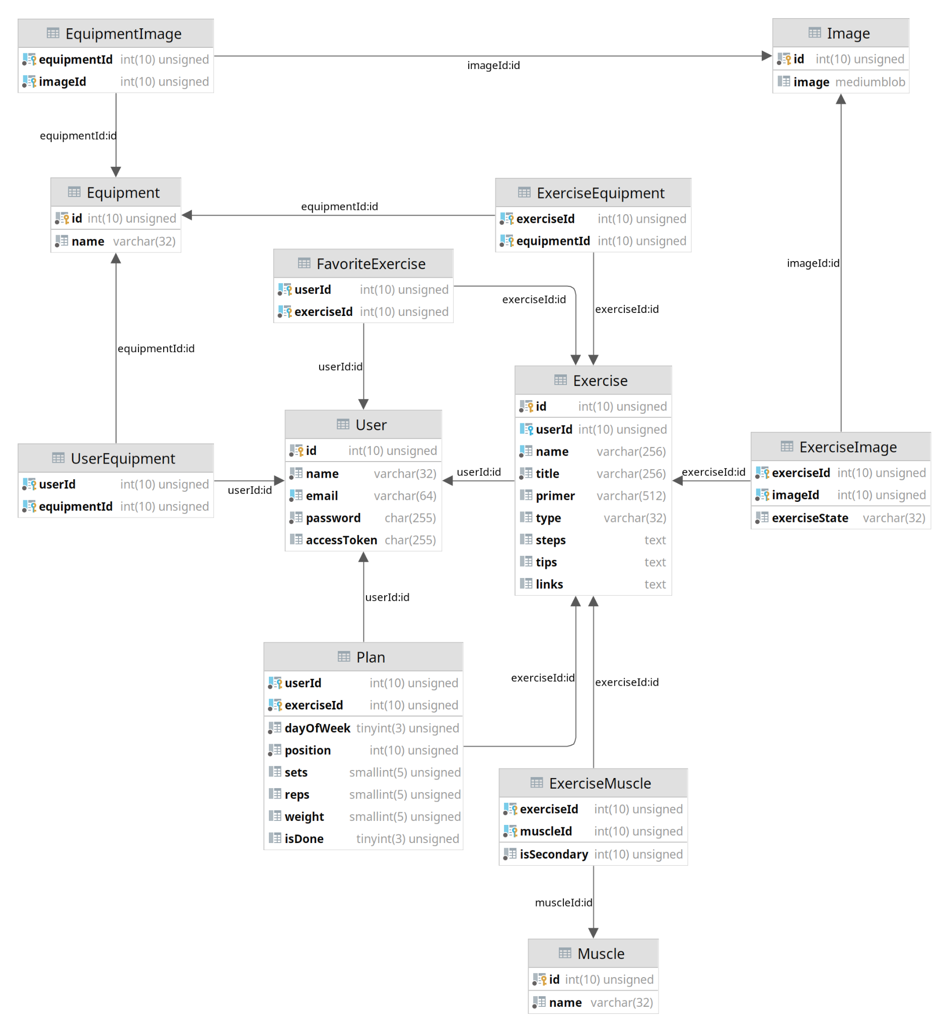

## 

## 2.5 Architecture Diagram

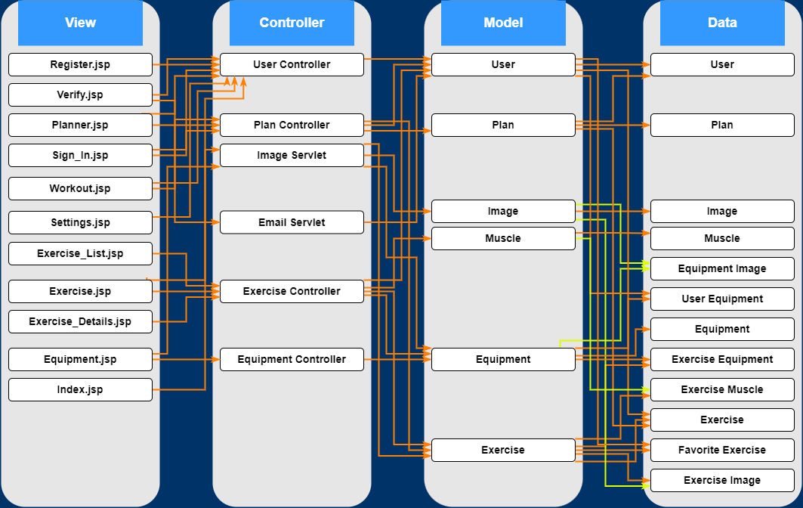

## 2.6 Data Dictionary

## 2.6.1 User

| **User** | | | | | | |
| --- | --- | --- | --- | --- | --- | --- |
| **K** | **NAME** | **TYPE** | **SIZE** | **NULL** | **DEFAULT** | **COMMENTS** |
| PK | id | int | 10 | NO |  |  |
|  | name | varchar | 32 | NO |  |  |
|  | email | varchar | 64 | NO |  | Used to access accounts. |
|  | password | char | 255 | NO |  |  |
|  | accessToken | char | 255 |  | NULL | Used to start a session with cookies. |

## 2.6.2 Exercise

| **Exercise** | | | | | | |
| --- | --- | --- | --- | --- | --- | --- |
| **K** | **NAME** | **TYPE** | **SIZE** | **NULL** | **DEFAULT** | **COMMENTS** |
| PK | id | int | 10 | NO |  |  |
| FK | userId | int | 10 |  | NULL |  |
|  | name | varchar | 256 | NO |  |  |
|  | title | varchar | 256 | NO |  |  |
|  | primer | varchar | 512 |  | NULL | Small description/summary of exercise. |
|  | type | varchar | 32 |  | NULL |  |
|  | steps | text |  |  | NULL |  |
|  | tips | text |  |  | NULL |  |
|  | links | text |  |  | NULL | Links or references. |

## 2.6.3 FavoriteExercise

| **FavoriteExercise** | | | | | | |
| --- | --- | --- | --- | --- | --- | --- |
| **K** | **NAME** | **TYPE** | **SIZE** | **NULL** | **DEFAULT** | **COMMENTS** |
| CK | userId | int | 10 | NO |  |  |
| CK | exerciseId | int | 10 | NO |  |  |

## 2.6.4 Plan

| **Plan** | | | | | | |
| --- | --- | --- | --- | --- | --- | --- |
| **K** | **NAME** | **TYPE** | **SIZE** | **NULL** | **DEFAULT** | **COMMENTS** |
| CK | userId | int | 10 | NO |  |  |
| CK | exerciseId | int | 10 | NO |  |  |
|  | dayOfWeek | tinyint | 3 | NO |  | Expressed as an integer 0-6 (Sunday-Saturday) |
|  | position | int | 10 | NO |  | Position in the list for a specific day. |
|  | sets | smallint | 5 |  | NULL |  |
|  | reps | smallint | 5 |  | NULL |  |
|  | weight | smallint | 5 |  | NULL |  |
|  | isDone | tinyint | 3 |  | 0 | Whether it was marked as done by the user. |

## 2.6.5 Muscle

| **Muscle** | | | | | | |
| --- | --- | --- | --- | --- | --- | --- |
| **K** | **NAME** | **TYPE** | **SIZE** | **NULL** | **DEFAULT** | **COMMENTS** |
| PK | id | int | 10 | NO |  |  |
|  | name | varchar | 32 | NO |  |  |

## 2.6.6 ExerciseMuscle

| **ExerciseMuscle** | | | | | | |
| --- | --- | --- | --- | --- | --- | --- |
| **K** | **NAME** | **TYPE** | **SIZE** | **NULL** | **DEFAULT** | **COMMENTS** |
| CK | exerciseId | int | 10 | NO |  |  |
| CK | muscleId | int | 10 | NO |  |  |
|  | isSecondary | int | 10 | NO | 0 |  |

## 2.6.7 Equipment

| **Equipment** | | | | | | |
| --- | --- | --- | --- | --- | --- | --- |
| **K** | **NAME** | **TYPE** | **SIZE** | **NULL** | **DEFAULT** | **COMMENTS** |
| PK | id | int | 10 | NO |  |  |
|  | name | varchar | 32 | NO |  |  |

## 2.6.8 ExerciseEquipment

| **ExerciseEquipment** | | | | | | |
| --- | --- | --- | --- | --- | --- | --- |
| **K** | **NAME** | **TYPE** | **SIZE** | **NULL** | **DEFAULT** | **COMMENTS** |
| CK | exerciseId | int | 10 | NO |  |  |
| CK | equipmentId | int | 10 | NO |  |  |

## 2.6.9 UserEquipment

| **UserEquipment** | | | | | | |
| --- | --- | --- | --- | --- | --- | --- |
| **K** | **NAME** | **TYPE** | **SIZE** | **NULL** | **DEFAULT** | **COMMENTS** |
| CK | userId | int | 10 | NO |  |  |
| CK | equipmentId | int | 10 | NO |  |  |

## 2.6.10 Image

| **Image** | | | | | | |
| --- | --- | --- | --- | --- | --- | --- |
| **K** | **NAME** | **TYPE** | **SIZE** | **NULL** | **DEFAULT** | **COMMENTS** |
| PK | id | int | 10 | NO |  |  |
|  | image | mediumblob |  |  |  |  |

## 2.6.11 ExerciseImage

| **ExerciseImage** | | | | | | |
| --- | --- | --- | --- | --- | --- | --- |
| **K** | **NAME** | **TYPE** | **SIZE** | **NULL** | **DEFAULT** | **COMMENTS** |
| CK | exerciseId | int | 10 | NO |  |  |
| CK | imageId | int | 10 | NO |  |  |
|  | exerciseState | varchar | 32 | NO | 0 | Relaxation or tension. |

## 2.6.12 EquipmentImage

| **EquipmentImage** | | | | | | |
| --- | --- | --- | --- | --- | --- | --- |
| **K** | **NAME** | **TYPE** | **SIZE** | **NULL** | **DEFAULT** | **COMMENTS** |
| CK | equipmentId | int | 10 | NO |  |  |
| CK | imageId | int | 10 | NO |  |  |

## 

## 2.7 Assumptions and Dependencies

* Users of XFit are assumed to have a computer with internet connection.
* Users familiarity with the terminology and the names of the routines is expected as this is not a training or educational application, it is for users who have a basic idea of exercises and equipment routines.
* Xfit uses exercises from a third party database and therefore it must follow their rules and terms of use.
* In order to use the main features of our application, a user must have a registered and verified account.
* In the first version only the English language will be supported.
* Users must have an existing email account in order to have full site functionality
* Once a user has registered and verified an email address, for the initial version of this application a user cannot change their email address.
* Equipment choices, Workout plans, and User custom exercises are exclusive to each user and cannot be shared among users.
* Users are assumed to be able to manually remove exercises from their routine if they want a type of routine that will reset at the end of a given day.

# 3. Specific Requirements

## 3.1 Use-Case Reports

### 3.1.1 Use Case 1: Logging in as User

**Scope:** Website Application

**Level:** User

**Primary Actor:** User

**StakeHolders and Interests:**

* User: Wants to sign in to establish connectivity with an existing account they have created.
* Database: Wants to maintain the integrity of User data based on User credentials.

**Pre-Conditions:** Website has reliable connectivity to web database, User has made an existing account.

**Post-Conditions:** User has access to full website functionality through the account they created for themselves.

**Main Flow:**

1. User accesses site Url and loads up the main page.
2. User selects the “sign in” option on the top right of the navbar
3. A modal with two text boxes are displayed labeled email and password.
4. User inputs their email and password and selects “sign in”.
5. User selects “remember me”to install a cookie onto their client
6. Controller takes user parameters and searches for existing user in database
7. User parameters match an existing user on database and existing user information is returned
8. User sign in is successful and the Todays exercises page is loaded with the users planned exercises for the current day of the week.
9. A cookie containing user sign in data is installed onto the client.

**Alternate Flow:**

1a) User accesses site Url with cookies stored on Client.

1. User is automatically logged into the site based on cookie data stored on client

5a) User does not select “remember me” during sign in

1. Controller takes user parameters and searches for existing user in database
2. User parameters match an existing user on database and existing user information is returned
3. User sign in is successful and the Todays exercises page is loaded with the users planned exercises for the current day of the week.
4. No cookie is installed onto the user’s client system

6a) No user email can be matched within the database.

1. sign in access is denied
2. Error message is displayed “Invalid Email or Password” on the web page as a pop up.

6b) User email has a match in the database but the password is incorrect.

1. Page is refreshed with an error message “invalid password”.
2. User is given the option to recover the forgotten password with the link “Forgot Password” on modal.
3. User selects the link.
4. Link redirects users to Account Recovery Page with an email address input text box.
5. User inputs the email address by selecting the send button.
6. Controller will determine if the email matches an existing email in the database.

6a) Email does not match existing email in the database.

1. page is refreshed and an error message is displayed "Invalid email address".
2. Application will send an email to users existing email address in the database with a randomly generated substitute password that will expire in an hour and stores it as part of the application session.

7a) User exits the browser or reaches the expiration time of the session.

1. Auto generated password will be deleted as part of the session.
2. User sign in with the randomly generated password.

8a) User attempts to sign in with an expired temporary password.

1. Site displays an error message "invalid password".

7a) Today's exercises page has no exercises loaded from the user information in the database.

1. Instead of a list of exercises, the page displays a button “Start planning”.
2. User selects “Start planning”
3. Site directs user to Planner page
4. Proceed Use Case #5, using planner

### 3.1.2 Use Case 2: Creating New Account

**Scope:** Website Application

**Level:** User

**Primary Actor:** User

**StakeHolders and Interests:**

* User: Wants to create a new instance in the database that will save configuration data from user registration.
* Database: Wants to maintain the integrity of the database and add a new user to the user table upon valid registration.

**Pre-Conditions:** Website has reliable connectivity to web database and user has not previously created an account.

**Post-Conditions:** User has created a brand new account with username, password, email information, and physical properties of the user.

**Main Flow:**

1. User from the page selects “Register” from the navbar.
2. The user is presented with a modal form with username, password, confirm password, email and text boxes.
3. User inputs their preferred username, password, confirm password, and email in the designated text boxes.
4. When User fills all required fields, the Register button will turn gray from blue, indicating the Register button can be selected.
5. The User selects "Register".
6. Site will redirect users to an email confirmation page displaying an input box for a confirm code that users will receive as an email through the email they inputted in the previous modal. The confirm code is stored in the application session.
7. User receives an email confirmation email.
8. User inputs given code in email in input text box.
9. User is redirected to the equipment selection page displaying a grid selection of available equipment and a table of saved equipment with options of “confirm” and “skip for later”. The User will have the option to select available equipment that they have at home.
10. User selects equipment from the grid selection.
11. User selects a save button on the bottom of the grid selection table.
12. Selected equipment will be saved onto the saved equipment table.
13. User hits confirm.
14. All user selections on this page will be saved to the database on the User Equipment table.
15. Site will redirect users to the Home page and display a greeting message to new user.

**Alternate Flow:**

*a) User closes the browser or cancels the registration process.

1. All user information and/or parameters will be discarded.
2. Session data will be discarded

3a) User inputs a weak password into the text box.

1. A message is then displayed in red “insufficient password. Make sure the password includes a capital letter, a mix of numbers and letters and is at least 8 characters long.”
2. User inputs a strong password
3. Register button is now able to be clicked
4. User clicks Register button

3b) User inputs a password in confirm password that does not match.

1. A message is then displayed in red “password does not match”.
2. User inputs a passwords that matches in both text fields.
3. Submit button is now able to be clicked.
4. User clicks submit

3c) User inputs an email that already exists in the database.

1. Site refreshes and displays an error message “This email is already in use, please create a new email.”
2. User inputs a new email.

5a) User selects the grayed out Register button before the required fields are filled out.

1. Site will outline required fields in red and displays an error message to the user to fill out required forms.

7a) User does not receive email.

1. User selects "resend email confirmation" link.

1a) User selects to change email.

1. modal appears with an email input text box.
2. User inputs new email
3. Email confirmation page refreshes.
4. Site will auto generate new code, store it in the application session and send a new email confirmation to users email with the new code.
5. Email confirmation page will refresh.
6. Site will auto generate new code,

store it in the application session and send a new email confirmation to users email with the new code.

8a) User exits the browser or allows session time to expire.

1. Session will expire and data will be lost.
2. Generated code will be invalid

8b) User inputs an expired code or incorrect code that does not match session data.

1. An error message will be displayed, "invalid code".

12a) User selects equipment in the saved equipment section.

1. User selects “remove”.
2. The selected equipment will be removed from the saved equipment section and will return to the main equipment selection section.

13a) User selects "skip for later".

1. All user selections on the equipment selection page are discarded.

### 3.1.3 Use Case 3: Viewing available Exercises

**Scope:** Website Application

**Level:** User

**Primary Actor:** User

**StakeHolders and Interests:**

* User: Wants to view the list of available exercises provided by the XFit database.
* Database: Holds the integrity of the database and presents exercises based on filter parameters possibly given by the user.

**Pre-Conditions:** Website has reliable connectivity to web database. User needs to have an existing account.

**Post-Conditions:** User views a specific type of exercise they selected through a filtered list of exercises and adds it to their favorites.

**Main Flow:**

1. User selects “Exercises” from the navbar in the home page.
2. Site will direct the user to the exercise list page.
3. The exercises will be sorted in alphabetical order as a default listing. Application and user created exercises will be displayed in the list with both having a heart icon to favorite the exercise and an “i” icon to view the details of the exercise. User created exercises will have both a heart icon to favorite the exercise and an “i” icon, but also a pencil icon to edit a user created exercise.
4. User selects additional filtering in the selection header to change exercise listing.
5. User selects their desired exercise in the list by selecting the “i” icon.
6. Site will display a modal with the exercise description page.
7. Exercise description page will feature the given exercise with a picture representation, description, and title. An option to favorite the exercise will be displayed in the modal.
8. User clicks “Close”
9. Modal closes.

**Alternate Flow:**

4a) The site is unable to find the exercise the user is searching for based on title and or based on filtering.

1. Site will display message “unavailable”

4b) User selects to view exercises only marked as favorites.

1. Only exercises favored by the user will be displayed in the list.

4c) User selects the filtering to only view exercises made by the User.

1. Only exercises that have been created by the user will be displayed in the exercise list.

4d) User selects the filtering to only view exercises that the User has the equipment for a given exercise.

1. Only application exercises that the user has equipment available for will be displayed in the exercise list.

5a) User selects the pencil icon.

1. Proceed to Use Case #6, Configure User Exercise

5b) User selects the heart icon.

1. Exercise is added to user favorites in the database indicated by a filled heart symbol.

1a) User selects the heart symbol that is already filled.

1. Exercise is removed from favorites with the heart symbol grayed out.

7a) User selected a User created exercise.

1. Description page will only feature a title and description but will feature an edit button for users to configure their own created exercise.
2. User selects the edit “pencil” button.

2b) User selects the heart icon.

1. Exercise is added to user favorites in the database indicated by a filled heart symbol.

1a) User selects the heart symbol that is already filled.

1. Exercise is removed from favorites with the heart symbol grayed out.
2. Proceed to Use Case #6, Configure User Exercise

7b) User selects the heart icon.

1. Exercise is added to user favorites in the database indicated by a filled heart symbol.

1a) User selects the heart symbol that is already filled.

1. Exercise is removed from favorites with the heart symbol grayed out.

### 3.1.4 Use Case 4: Configuring User Account

**Scope:** Website Application

**Level:** User

**Primary Actor:** User

**StakeHolders and Interests:**

* User: Wants to reconfigure account settings in the database
* Database: Wants to accurately reflect user changes to make the appropriate updates to a given user

**Pre-Conditions:** User has successfully created a new account. User needs to have an existing account.

**Post-Conditions:** User has successfully made the appropriate changes to their account settings and database has maintained data integrity while applying the changes from user.

**Main Flow:**

1. User from the page selects the Account icon on the top right of the site nav bar.
2. A drop down menu with four options are displayed from the account icon, "Settings", “Custom Exercises”, “equipment”, and “Log Out”.
3. User from the Home page selects the button "Settings" from profile dropdown.
4. Site redirects user to Profile Page.
5. Profile Page is displayed with user details of Username, Email, and password (although hidden) and an option to “edit”.
6. User selects “Edit”.
7. User has the option to make any of the following changes to *Username. Password, Email.* Username, password, confirm password, and email are displayed as text boxes.
8. When User has entered text in any of the text boxes or selected a new item from the drop down menus the “Save” button at the bottom will turn blue from gray indicating that it's able to be selected.
9. User selects the save button.
10. A dialog confirmation message will be displayed to confirm “changes to User Account” have been saved with options yes or no.
11. User selects “yes”.
12. Site updates user profile to the configured changes.

**Alternate Flow:**

4a) User selects “Log Out”.

1. Proceed Use Case #8, Logging Out

4b) User selects “Custom Exercises”.

1. Performs User Case 7: Configuring User Custom Exercise

4c) User selects “equipment.”

1. User is redirected to the equipment selection page displaying a grid selection of available equipment.
2. A Saved equipment section in the page shows previous selected equipment selected and saved by the User.

2a) User has not saved any equipment previously and none is available in the database.

1. The saved equipment section will be blank.
2. User selects equipment from the grid selection.
3. User selects a save button on the bottom of the grid selection table.
4. Selected equipment will be saved onto the saved equipment table.

12a) User selects equipment in the saved equipment section.

1. User selects “remove”.
2. The selected equipment will be removed from the saved equipment section and will return to the main equipment selection section.

6-8a) User selects “cancel” on the bottom of the page.

1. Site discards any changes made and returns the user to the home page.

8a) User inputs a weak password into the text box.

1. A message is then displayed in red “insufficient password. Make sure the password includes capital letters and numbers and is at least 8 characters long.”
2. User inputs a strong password.
3. Save button is able to be clicked
4. Return to step 6 of main flow

8b) User inputs a password in the confirm text box that does not match the new password.

1. A message is then displayed in red “password does not match”.
2. User inputs a password that matches in both text fields.
3. Save button is now able to be clicked.
4. Return to step 6 of main flow

9a) User selects “Reset changes”

1. Site will refresh all settings before any changes made in configurations before the save button is selected.
2. Return to step 4 of main flow

11a) User selects “No”

1. Dialog box will close and return the user to configuration pages.
2. Return to step 5 of main flow.

### **3.1.**5 **Use Case** 5**:** Adding Exercise to a day in the Planner

**Scope:** Website Application

**Level:** User

**Primary Actor:** User

**StakeHolders and Interests:**

* User: Wants to create a routine list for a given day in the planner page that will be saved on the database.
* Database: Wants to save a routine for each day in the plan table based on user customizations.

**Pre-Conditions:** Website has reliable connection to database and User has an existing account and is logged into the website.

**Post-Conditions:** The weekly planner calendar displays the selected exercises on a given day from the filtered list based on user selected equipment.

**Main Flow:**

1. User selects "Planner" from the site nav bar.
2. Site redirects user to the Routine Planner page, displaying an array of 7 days in the week for the user to select from, each in the form of a list.
3. User selects one of 7 days in the array.
4. In the RoutinePlanner page on the right it will be displayed a scroll list box of all filtered exercises in the site including user created exercises. Each exercise can be selected to be added to the routine. Users can add the selected exercise to routine by selecting the “(<-)” button on the list item. Filtering options exist for the list and filtering can be based on user equipment, user created exercises, or user favorited exercises. The exercises will be sorted in alphabetical order as a default listing.
5. User selects the “(<-)” button on a given exercise in the list.
6. Selected exercise is added on to the routine list with an empty amount of cycles and reps with a “(->)” button.
7. User selects exercise on the routine list to display a drop down menu of "edit reps/cycles”.
8. From the exercise selected, a drop down menu will be displayed with number input boxes for users to edit cycles and reps.
9. User selects "save routine" at the of the Routine Planner page.
10. A dialog confirmation box asks the user to confirm saving.
11. User selects "yes".
12. Site displays confirmation message and directs user to the weekly Schedule page with an updated display of routine for that given day.

**Alternate Flow:**

1a) User attempt to create a plan without having an account.

1. User will be redirected to the sign in page

4-9a) User selects "Clear".

1. a dialog box will ask for confirmation of deletion of routine for the selected day.
2. User selects "Yes".

2a) User selects "No."

1. Dialog box will disappear and return to routine options.
2. Routine for selected day will be cleared.

6a) User clicks the “(->)” button.

1. Exercise is removed from the routine list and is returned to the exercise list.

11a) User selects "no".

1. Site closes the dialog box and cancels the saving process.
2. Returns the user to the weekly Schedule page.

### 3.1.6 Use Case 6: User Adding Custom Exercise

**Scope:** Website Application

**Level:**User

**Primary Actor:** User

**StakeHolders and Interests:**

* User: Wants to create a user specific exercise that doesn’t exist in the site exercise table but will be stored in a user specific table for their custom exercises.
* Database: Wants to maintain a table of user specific exercises that users can use in the exercise list page or when making a routine in the planner section.

**Pre-Conditions:** User must have created an account, must be logged in, and have configured their account profile.

**Post-Conditions:** User has created a User-specific custom exercise that does not exist in the website with a title, description, and tags that can be searched for in the site but specific to them.

**Main Flow:**

1. User selects “Exercises” from the main page in the site nav bar.
2. Site redirects user to Exercise list page.
3. User selects the “add custom exercise” from the exercise list page.
4. Site will direct the user to a custom exercise modal with text fields for Title, Description, Tags and a create button and cancel button.
5. User fills Title Field.
6. User fills Description field.
7. User fills Tags field.
8. Once all fields are non empty, the “create” button will be enabled.
9. User selects Create.
10. A confirmation message will be displayed to confirm creation of “ Custom Exercise” with options of yes or no.
11. User selects “Yes”.
12. User returns to the Exercise list page with a new instance of a user custom exercise saved to the user account.

**Alternate Flow**

1a) User Selects Account icon on top right on site nav bar from the page.

1. A drop down menu with four options are displayed from the account icon, "Settings", “Custom Exercises”, “Custom Exercises” ,and “Log Out”.
2. User selects from the menu, “Custom Exercises”.
3. Site redirects user to User Custom Exercise List Page, displaying a list of all user custom exercises in alphabetical order. A search bar and filters similar to the Exercise list page are present. An add custom exercise option is also displayed.

3-7a) User selects “Cancel”.

1. Site will close custom exercise page discarding any additions made by the user.
2. User selects the option to add a new custom exercise.
3. Site will direct the user to a custom exercise page with text fields for Title, Description, Tags and a create button and cancel button.
4. User fills Title Field.

6a) User attempts to create a custom exercise with a duplicate Title of exercise in the database.

1. Users will not be able to select the create button.
2. Error message will be displayed warning users that their custom exercise has a title of one that already exists.
3. User fills Description field.
4. User fills Tags field.
5. Once all fields are non empty, the “create” button will be enabled.
6. User selects Create.
7. A confirmation message will be displayed to confirm creation of “ Custom Exercise” with options of yes or no.
8. User selects “Yes”.

12a) User selects “No”.

1. Site will close the confirmation page and will return the user to the editing page without saving.
2. User returns to the Exercise list page with a new instance of a user custom exercise saved to the user account.

4-8a) User selects “Cancel”.

1. Site will close custom exercise page discarding any additions made by the user.

5a) User attempts to create a custom exercise with a duplicate Title of exercise in the database.

1. Users will not be able to select the create button.
2. Error message will be displayed warning users that their custom exercise has a title of one that already exists.

10a) User selects “no”.

1. Site will close the confirmation page and will return the user to the editing page without saving.

### 3.1.7 Use Case 7: Editing Custom Exercise

**Scope:** Website Application

**Level:** User

**Primary Actor:** User

**StakeHolders and Interests:**

* User: Wants to configure an instance of a User Custom Exercise with a title and description.
* Database: Wants to maintain User Data integrity and hold instances of Custom Exercises created by the user that will persist even while the user is logged off.

**Pre-Conditions:** User must have an existing account in the database of the application. Users must be logged on with a reliable connection to the site database. In order to configure a user custom exercise users must have previously created an instance of a custom exercise.

**Post-Conditions:** User has configured an existing instance of a User Custom Exercise that will be saved to their account.

**Main Flow:**

1. User from the page selects the Account Icon on the top right of the nav bar.
2. A drop down menu will appear with options “Profile, Custom Exercises, equipment, Log out”
3. User selects “Custom Exercises”.
4. Site redirects user to the User Custom Exercise list Page, displaying a list of all user custom exercises in alphabetical order. A search bar and filter options similar to the Exercise list page are present. An “add custom exercise” option is also displayed.
5. User selects an exercise in the list.
6. Three option icons will appear on the right side of the exercise on the list. A heart, A pencil, and a trash bin.
7. User selects the pencil icon.
8. Site displays a dialog box with the text fields of the Custom Exercise page such as Title and Description filled out with what was previously configured for the selected Custom Exercise. A Save and Cancel button are displayed on the bottom.
9. User makes the appropriate changes they wish for in the Custom Exercise text fields.
10. User select “Save”.
11. Site will save all changes made by the user to the site database.
12. User is redirected to the User Exercise List page.

**Alternate Flow:**

3a) User selects “Profile.

1. Performs Use Case #4: Configuring User Account

3b) User selects “Log Out”

1. Performs Use Case #8: Logging Out

4a) User selects “Add Custom Exercise”.

1. Performs Use Case #6: Add Custom Exercise

7a) User selects the heart icon

1. Exercise is added to user favorites in the database indicated by a filled heart symbol.

1a) User selects the heart symbol that is already filled.

1. Exercise is removed from favorites with the heart symbol grayed out.

7b) User selects the trash icon

1. A confirmation deletion message will be displayed with two options of yes or no.
2. User selects “yes”.

2a) User selects “no”.

1. Confirmation message is removed and no changes will be made to User exercise.
2. Custom exercise will be deleted from the User Exercise table in the database and removed from the list of User exercises.

10a) User selects “Cancel”.

1. Dialog box for configuring exercise is closed.

1a) User has made changes to Custom Exercise different from the initial opening.

1. A confirmation message will ask the user if they wish to discard any changes with options “yes” or “no”.
2. User selects “yes”.

2a) User selects “no”

1. Confirmation message will close allowing the user to continue editing custom exercise.
2. Site will discard any changes made to Custom exercise and return the user to list.

### 3.1.8 Use Case 8: Logging out

**Scope:** Website Application

**Level:** User

**Primary Actor:** User

**StakeHolders and Interests:**

* User: Wants to log out and close the current site session used by the user.
* Database: Wants to maintain User Data integrity while the user is logged off.

**Pre-Conditions:** User must have an existing account in the database of the application and must be currently logged on into the site with a session currently active.

**Post-Conditions:** User session is closed and site displays to user the ‘guest’ view of the application

**Main Flow:**

1. User from the site nav bar selects the account icon.
2. A drop down menu with four options is displayed labeled “Profile”, “Custom Exercises”, “equipment”, and “Log Out”.
3. User selects “Log Out”.
4. Site session has expired and the user is redirected to the home page.
5. Home page displays the default/guest version with options of “Sign in” and “Register” in the nav bar.

**Alternate Flow:**

3a) User selects “Profile.

1. Performs Use Case #4: Configuring User Account

3b) User selects “Custom Exercises”.

1. Performs User Case 7: Configuring User Custom Exercise

3c) User selects “equipment.”

1. User is redirected to the equipment selection page displaying a grid selection of available equipment.
2. A Saved equipment section in the page shows previous selected equipment selected and saved by the User.

2a) User has not saved any equipment previously and none is available in the database.

1. The saved equipment section will be blank.
2. User selects equipment from the grid selection.
3. User selects a save button on the bottom of the grid selection table.
4. Selected equipment will be saved onto the saved equipment table.

12a) User selects equipment in the saved equipment section.

1. User selects “remove”.
2. The selected equipment will be removed from the saved equipment section and will return to the main equipment selection section.

### 3.1.9 Use Case 9: Today’s Workout

**Scope:** Website Application

**Level:** User

**Primary Actor:** User

**StakeHolders and Interests:**

-User: Wants to view a specific workout routine for the current day of the week after logging in or by going to Today's workout section.

-Database: Wants to maintain the integrity of the Plan table from the database and use it to display the exercises that are linked to the current day's routine for the user.

**Pre-Conditions:** User must have previously registered an account and has the capability to sign into the website with an existing email and password.

**Post-Conditions:** User see the exercises they have previously saved in a check list format based on the exercises they have previously saved for that current day of the week.

**Main Flow:**

1. User from the guest version of the home page selects “Sign in”
2. User logins in with their email and password.
3. User is redirected to the today's workout page, displaying any exercises the user has planned for that current day of the week
4. User selects an exercise to remove off the list by selecting the check box

**Alternate Flow:**

1a) User from the nav bar of home page selects the option “Today's workout”

1. User is redirected to the today's workout page, displaying any exercises the user has planned for that current day of the week

1a) User attempts to view Today’s workout without being logged in.

1. User will be redirected to the login page.

3a) User has previously not planned any exercises for the routine for the current day of the week.

1. The routine displays no exercises and a suggestion button for users to add exercises to a routine is displayed as “Start Planning”
2. User selects “Start Planning”
3. User is redirected to the routine Planner page displaying all the days of the week in which the user can select from to start planning.

## 3.2 Class diagram

## 

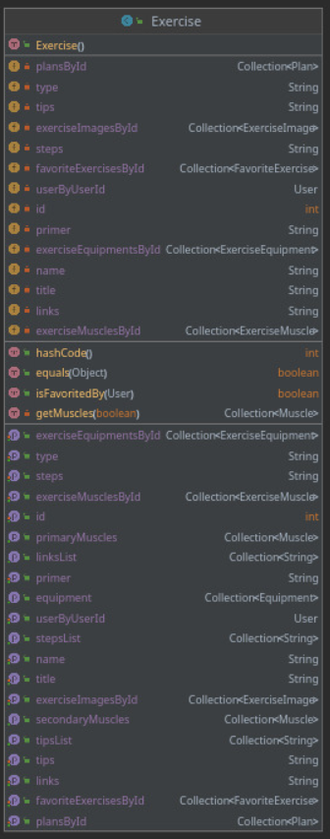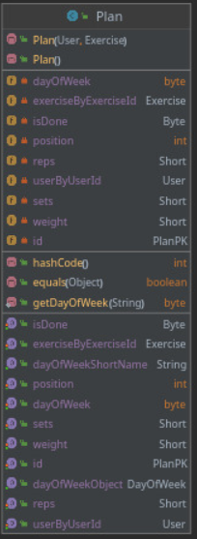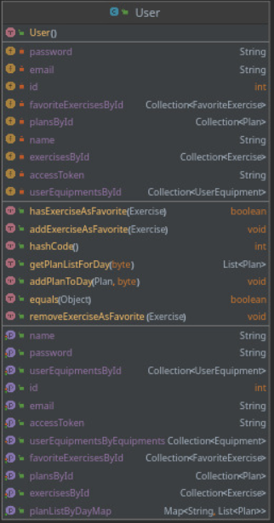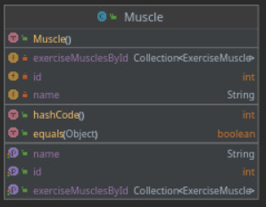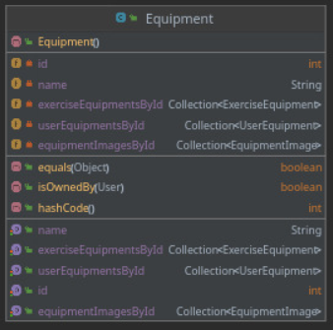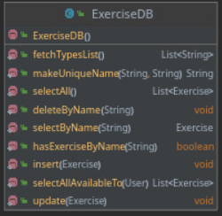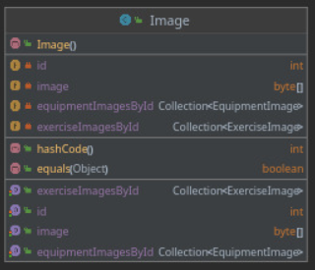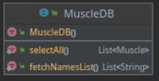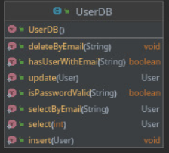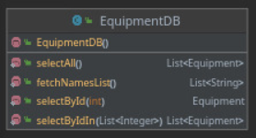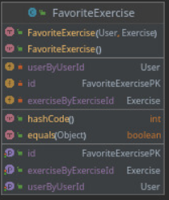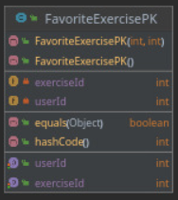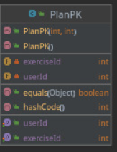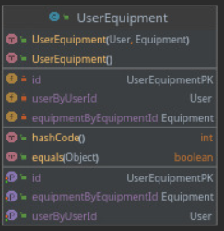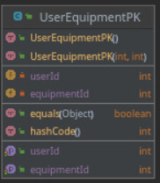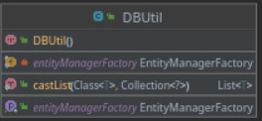

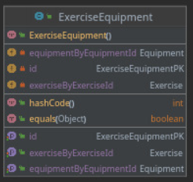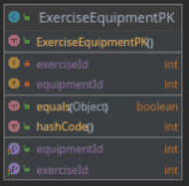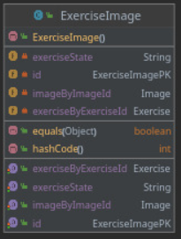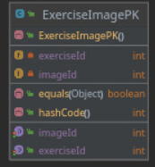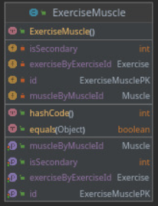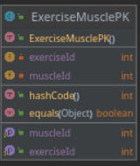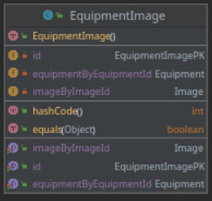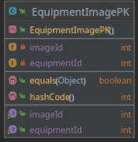

## 

## 3.3 Supplementary Requirements

* Server functionality shall be available 24 hours a day, 7 days a week. There shall be no more than 4% downtime.
* Software availability is 89.9% and it is specified in percentage of time available and hours of use, maintenance access, degraded mode operations.
* Mean Time Between Failures (MTBF) for our system is expected to be greater or more than 5 days.
* Accuracy (resolution) and accuracy (by some known standards) that is required in the systems output will be managed supporting the software to run at most times.
* The users using data extract and importing the reports from this output tool should be provided by supporting software to run them .csv, .pdf