PHONE BOOTH PCB

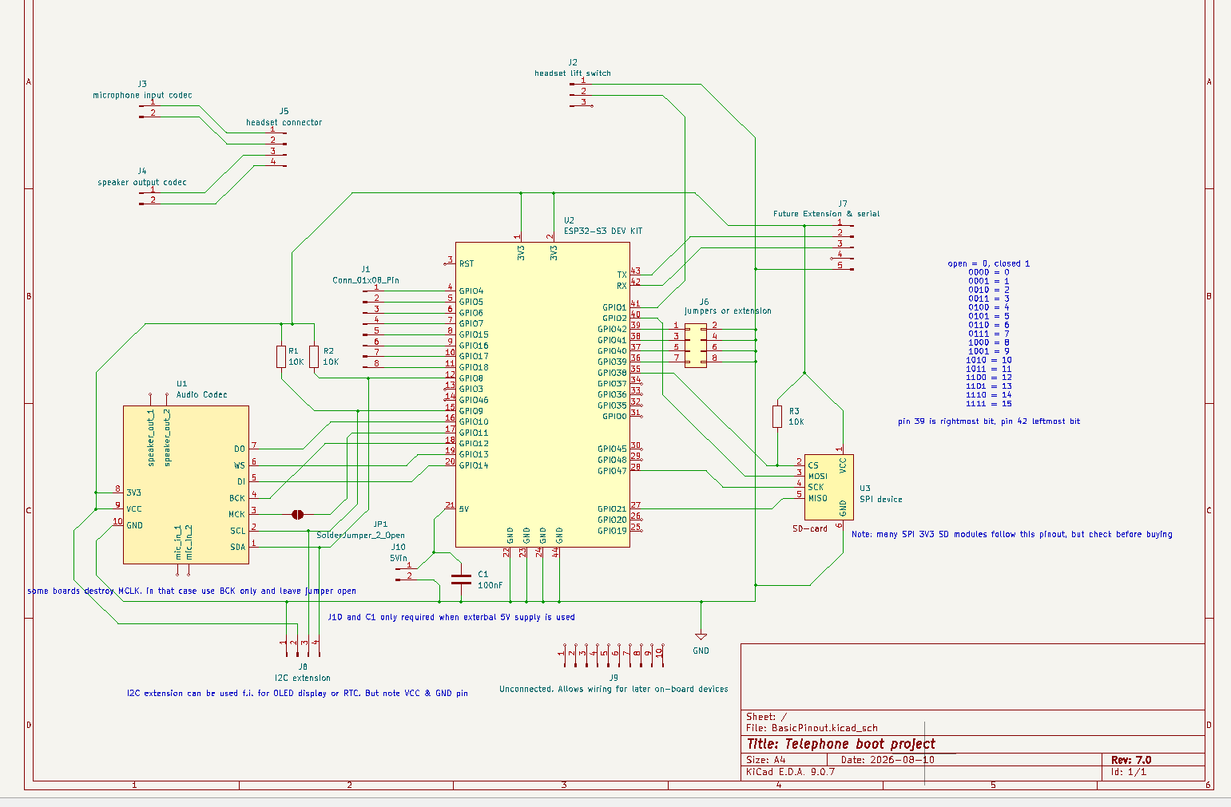–

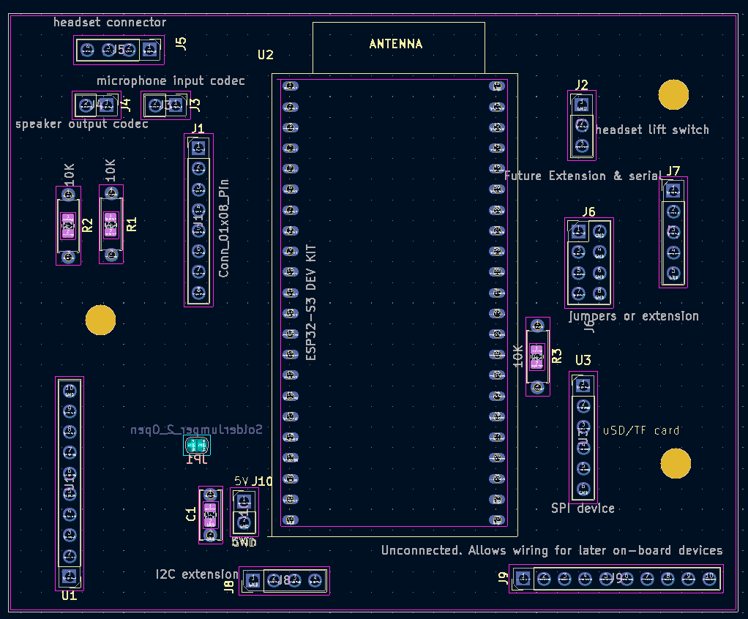

Development boards (U)
Development boards can be mounted in two ways: Either directly on the PCB, placing the pins in the holes. Or by first mounting female connectors (JST female, 2.54mm, PCB) and insert the board in them. This has the advantage that defective boards can be replaced easily or that boards can be removed and used elsewhere later. However disadvantage is that mounting is less rigid and in long term may give connection problems.
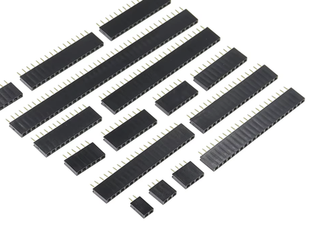
U1: Mono audio module,
Mount on front side, facing towards ESP. Use the variant with microphone NOT mounted on the PCB
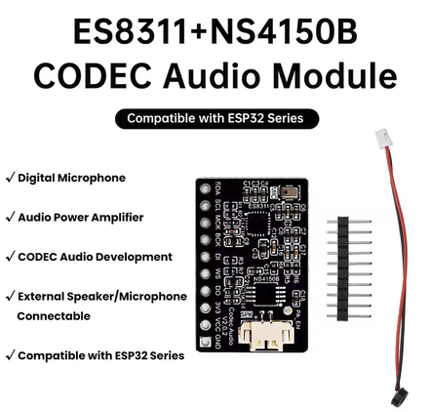

SDA --- 0 --- GPIO8
SCL --- 0 --- GPIO9
MCK --- 0 --- GPIO11 (note: jumper JP1 must be closed)
BCK --- 0 --- GPIO12
DI --- 0 --- GPIO14
WS --- 0 --- GPIO13
DO --- 0 --- GPIO19
VCC --- 0 --- 3V3
3V --- 0 --- 3V3
GDN --- 0 --- GND
U2: ESP32-S3 Dev-kit N16R8…
Mount on front side, make sure you use the correct variant, with headers mounted
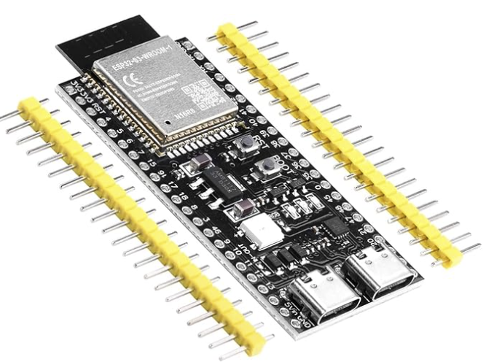

U3: SPI uSD-card reader
This must be a 3V3 variant.
Mount on front side, facing away from ESP
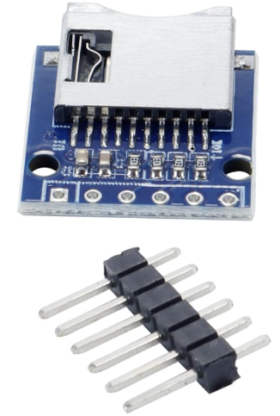

3V3 --- 0 --- 3V3
CS --- 0 --- GPIO38
MOSI --- 0 --- GPIO48
SCK --- 0 --- GPIO47
MISO --- 0 --- GPIO21
GND --- 0 --- GND

Connectors (J)

J1: 8x1 connector. Intended to connect 4x4 matrix keyboard. Can also be used for any other generic I/O functions. Recommended to be male, but female also possible.
0 --- GPIO4
0 --- GPIO5
0 --- GPIO6
0 --- GPIO7
0 --- GPIO15
0 --- GPIO16
0 --- GPIO17
0 --- GPIO18
J2: 3x1 connector. Intended to be used for headset lift detection, should be male
HS1 --- 0 --- GND
HS2 --- 0 --- GPIO1
HS3 --- 0 --- NC
J3: 2x1 connector. Intended to connect to microphone input of the audio codec U1. This can be done by soldering the wires directly into the mounting holes, or by adding a 2-pin male or female connector and make an adapter cable.
0 0
mic+ mic- (wire to microphone input codec U3)
J4: 2x1 connector. Intended to connect to speaker output of the audio codec U1. This can be done by soldering the wires directly into the mounting holes, or by adding a 2-pin male or female connector and make an adapter cable.
0 0
spk+ spk- (wire to speaker output codec U3)
J5: 4x1 connector. Intended to connect the 4x1 connector from the headset. Make sure connector orientation (Mic and speaker) matches the cables that go to the audio codec U1. Must be male.
0 0 0 0
Mic+ mic- spk + spk-
J6, 4x2 connector. Intended for jumpers to create board ID by placing jumpers between the four pins on the left to the 4 pins on the right. 16 combinations are possible this way. Must be male.
Can however also be used for future extension or to set other configurable behavior.
GPIO42 --- 0 0 --- GND
GPIO41 --- 0 0 --- GND
GPIO40 --- 0 0 --- GND
GPIO39 --- 0 0 --- GND
J7: 5x1 connector. Future extension or serial debugging. Do not place when not required
3V3 --- 0
TX --- 0
RX --- 0
NC --- 0
GND --- 0
J8: 4x1 connector. Can be used for additional I2C devices, like real-time clock or display. Pinout from left to right: GND, 3V3, SCL, SDA. This matches several OLED displays which can thus be soldered in place but only on the front side. Do not place when not required
0 0 0 0
GND, 3V3, SCL, SDA
J9: 10x1 connector .This connector is not connected to anything. It can be used when extra devices need to be connected to I2C, I2S or SPI. By adding wires on the back-side of the PCB to the pins, you can create an additional connector for these. Do not place when not required.
J10: 2x1 connector. Use this connector if you have an external 5V power supply, for instance battery powered. Do not place when not required. 5V5 is the maximum input value, make sure to notice polarity or the ESP may be damaged. Also see component C1.
0 --- 5V
0 --- GND

Other components
R1, R2, R3: pull-up resistors for I2C SDA and SCL, and CS of SPI. Required for signal stability. Recommended to be 10K 1/4W, or at least between 4K7 and 10K. Can be either though-hole or 803 sized SMD component. Must be placed in order to make devices work properly.
C1: only required when external 5V power supply is connected to J10, to remove potential noise from wires. Recommended value 100nF ceramic. Do not place when external 5V is not used. Can be either though-hole or 803 sized SMD component
JP1: Solder jumper. During design it proved that some codec modules (U1) destroy the MCLK signal from the ESP. For this reason the former project did not use MCLK but instead derived MCLK internally from BCLK. If the module is good and allows MCLK, this solder jumper can be closed by soldering to connect MCLK from the codec to pin 11 of the ESP.

