**MY Home Made LED Controller System, Developed on visual studio 2008(ASP+C#)**

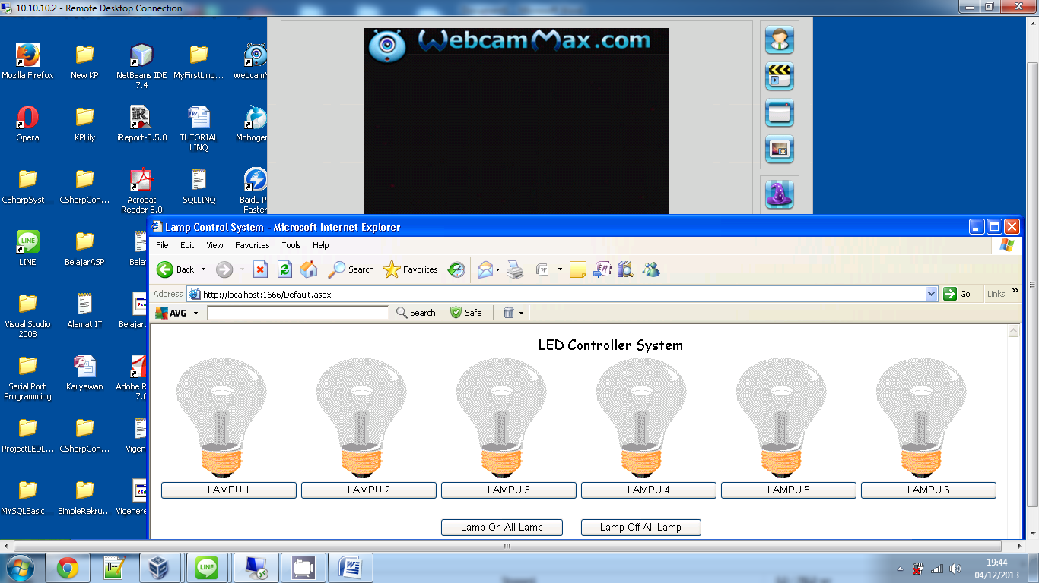

Try Turn ON 1st LAMP

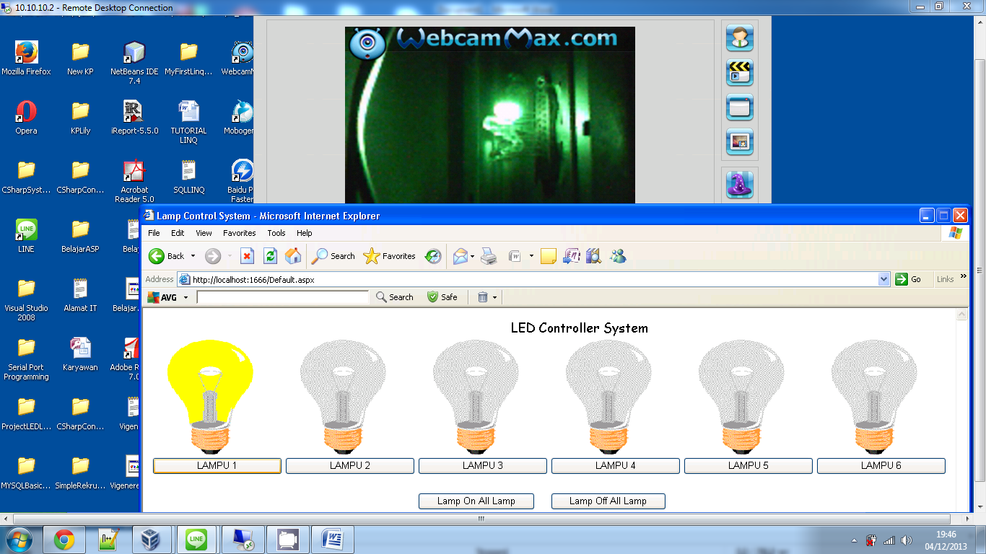

Try Turn ON 2nd LAMP

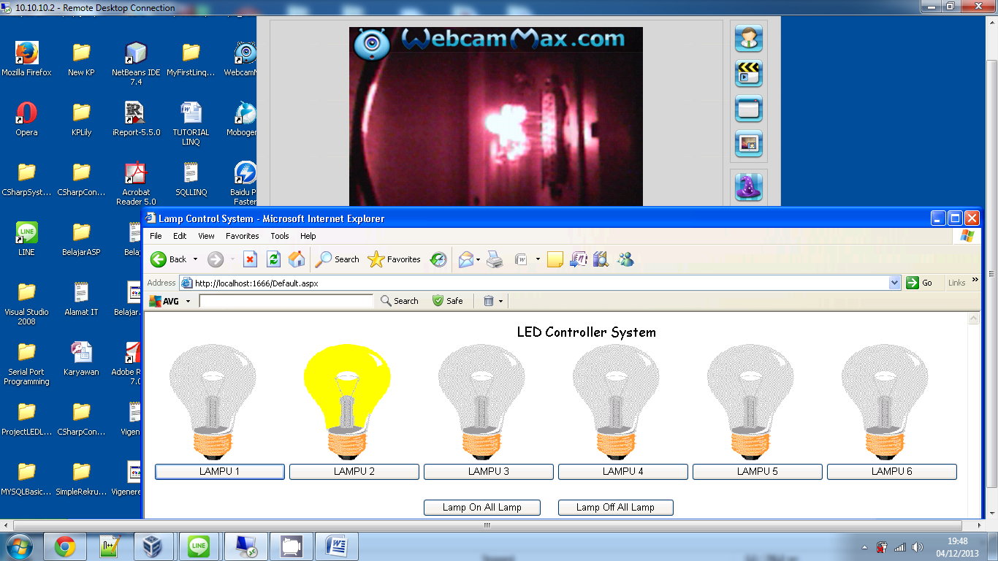

Try Turn ON 3rd LAMP

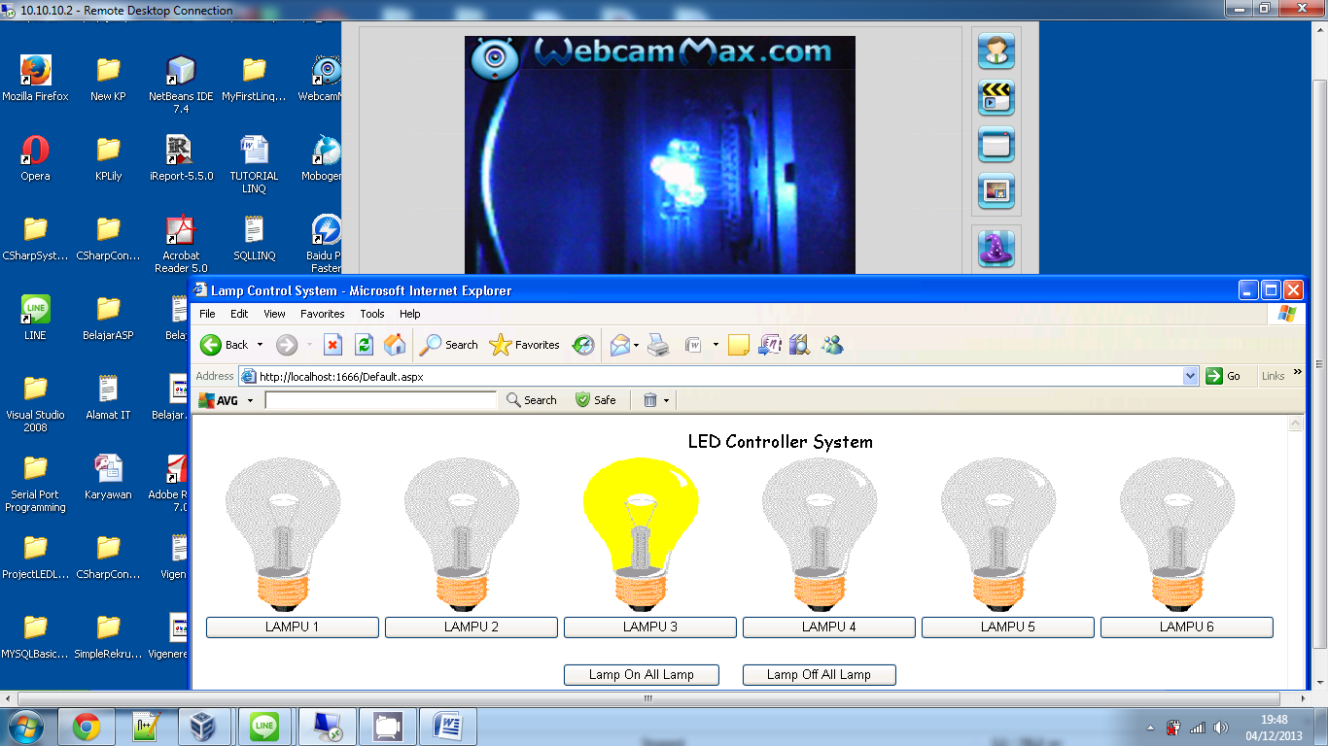

Try Turn ON 4th LAMP

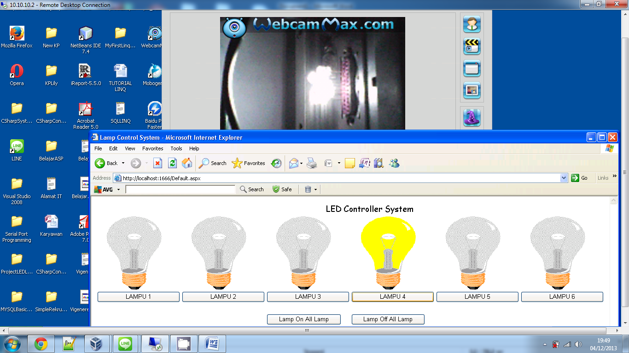

Try Turn ON 5th LAMP

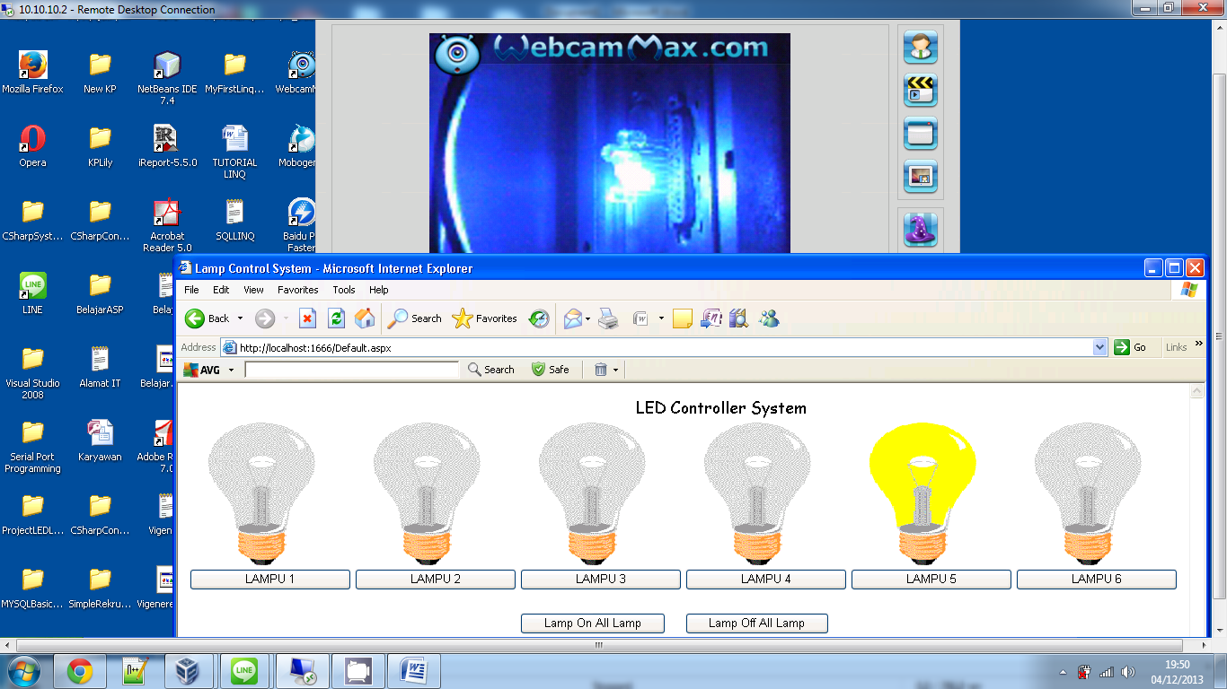

Try Turn ON 6th LAMP

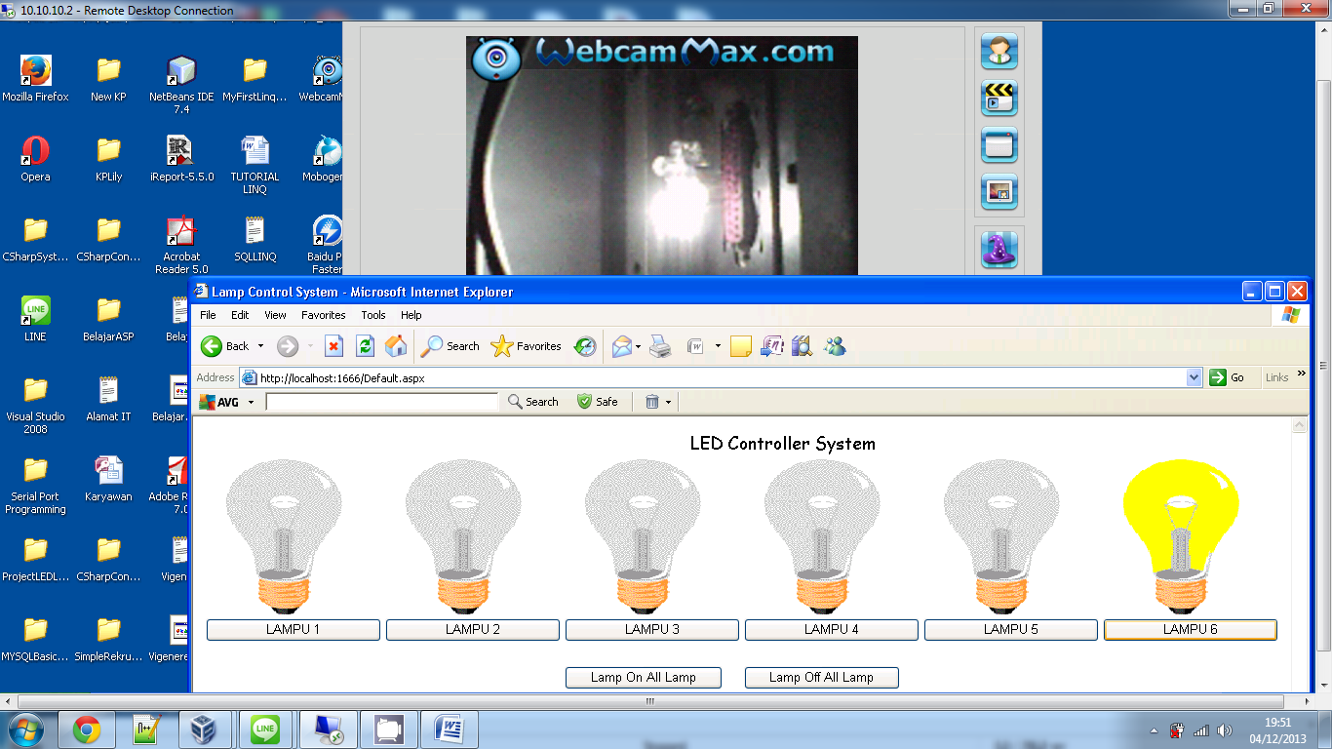

Try Turn ON 1th, 3rd, 5th LAMP

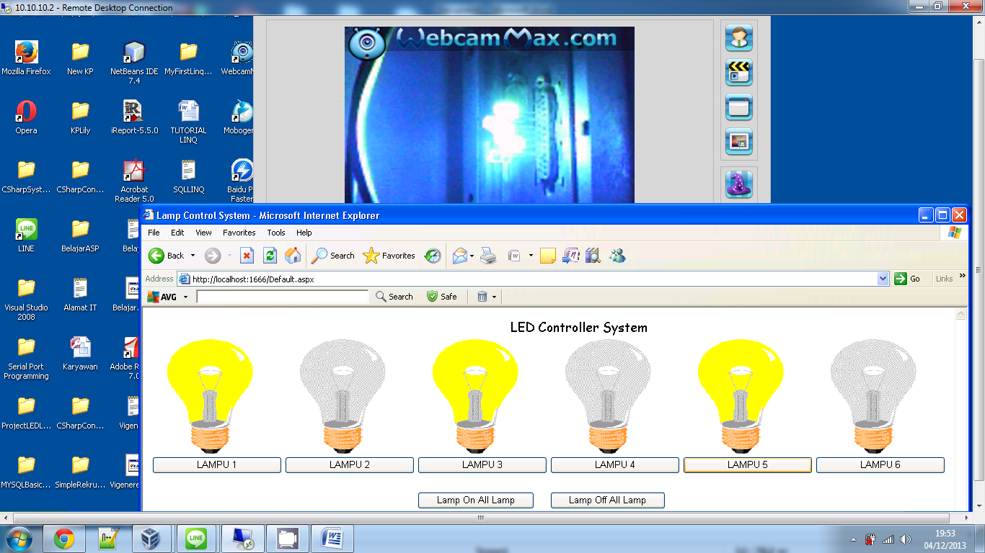

Try Turn ON 2nd, 4th, 6th LAMP

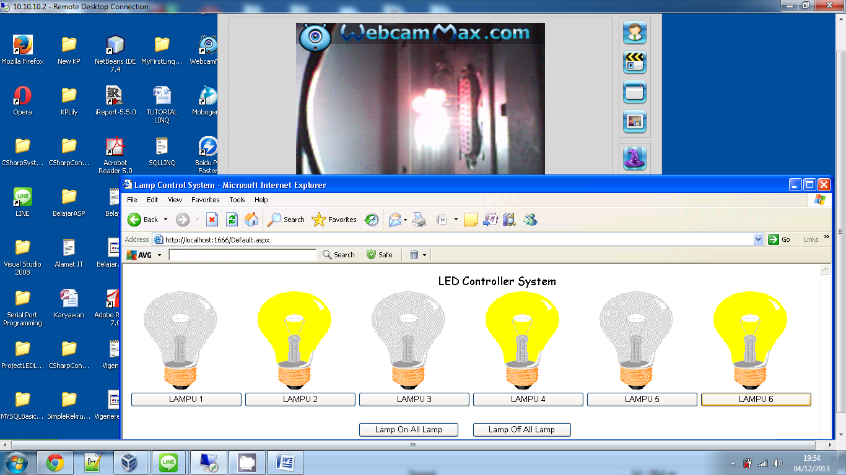

Try to turn on all Lamp using “Lamp On All Lamp” Button

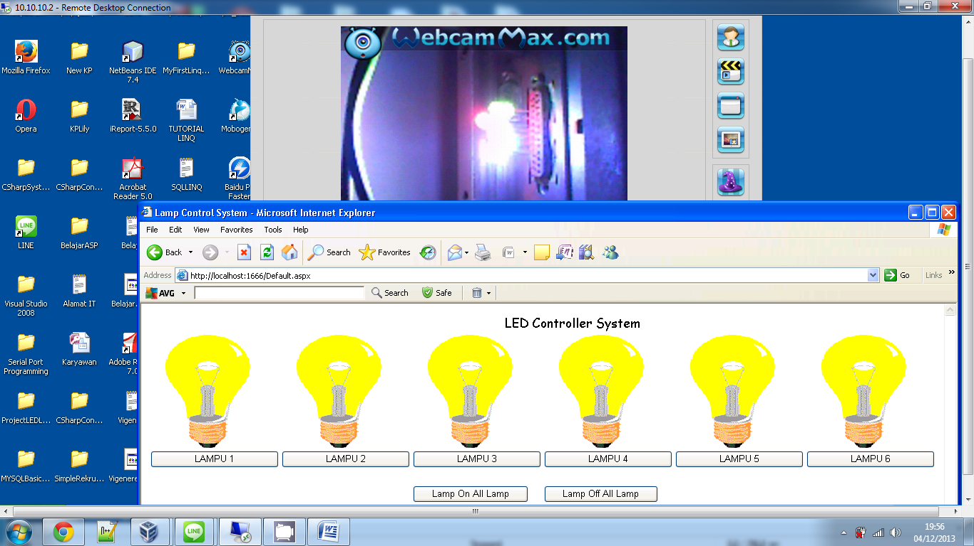

Try to turn off all Lamp using “Lamp OF All Lamp” Button

