Export publication records with SDG-labels from SciVal

* Logon to [SciVal](https://scival.com/) and go to Benchmarking
* Set organization under Institutions and Groups or Researchers and Groups in the left hand menu
* Set year range [make sure selection =< 100.000 records]
* Go to table view
* Click on the ‘overall’ number of publications in the table

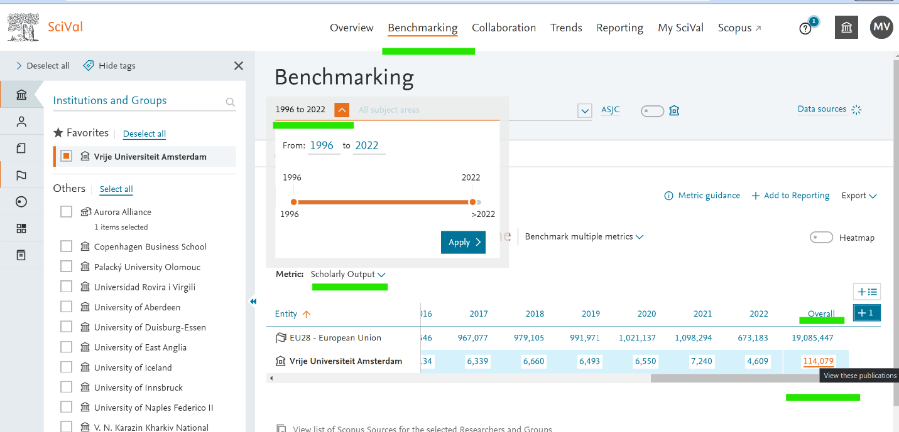

* In the window that opens: choose Export > **Export spreadsheet**

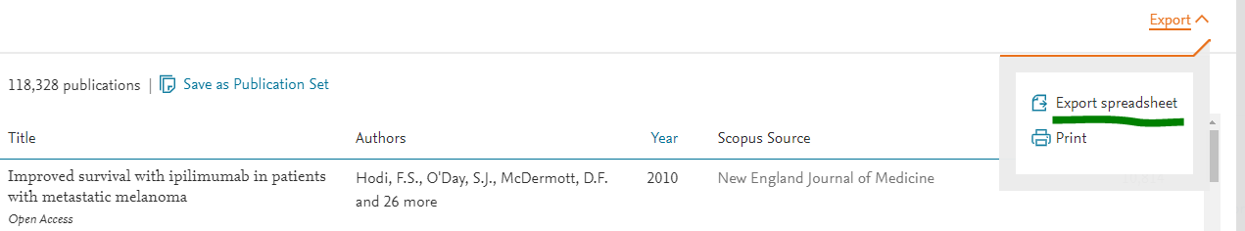

* Select the fields DOI, EID and Sustainable Development Goals and choose Export CSV

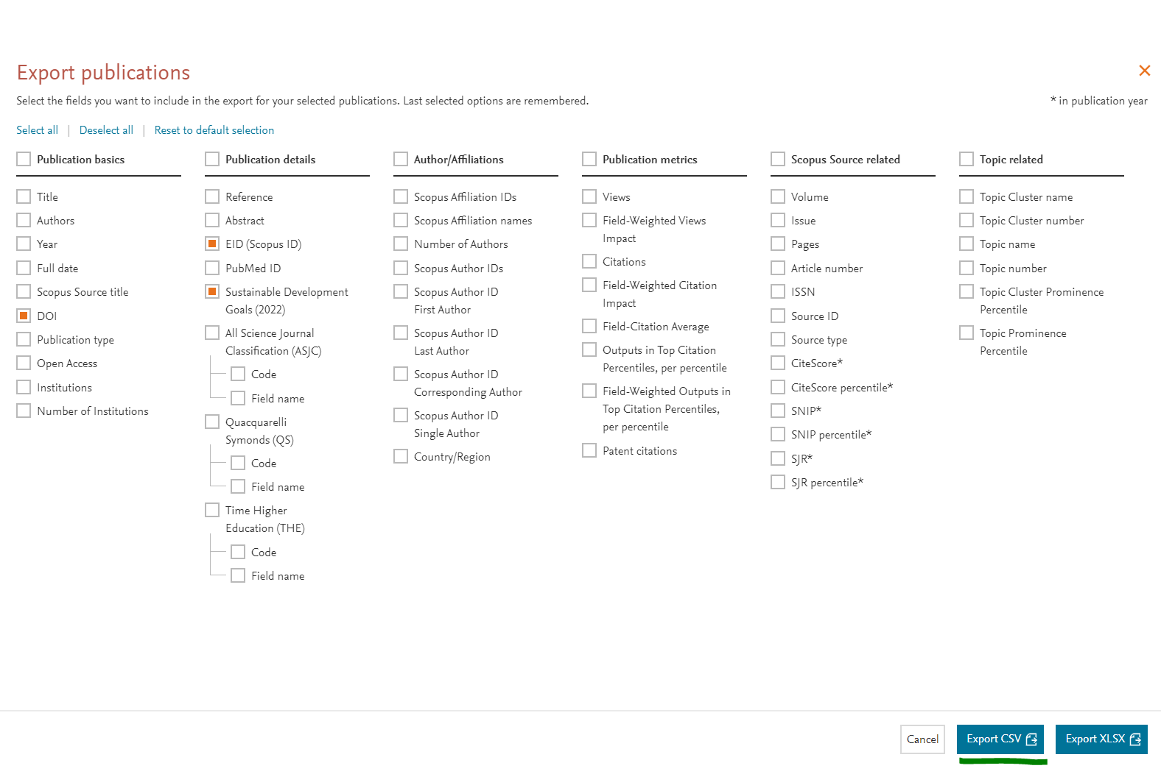

* Wait for the download-link to be sent to your e-mail address