Source Data Mapping Approach to CDMV5.4
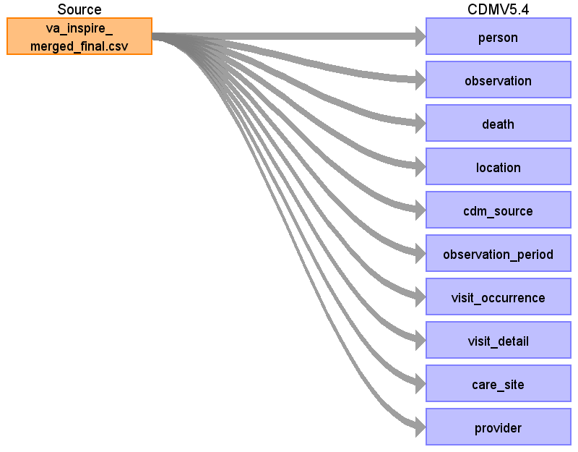
Table name: person
This table serves as the central identity management for all Persons in the database. It contains records that uniquely identify each person or patient, and some demographic information.

All records in this table are independent Persons.
Reading from va_inspire_merged_final.csv
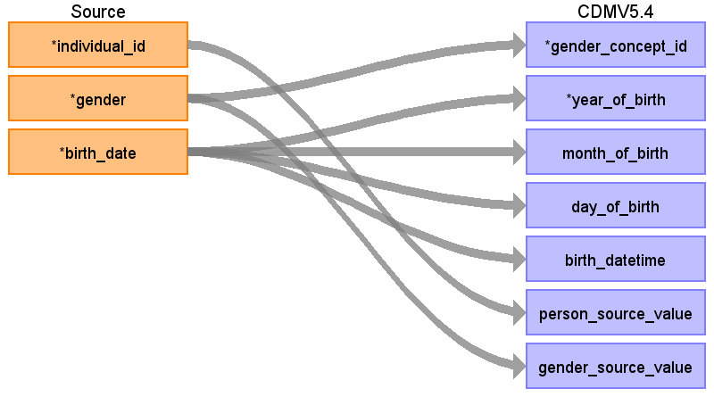
Destination Field | Source Field | Logic | Comment
person_id |  |  | A unique identifier for every person. Autogenerated
gender_concept_id | gender |  | Male = 8507  Female = 8532  If gender is missing, set to 4214687
year_of_birth | birth_date |  | Extract year birth from birthdate
month_of_birth | birth_date |  | Extract month from birthdate
day_of_birth | birth_date |  | Extract day from birthdate
birth_datetime | birth_date |  | Indicate birthdate plus 00:00:00 and convert to datetime
race_concept_id |  |  | Indicate 38003600 - African
ethnicity_concept_id |  |  | Indicate 1547281 = Subsaharan Africa  1546912 = North African
location_id |  |  | Populate this with a foreign key from the  LOCATION table
provider_id |  |  | Populate this with a foreign key from the  PROVIDER table
care_site_id |  |  | Populate this with a foreign key from the  CARESITE table
person_source_value | individual_id |  | Verbatim value as it appears in source data
gender_source_value | gender |  | Verbatim value as it appears in source data
gender_source_concept_id |  |  | SET TO 0
race_source_value |  |  | Indicate African
race_source_concept_id |  |  | SET TO 0
ethnicity_source_value |  |  | Indicate Subsaharan Africa or  North African where appropriate
ethnicity_source_concept_id |  |  | SET TO 0
Table name: observation
The OBSERVATION table captures clinical facts about a Person obtained in the context of examination, questioning or a procedure. Any data that cannot be represented by any other domains, such as social and lifestyle facts, medical history, family history, etc. are recorded here.

The observation table usually records the date or datetime of when the observation was obtained, not the date of the observation starting.
Reading from va_inspire_merged_final.csv
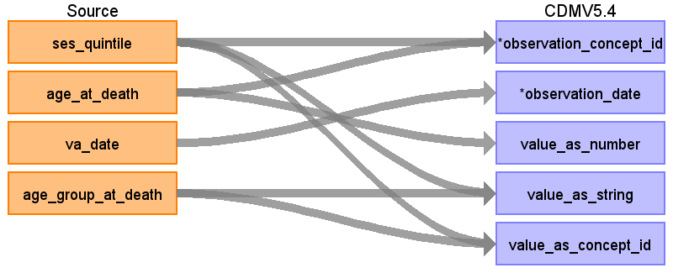
Destination Field | Source Field | Logic | Comment
observation_id |  |  | A unique identifier for every observation. Autogenerated
person_id |  |  | Populate this with a foreign key from the PERSON table
observation_concept_id | ses_quintile  age_at_death |  | Indicate  ses_quintile - 44803984 (Relative wealth)  OR 4249447 - Economic status  age at death - 3038421  level of education - 42528763
observation_date | va_date
observation_datetime |  |  | SET TO NULL
observation_type_concept_id |  |  | Indicate 32883 - Survey  ## TBD(Kindly check on this part if right.  Reasoning behind it was that it was captured during a VA - which can be classified as a survey )
value_as_number | age_at_death
value_as_string | age_group_at_death  ses_quintile |  | Indicate Verbatim value of the observations as it appears in source data
value_as_concept_id | ses_quintile  age_group_at_death |  | #Under Relative Wealth  For middle/middle upper indicate 4072607 (moderate household income)  For lower/middle lower indicate 4074773 (low household income)  For upper indicate 4074774 (high household income)  #Under Economic status  lower - 4277050  middle lower - 4198183  middle - 4330874  middle upper - 4274784  upper - 4311552  #Age groups  Under 5 = 45884506  5-14 = 45883427  15-24 = 45876531  25-39 = 45883482  40-64 = 45881960  65 and above = 45881961  #education levels  no education = 45880050  primary = 44800023  secondary/high school = 43021808/4074914/45876261  higher education = 4059166
qualifier_concept_id |  |  | SET TO 0
unit_concept_id |  |  | SET TO 0
provider_id |  |  | Populate this with a foreign key from the  PROVIDER table
visit_occurrence_id |  |  | Populate this with a foreign key from the  VISIT OCCURENCE table
visit_detail_id |  |  | Populate this with a foreign key from the  VISIT DETAIL table
observation_source_value |  |  | SET TO NULL
observation_source_concept_id |  |  | SET TO 0
unit_source_value |  |  | SET TO NULL
qualifier_source_value |  |  | SET TO NULL
value_source_value |  |  | SET TO NULL
observation_event_id |  |  | SET TO NULL
obs_event_field_concept_id |  |  | SET TO 0
Table name: death
The death domain contains the clinical event for how and when a Person dies. A person can have up to one record if the source system contains evidence about the Death, such as: Condition in an administrative claim, status of enrollment into a health plan, or explicit record in EHR data.
Reading from va_inspire_merged_final.csv
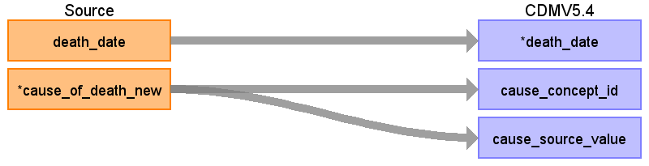
Destination Field | Source Field | Logic | Comment
person_id |  |  | Populate this with a foreign key from the PERSON table
death_date | death_date
death_datetime |  |  | Indicate deathdate plus 00:00:00 and convert to datetime
death_type_concept_id |  |  | Indicate 32883 - For survey.  OR  32880 - Standard algorithm (A record calculated by an algorithm) InterVA uses algorithm
cause_concept_id | cause_of_death_new |  | Indicate these concept ids  Unknown 441413  06.01 Acute abdomen 4241033  02.04 breast neoplasms 81251  02.01 oral neoplasms 4130986  01.03 HIV/AIDS related death 439727  Animal Bite or Attack 45877493  12.10 Exposure to force of nature 437453  12.08 intentional self-harm 4303690  02.05, 02.06 reproductive neoplasms m,f 4113639  12.02 Other transport accident 435713  Cerebrovascular disease 381591  10.99 other and unspecified neonatal cod 4042220  01.12 Dengue fever 440022  Eclampsia 443700  03.02 Severe malnutrition 440370  09.06 Pregnancy-related sepsis 37175321  12.07 Accid poisoning & noxious subs 436581  Carcinoma of the lung 40492938  AIDS and Pulmonary tuberculosis 37116831  All other specified and Unspecified cardiovascular disorders 134057  12.99 Other and unspecified external CoD 432795  07.01 Renal failure 192359  01.02 Acute resp infect incl pneumonia 4112341  Pneumonia 255848  Renal disorders 198124  Congestive cardiac failure 319835  03.01 severe anaemia 439777  02.99 other and unspecified neoplasms 432582  Carcinoma of gastrointestinal tract 4244495  Ischaemic heart disease 4185932  09.04 obstetric haemorrhage 443929  Acute abdominal conditions 4023573  Tetanus 435740  02.03 respiratory neoplasms 252280  Other specified unintentional injuries 4053720  Hypertension 316866  09.07 anaemia of pregnancy 4099889  01.01 Sepsis (non-obstetric) 132797  11.02 Macerated stillbirth 4028787  04.99 Other and unspecified cardiac dis 321588  05.02 Asthma 317009  03.03 Diabetes mellitus 201820  All other and unspecified specified noncommunicable diseases 443783  Homicidal injuries 4101415  10.04 Neonatal sepsis 4071063  01.10 Pertussis 257778  10.01 Prematurity 36675035  02.02 digestive neoplasms 196931  12.03 Accid fall 435991  01.06 Measles 4030555  04.02 Stroke 36210384  All other perinatal causes 4187201  08.01 Epilepsy 380378  12.04 Accid drowning and submersion 436593  04.01 Acute cardiac disease 4215140  11.01 Fresh stillbirth 4034159  10.02 Birth asphyxia 4184996  10.06 Congenital malformation 4079975  06.02 Liver cirrhosis 4064161  12.05 Accid expos to smoke fire & flame 4143700  01.07 Meningitis and encephalitis 4322814  05.01 chronic obstructive pulmonary dis 255573  Ruptured uterus 444066  12.01 Road traffic accident 437165  All other specified and Unspecified Acute Respiratory Infections 4112341  01.04 Diarrhoeal diseases 4134607  10.03 Neonatal pneumonia 4051337  All other specified acute abdominal conditions 4023573  09.02 abortion-related death 4080913  09.05 Obstructed labour 193827  12.09 Assault 439237  Carcinoma breast 4116071  01.11 Haemorrhagic fever 4347554  Puerperal sepsis 4102318  01.09 pulmonary tuberculosis 253954  Burns 442013  09.03 pregnancy-induced hypertension 4167493  09.01 ectopic pregnancy 437611  01.05 Malaria 438067  04.03 Sickle cell with crisis 26942  12.06 Contact with venomous plant/animal 4155221  All other forms of tuberculosis 434557  All other specified and unspecified liver diseases 194984  01.99 Other and unspecified infectious diseases 432250  Unspecified Acute febrile illness 4166729  All other specified symptoms, signs and syndromes 40759950  All other specified acute febrile illness 4166729  Neonatal tetanus 133024  09.99 other and unspecified maternal cod 439658  Carcinoma cervix or uterus 4310575  Central nervous system disorders 376106  Chronic hepatitis 200763  Viral Hepatitis 4291005  P59.9 neonatal jaundice 435656  K59.9 Functional Intestinal disorder 196151
cause_source_value | cause_of_death_new |  | Indicate Verbatim value as it appears in source data
cause_source_concept_id |  |  | SET TO 0
Table name: location
The LOCATION table represents a generic way to capture physical location or address information of Persons and Care Sites.
Reading from va_inspire_merged_final.csv
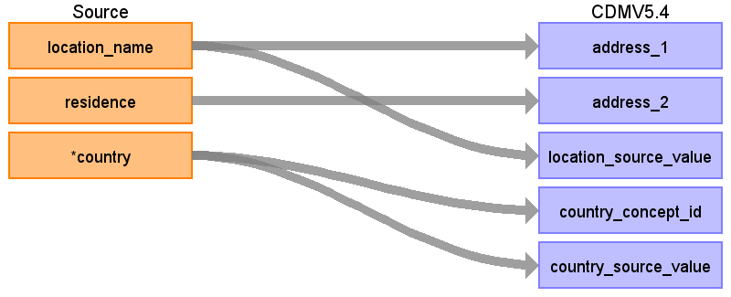
Destination Field | Source Field | Logic | Comment
location_id |  |  | A unique identifier for every location. Autogenerated
address_1 | location_name
address_2 | residence
city |  |  | Set to NULL
state |  |  | Set to NULL
zip |  |  | Set to NULL
county |  |  | Set to NULL
location_source_value | location_name |  | Indicate verbatim value as it appears in source data
country_concept_id | country |  | Concept id of the countries  Ethiopia = 4071835  Kenya = 4075204  Uganda = 4071840  Malawi = 4072113  Burkina Faso = 4075209  Senegal = 4071848  The Gambia = 4329867
country_source_value | country |  | Verbatim value as it appears in source data
latitude |  |  | Indicate latitude for each of the location  Harar = 9.3129314  Haramaya = 9.3919283  Kersa = 9.2486416  Iganga/Mayuge = 0.5415745  Karonga = -9.9458954  korogocho = -1.2524607  viwandani = -1.3066697  Ouagadougou = 12.3587779
longitude |  |  | Indicate longitude:  Harar = 39.8707564  Haramaya = 42.0028566  Kersa = 41.6415642  Iganga/Mayuge = 33.3064786  Karonga = 33.8749464  korogocho = 36.8791299  viwandani = 36.8662333  Ouagadougou = -1.7016636
Table name: cdm_source
The CDM_SOURCE table contains detail about the source database and the process used to transform the data into the OMOP Common Data Model.
Reading from va_inspire_merged_final.csv
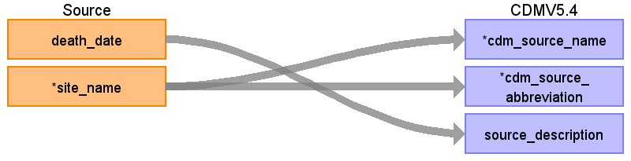
Destination Field | Source Field | Logic | Comment
cdm_source_name | site_name
cdm_source_abbreviation | site_name
cdm_holder |  |  | Set to 'APHRC'
source_description | death_date |  | CONCATENATE the string with minimum death_date and maximum death_date  "Verbal Autopsy Data from ", min_death_date, " to ", max_death_date
source_documentation_reference |  |  | Set to NULL
cdm_etl_reference |  |  | Link to INSPIRE-VA-Data-to-OMOP-ETL repository in DSP github  https://github.com/APHRC-DSE/INSPIRE-VA-Data-to-OMOP-ETL
source_release_date |  |  | The date the data was extracted from the source system. In some systems that is the same as the date the ETL was run.  Typically the latest event date in the source is on the source_release_date. (Set to Maximum death_date or va_date)
cdm_release_date |  |  | The date the ETL script was completed.  Typically this is after the source_release_date.
cdm_version |  |  | Version of CDM - '5.4'
cdm_version_concept_id |  |  | 756265 - OMOP CDM Version 5.4.0
vocabulary_version |  |  | Vocabulary version used.  "v5.0 27-AUG-25"
Table name: observation_period
This table contains records which define spans of time during which two conditions are expected to hold: (i) Clinical Events that happened to the Person are recorded in the Event tables, and (ii) absence of records indicate such Events did not occur during this span of time.

Events may exist outside all of the time spans of the OBSERVATION_PERIOD records for a patient, however, absence of an Event outside these time spans cannot be construed as evidence of absence of an Event.
Reading from va_inspire_merged_final.csv
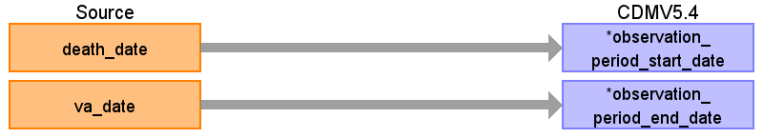
Destination Field | Source Field | Logic | Comment
observation_period_id |  |  | A unique identifier for every observation period. Autogenerated
person_id |  |  | Populate this with a foreign key from the PERSON table
observation_period_start_date | death_date |  | Earliest Event date available for the Person
observation_period_end_date | va_date |  | Last Event date available for the Person
period_type_concept_id |  |  | Indicate 32883 - For survey.
Table name: visit_occurrence
This table contains Events where Persons engage with the healthcare system for a duration of time. They are often also called “Encounters”. Visits are defined by a configuration of circumstances under which they occur, such as (i) whether the patient comes to a healthcare institution, the other way around, or the interaction is remote, (ii) whether and what kind of trained medical staff is delivering the service during the Visit, and (iii) whether the Visit is transient or for a longer period involving a stay in bed.
Reading from va_inspire_merged_final.csv
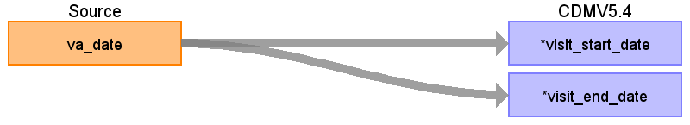
Destination Field | Source Field | Logic | Comment
visit_occurrence_id |  |  | A unique identifier for every visit occurence. Autogenerated
person_id |  |  | Populate this with a foreign key from the PERSON table
visit_concept_id |  |  | Case Management Visit: Person interacting with healthcare system, without a Care Site, within a day, with no Providers involved, for administrative purposes  Case Management Agency - 38004193
visit_start_date | va_date
visit_start_datetime |  |  | Set to NULL
visit_end_date | va_date
visit_end_datetime |  |  | Set to NULL
visit_type_concept_id |  |  | 32883 for survey
provider_id |  |  | Populate this with a foreign key from the PROVIDER table
care_site_id |  |  | Populate this with a foreign key from the CARESITE table
visit_source_value |  |  | Verbal Autopsy Interview
visit_source_concept_id |  |  | Set to 0
admitted_from_concept_id |  |  | Set to 0
admitted_from_source_value |  |  | Set to NULL
discharged_to_concept_id |  |  | Set to 0
discharged_to_source_value |  |  | Set to NULL
preceding_visit_occurrence_id |  |  | Set to NULL
Table name: visit_detail
The VISIT_DETAIL table is an optional table used to represents details of each record in the parent VISIT_OCCURRENCE table. A good example of this would be the movement between units in a hospital during an inpatient stay or claim lines associated with a one insurance claim. For every record in the VISIT_OCCURRENCE table there may be 0 or more records in the VISIT_DETAIL table with a 1:n relationship where n may be 0. The VISIT_DETAIL table is structurally very similar to VISIT_OCCURRENCE table and belongs to the visit domain.
Reading from va_inspire_merged_final.csv
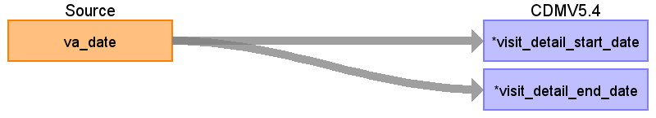
Destination Field | Source Field | Logic | Comment
visit_detail_id |  |  | A unique identifier for every visit detail. Autogenerated
person_id |  |  | Populate this with a foreign key from the PERSON table
visit_detail_concept_id |  |  | Case Management Visit: Person interacting with healthcare system, without a Care Site, within a day, with no Providers involved, for administrative purposes  Case Management Agency - 38004193
visit_detail_start_date | va_date
visit_detail_start_datetime |  |  | Set to NULL
visit_detail_end_date | va_date
visit_detail_end_datetime |  |  | Set to NULL
visit_detail_type_concept_id |  |  | 32883 for survey
provider_id |  |  | Populate this with a foreign key from the PROVIDER table
care_site_id |  |  | Populate this with a foreign key from the CARE SITE table
visit_detail_source_value |  |  | Verbal Autopsy Interview
visit_detail_source_concept_id |  |  | Set to 0
admitted_from_concept_id |  |  | Set to 0
admitted_from_source_value |  |  | Set to NULL
discharged_to_source_value |  |  | Set to NULL
discharged_to_concept_id |  |  | Set to 0
preceding_visit_detail_id |  |  | Set to NULL
parent_visit_detail_id |  |  | Set to NULL
visit_occurrence_id |  |  | Populate this with a foreign key from the VISIT OCCURENCE table
Table name: care_site
The CARE_SITE table contains a list of uniquely identified institutional (physical or organizational) units where healthcare delivery is practiced (offices, wards, hospitals, clinics, etc.).
Reading from va_inspire_merged_final.csv
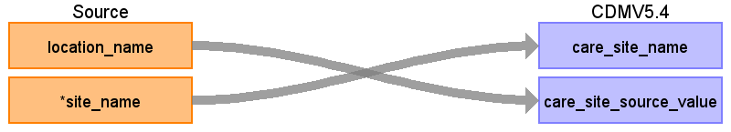
Destination Field | Source Field | Logic | Comment
care_site_id |  |  | A unique identifier for every care site. Autogenerated
care_site_name | site_name
place_of_service_concept_id |  |  | 581476 = Home visit
location_id |  |  | Populate this with a foreign key from the LOCATION table
care_site_source_value | location_name |  | Indicate Verbatim value of the observations as it appears in source data  This could be an identifier separate from the name of the care_site.
place_of_service_source_value |  |  | Set to NULL
Table name: provider
The PROVIDER table contains a list of uniquely identified healthcare providers; duplication is not allowed. These are individuals providing hands-on healthcare to patients, such as physicians, nurses, midwives, physical therapists etc.
Reading from va_inspire_merged_final.csv
Destination Field | Source Field | Logic | Comment
provider_id |  |  | A unique identifier for every provider. Autogenerated
provider_name |  |  | Set to NULL
npi |  |  | Set to NULL
dea |  |  | Set to NULL
specialty_concept_id |  |  | Autopsy diagnosis - 4210301
care_site_id |  |  | Populate this with a foreign key from the CARE SITE  table
year_of_birth |  |  | Set to NULL
gender_concept_id |  |  | Set to 0
provider_source_value |  |  | Set to NULL
specialty_source_value |  |  | Verbal Autopsy
specialty_source_concept_id |  |  | Set to 0
gender_source_value |  |  | Set to NULL
gender_source_concept_id |  |  | Set to 0
Table name: condition_occurrence
Table name: drug_exposure
Table name: procedure_occurrence
Table name: device_exposure
Table name: measurement
Table name: note
Table name: note_nlp
Table name: specimen
Table name: fact_relationship
Table name: payer_plan_period
Table name: cost
Table name: drug_era
Table name: condition_era
Table name: dose_era
Table name: episode
Table name: episode_event
Table name: metadata
Table name: cohort
Table name: cohort_definition
Appendix: source tables
Table: va_inspire_merged_final.csv
Field | Type | Most freq. value | Comment
individual_id | VARCHAR
gender | VARCHAR | Male
birth_date | DATE | 1948-02-01
location_name | VARCHAR | Kersa
residence | VARCHAR | Urban
ses_quintile | VARCHAR | lower
death_date | DATE | 2021-10-01
year_death | INT | 2021
age_at_death | REAL | 0
site_name | VARCHAR | Hararghe_HDSS
country | VARCHAR | Ethiopia
va_date | DATE
age_group_at_death | VARCHAR | Under 5
cause_of_death_new | VARCHAR | Unknown
general_cause_of_death | VARCHAR | non communicable diseases

