CprE 381, Computer Organization and

Assembly-Level Programming

Lab 2 Report

Student Name ________Rosemary Reinhart_____________________

Submit a typeset pdf version of this on Canvas by the due date. Refer to the highlighted language in the lab document for the context of the following questions.

[Part 3 (a)] Draw the interface description (i.e., the “symbol” or high-level blackbox) for the RISC-V register file. Which ports do you think are necessary, and how wide (in bits) do they need to be?
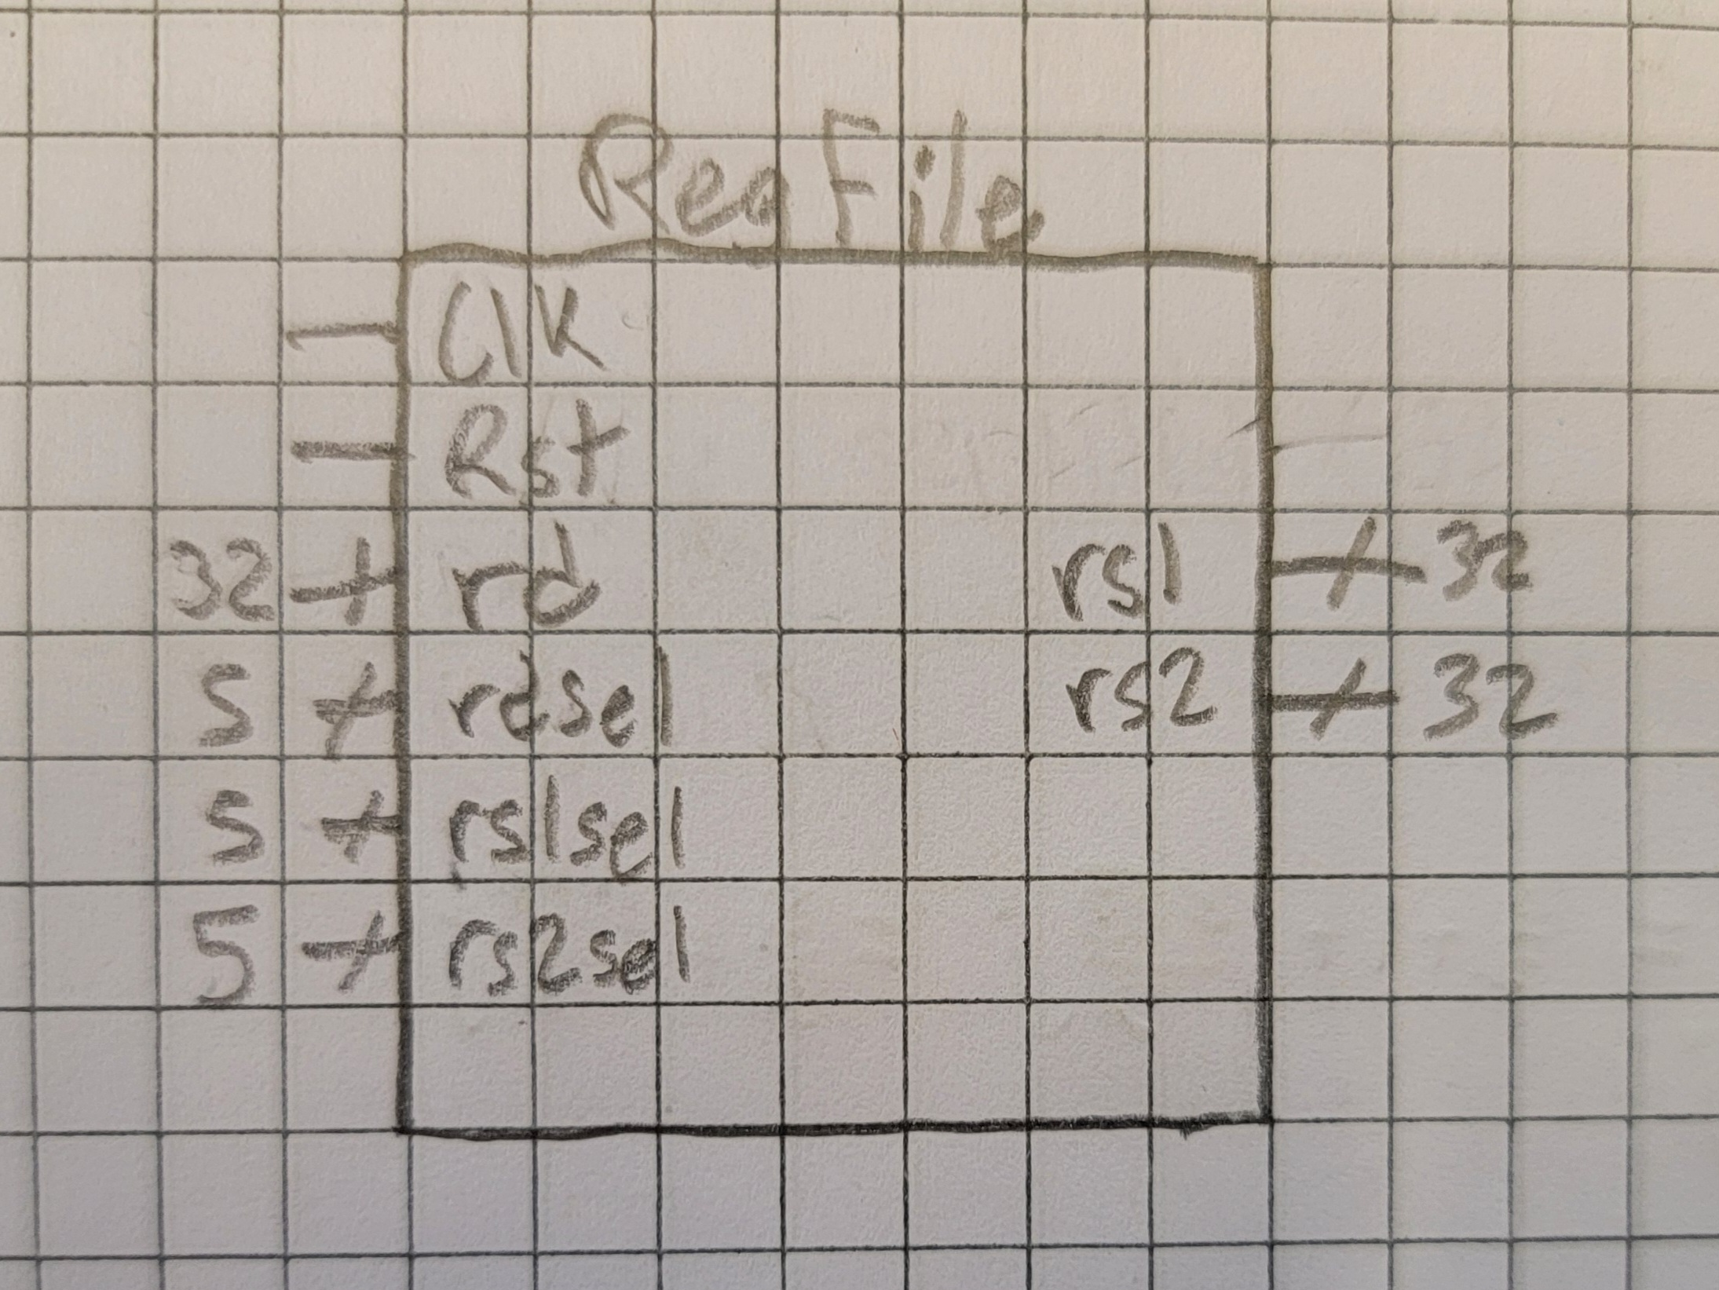
I think that all these ports are necessary except for maybe the Rst pin, as it would just reset all registers to 0 and that can be done with other inputs albeit less efficiently.

[Part 3 (b)] Create an N-bit register using this flip-flop as your basis.
I did that, not sure what to put here exactly.

[Part 3 (c)] Waveform.
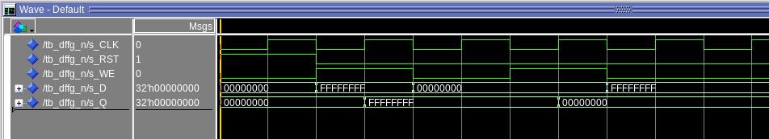

[Part 3 (d)] What type of decoder would be required by the RISC-V register file and why?
A 5 to 32 bit decoder is required, because there are 32 registers to choose from.

[Part 3 (e)] Waveform.
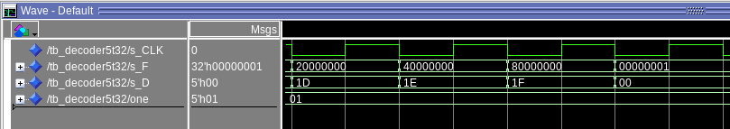

[Part 3 (f)] In your write-up, describe and defend the design you intend on implementing for the next part.
I intend to use a 5 bit 32t1 mux design using AND and NOT gates as well as when else statements. I am not going to overly optimize it, but it shouldn’t be super complicated anyways.

[Part 3 (g)] Waveform.
For these tests I just set each register to its value in hex. It does not directly copy the input, but outputs it from the register where that same value is already stored.
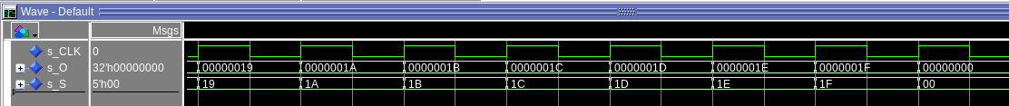

[Part 3 (h)] Draw a (simplified) schematic (i.e., components within the high-level blackbox) for the RISC-V register file, using the same top-level interface ports as in your solution describe above and using only the register, decoder, and mux VHDL components you have created.
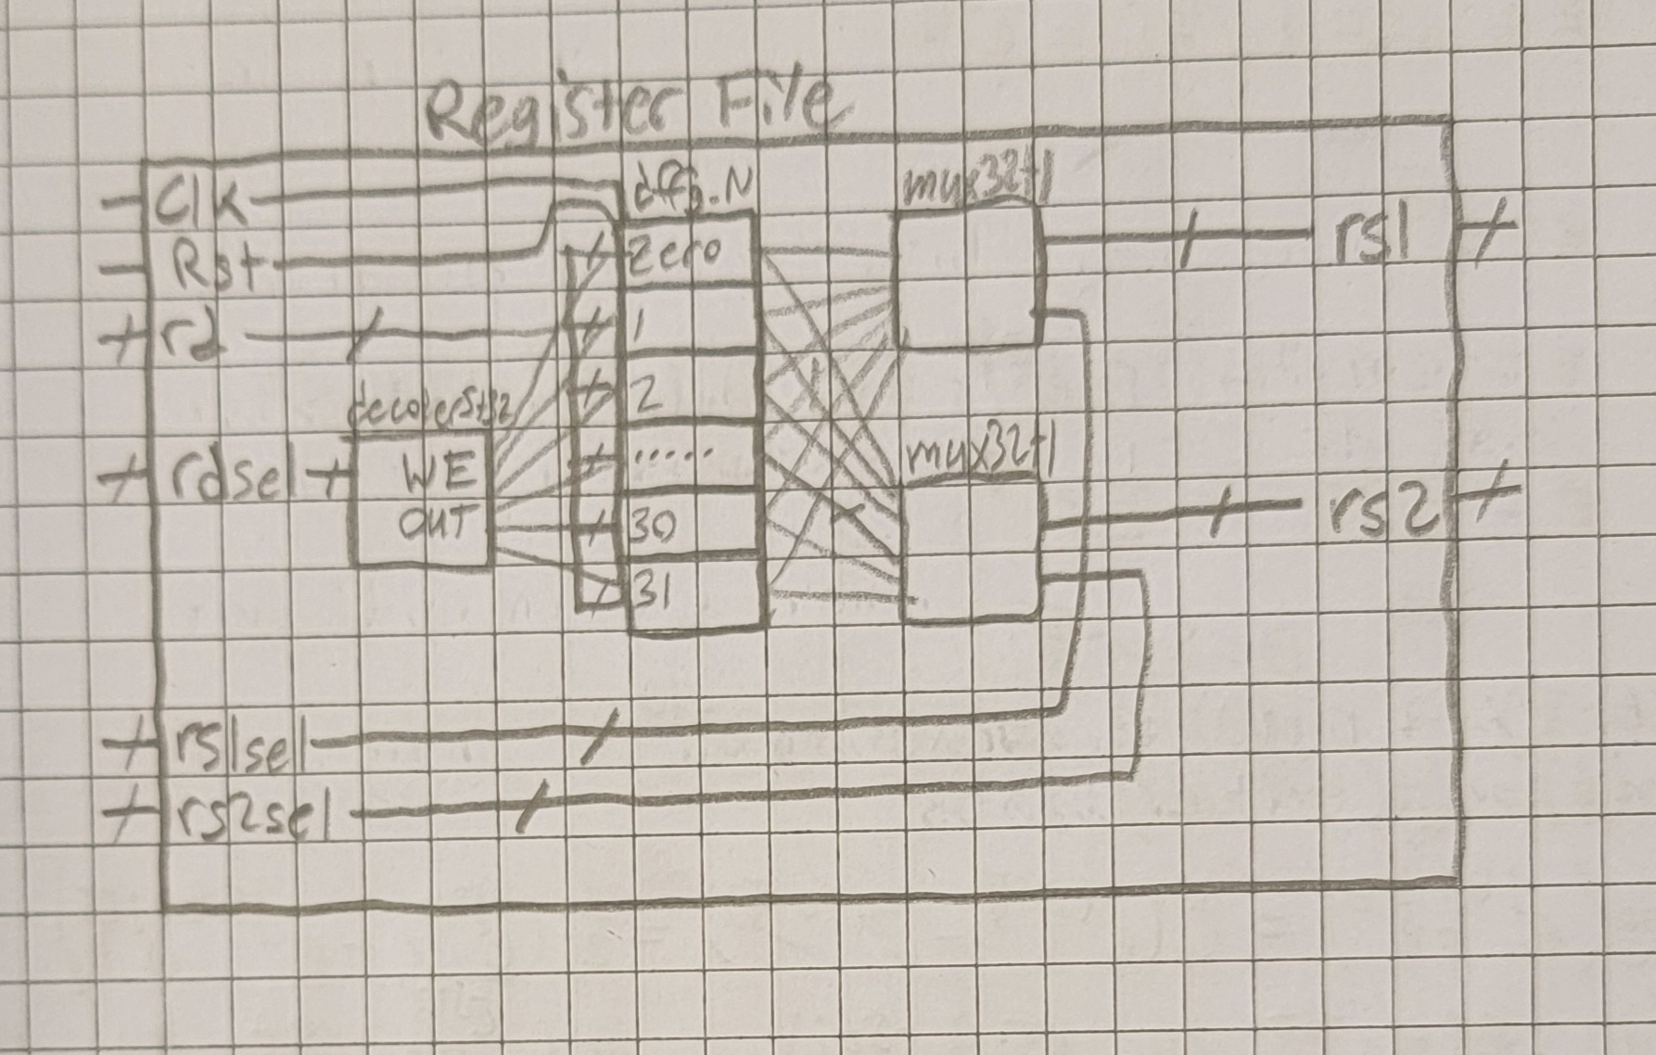

[Part 3 (i)] Waveform.
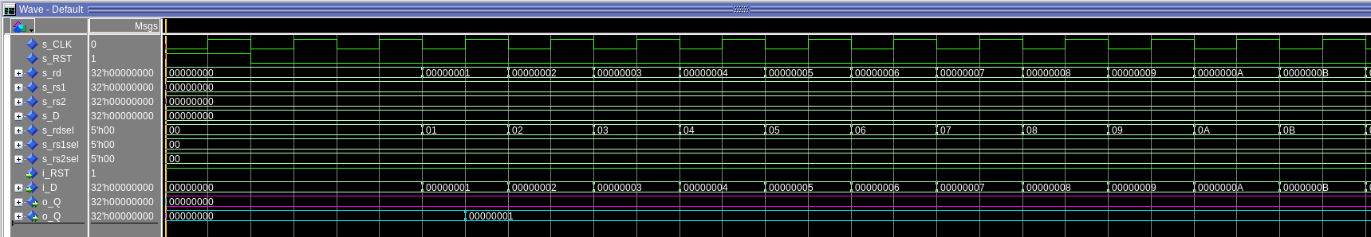
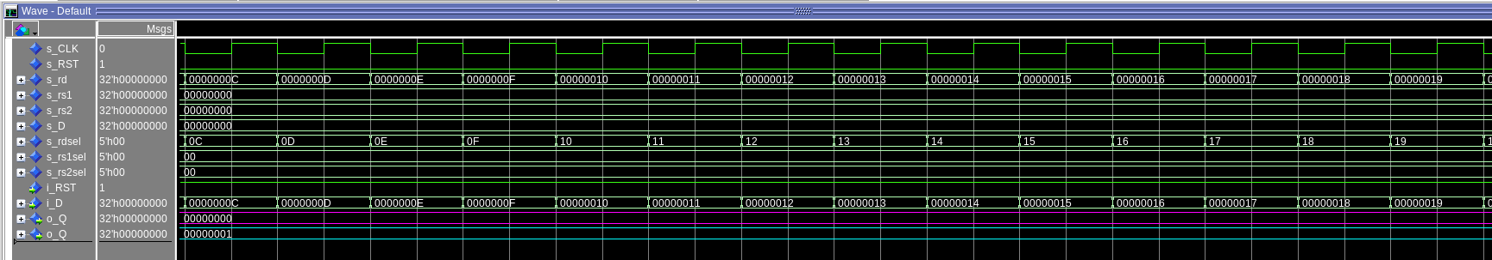
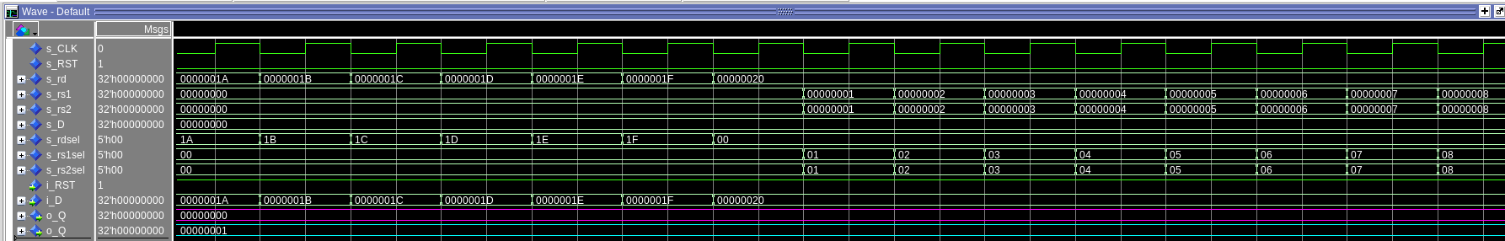
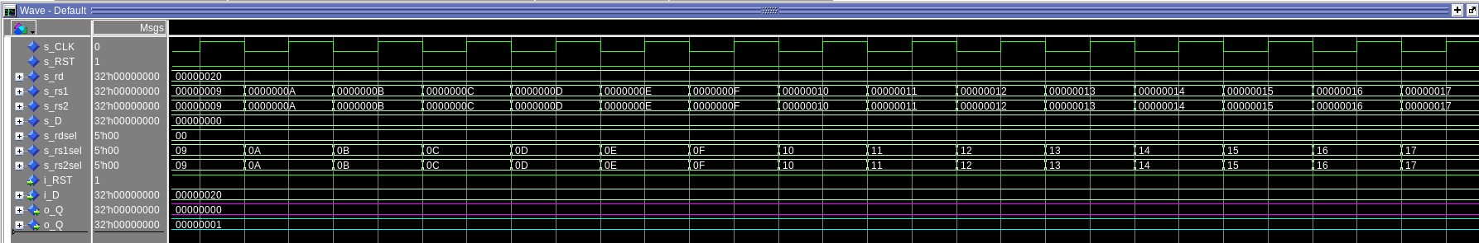
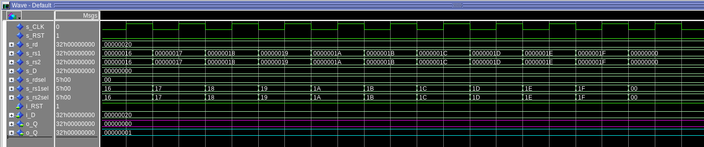
The i_RST, i_D, and o_Q colored in magenta are all from register x0. o_Q colored in cyan is from register x1.

[Part 4 (b)] Draw a symbol for this RISC-V-like datapath.
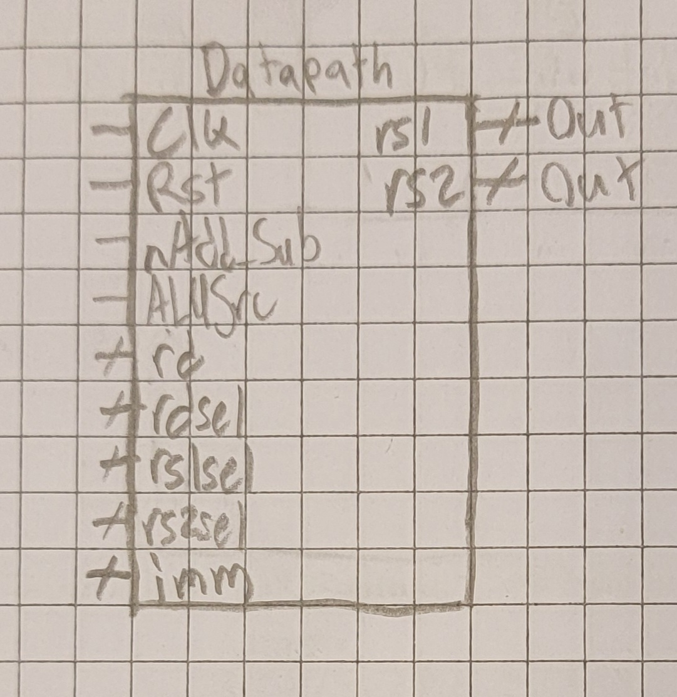

[Part 4 (c)] Draw a schematic of the simplified RISC-V processor datapath consisting only of the component described in part (a) and the register file from problem (1).
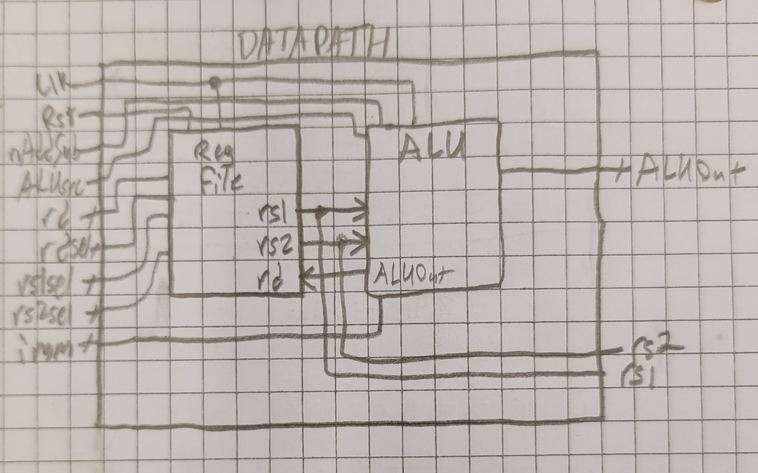

[Part 4 (d)] Include in your report waveform screenshots that demonstrate your properly functioning design. Annotate what the final state of the register file should be and provide a mapping of the registers used in your drawing to the register names.
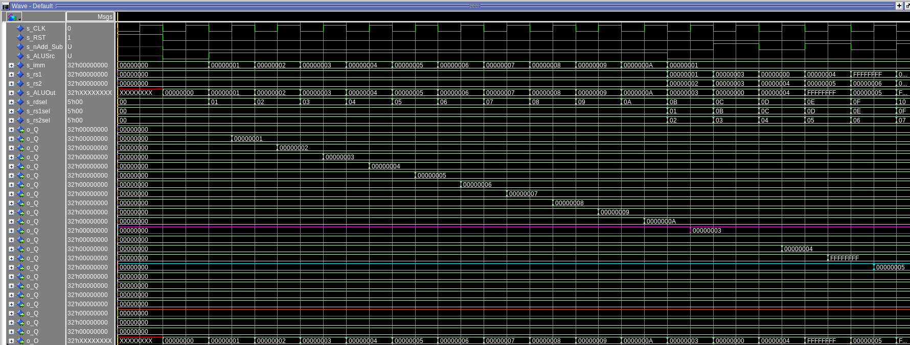
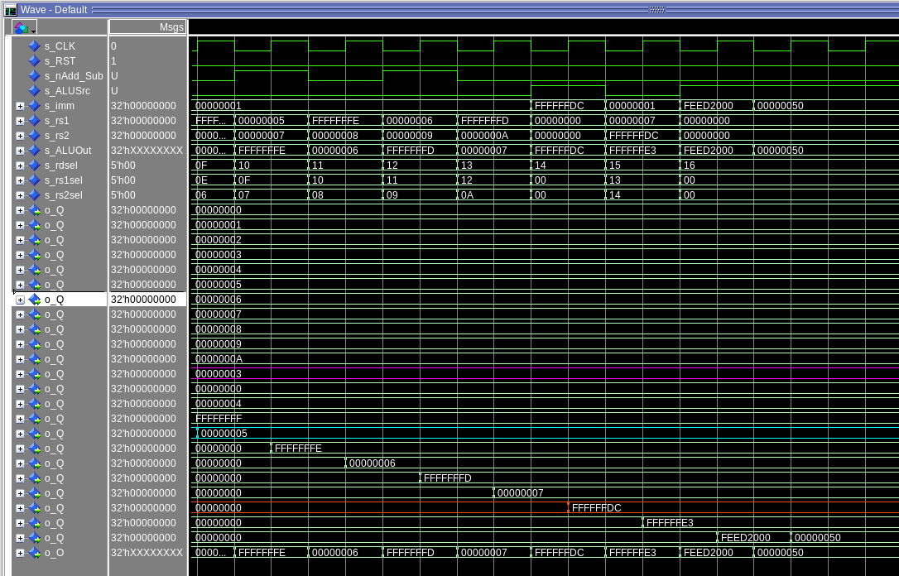
The waves labelled o_Q are the registers. X0 through x10 all have the value 0 through 10 stored. X11 is in magenta. X15 is in cyan. X20 is in orange red.
The final states of registers x0 through x10 are 0 through 10 respectively. The final states of the rest are x11 = 3, x12 = 0, x13 = 4, x14 = -1, x15 = 5, x16 = -2, x17 = 6, x18 = -3, x19 = 7, x20 = -35, x21 = -28, and x22 = 0xFEED2050.

[Part 5 (a)] Read through the mem.vhd file, and based on your understanding of the VHDL implementation, provide a 2-3 sentence description of each of the individual ports (both generic and regular).

DATA_WIDTH: this sets the width of a word in memory. Changing this changes the size of what is read from memory.
ADDR_WIDTH: this sets the width of the possible addresses. Changing this changes the size of the memory.
BYTE_WIDTH: this sets the width of bytes. Changing this changes how bytes are defined.

clk: this is a standard clock in, it controls synchronous actions. In this file it controls when memory gets read.
addr: this is the input address for what is to be written to memory or read from memory. It does both as far as I can tell reading this.
data: this is the input data to be stored in memory. When we is 1 it writes this value to the address addr in ram.
be: sets what bytes are to be written to memory. If bit 0 is 0, then byte 0 will not be written.
we: write enable. Enables writing to memory. Without this it would not know when to write.
q: output from memory. This is where the ram gets unloaded to.

[Part 5 (c)] Waveforms and hex file.

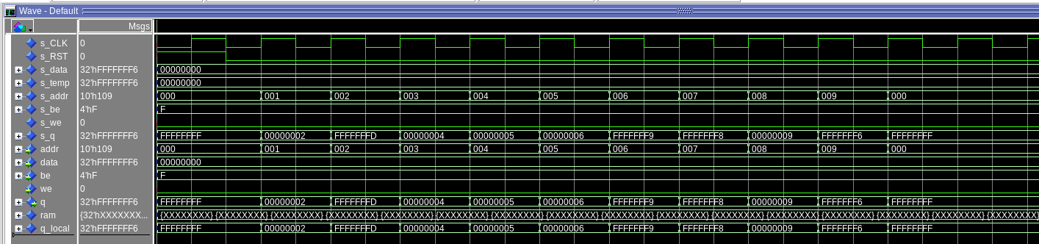
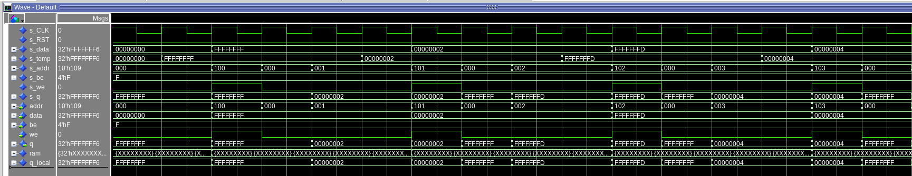
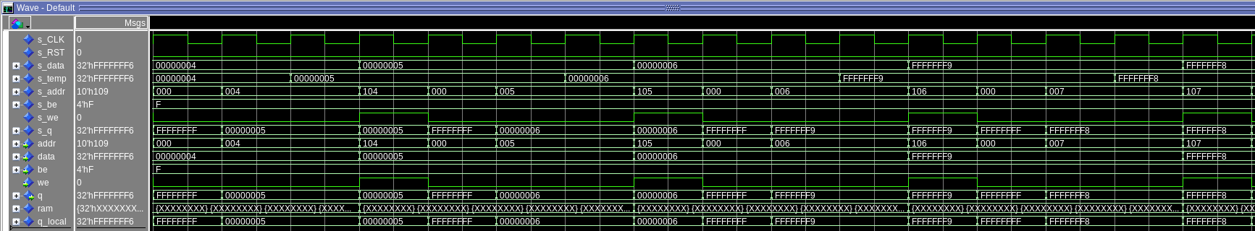
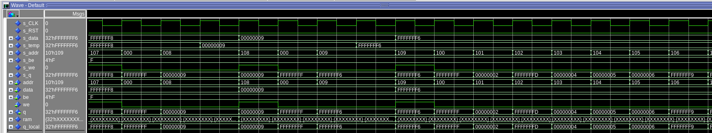
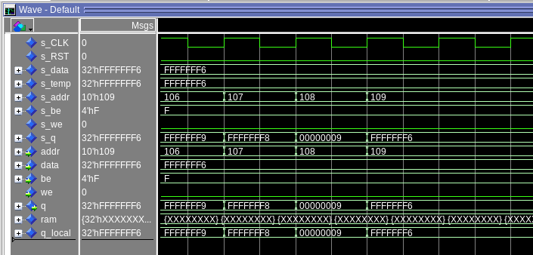

// File Format:
//
// The text file can contain whitespace characters, comments (C-style),
// and binary ($readmemb) or hexadecimal ($readmemh) data values. Both
// types of data values can contain x or X, z or Z, and the underscore
// character.
//
// The data values are assigned to memory words from left to right,
// beginning at start_addr or the left array bound (the default). The
// next address to load may be specified in the file itself using @hhhhhh,
// where h is a hexadecimal character. Spaces between the @ and the address
// character are not allowed. It shall be an error if there are too many
// words in the file or if an address is outside the bounds of the array.
//
FFFFFFFF // Loads at address 0
00000002
FFFFFFFD
00000004
00000005
00000006
FFFFFFF9
FFFFFFF8
00000009
FFFFFFF6 // Loads at address 9

@15 // Specifies the following values will be loaded starting at address 0x15 (remember, this is a .hex file so the values are in hex) or 21 in decimal
0000a000 // Loads at address 0x15
0000b000 // Loads at address 0x16

[Part 6 (a)] What are the RISC-V instructions that require some value to be sign extended? What are the RISC-V instructions that require some value to be zero extended? What are the RISC-V instructions that require some value to be appended with zero?

Most instructions that use immediates need them to be sign extended before using them, excluding those instructions that are specifically unsigned as those need to be zero extended instead. This includes I, S, SB, U, and UJ type instructions.
lui needs to append 3 zeros to the end, or 12 bits.

[Part 6 (b)] what are the different “extender” components that would be required by a RISC-V processor implementation (i.e., number of bits of input and sign vs zero extension vs zero appending)?
There needs to be a sign extender and zero extender for 12 bits as well as a zero append for 20 bits.
[Part 6 (d)] Waveform.
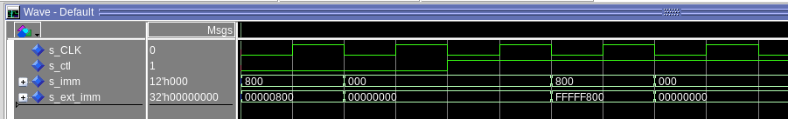
extender12.vhd
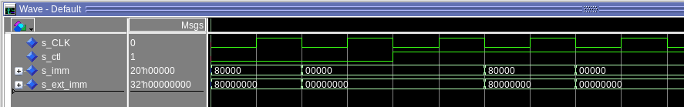
extender20.vhd

[Part 7 (a)] what control signals will need to be added to the simple processor from part 2? How do these control signals correspond to the ports on the mem.vhd component analyzed in part 3?

addr, be, we, imm2 all need to be added. They for the most part lead into the memory except for imm2 which goes into the sign extender then the alu then the registers before memory.

[Part 7 (b)] Draw a schematic of a simplified RISC-V processor consisting only of the base components used in part 2, the extender component described in part 4, and the data memory from part 3.
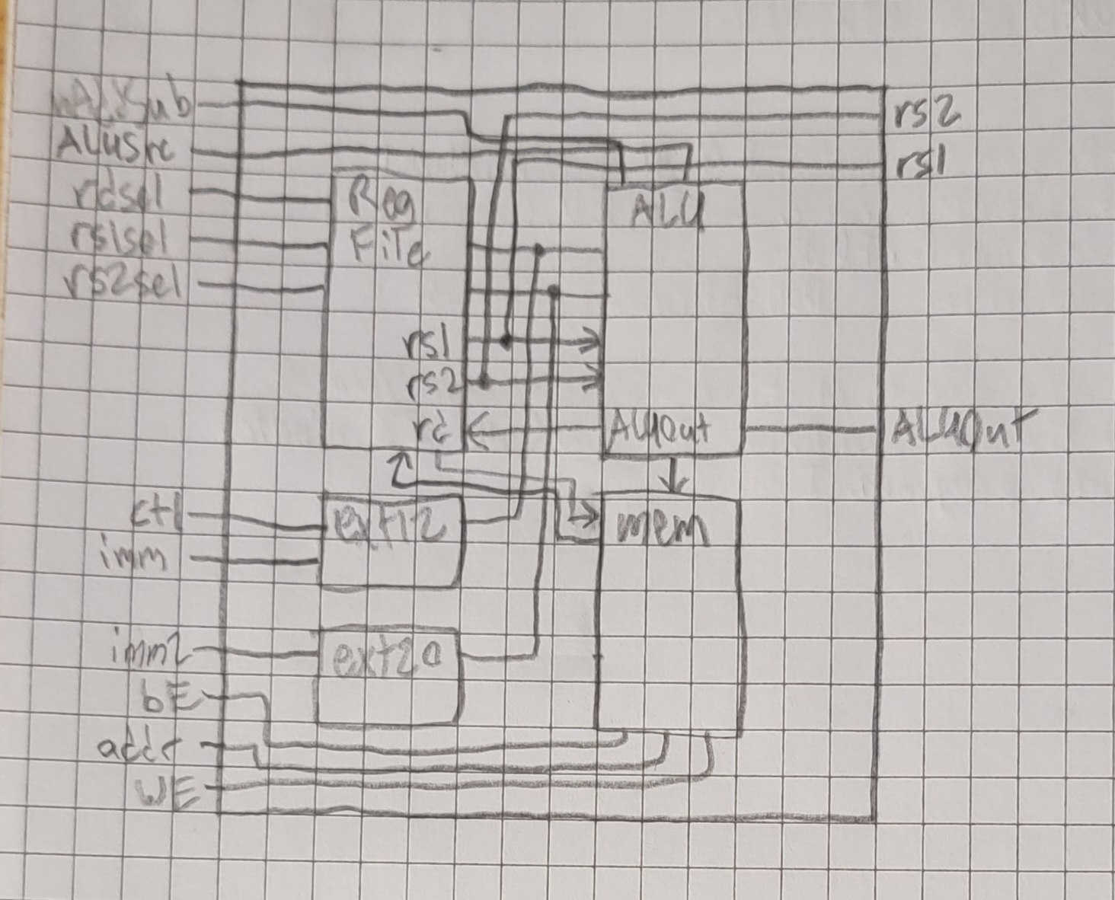

[Part 7 (c)] Waveform.
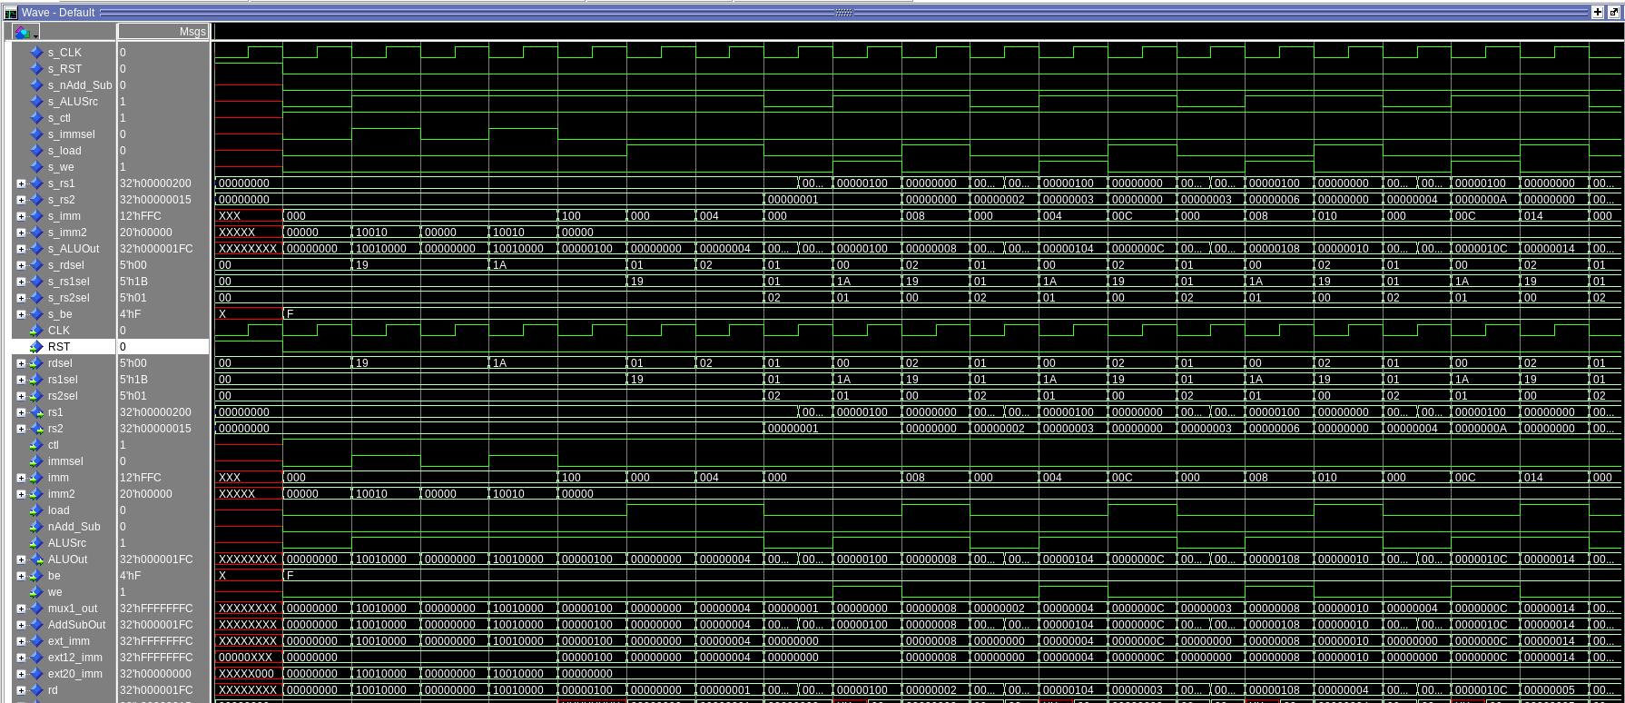
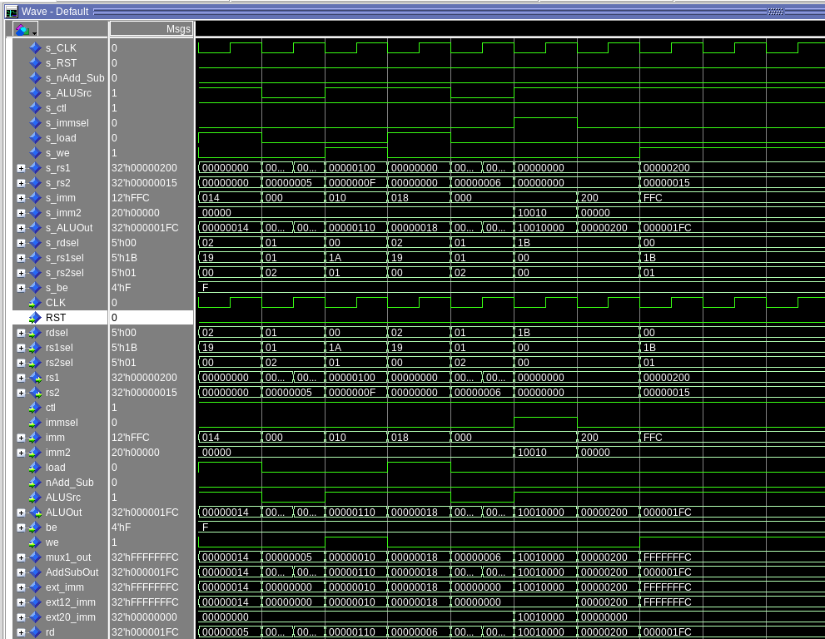
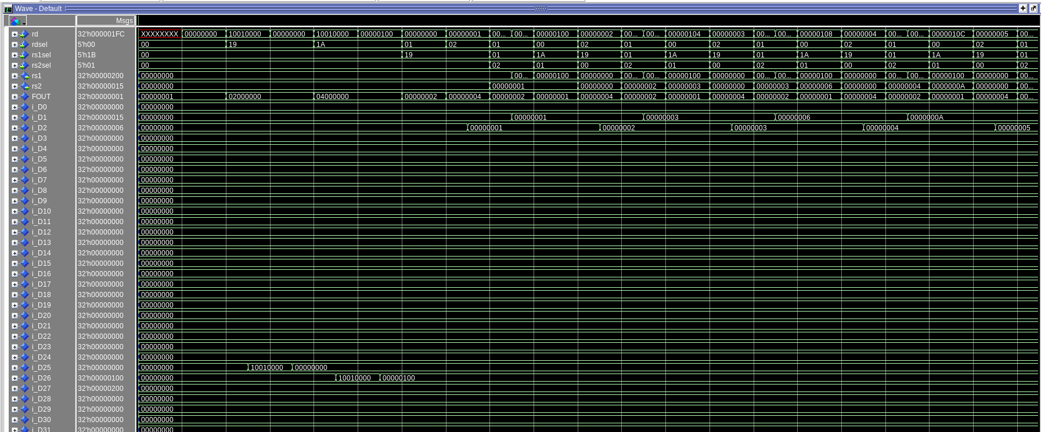
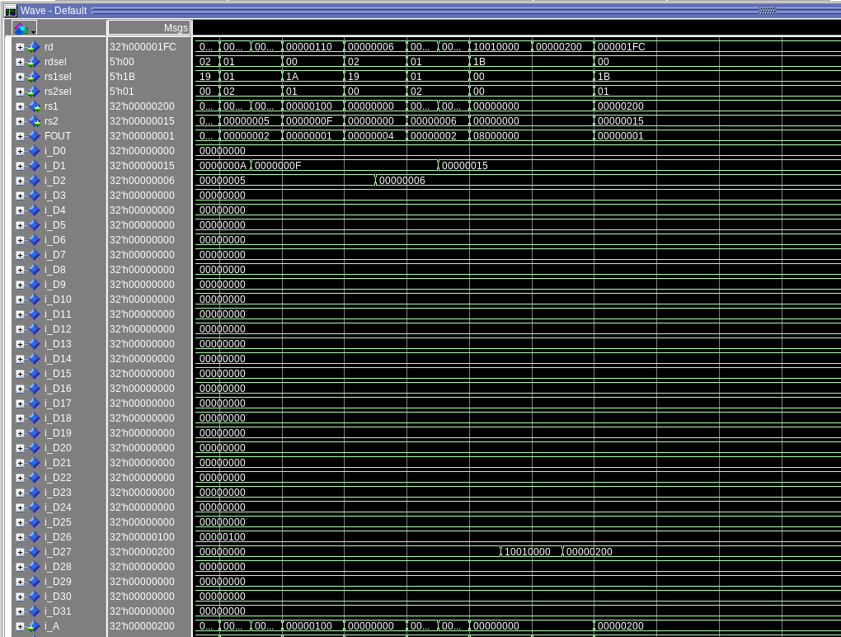
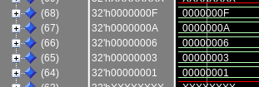

The only issue I have seen is that the dmem.hex file and mem.vhd file use word addressing whereas we use byte addressing. I fixed this by just dividing the address by 4 before fetching it from memory.

The following is the contents of the dmem.hex file. I just wrote 0 through 31 to the addresses since no official data was provided that worked for this test bench. At least not that I could find.

// File Format:
//
// The text file can contain whitespace characters, comments (C-style),
// and binary ($readmemb) or hexadecimal ($readmemh) data values. Both
// types of data values can contain x or X, z or Z, and the underscore
// character.
//
// The data values are assigned to memory words from left to right,
// beginning at start_addr or the left array bound (the default). The
// next address to load may be specified in the file itself using @hhhhhh,
// where h is a hexadecimal character. Spaces between the @ and the address
// character are not allowed. It shall be an error if there are too many
// words in the file or if an address is outside the bounds of the array.
//

00000000
00000001
00000002
00000003
00000004
00000005
00000006
00000007
00000008
00000009
0000000A
0000000B
0000000C
0000000D
0000000E
0000000F
00000010
00000011
00000012
00000013
00000014
00000015
00000016
00000017
00000018
00000019
0000001A
0000001B
0000001C
0000001D
0000001E
0000001F

[Part 7 (d)] Compare the Questasim waveform/memory list against the RARs output/memory list.
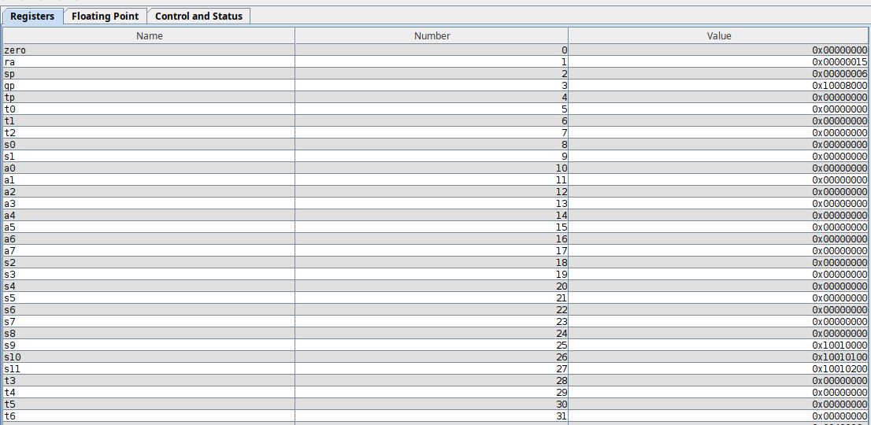
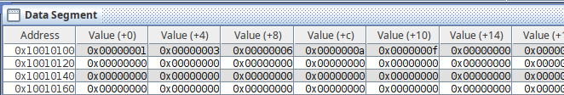

The outputs of the RARS program and the same program on my datapath are the same. Initially I messed up the addresses inputting my test cases so I fixed that and it works fine.

