**Box Models of Ozone-Depleting Substances**

Guus Velders, Oct. 2019 (adapted from Susan Solomon)

In 1977, James Lovelock published (Nature 267, p32, 1977) a landmark paper in the prestigious journal *Nature* presenting measurements of methyl chloroform, an industrial chemical that had been used as a solvent and cleaning agent. Figure 1 is the pioneering graphic that moved the science forward at that time through simple arguments. Methyl chloroform is chemically destroyed by reaction with the hydroxyl radical (OH) in the troposphere, and we now know that its global atmospheric lifetime is about 5 years. This number was very uncertain at the time when Lovelock wrote his historic paper, with some skeptics arguing that the gas couldn’t last more than a few days or weeks in the atmosphere. The paper was instrumental in establishing beyond doubt that this gas lasts for years. He made similar measurements of several other ozone-destroying gases, and is credited with being the first to establish the long lifetimes of key industrial gases. He noted some associated risks:

Lovelock noted that *‘if current theories of ozone depletion by chlorine-containing species are confirmed and if methyl chloroform is produced in ever increasing quantities for several decades….the atmospheric burden would give cause for concern.’*

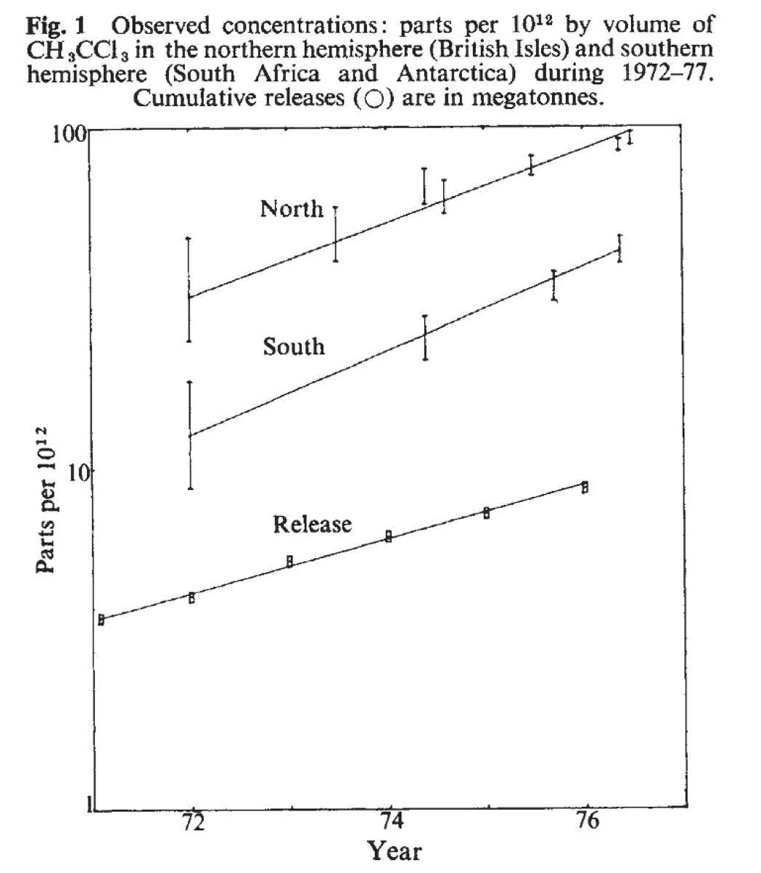

Task: Use Python to build simple box models (one- and two-box) for this gas, and use these to study how such a gas spreads between hemispheres, and how it would behave if it were phased out. Also take a look at how a much longer-lived ozone depleting substance (such as CFC-11, which has an atmospheric lifetime of about 52 years) would behave if it were emitted and phased out in a similar way.

1. Perform a series of calculations for global methyl chloroform abundance versus time based on global emissions and an assumed lifetime as your tool in a one-box model following the tutorial. Use a numerical approach and produce a graph of the total global abundance (parts per 1012 by volume, see Lovelock’s Figure 1) versus time from 1972-1990. Adopt a global atmospheric lifetime of 5 years, which makes the value of *k* in the equation below equal to 1/5 year-1. Use a value for global emissions (*P* in the equation below) by year of 0.5 megatonne per year for every year shown. Assume the global average abundance of methyl chloroform at the start of 1972 is 20 parts per 1012 by volume. The one box equation for global methyl chloroform abundance *[A]* can be written as:



Use more than one method to solve the equations.

2. Now solve this problem numerically as a two-box model, as Lovelock did. Make the same basic assumptions as in Part 1. However, assume that 100% of the world production and emission occurs in the Northern Hemisphere (NH), and allow chemical loss to occur in both hemispheres. Assume that the abundances of methyl chloroform at the start of 1972 are 30 and 10 parts per 1012 by volume in the NH and SH, respectively. Also include exchange between the hemispheres, using an exchange timescale (1/ke below) of 2 years:

NH $\overset{⇔}{ke}$ SH (Two-way exchange; *ke*)

The equations to solve are:



Produce a graph of the abundance of methyl chloroform (parts per 1012 by volume, as in Lovelock’s Figure 1) for both hemispheres versus time from 1972-1976. Compare to your one box solution in part 1. Experiment with the range of uncertainty in the value of the lifetime to see how it would affect your graph.

3. Stop all emissions abruptly in 1977 and run your model out to 1990, again using a 5 year lifetime. Graph your results. Discuss the behavior of methyl chloroform in the two hemispheres in this case.

4. Use the emissions from file to calculate the abundance from 1950 to 2016 and compare the results with observations from the AGAGE network (<https://agage.mit.edu/>).

5. Repeat the exercise of part 3 and 4 for a gas with a 52 year lifetime (CFC-11). Graph your results, and discuss the differences you obtained for the very long-lived gases compared to methyl chloroform.

6. Since 2012 CFC-11 concentrations do not decrease as fast as expected (Montzka et al., Nature 2018; Rigby et al., Nature 2019). Additional emissions originate, at least in part, from China. Try to estimate the magnitude of these emissions from the observations and your model.