Andrei Kushkin

12/18/2014

Calculating the Number of Pixels per Square Unit from a Binary Raster Using Self Adjusting Network Generating Algorithm

This Python ArcGIS tool addresses the problem of counting the number of pixels of a studied entity and turning it into a “pixels per square unit” heatmap. The algorithm was designed for working with cornfield images but should be applicable in other scopes too.

**Methods**

The script takes binary raster data as input and produces a heatmap using the IDW interpolation technique. Pixels of interest should have integer values of 1, all other pixels should be zeros or “NoData”.

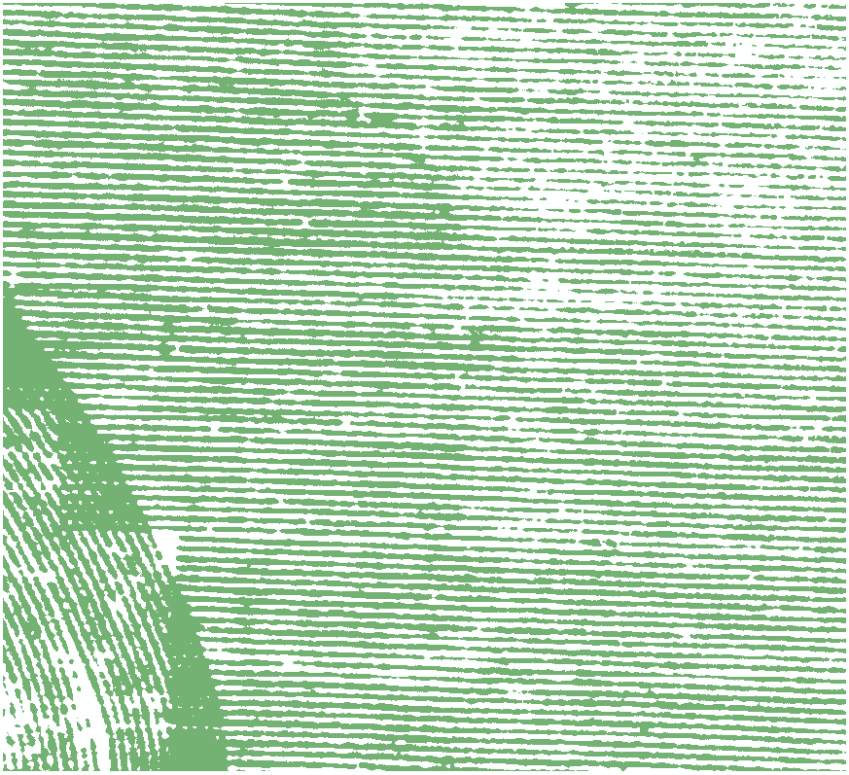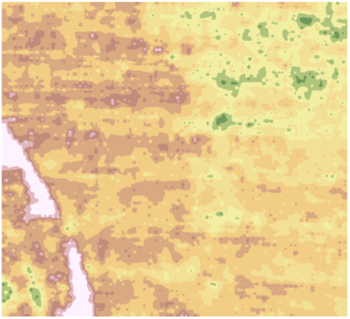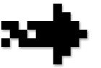

First, the input raster is converted to a vector using the *raster to polygon* tool.

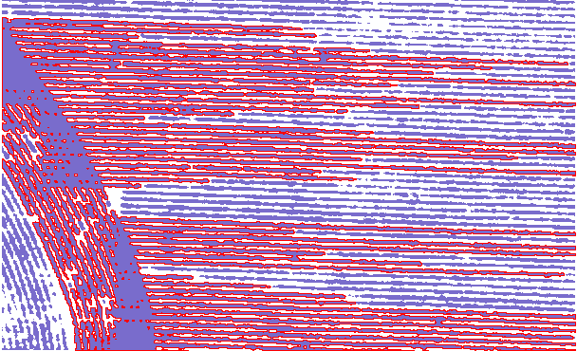

Example of a big polygon highlighted in red.

Next, obtained polygons are split with a regular grid. To do that, a fishnet must be generated. The cell size of this fishnet is one of the input parameters of the tool and should be set based on input raster size and resolution. A one-by-one meter fishnet is generated by default. The extent of the input raster is automatically considered for generating intermediate and final data outputs.

Once the fishnet is generated, polygons are cut with *Intersect* tool. The output might contain multipart polygons and are turned into single-part polygons using the *Multipart To Singlepart* tool. Then the polygons that are too small are filtered out to obtain a cleaner result and reduce the computational load. To do this, *select by attribute* is applied, using the area field from the attribute table. The threshold for polygon filtering is another optional parameter of the tool and is 0.1 square meters by default.

The next step is generating centroids of the remaining polygons with the *Feature to point* tool. These points serve as “centers of gravity” to which the network is adjusted to follow the distribution of the studied phenomena.

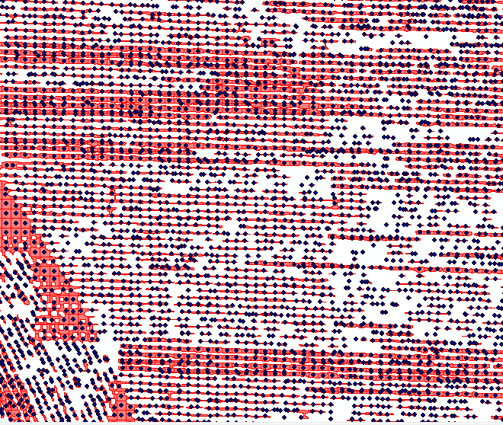

Corn point overlaid on polygons cut with a fishnet.

Next, the *Thiessen polygons* tool is applied to the points and that is how the adjusted network is produced. The screenshot below shows corn (light blue), corn points or “centers of gravity” (dark blue), and Thiessenpolygons.

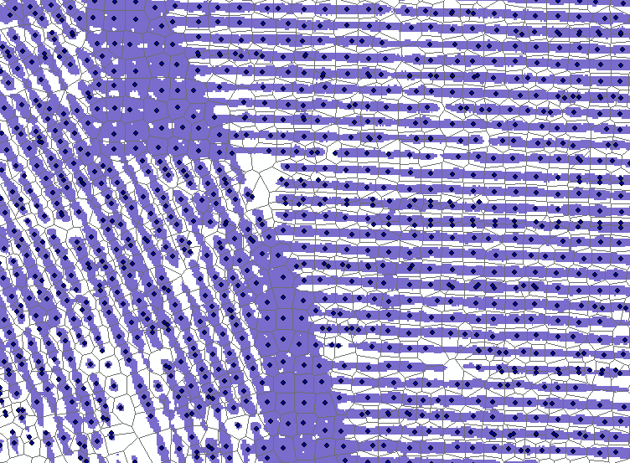

Since a grid was used to cut initial corn polygons, Voronoi polygons are about the same size.

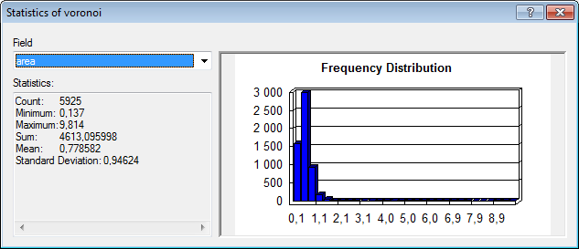

Distribution of Voronoi polygons area

This distribution still shows some variety, which might be reduced by aggregating points sitting close to each other, or additional processing of Voronoi polygons (select smallest polygons by area, cut and paste to a new layer, unite all polygons to a multi polygon, adjacent polygons should be merged, then explode multi polygons to a group of single polygons and insert them back to the original Voronoi polygon layer). This additional processing is not implemented in the current version of the tool.

To get pixels per area count, the area and number of pixels in each Thiessen polygon need to be calculated. The number of pixels in each Thiessen polygon is obtained using the *Zonal statistics* tool. Binary corn raster and Thiessen polygons are inputs to this tool.

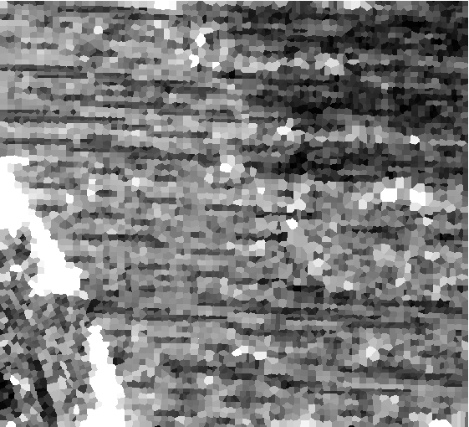

Number of corn pixels in each Thiessen polygon.

A Raster with the area of each Thiessen polygon is generated using the *Zonal geometry* tool. This tool uses Thiessen polygons as input. Generated rasters must have the same pixel size, which is done automatically, by applying the cell size of the initial binary raster.

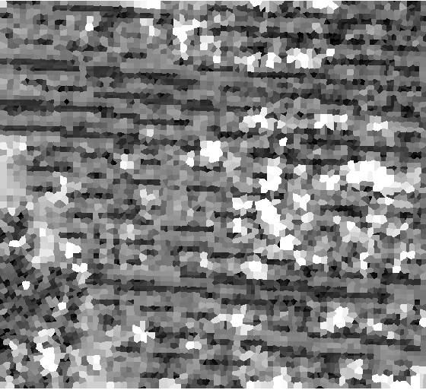

Area of each polygon

Map algebra (*Raster calculator*) is then used to calculate pixels per square unit raster. Pixel count raster is simply divided by area raster.

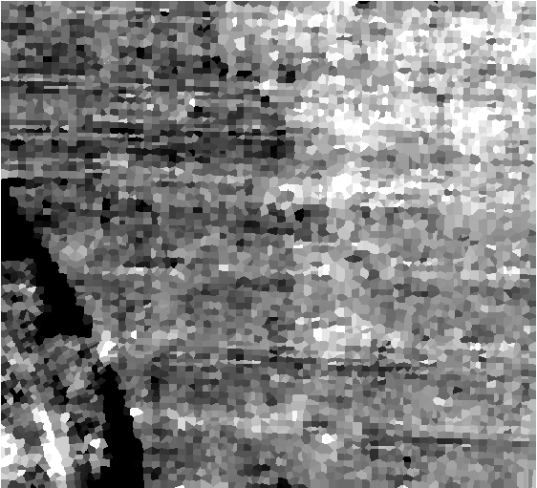

Pixels per square meter in each Thiessen polygon

The last step is producing a heatmap. Pixels per square unit values are extracted to points *(Extract values to points* tool). The point shape file generated previously can be used here if there were no changes in Thiessen polygons. If there were, a new set of points should be generated (*Feature to point* tool) from the final Thiessen polygons.

The last step is the interpolation of obtained points to a surface. There are multiple options available in ArcGIS under *Spatial analyst tools/Interpolation*. At this point, the IDW interpolation is used.

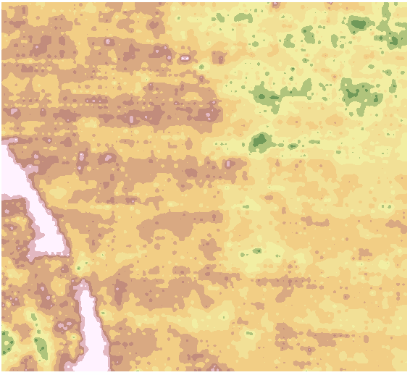

Heatmap. White and red – more corn, yellow and green less corn.

The code consists of several logic steps: importing modules, setting up the environment, getting parameters from the tool interface, applying tools, and clearing memory. The overall logic structure of the code is sown by the flowchart:

