Robotics project with Arduino
Introduction
Under the guidance of four students and one professor from Worcester Polytechnic Institute, we had to design and implement a robot using Arduino. We decided to build a robot which would be able to avoid the obstacles and as a second mode it should be controlled by an android phone. However, we wanted to make this project more challenging, so we decided to build a third mode, one that made the robot follow us.

Part I: Hardware Components
Here are the features we decided our robot will have:
- It should be a vehicle that can move forward, backwards and turn.
- It should be easy to assemble and disassemble.
- It should have a mode in which it is able to move on its own, detecting obstacles ahead and avoiding them.
- It should have a mode in which it can be fully controlled from our Android smartphone.
- It should have a mode in which it can follow us.
- It should be easy to hack, change and improve.
Shopping list :
Ultrasonic Range Finder

Bluetooth Serial Module

Motor

Wheels

Dual Motor Controller

Ball Caster

Logic Level Converter

The Arduino board :
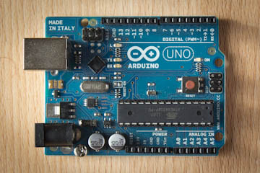

Arduino is the brain of the robot, it controls all other parts of the robot and also the code will be stored in there.
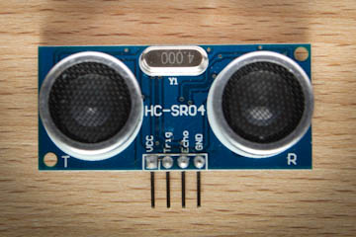
Ultrasonic range finder

Distance sensors send an ultrasonic signal forward and then wait to receive a bounced signal. Depending on how long the signal takes to bounce back the approximated distance to an obstacle can be calculated. We will use this little device to prevent the robot from hitting walls or other obstacles in its way and detect the person’s movement (in the third mode)

Bluetooth Serial Module
The easiest way to control the robot from a smartphone is via the Bluetooth serial interface that all modern smartphones have.
The motor driver
The Arduino board cannot directly control a motor. The tricky part is to be able to make the motor selectively run forward or backwards, which requires swapping power and ground inputs into the motor.
Breadboard and Jumper cables
We will use them to connect components together.
The vehicle kit
We will use an aluminum board and a foxy glass board and we will connect them together .
Wheels
There will be two wheels.
Motors
There will be two DC motors which will run the wheels.
Ball Caster
The ball caster will work as a third wheel.

Part II: Programming the Arduino
We couldn’t use an Arduino if we didn’t know how it works. That’s why we were trained the first two weeks to program the arduino.
Here is a diagram of a typical Arduino board :
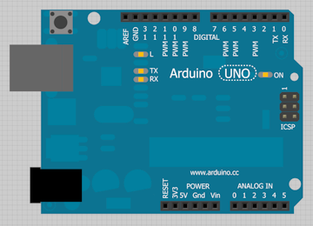
On the left side it is the USB port (grey box) and the power input jack (black box). During testing we will power our Arduino with a USB cable, but the final robot will receive power from a battery box connected to the power input jack.
On the top, from right to left there are 14 pins labeled 0 to 13. These are the digital pins. These pins can be individually configured as inputs or outputs, meaning that digital data can be read or written from connected devices on these pins. Since these pins are digital, they have only two possible states, HIGH and LOW.
Part III: Assembling the Robot
After we got the parts and made some calculations about the length, width and height of the robot, we cut the boards (aluminum and foxy glass). Then we created a 3D view of the robot.
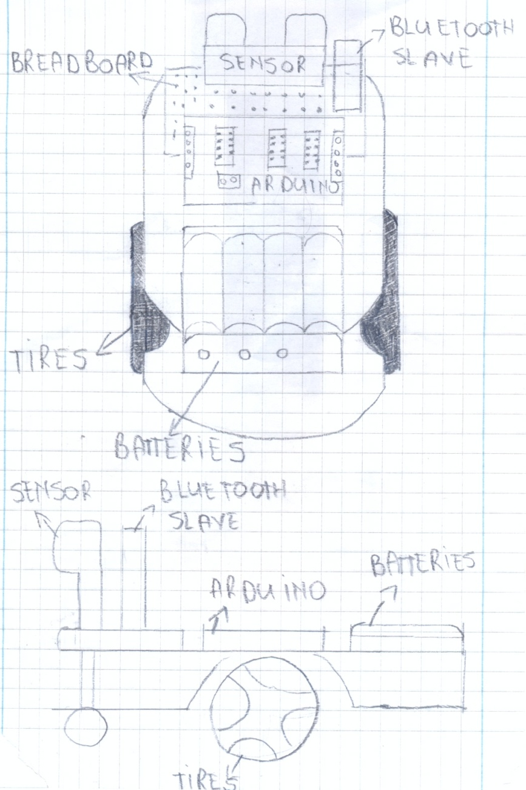
3D views
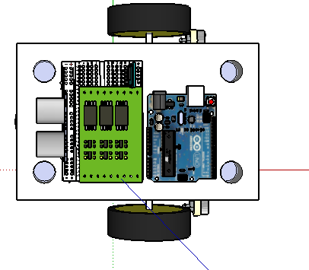
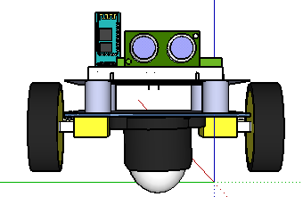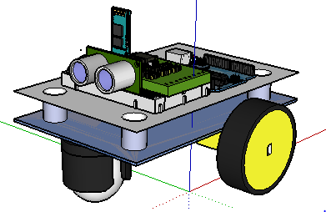

Part VI Circuit schematics :
A very important part of our project was the connection of the components with each other. All the components should be wired with the arduino, which serves as an interface between dhe hardware parts and the software program.
Ultrasonic range sensor
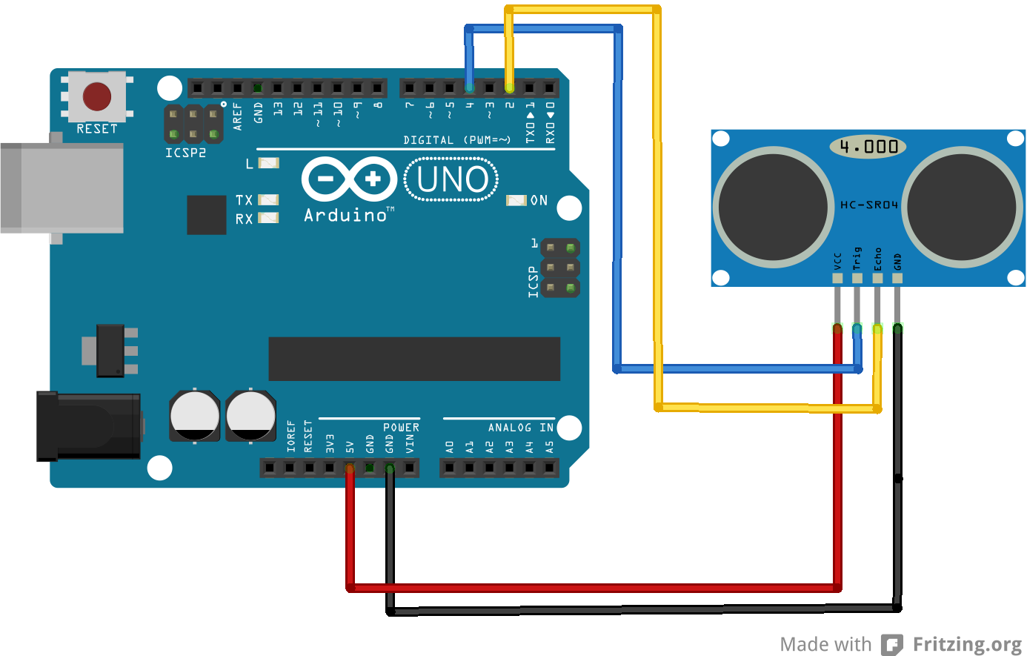
The ultrasonic range sensor has 4 pins: Vcc, Trig, Echo and GND. The Vcc pin will be connected with the 5V pin of the arduino, Trig and Echo pins can be connected with any of the available pins of the arduino, we have used the digital pins 2 and 4. The GND pin will be connected with the GND pin of the arduino.

Bluetooth slave and bidirectional logic converter
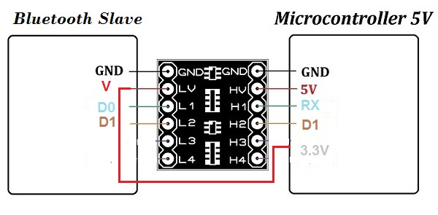
The first problem that we had with the bluetooth slave was the operating voltage of 3.3V. We should convert the logic levels and the voltage of 5V that we can take from arduino. So, we decided to use a bidirectional logic level converter. The LV side will be used to connect the pins of the bluetooth slave and the HV side will be used to connect the pins of arduino. The V pin goes to LV , HV goes to 5V of arduino, also we connect the LV with the 3.3V of the arduino, D0 goes to LV1, HV1 goes to RX of arduino (digital pin 0). We don’t need to use the D1 pin of the bluetooth slave.
Dual motor driver
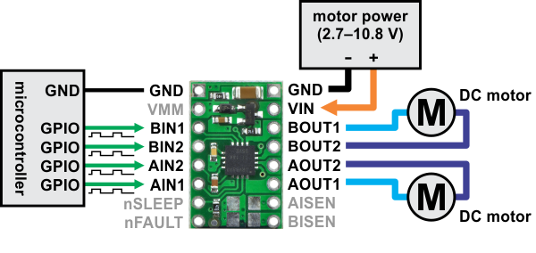
Arduino can not move the DC motors on itself so we decided to use a dual motor driver. It has 16 pins, but we use only 10 of them. The circuit can be supplied with a voltage 2.7V-10.8V. We use 6V (4x1.5V batteries). The first motor connects with BOUT1 and BOUT2 pinS and the BIN1 with BIN2 are connected with PWM pins of the arduino, to modulate the duty cycle and change the speed of the DC motors (when the robot turns, the speed should be slower than when it moves forward). The second motor connects with AOUT2 and AOUT1 pinS and the AIN2 with AIN1 are connected with PWM pins of the arduino, to modulate the duty cycle and change the speed of the DC motors (when the robot turns, the speed should be slower than when it moves forward).
We also used the Fritzing program for the connection of components.
Breadboard view

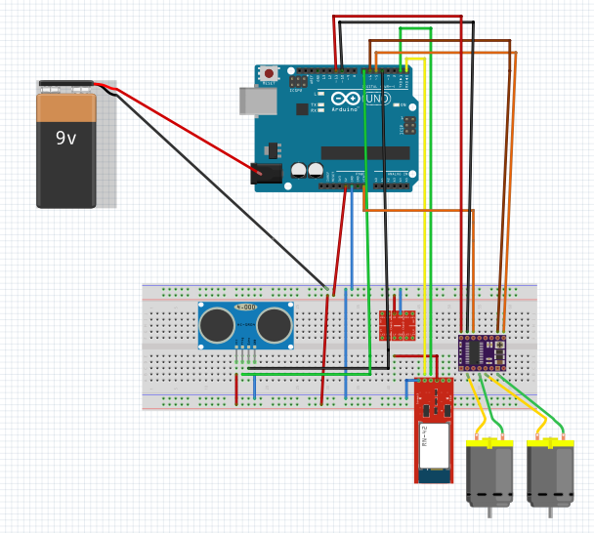

Schematic view
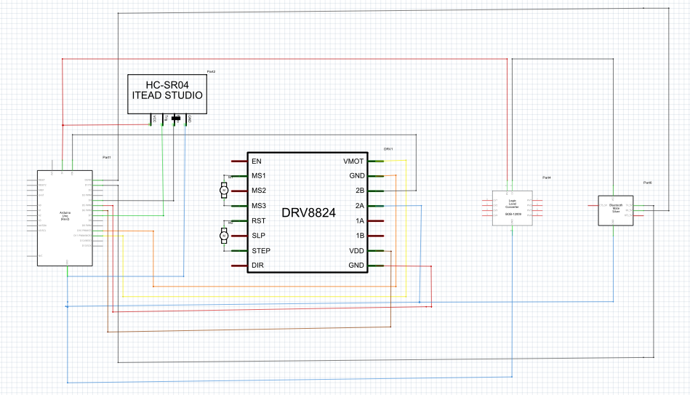
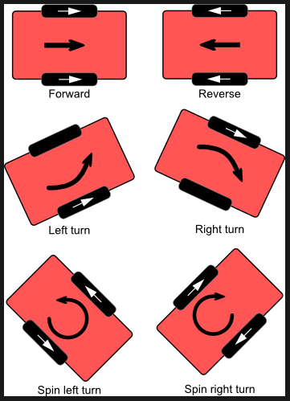
Part V Programming the robot:
The robot has three modes:
1. Random mode
2. Remote Control Mode
3. Following mode

The 1st mode of the robot (the random mode)
In order to program this mode we created two states:
- Drive forward
- Turn
We sat the initial state to drive forward and then the ultrasonic range finder calculates the distance of nearby objects. If the sensor calculates a distance equal to or less than 30cm, the state will set to turn. In this state the robot will turn approximately 90 degrees to avoid the obstacle.
The 2nd mode of the robot (the random mode)
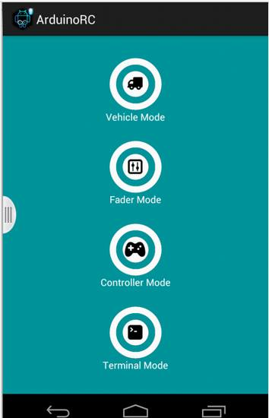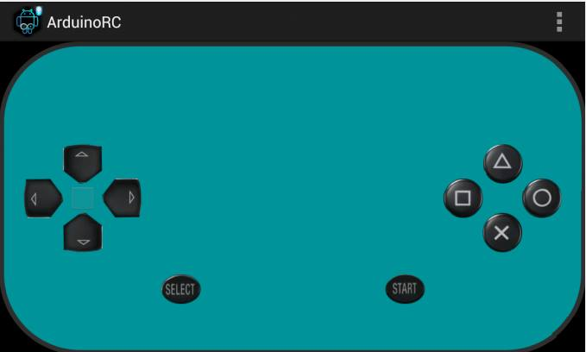

After we solved the hardware problems with the Bluetooth module, we downloaded the app “Arduino Bluetooth Controller” and configured the commands. Then, the code was done straightforwardly.
As we can tell from the name of this mode robot will move in a random mode and it will be able to avoid the obstacle.

The 3rd mode of robot movement (the following mode)
This is the mode which created us a lot of problems. Nevertheless, after working hard and having a lot of debugging we finally made it.
In order to built it successfully we created three states:
- Search forward
- Search left
- Search right
Then we created a simple algorithm: 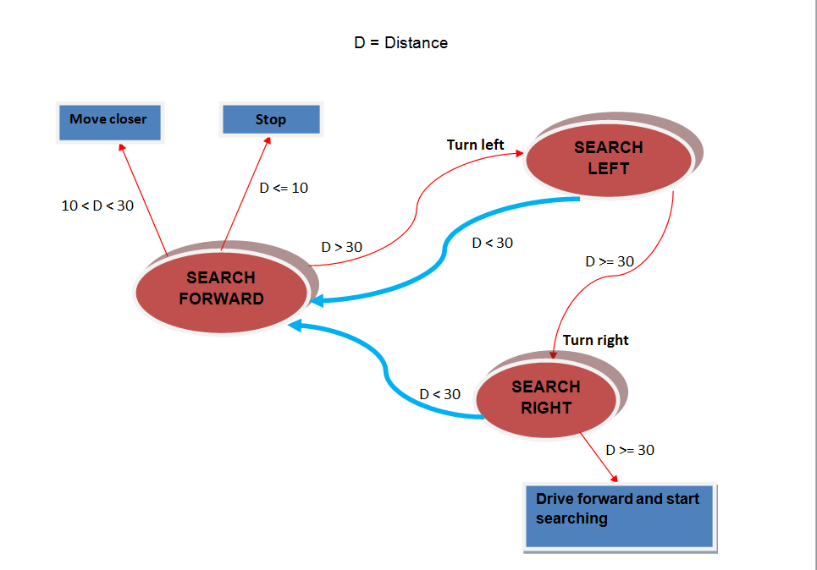

After we successfully completed all three modes separately, we had to merge them into one single code and file. It seemed a bit difficult at first but after we sat down and started to code, we did it step by step. We configured the Bluetooth app that we got for the second mode:
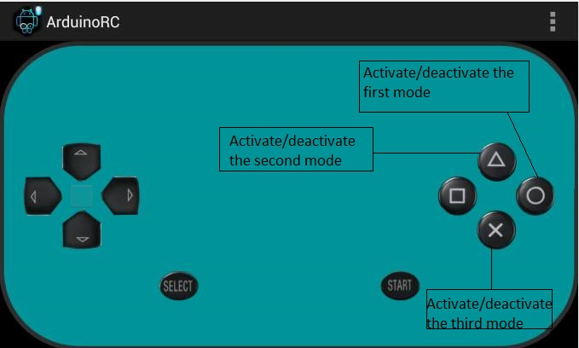
In conclusion, the robotics project was a successful one as we completed all our goals. During this project we worked hard and learned a lot. We are now eager to continue working on similar projects.

