HealthCare Data Metrics Project
Summary:
Build an AWS-native data pipeline that ingests CMS nursing home staffing data from CSV, transform it through a three-layer medallion architecture using Delta Lake on S3, run automated data quality checks before publishing, and surface the results through a Streamlit dashboard. The whole thing is orchestrated by AWS Glue Workflow with email alerts on success or failure.
Architecture:
The architecture has six stages, all implemented inside a single Glue Workflow using Pyspark:
Ingestion
- Bronze Ingestion. Authenticates to the Google Drive API using a service-account key stored in AWS Secrets Manager. Only relevant CSV files are ingested into bronze layer: PBJ_Daily_Nurse_Staffing_Q2_2024.csv and NH_ProviderInfo_Oct2024.csv.
  - Bronze Layer ensures data is sanitized – ready for Delta format.
  - Data written directly to S3 and registered in Glue Catalog via Spark SQL
  - PBJ file will feed the fact table and NH_Provider will feed the dim table

Cleaning and Transformation (STAR Schema Format)

- Silver DIM Table Creation. The second job gets latest snapshot from bronze using load_date. Gets all the columns needed for dim_provider from NH_provider.
  - Cleans and transforms data for DIM table dim_provider using type casts, aliases and Booleans.
  - Data written to S3 and registered in Glue Catalog
- Silver FACT Table Creation. Third job retrieves necessary data from bronze PBJ file to get frequently changing data.
  - Grain: one row per provnum and workdate (Primary keys).
  - Data is merged or inserted based on primary key on all runs and re-runs
  - Data is partitioned by quarter as CMS updates every quarter.
  - Hourly metrics are calculated here and joins if necessary.

Data quality checks, notifications and gold creation

- Data Quality Checks. Five checks are completed here before moving to gold:
    - PBJ_daily has at least 1M rows (catches empty or partial load)
    - Primary keys are not null (Integrity of PK)
    - Primary keys are unique (catches merge bugs and grain integrity)
    - HPRD (Hours Per Resident Day) is between 0-35. (catches any unit errors, nurses per resident wouldn’t normally have over certain number of hours)
    - Workdate is not in future (bad date casts)
- Gold Layer. Focus is to aggregate and join data into different tables to be used by dashboard (Streamlit). All four tables are full overwrites each run
  - Facility_summary – one row per facility
  - State_summary – one row per state
  - Facility_monthly_trend – provnum * year_month
  - State_monthly_trend – state * year_month
- SNS Notification. Simple python script to send failures and success to email. In the workflow, glue job parameters are used to indicate workflow component, message, status and SNS ARN.
Workflow Orchestration:
- Workflow A, nh-pbj-quarterly, is the primary workflow that will get run quarterly(when CMS delivers updated data)
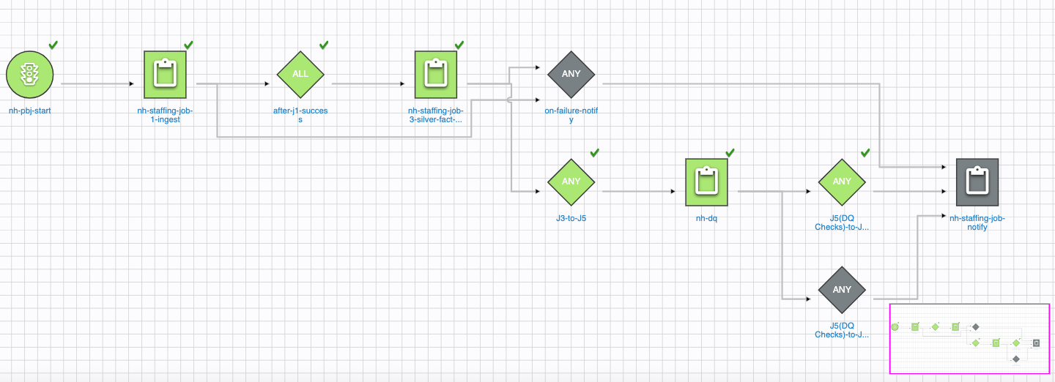
- Workflow B, nh-providerinfo-refresh, gets run less often, just to refresh the Dim provider info.
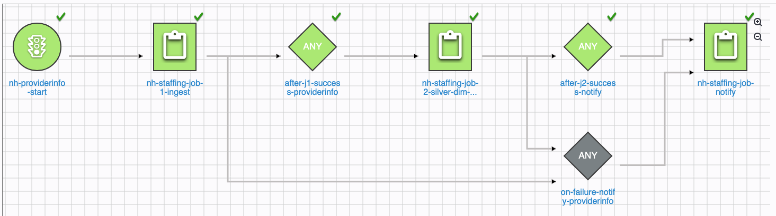

Architecture Diagram:

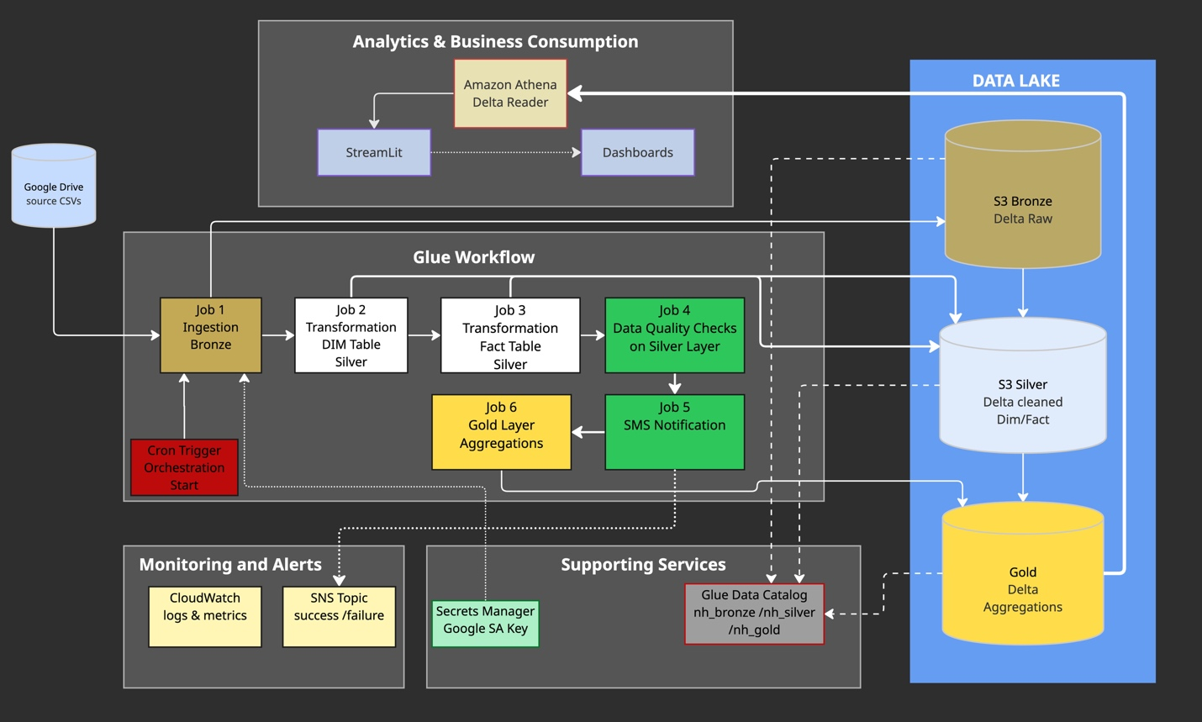

Dashboards:
The gold layer contains 4 tables pre-aggregated for simpler and faster dashboard creation. Each table is a source for a specific visualization.
- A refresh python script(refresh-data.py) is run each time locally and produces 4 parquet files in a data folder to be used by Streamlit application.
- Main script called app.py is run to create the streamlit dashboards.
  - Summary
  - 3 tabs for each metric
  - Within each tab, the dashboards
Below are some samples of dashboards created:
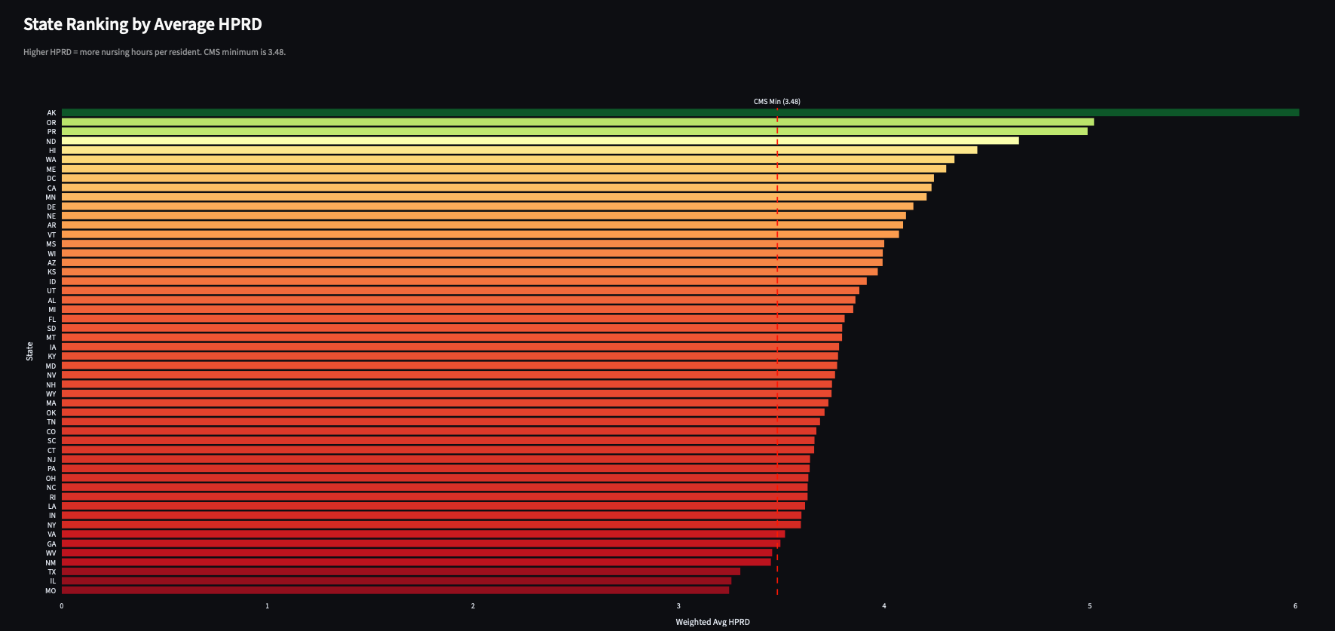

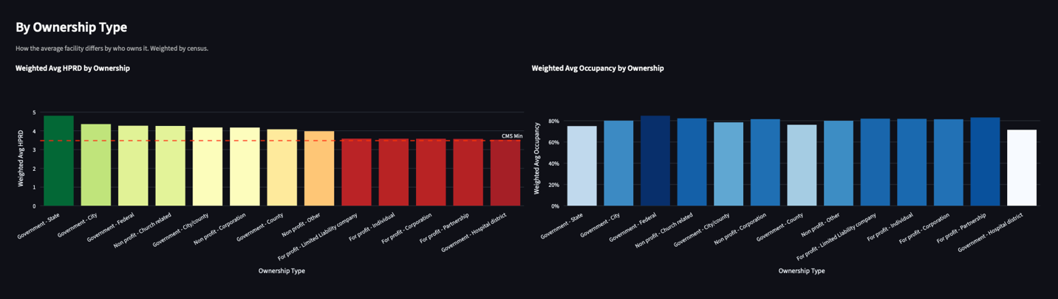

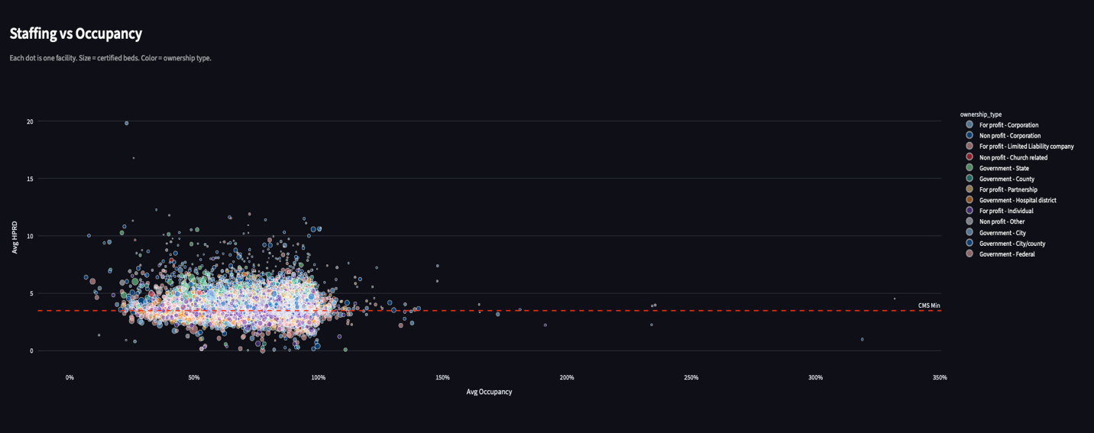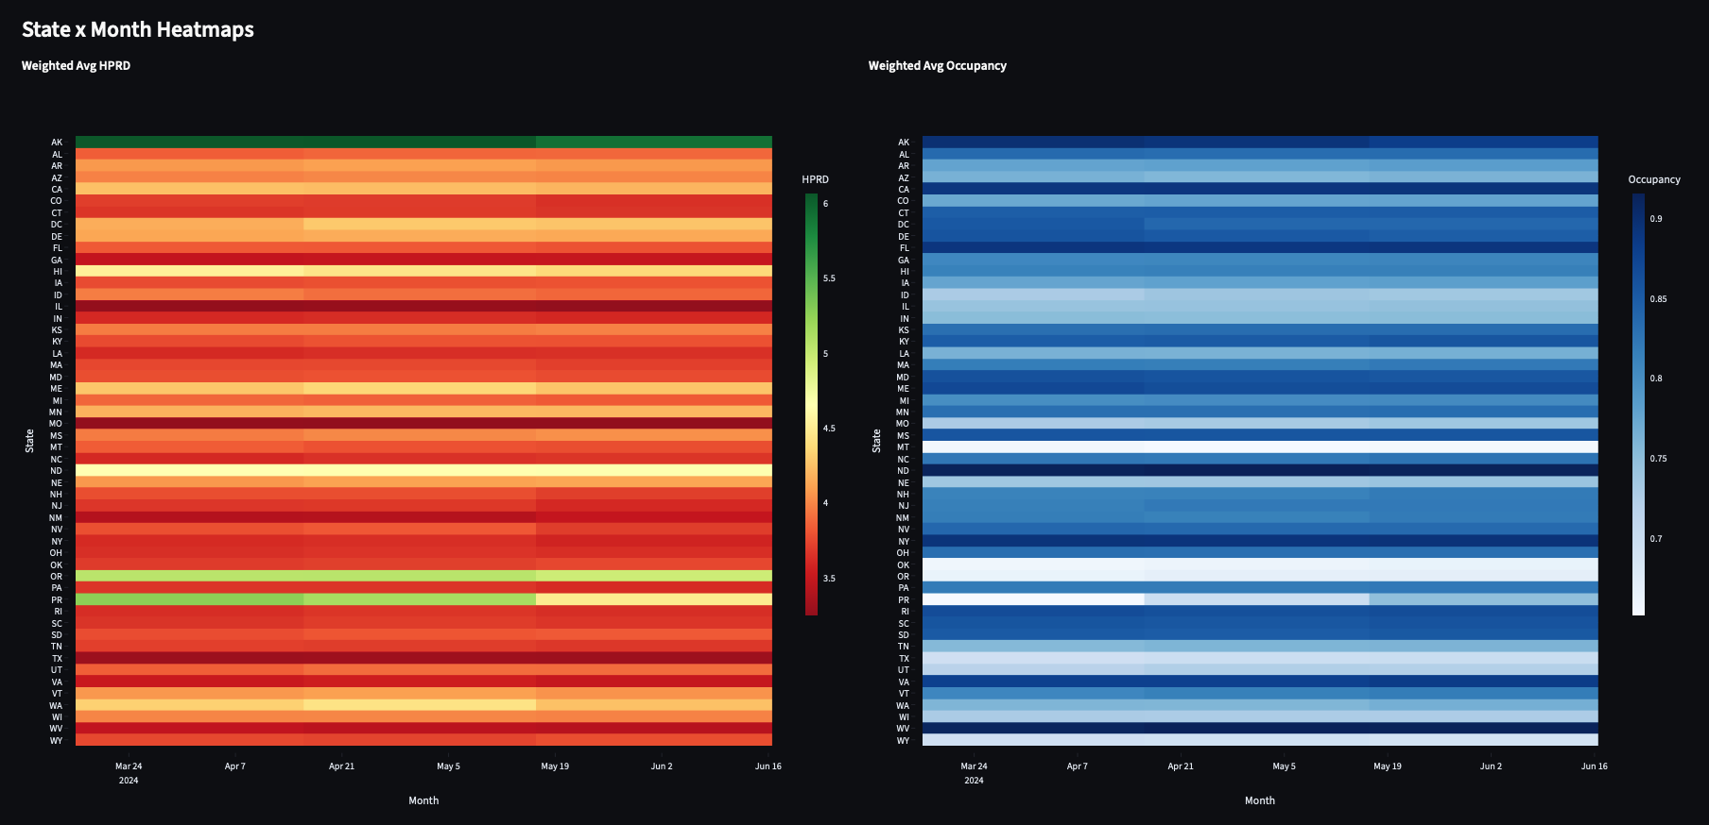
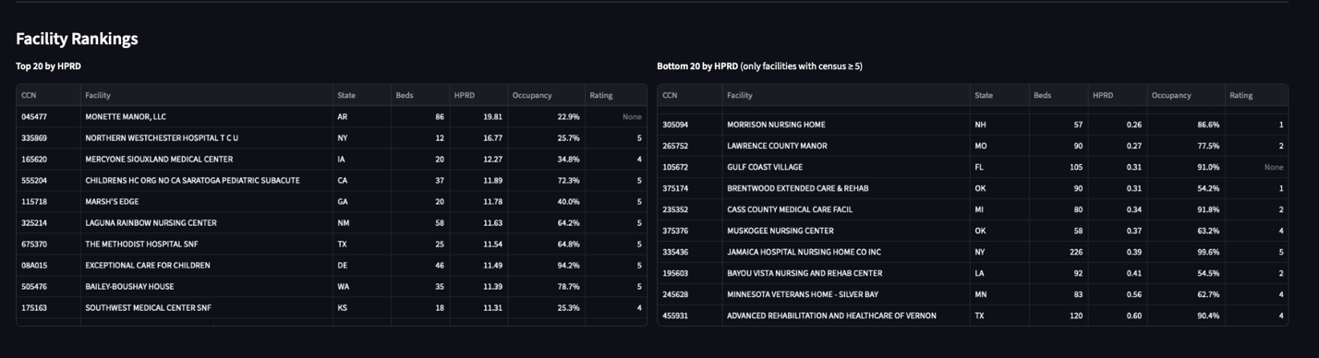

Key Metrics:
HPRD  (Hours per Resident Daily) | total_nurse_hours / mdscensus | Hours of nursing care per resident per day. Headline  staffing metric.
Occupancy rate | mdscensus / certified_beds | Fraction of beds occupied. 1.0 = fully occupied.
Nurse-to-patient ratio | mdscensus / (total_nurse_hours / 24) | Residents per concurrent nurse on shift, averaged across  the day.
Contractor % | contractor_hours / total_nurse_hours | Share of nurse hours from agency/contract staff. Higher =  more staffing strain.
Weighted average HPRD | sum(hprd * mdscensus) /  sum(mdscensus) | State or ownership rollup. Census-weighted so larger  facilities count more.
mdscensus | Minimum Data Set Census | Count of residents in the facility that day

