CS 385 – FINAL REPORT

RACHAEL GRABOWSKI & MICHAEL LANG

# INSTRUCTION SET

|  |  |  |  |  |  |
| --- | --- | --- | --- | --- | --- |
| **Name** | **Syntax** | **Meaning** | **Format** | **Opcode** | **Encoding** |
| **Add** | add $d, $s, $t | $d 🡨 $s + $t | R | 0000 | 0000 sstt dd-- ---- |
| **Subtract** | sub $d, $s, $t | $d 🡨 $s - $t | R | 0001 | 0001 sstt dd-- ---- |
| **And** | and $d, $s, $t | $d 🡨 $s & $t | R | 0010 | 0010 sstt dd-- ---- |
| **Or** | or $d, $s, $t | $d 🡨 $s | $t | R | 0011 | 0011 sstt dd-- ---- |
| **Add Immediate** | addi $t, $s, C | $t 🡨 $s + C | I | 0100 | 0100 sstt CCCC CCCC |
| **Load word** | lw $t, C($s) | $t 🡨 DataMem[$s+C] | I | 0101 | 0101 sstt CCCC CCCC |
| **Store word** | sw $t, C($s) | DataMem[$s+C] 🡨 $t | I | 0110 | 0110 sstt CCCC CCCC |
| **Set on less than** | slt $d, $s, $t | $d = ($s < $t) | R | 0111 | 0111 sstt dd-- ---- |
| **Branch on equal** | beq $s, $t, C | if ($s == $t) goto C | I | 1000 | 1000 sstt CCCC CCCC |
| **Branch on not equal** | bne $s, $t, C | if ($s != $t) goto C | I | 1001 | 1001 sstt CCCC CCCC |
| **Shift left logical** | sll $d, $t, shamt | $d 🡨 $t << shamt | R | 1010 | 1010 --tt ddaa aa-- |
| **Shift right logical** | srl $d, $t, shamt | $d 🡨 $t >> shamt | R | 1011 | 1011 --tt ddaa aa-- |
| **Jump** | j C | PC 🡨 C | I | 1100 | 1100 ---- CCCC CCCC |

Our implementation of a 16-bit mini pipelined MIPS machine (using gate modeling and behavioral modeling in Verilog) includes the following instructions: add, sub, and, or, addi, lw, sw, slt, beq, bne, sll, srl, j (see the table above for corresponding OP codes).

|  |  |  |  |  |  |
| --- | --- | --- | --- | --- | --- |
| **R-Format** | | | | | |
| **OP** | RS | RT | RD | shamt | Unused |
| **4** | 2 | 2 | 2 | 4 | 2 |

|  |  |  |  |
| --- | --- | --- | --- |
| I-Format | | | |
| OP | RS | RT | Address/Value |
| 4 | 2 | 2 | 8 |

# Major Component Descriptions

## Instruction Memory

The instruction memory is represented by our input.hex file (see “input.hex” below)

## ALU

The ALU is a 16-bit ALU comprised of four 4-bit ALUs. It is capable of detecting overflow and zero.

## Register File

Register r0 is static 0 (it cannot change or be changed). The register file is 4-word by 16-bits-per-word.

## Control Unit

The mainCtrl unit takes IFID_InstrMem[15:12] as input, and outputs a control signal to the IDEX register. The control options are: RegDst, BEQ, BNE, MemToReg, MemWrite, ALUsrc, RegWrite, SLL, SRL, and ALUctl.

## input.hex

The input.hex file is how we loaded our code into our program, instead of hard-coding our testing instructions. This made it very easy to swap between different sets of instructions for testing at various points in the project. MIPS ASM instructions were converted into binary, and those binary instructions were then converted into hex instructions. Those hex instructions were then read by the CPU module into instruction memory.

# DIAGRAM

Diagram is best viewed at 250% or larger

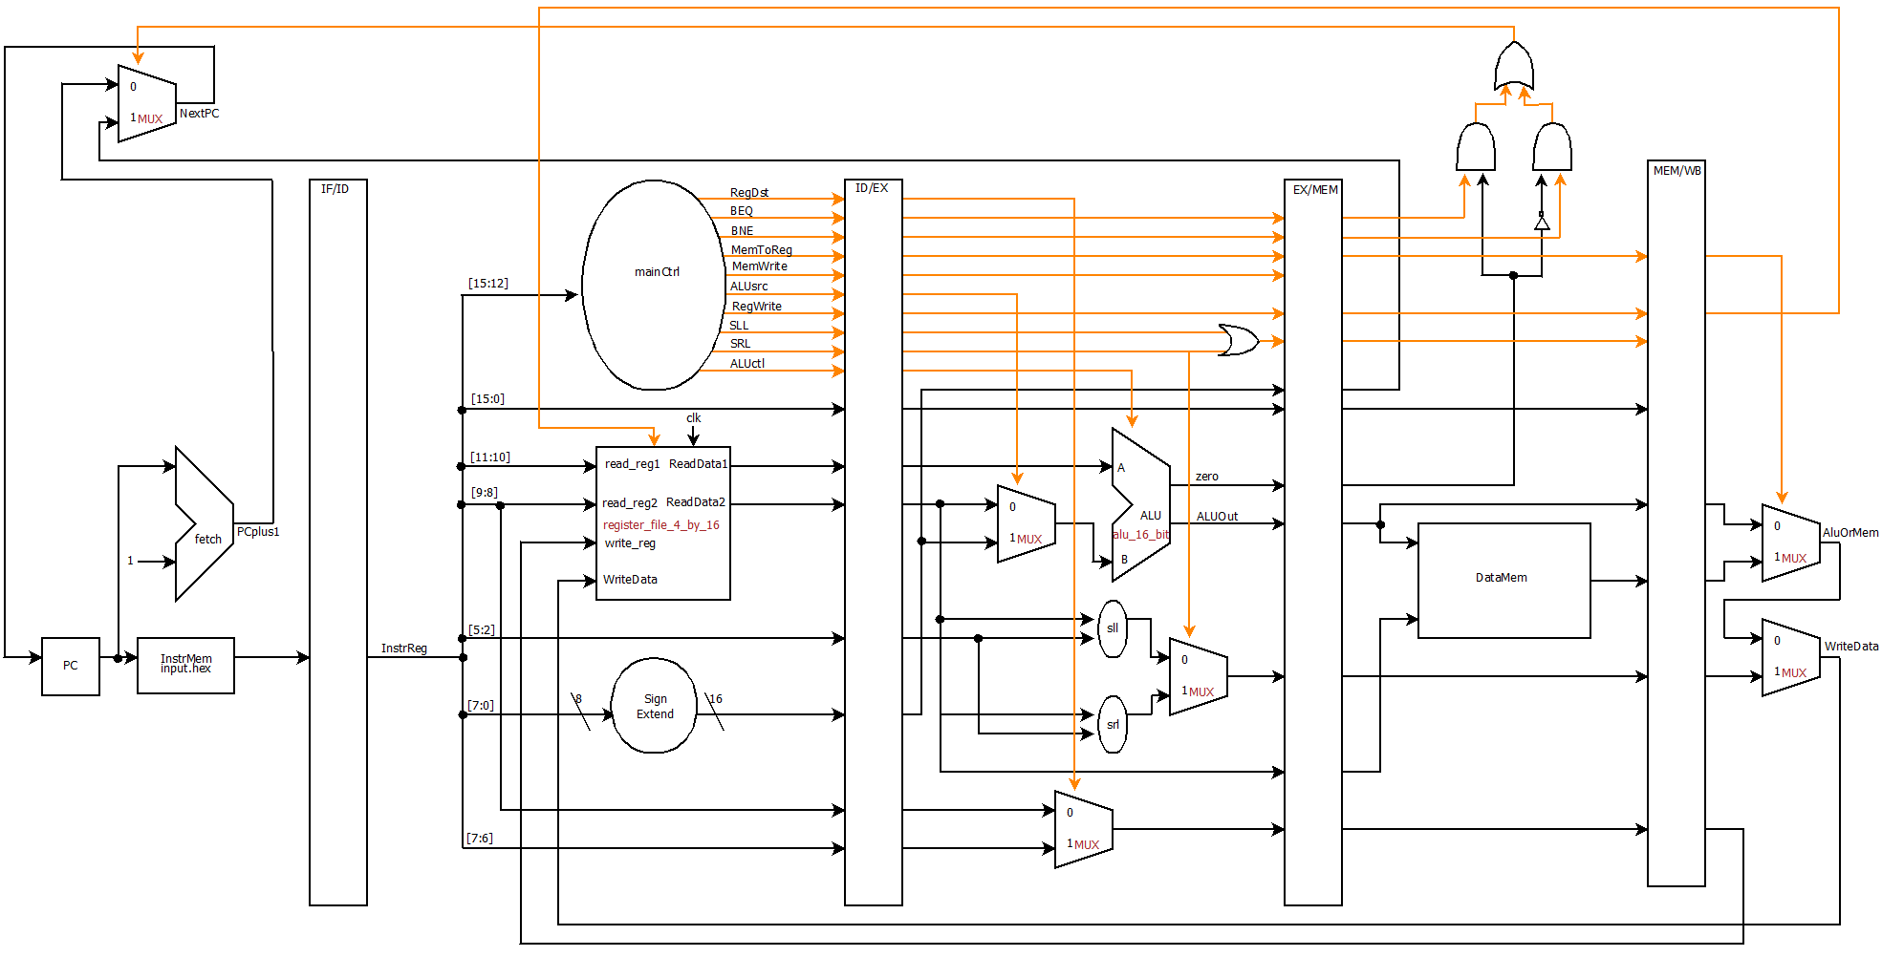

# VERILOG SOURCE CODE

## module alu_1_bit(result, c_out, a, b, less, c_in, op);

input a, b;

input less;

input c_in;

input [2:0] op;

output result, c_out;

wire m, n, p, q, r;

not g1(m, b);

mux_2_to_1 mux1(n, b, m, op[2]);

and g2(p, a, n);

or g3(q, a, n);

full_adder fa(r, c_out, a, n, c_in);

mux_4_to_1 mux2(result, p, q, r, less, op[1:0]);

endmodule

## module alu_1_bit_msb(result, overflow, set, c_out, a, b, less, c_in, op);

input a, b;

input less;

input c_in;

input [2:0] op;

output result, overflow, set, c_out;

wire m, n, p, q;

not g1(m, b);

mux_2_to_1 mux1(n, b, m, op[2]);

and g2(p, a, n);

or g3(q, a, n);

full_adder fa(set, c_out, a, n, c_in);

mux_4_to_1 mux2(result, p, q, set, less, op[1:0]);

xor g4(overflow, c_out, c_in);

endmodule

## module alu_4_bit(result, zero, c_out, a, b, less, c_in, op);

input [3:0] a;

input [3:0] b;

input less;

input c_in;

input [2:0] op;

output [3:0] result;

output zero, c_out;

wire p, q, r, s, t;

alu_1_bit alu_0(result[0], p, a[0], b[0], less, c_in, op),

alu_1(result[1], q, a[1], b[1], 0, p, op),

alu_2(result[2], r, a[2], b[2], 0, q, op),

alu_3(result[3], c_out, a[3], b[3], 0, r, op);

or g1(s, result[0], result[1]),

g2(t, result[2], result[3]);

nor g3(zero, s, t);

endmodule

## module alu_4_bit_last(result, overflow, set, zero, c_out, a, b, c_in, op);

input [3:0] a;

input [3:0] b;

input c_in;

input [2:0] op;

output [3:0] result;

output overflow, set, zero, c_out;

wire p, q, r, s, t;

alu_1_bit alu_0(result[0], p, a[0], b[0], 0, c_in, op),

alu_1(result[1], q, a[1], b[1], 0, p, op),

alu_2(result[2], r, a[2], b[2], 0, q, op);

alu_1_bit_msb alu_3(result[3], overflow, set, c_out, a[3], b[3], 0, r, op);

or g1(s, result[0], result[1]),

g2(t, result[2], result[3]);

nor g3(zero, s, t);

endmodule

## module alu_16_bit(result, overflow, zero, c_out, a, b, op);

input [15:0] a;

input [15:0] b;

input [2:0] op;

output [15:0] result;

output overflow, zero, c_out;

wire p, q, r, s, t, u, v, w, x;

wire less;

alu_4_bit alu_0(result[3:0], s, p, a[3:0], b[3:0], less, op[2], op),

alu_1(result[7:4], t, q, a[7:4], b[7:4], 0, p, op),

alu_2(result[11:8], u, r, a[11:8], b[11:8], 0, q, op);

alu_4_bit_last alu_3(result[15:12], overflow, less, v, c_out, a[15:12], b[15:12], r, op);

and g1(w, s, t),

g2(x, u, v),

g3(zero, w, x);

endmodule

## module d_flip_flop(D,CLK,Q);

input D,CLK;

output Q;

wire CLK1, Y;

not not1 (CLK1,CLK);

d_latch D1(D,CLK, Y),

D2(Y,CLK1,Q);

endmodule

## module d_latch(D,C,Q);

input D,C;

output Q;

wire x,y,D1,Q1;

nand nand1 (x,D, C),

nand2 (y,D1,C),

nand3 (Q,x,Q1),

nand4 (Q1,y,Q);

not not1 (D1,D);

endmodule

## module decoder_2_to_4(out, sel);

input [1:0] sel;

output [3:0] out;

wire not_sel0, not_sel1;

not n0(not_sel0, sel[0]),

n1(not_sel1, sel[1]);

and a0(out[0], not_sel0, not_sel1),

a1(out[1], sel[0], not_sel1),

a2(out[2], not_sel0, sel[1]),

a3(out[3], sel[0], sel[1]);

endmodule

## module half_adder(sum, c_out, a, b);

input a, b;

output sum, c_out;

xor g1 (sum, a, b);

and g2 (c_out, a, b);

endmodule

## module full_adder(sum, c_out, a, b, c_in);

input a, b, c_in;

output sum, c_out;

wire p, q, r;

half_adder ha1(p, q, a, b),

ha2(sum, r, p, c_in);

or g1(c_out, r, q);

endmodule

## module mux_2_to_1(x, a, b, sel);

input a, b, sel;

output x;

wire p, q, r;

not g1 (p, sel);

and g2 (q, a, p),

g3 (r, b, sel);

or g4 (x, q, r);

endmodule

## module mux_4_to_1(x, a, b, c, d, sel);

input a, b, c, d;

input [1:0] sel;

output x;

wire p, q;

mux_2_to_1 mux1(p, a, b, sel[0]),

mux2(q, c, d, sel[0]),

mux3(x, p, q, sel[1]);

endmodule

## module mux_4_to_2(x, a, b, sel);

input [1:0] a, b;

input sel;

output [1:0] x;

mux_2_to_1 mux1(x[0], a[0], b[0], sel),

mux2(x[1], a[1], b[1], sel);

endmodule

## module mux_32_to_16(x, a, b, sel);

input [15:0] a, b;

input sel;

output [15:0] x;

mux_2_to_1 m0(x[0], a[0], b[0], sel),

m1(x[1], a[1], b[1], sel),

m2(x[2], a[2], b[2], sel),

m3(x[3], a[3], b[3], sel),

m4(x[4], a[4], b[4], sel),

m5(x[5], a[5], b[5], sel),

m6(x[6], a[6], b[6], sel),

m7(x[7], a[7], b[7], sel),

m8(x[8], a[8], b[8], sel),

m9(x[9], a[9], b[9], sel),

m10(x[10], a[10], b[10], sel),

m11(x[11], a[11], b[11], sel),

m12(x[12], a[12], b[12], sel),

m13(x[13], a[13], b[13], sel),

m14(x[14], a[14], b[14], sel),

m15(x[15], a[15], b[15], sel);

endmodule

## module mux_64_to_16(x, a, b, c, d, sel);

input [15:0] a, b, c, d;

input [1:0] sel;

output [15:0] x;

mux_4_to_1 m0(x[0], a[0], b[0], c[0], d[0], sel),

m1(x[1], a[1], b[1], c[1], d[1], sel),

m2(x[2], a[2], b[2], c[2], d[2], sel),

m3(x[3], a[3], b[3], c[3], d[3], sel),

m4(x[4], a[4], b[4], c[4], d[4], sel),

m5(x[5], a[5], b[5], c[5], d[5], sel),

m6(x[6], a[6], b[6], c[6], d[6], sel),

m7(x[7], a[7], b[7], c[7], d[7], sel),

m8(x[8], a[8], b[8], c[8], d[8], sel),

m9(x[9], a[9], b[9], c[9], d[9], sel),

m10(x[10], a[10], b[10], c[10], d[10], sel),

m11(x[11], a[11], b[11], c[11], d[11], sel),

m12(x[12], a[12], b[12], c[12], d[12], sel),

m13(x[13], a[13], b[13], c[13], d[13], sel),

m14(x[14], a[14], b[14], c[14], d[14], sel),

m15(x[15], a[15], b[15], c[15], d[15], sel);

endmodule

module register_16_bit(out, in, clk);

input [15:0] in;

input clk;

output [15:0] out;

d_flip_flop d0(in[0], clk, out[0]),

d1(in[1], clk, out[1]),

d2(in[2], clk, out[2]),

d3(in[3], clk, out[3]),

d4(in[4], clk, out[4]),

d5(in[5], clk, out[5]),

d6(in[6], clk, out[6]),

d7(in[7], clk, out[7]),

d8(in[8], clk, out[8]),

d9(in[9], clk, out[9]),

d10(in[10], clk, out[10]),

d11(in[11], clk, out[11]),

d12(in[12], clk, out[12]),

d13(in[13], clk, out[13]),

d14(in[14], clk, out[14]),

d15(in[15], clk, out[15]);

endmodule

module register_file_4_by_16(read_data1, read_data2, read_reg1, read_reg2, write_reg, write_data, reg_write, clk);

input [1:0] read_reg1, read_reg2, write_reg;

input [15:0] write_data;

input reg_write, clk;

output [15:0] read_data1, read_data2;

wire [3:0] w, c;

wire p;

wire [15:0] q1, q2, q3;

decoder_2_to_4 dec(w, write_reg);

and g1(p, reg_write, clk),

g2(c[1], p, w[1]),

g3(c[2], p, w[2]),

g4(c[3], p, w[3]);

register_16_bit r1(q1, write_data, c[1]),

r2(q2, write_data, c[2]),

r3(q3, write_data, c[3]);

mux_64_to_16 m1(read_data1, 0, q1, q2, q3, read_reg1),

m2(read_data2, 0, q1, q2, q3, read_reg2);

endmodule

## module shift_left_logical(out, in, shift_amount);

input [15:0] in;

input [3:0] shift_amount;

output [15:0] out;

wire [15:0] p, q, r;

mux_32_to_16 mux1(p, in[15:0], {in[7:0],8'b0}, shift_amount[3]),

mux2(q, p, {p[11:0],4'b0}, shift_amount[2]),

mux3(r, q, {q[13:0],2'b0}, shift_amount[1]),

mux4(out, r, {r[14:0],1'b0}, shift_amount[0]);

endmodule

## module shift_right_logical(out, in, shift_amount);

input [15:0] in;

input [3:0] shift_amount;

output [15:0] out;

wire [15:0] p, q, r;

mux_32_to_16 mux1(p, in[15:0], {8'b0,in[15:8]}, shift_amount[3]),

mux2(q, p, {4'b0,p[15:4]}, shift_amount[2]),

mux3(r, q, {2'b0,q[15:2]}, shift_amount[1]),

mux4(out, r, {1'b0,r[15:1]}, shift_amount[0]);

endmodule

## module CPU (clock, PC, IFID_InstrReg, IDEX_InstrReg, EXMEM_InstrReg, MEMWB_InstrReg, WriteData);

input clock;

output [15:0] PC, WriteData, IFID_InstrReg, IDEX_InstrReg, EXMEM_InstrReg, MEMWB_InstrReg;

// IF

wire [15:0] NextPC, PCplus1;

reg [15:0] PC, IFID_InstrReg;

reg [15:0] InstrMem[0:511];

alu_16_bit fetch(PCplus1, unused1, unused2, unused3, PC, 1, 3'b010);

mux_32_to_16 mux1(NextPC, PCplus1, EXMEM_SignExtend, PCsrc);

// Read hex data from text file into InstrMem

initial begin

$readmemh("input4.hex", InstrMem);

DataMem[0] = 16'h400;

DataMem[1] = 16'hfad;

end

// ID

reg [15:0] IDEX_InstrReg;

wire [11:0] control;

reg IDEX_RegDst, IDEX_BEQ, IDEX_BNE, IDEX_MemToReg, IDEX_MemWrite, IDEX_ALUsrc, IDEX_RegWrite, IDEX_SLL, IDEX_SRL;

reg [2:0] IDEX_ALUctl;

wire [15:0] ReadData1, ReadData2, SignExtend, WriteData;

reg [15:0] IDEX_ReadData1, IDEX_ReadData2, IDEX_SignExtend;

reg [1:0] IDEX_rt, IDEX_rd;

reg [3:0] IDEX_shamt;

register_file_4_by_16 regFile(ReadData1, ReadData2, IFID_InstrReg[11:10], IFID_InstrReg[9:8], MEMWB_WriteReg, WriteData, MEMWB_RegWrite, clock);

main_control mainCtrl(IFID_InstrReg[15:12], control);

assign SignExtend = {{8{IFID_InstrReg[7]}},IFID_InstrReg[7:0]}; // sign extension

// EX

wire [15:0] B, ALUout, ShiftLOut, ShiftROut, Shifted;

wire [1:0] WriteReg;

wire Zero, ShiftToReg;

reg EXMEM_RegWrite, EXMEM_MemToReg;

reg EXMEM_MemWrite, EXMEM_BEQ, EXMEM_BNE, EXMEM_ShiftToReg;

reg EXMEM_Zero;

reg [15:0] EXMEM_SignExtend, EXMEM_ALUout, EXMEM_ReadData2, EXMEM_Shifted;

reg [15:0] EXMEM_InstrReg;

reg [1:0] EXMEM_WriteReg;

alu_16_bit ex(ALUout, unused4, Zero, unused5, IDEX_ReadData1, B, IDEX_ALUctl);

mux_4_to_2 mux2(WriteReg, IDEX_rt, IDEX_rd, IDEX_RegDst);

mux_32_to_16 mux3(B, IDEX_ReadData2, IDEX_SignExtend, IDEX_ALUsrc);

shift_left_logical sll(ShiftLOut, IDEX_ReadData2, IDEX_shamt);

shift_right_logical srl(ShiftROut, IDEX_ReadData2, IDEX_shamt);

mux_32_to_16 mux4(Shifted, ShiftLOut, ShiftROut, IDEX_SRL);

or g1(ShiftToReg, IDEX_SLL, IDEX_SRL);

// MEM

wire [15:0] MemOut, AluOrMem;

wire NotZero, ne, eq, PCsrc;

reg MEMWB_RegWrite, MEMWB_MemToReg, MEMWB_ShiftToReg;

reg [15:0] DataMem[0:511];

reg [15:0] MEMWB_MemOut, MEMWB_ALUout, MEMWB_Shifted;

reg [15:0] MEMWB_InstrReg;

reg [1:0] MEMWB_WriteReg;

not g2(NotZero, EXMEM_Zero);

and g3(ne, EXMEM_BNE, NotZero),

g4(eq, EXMEM_BEQ, EXMEM_Zero);

or g5(PCsrc, ne, eq);

assign MemOut = DataMem[EXMEM_ALUout];

always @(negedge clock) begin

if(EXMEM_MemWrite)

DataMem[EXMEM_ALUout] <= EXMEM_ReadData2;

end

// WB

mux_32_to_16 mux5(AluOrMem, MEMWB_ALUout, MEMWB_MemOut, MEMWB_MemToReg);

mux_32_to_16 mux6(WriteData, AluOrMem, MEMWB_Shifted, MEMWB_ShiftToReg);

initial begin

// Initialize registers

PC = 0;

IFID_InstrReg = 0;

IDEX_InstrReg = 0;

IDEX_RegDst = 0;

IDEX_BEQ = 0;

IDEX_BNE = 0;

IDEX_MemToReg = 0;

IDEX_MemWrite = 0;

IDEX_ALUsrc = 0;

IDEX_RegWrite = 0;

IDEX_SLL = 0;

IDEX_SRL = 0;

IDEX_shamt = 0;

IDEX_ALUctl = 3'b000;

IDEX_ReadData1 = 0;

IDEX_ReadData2 = 0;

IDEX_SignExtend = 0;

IDEX_rd = 0;

IDEX_rt = 0;

EXMEM_InstrReg = 0;

EXMEM_BEQ = 0;

EXMEM_BNE = 0;

EXMEM_MemToReg = 0;

EXMEM_MemWrite = 0;

EXMEM_RegWrite = 0;

EXMEM_ShiftToReg = 0;

EXMEM_ALUout = 0;

EXMEM_ReadData2 = 0;

EXMEM_SignExtend = 0;

EXMEM_Shifted = 0;

EXMEM_WriteReg = 0;

EXMEM_Zero = 0;

MEMWB_MemToReg = 0;

MEMWB_RegWrite = 0;

MEMWB_ShiftToReg = 0;

MEMWB_ALUout = 0;

MEMWB_InstrReg = 0;

MEMWB_MemOut = 0;

MEMWB_Shifted = 0;

MEMWB_WriteReg = 0;

end

always @(negedge clock) begin

// Stage 1 -- IF

IFID_InstrReg <= InstrMem[PC];

PC <= NextPC;

// Stage 2 -- ID

IDEX_InstrReg <= IFID_InstrReg;

{IDEX_RegDst, IDEX_BEQ, IDEX_BNE, IDEX_MemToReg, IDEX_MemWrite, IDEX_ALUsrc, IDEX_RegWrite, IDEX_SLL, IDEX_SRL, IDEX_ALUctl} <= control;

IDEX_ReadData1 <= ReadData1;

IDEX_ReadData2 <= ReadData2;

IDEX_SignExtend <= SignExtend;

IDEX_rt <= IFID_InstrReg[9:8];

IDEX_rd <= IFID_InstrReg[7:6];

IDEX_shamt <= IFID_InstrReg[5:2];

// Stage 3 -- EX

EXMEM_InstrReg <= IDEX_InstrReg;

EXMEM_RegWrite <= IDEX_RegWrite;

EXMEM_MemToReg <= IDEX_MemToReg;

EXMEM_ShiftToReg <= ShiftToReg;

EXMEM_BEQ <= IDEX_BEQ;

EXMEM_BNE <= IDEX_BNE;

EXMEM_MemWrite <= IDEX_MemWrite;

EXMEM_Zero <= Zero;

EXMEM_ALUout <= ALUout;

EXMEM_ReadData2 <= IDEX_ReadData2;

EXMEM_WriteReg <= WriteReg;

EXMEM_SignExtend <= IDEX_SignExtend;

EXMEM_Shifted <= Shifted;

// Stage 4 -- MEM

MEMWB_InstrReg <= EXMEM_InstrReg;

MEMWB_RegWrite <= EXMEM_RegWrite;

MEMWB_MemToReg <= EXMEM_MemToReg;

MEMWB_ShiftToReg <= EXMEM_ShiftToReg;

MEMWB_MemOut <= MemOut;

MEMWB_ALUout <= EXMEM_ALUout;

MEMWB_WriteReg <= EXMEM_WriteReg;

MEMWB_Shifted <= EXMEM_Shifted;

end

endmodule

## module main_control(Op,Control);

input [3:0] Op;

output reg [11:0] Control;

always @(Op) case (Op)

// {RegDst, BEQ, BNE, MemtoReg, MemWrite, ALUSrc, RegWrite, SLL, SRL, ALUctl[2], ALUctl[1], ALUctl[0]}

4'b0000: Control <= 12'b100000100010; // add

4'b0001: Control <= 12'b100000100110; // sub

4'b0010: Control <= 12'b100000100000; // and

4'b0011: Control <= 12'b100000100001; // or

4'b0100: Control <= 12'b000001100010; // addi

4'b0101: Control <= 12'b000111100010; // lw

4'b0110: Control <= 12'b000011000010; // sw

4'b0111: Control <= 12'b100000100111; // slt

4'b1000: Control <= 12'b010000000110; // beq

4'b1001: Control <= 12'b001000000110; // bne

4'b1010: Control <= 12'b100000110000; // sll

4'b1011: Control <= 12'b100000101000; // srl

4'b1100: Control <= 12'b011000000110; // j

endcase

endmodule

## module test ();

reg clock;

wire [15:0] PC, IFID_InstrReg, IDEX_InstrReg, EXMEM_InstrReg, MEMWB_InstrReg, WriteData;

CPU test_cpu(clock, PC, IFID_InstrReg, IDEX_InstrReg, EXMEM_InstrReg, MEMWB_InstrReg, WriteData);

always #1 clock = ~clock;

initial begin

$display ("time PC IFID_IR IDEX_IR EXMEM_IR MEMWB_IR WD");

$monitor ("%2d %3d %h %h %h %h %h", $time, PC, IFID_InstrReg, IDEX_InstrReg, EXMEM_InstrReg, MEMWB_InstrReg, WriteData);

clock = 1;

#163 $finish;

end

endmodule

# Testing & Results

## Testing Code

The test code was run twice – once with nops and once without. Here, the hex file with nops is included. However, the screenshot and plaintext output of both runs are below.

### input4.hex

5100 // lw $1, 0($0) ==> 0101 0001 0000 0000 // $1 <- x

5201 // lw $2, 1($0) ==> 0101 0010 0000 0001 // $2 <- y

4300 // addi $3, $0, 0 ==> 0100 0011 0000 0000 // $3 <- 0

0000 // nop ==> 0000 0000 0000 0000 // nop

0000 // nop ==> 0000 0000 0000 0000 // nop

8827 // beq $2, $0, 39 ==> 1000 1000 0010 0111 // if y == 0 goto 39

0000 // nop ==> 0000 0000 0000 0000 // nop

0000 // nop ==> 0000 0000 0000 0000 // nop

0000 // nop ==> 0000 0000 0000 0000 // nop

6302 // sw $3, 2($0) ==> 0110 0011 0000 0010 // a <- $3

0000 // nop ==> 0000 0000 0000 0000 // nop

0000 // nop ==> 0000 0000 0000 0000 // nop

0000 // nop ==> 0000 0000 0000 0000 // nop

4301 // addi $3, $0, 1 ==> 0100 0011 0000 0001 // $3 <- 1

0000 // nop ==> 0000 0000 0000 0000 // nop

0000 // nop ==> 0000 0000 0000 0000 // nop

0000 // nop ==> 0000 0000 0000 0000 // nop

2bc0 // and $3, $2, $3 ==> 0010 1011 1100 0000 // $3 <- y && 1

0000 // nop ==> 0000 0000 0000 0000 // nop

0000 // nop ==> 0000 0000 0000 0000 // nop

0000 // nop ==> 0000 0000 0000 0000 // nop

8c1e // beq $3, $0, 30 ==> 1000 1100 0001 1110 // if $3 == 0 goto 30

0000 // nop ==> 0000 0000 0000 0000 // nop

0000 // nop ==> 0000 0000 0000 0000 // nop

0000 // nop ==> 0000 0000 0000 0000 // nop

5302 // lw $3, 2($0) ==> 0101 0011 0000 0010 // $3 <- a

0000 // nop ==> 0000 0000 0000 0000 // nop

0000 // nop ==> 0000 0000 0000 0000 // nop

0000 // nop ==> 0000 0000 0000 0000 // nop

0dc0 // add $3, $3, $1 ==> 0000 1101 1100 0000 // $3 <- a + x

a144 // sll $1, $1, 1 ==> 1010 0001 0100 0100 // x *= 2

b286 // srl $2, $2, 1 ==> 1011 0010 1000 0100 // y //= 2

0000 // nop ==> 0000 0000 0000 0000 // nop

0000 // nop ==> 0000 0000 0000 0000 // nop

0000 // nop ==> 0000 0000 0000 0000 // nop

c005 // j 5 ==> 1100 0000 0000 0101 // goto 5

0000 // nop ==> 0000 0000 0000 0000 // nop

0000 // nop ==> 0000 0000 0000 0000 // nop

0000 // nop ==> 0000 0000 0000 0000 // nop

4f00 // addi $3, $3, 0 ==> 0100 1111 0000 0000 // a += 0

## Testing Results

### Screenshot (with NOP)

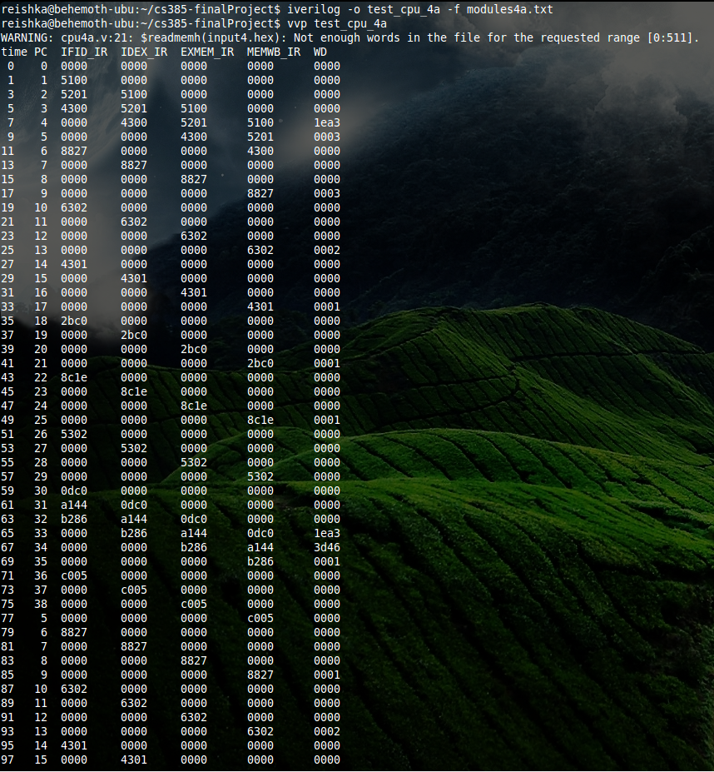

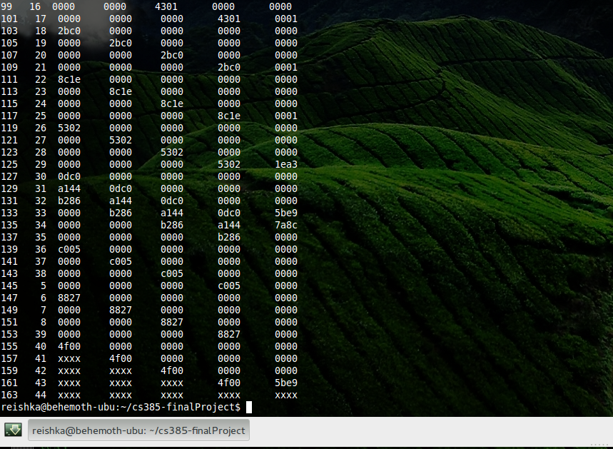

### Plaintext (with NOP)

reishka@behemoth-ubu:~/cs385-finalProject$ iverilog -o test_cpu_4a -f modules4a.txt

reishka@behemoth-ubu:~/cs385-finalProject$ vvp test_cpu_4a

WARNING: cpu4a.v:21: $readmemh(input4.hex): Not enough words in the file for the requested range [0:511].

time PC IFID_IR IDEX_IR EXMEM_IR MEMWB_IR WD

0 0 0000 0000 0000 0000 0000

1 1 5100 0000 0000 0000 0000

3 2 5201 5100 0000 0000 0000

5 3 4300 5201 5100 0000 0000

7 4 0000 4300 5201 5100 1ea3

9 5 0000 0000 4300 5201 0003

11 6 8827 0000 0000 4300 0000

13 7 0000 8827 0000 0000 0000

15 8 0000 0000 8827 0000 0000

17 9 0000 0000 0000 8827 0003

19 10 6302 0000 0000 0000 0000

21 11 0000 6302 0000 0000 0000

23 12 0000 0000 6302 0000 0000

25 13 0000 0000 0000 6302 0002

27 14 4301 0000 0000 0000 0000

29 15 0000 4301 0000 0000 0000

31 16 0000 0000 4301 0000 0000

33 17 0000 0000 0000 4301 0001

35 18 2bc0 0000 0000 0000 0000

37 19 0000 2bc0 0000 0000 0000

39 20 0000 0000 2bc0 0000 0000

41 21 0000 0000 0000 2bc0 0001

43 22 8c1e 0000 0000 0000 0000

45 23 0000 8c1e 0000 0000 0000

47 24 0000 0000 8c1e 0000 0000

49 25 0000 0000 0000 8c1e 0001

51 26 5302 0000 0000 0000 0000

53 27 0000 5302 0000 0000 0000

55 28 0000 0000 5302 0000 0000

57 29 0000 0000 0000 5302 0000

59 30 0dc0 0000 0000 0000 0000

61 31 a144 0dc0 0000 0000 0000

63 32 b286 a144 0dc0 0000 0000

65 33 0000 b286 a144 0dc0 1ea3

67 34 0000 0000 b286 a144 3d46

69 35 0000 0000 0000 b286 0001

71 36 c005 0000 0000 0000 0000

73 37 0000 c005 0000 0000 0000

75 38 0000 0000 c005 0000 0000

77 5 0000 0000 0000 c005 0000

79 6 8827 0000 0000 0000 0000

81 7 0000 8827 0000 0000 0000

83 8 0000 0000 8827 0000 0000

85 9 0000 0000 0000 8827 0001

87 10 6302 0000 0000 0000 0000

89 11 0000 6302 0000 0000 0000

91 12 0000 0000 6302 0000 0000

93 13 0000 0000 0000 6302 0002

95 14 4301 0000 0000 0000 0000

97 15 0000 4301 0000 0000 0000

99 16 0000 0000 4301 0000 0000

101 17 0000 0000 0000 4301 0001

103 18 2bc0 0000 0000 0000 0000

105 19 0000 2bc0 0000 0000 0000

107 20 0000 0000 2bc0 0000 0000

109 21 0000 0000 0000 2bc0 0001

111 22 8c1e 0000 0000 0000 0000

113 23 0000 8c1e 0000 0000 0000

115 24 0000 0000 8c1e 0000 0000

117 25 0000 0000 0000 8c1e 0001

119 26 5302 0000 0000 0000 0000

121 27 0000 5302 0000 0000 0000

123 28 0000 0000 5302 0000 0000

125 29 0000 0000 0000 5302 1ea3

127 30 0dc0 0000 0000 0000 0000

129 31 a144 0dc0 0000 0000 0000

131 32 b286 a144 0dc0 0000 0000

133 33 0000 b286 a144 0dc0 5be9

135 34 0000 0000 b286 a144 7a8c

137 35 0000 0000 0000 b286 0000

139 36 c005 0000 0000 0000 0000

141 37 0000 c005 0000 0000 0000

143 38 0000 0000 c005 0000 0000

145 5 0000 0000 0000 c005 0000

147 6 8827 0000 0000 0000 0000

149 7 0000 8827 0000 0000 0000

151 8 0000 0000 8827 0000 0000

153 39 0000 0000 0000 8827 0000

155 40 4f00 0000 0000 0000 0000

157 41 xxxx 4f00 0000 0000 0000

159 42 xxxx xxxx 4f00 0000 0000

161 43 xxxx xxxx xxxx 4f00 5be9

163 44 xxxx xxxx xxxx xxxx xxxx

reishka@behemoth-ubu:~/cs385-finalProject$

### Screenshot (without NOP)

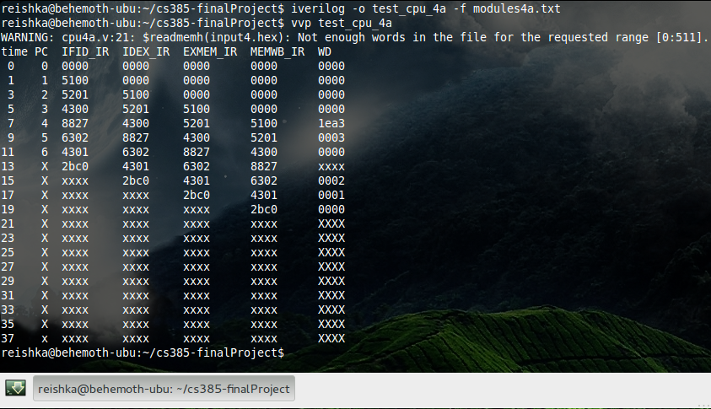

### Plaintext (without NOP)

reishka@behemoth-ubu:~/cs385-finalProject$ iverilog -o test_cpu_4a -f modules4a.txt

reishka@behemoth-ubu:~/cs385-finalProject$ vvp test_cpu_4a

WARNING: cpu4a.v:21: $readmemh(input4.hex): Not enough words in the file for the requested range [0:511].

time PC IFID_IR IDEX_IR EXMEM_IR MEMWB_IR WD

0 0 0000 0000 0000 0000 0000

1 1 5100 0000 0000 0000 0000

3 2 5201 5100 0000 0000 0000

5 3 4300 5201 5100 0000 0000

7 4 8827 4300 5201 5100 1ea3

9 5 6302 8827 4300 5201 0003

11 6 4301 6302 8827 4300 0000

13 X 2bc0 4301 6302 8827 xxxx

15 X xxxx 2bc0 4301 6302 0002

17 X xxxx xxxx 2bc0 4301 0001

19 X xxxx xxxx xxxx 2bc0 0000

21 X xxxx xxxx xxxx xxxx XXXX

23 X xxxx xxxx xxxx xxxx XXXX

25 X xxxx xxxx xxxx xxxx XXXX

27 X xxxx xxxx xxxx xxxx XXXX

29 X xxxx xxxx xxxx xxxx XXXX

31 X xxxx xxxx xxxx xxxx XXXX

33 X xxxx xxxx xxxx xxxx XXXX

35 X xxxx xxxx xxxx xxxx XXXX

37 x xxxx xxxx xxxx xxxx XXXX

reishka@behemoth-ubu:~/cs385-finalProject$