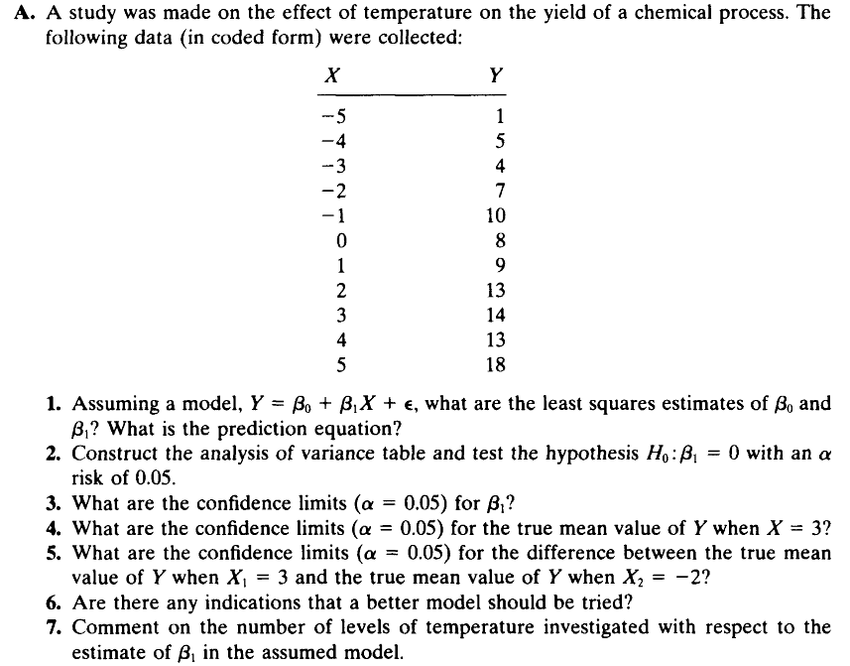

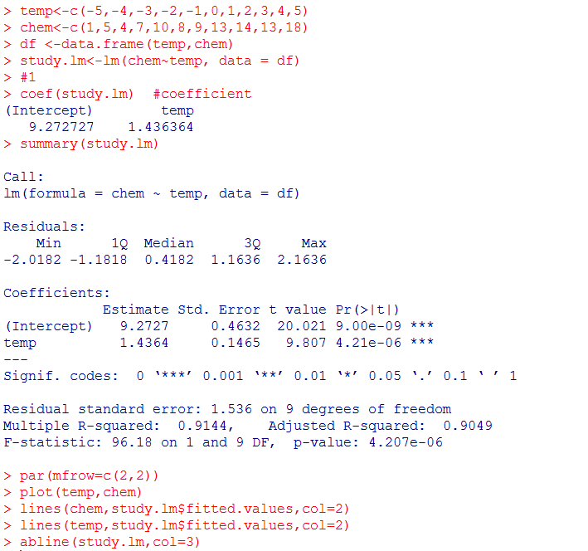 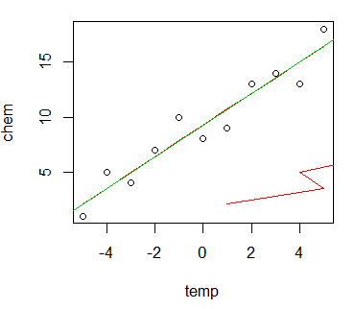

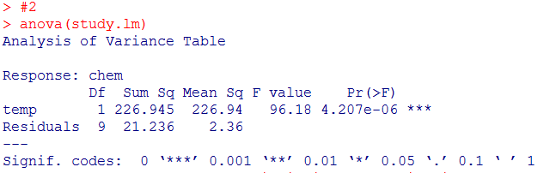

#Here we see that the F statistic is 96.18 which is greater than F(1,9,0.95)=5.12 with a p-value very close to zero. The conclusion: there is very strong evidence that H0 : B1 = 0 is false, that is, there is strong evidence that H0:B1=0 is false, that is there is strong evidence that B1≠0. Moreover, we conclude that the regression relationship between temp and chem is significant.

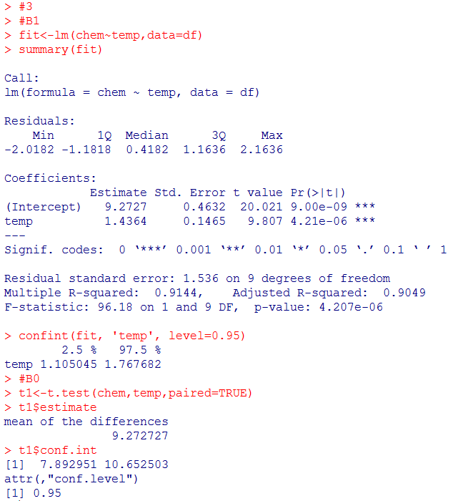

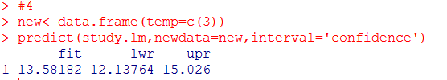



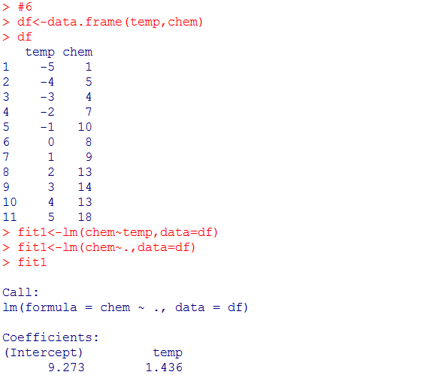

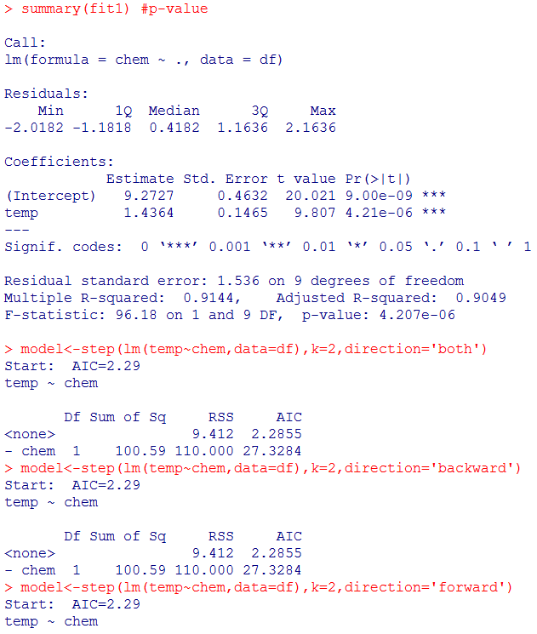



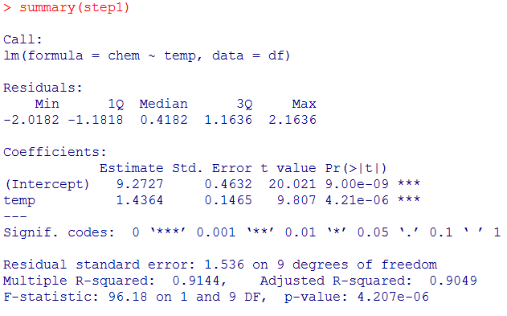

#There is no alternative model

#7

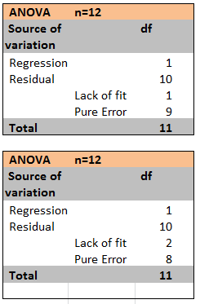

There are many other possibilities.

For an experiment of about the same size, one possibility would be to choose three widely spaced levels and to take four observations at each of these levels.

Since we have only 1 degree of freedom for lack of fit, this is not entirely satisfactory.

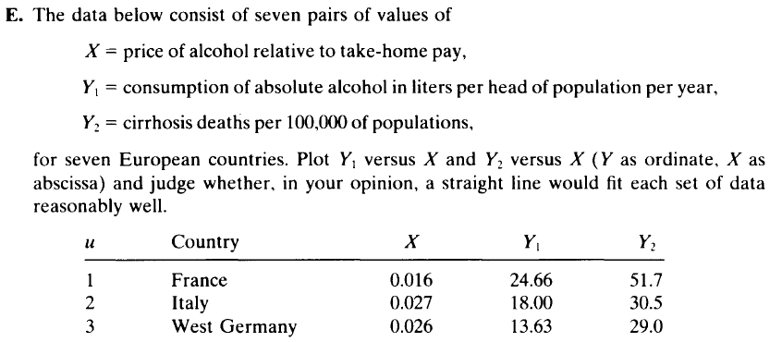

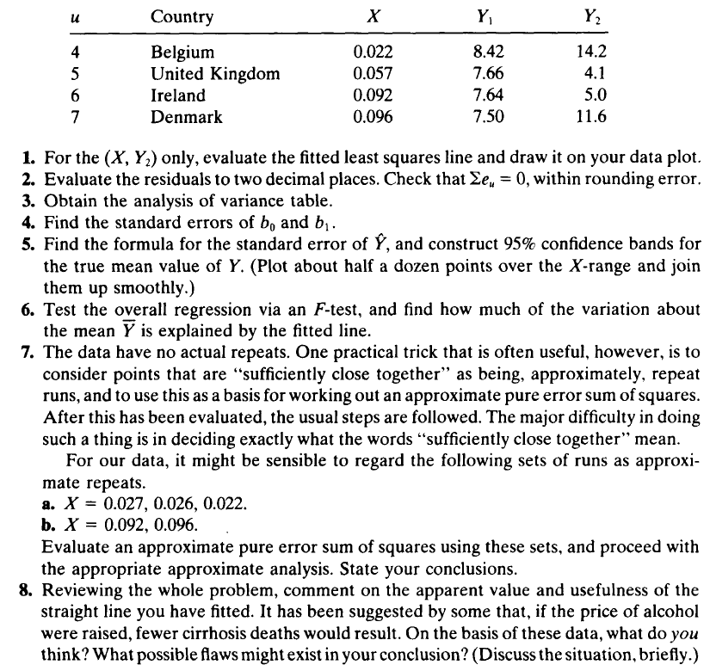

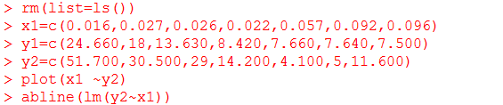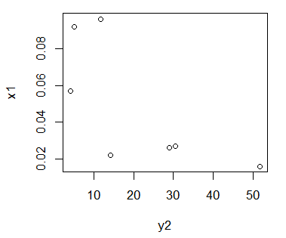

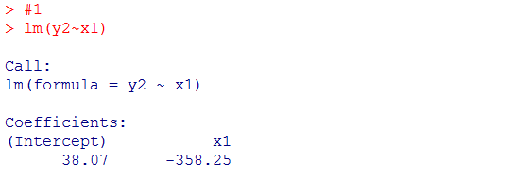

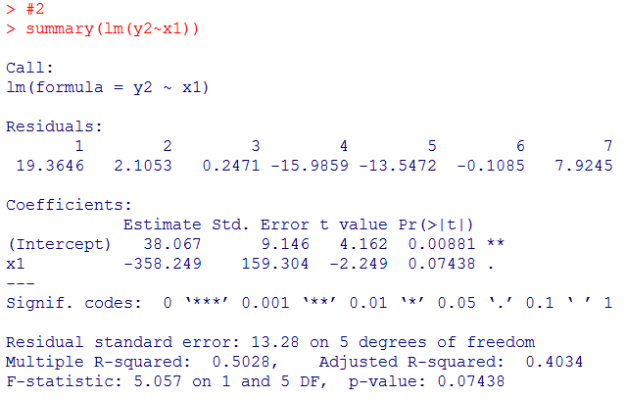

#4

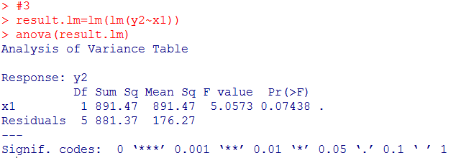

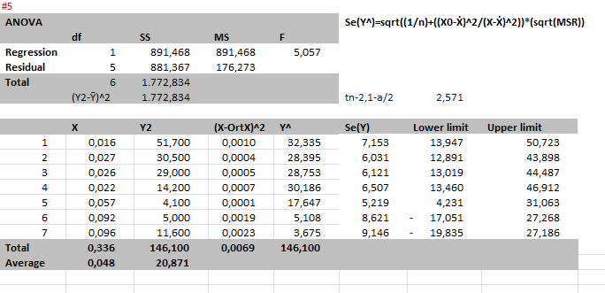





5.68 with (2,3) df close to the 10% upper-tail point of 5.46

#8

Line gives the idea that higher costs for alcohol are associated with fewer deaths.

However it is unknown that the deaths depend on the costs.

If price of alcohol is raised, the death could reduce.

Especially,The countries where have low price of alcohol but high death rates such as France, Italy, West Germany, Belgium ,

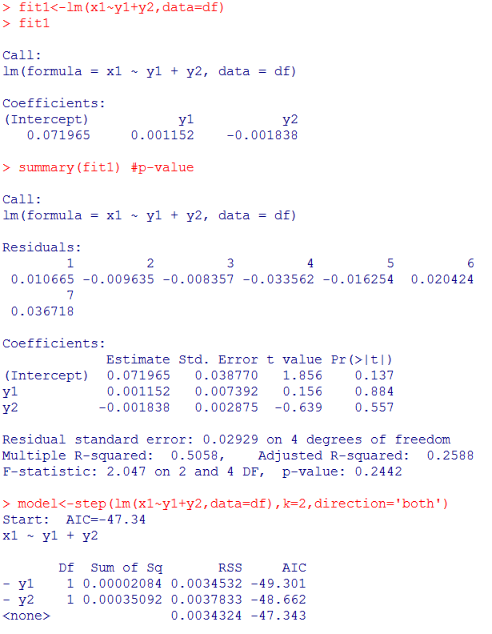

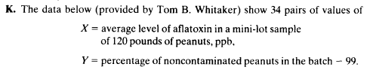

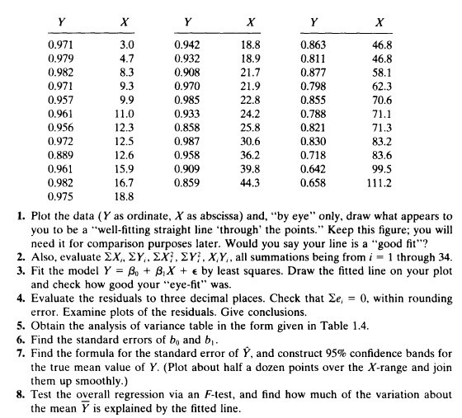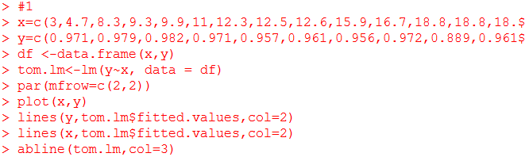 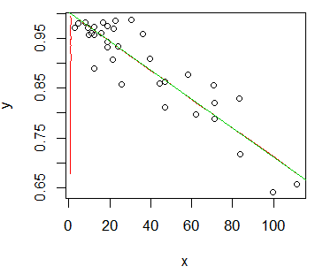

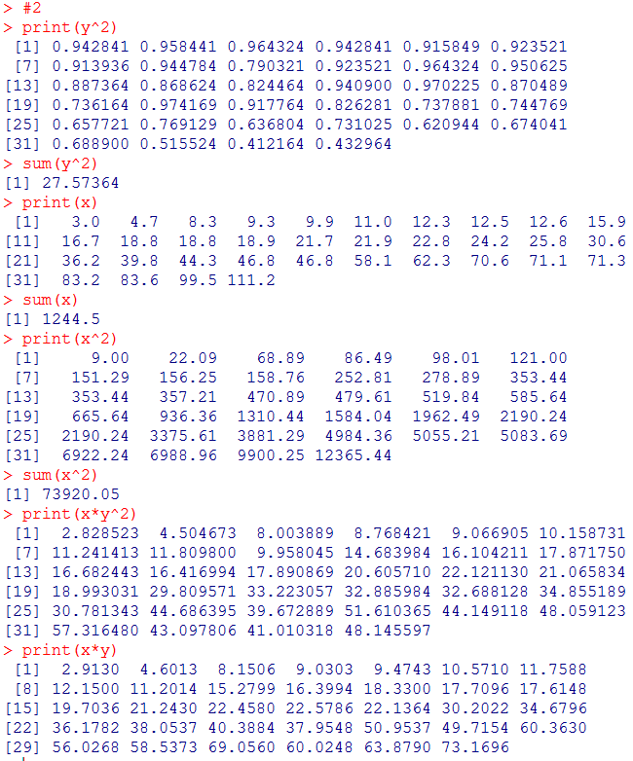

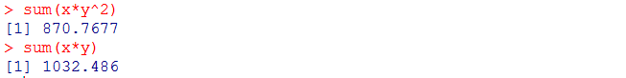

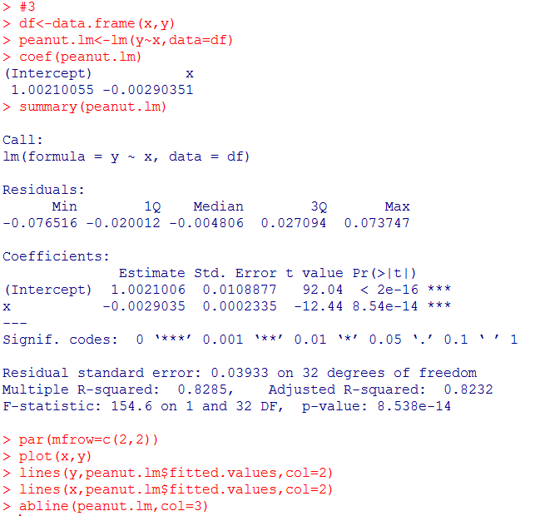 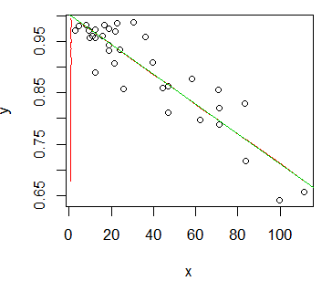

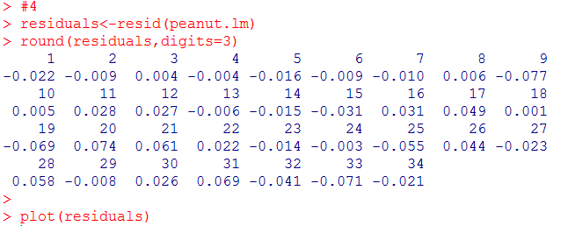 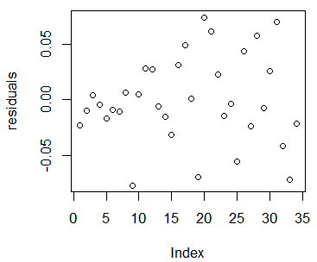

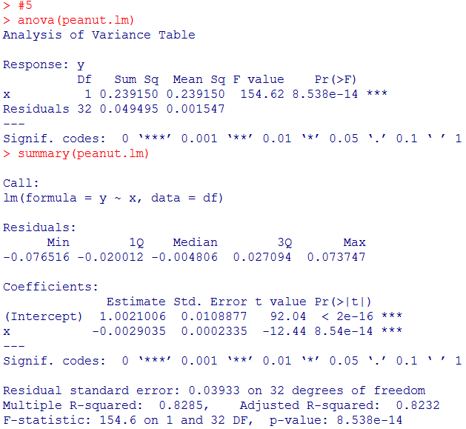

#6

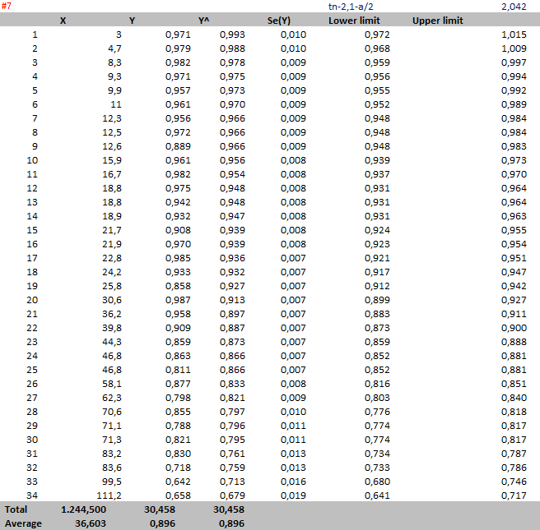

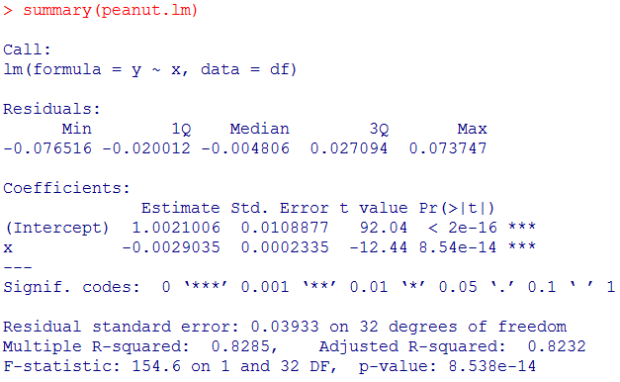

F-test statistics for overall regression is 154.6

F(1,30,0.95)=4.17

Reject the null hypothesis that

H0 : B1 = 0 , R2=82.9%

So that 82.9% of the variation about the mean Ῡ is explained by our linear regression.

#8

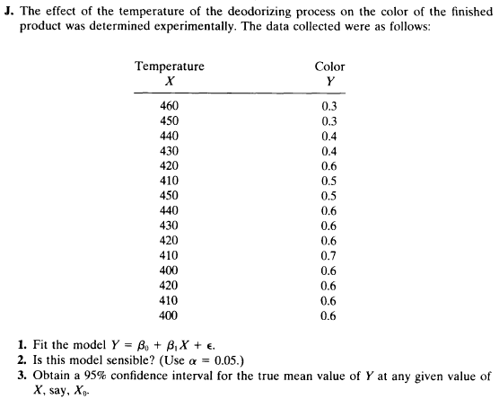

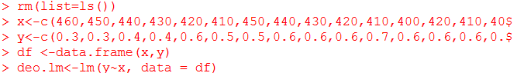

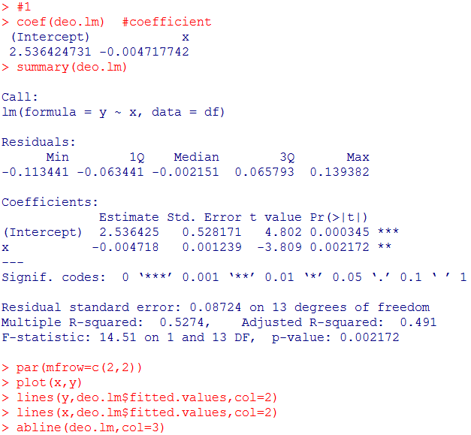 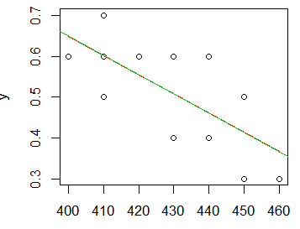

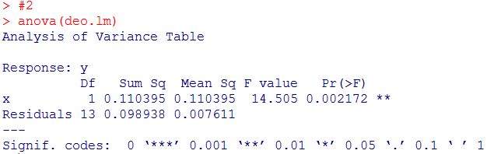

#Here we see that the F statistic is 14.5 which is greater than F(1,13,0.95)=4.67 with a p-value very close to zero. The conclusion: Regression is significant, if there is no lack of fit.



F statistic is 1.038 which is lower than F(5,8,0.95)=3.69

The conclusionLack of fit is not significant.



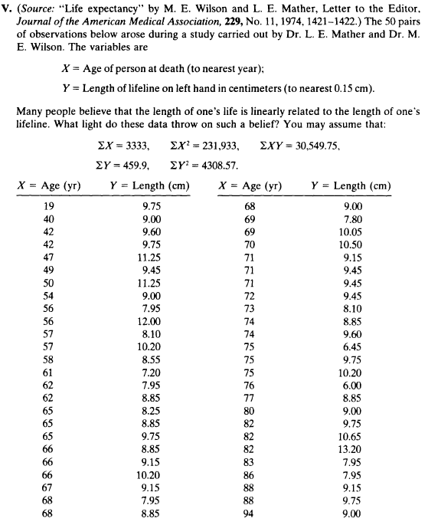

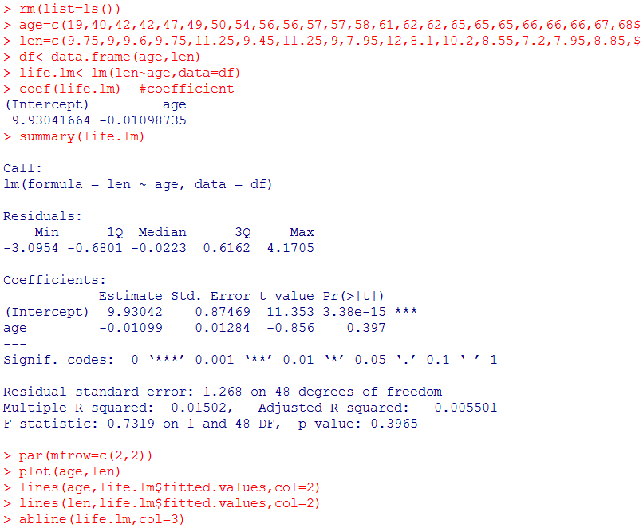 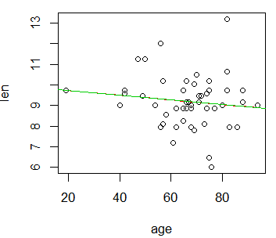

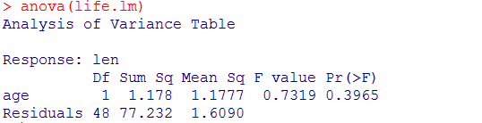



F-test statistics for overall regression is 0.7319

F(1,48,0.95)=4.05

F(30,18,0.95)=2.11

There is no significant lack of fit and the regression slope is not significant.

Conclusion: These data don’t prove the idea that length of life is related with length of lifeline.

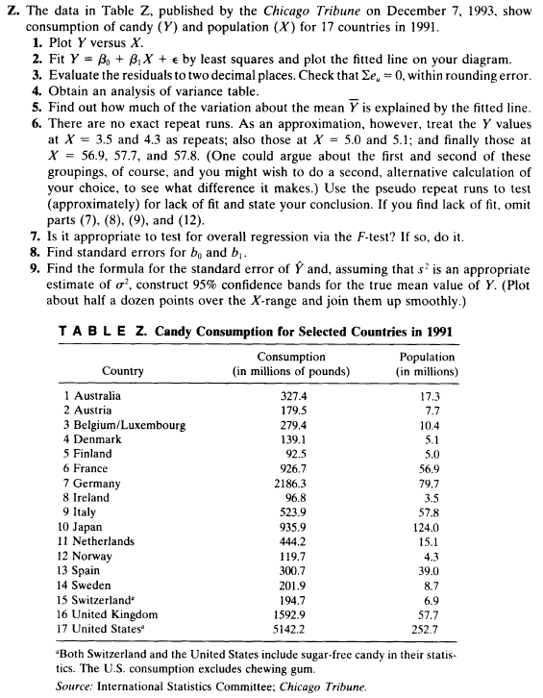

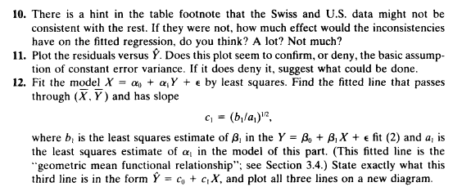



 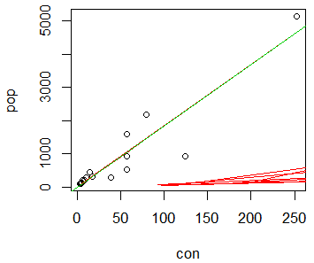

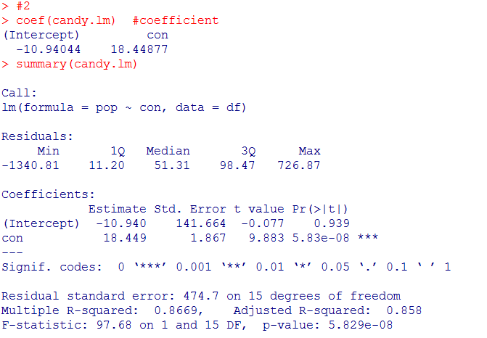

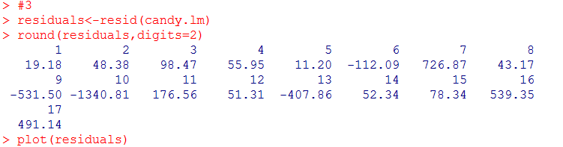 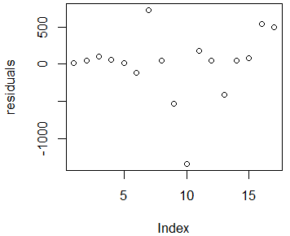

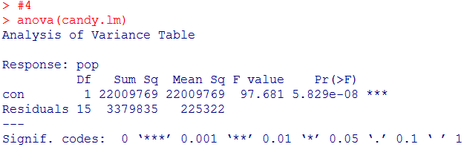





F=1.74 woth (4,11) degree of freedom.

There is no lack of fit.

#7

#Here we see that the F statistic is 14.5 which is greater than F(1,15,0.95)=97.68 with a p-value very close to zero. The conclusion: Regression is significant, if there is no lack of fit.

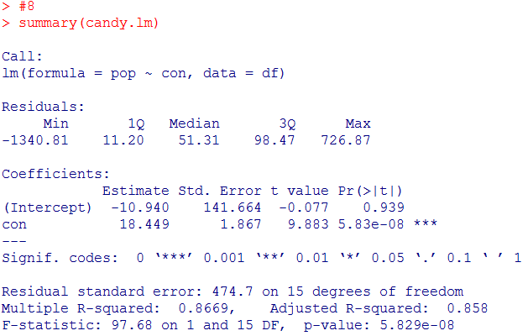



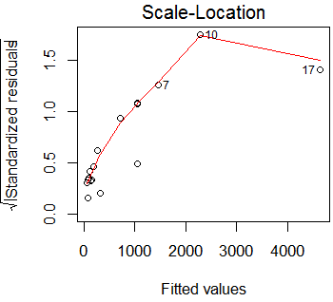#10

#The Swiss data point would not have much effect as it is down close to

other small results.

#The U.S. Data point is at extreme and changing it would have an effect,

The e versus ^Y has funnel-shaped characteristics, which imply more variation in larger Y-values



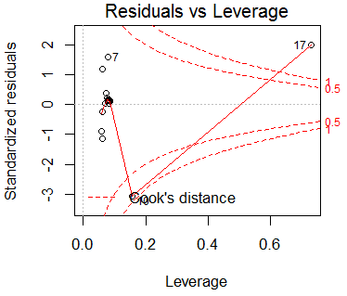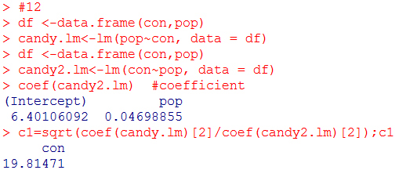

^Y-Ῡ=c1(X-Ẋ) 🡪 ^Y-804.93=19.81471(X-44.224)

^Y=71.357+19.81471X

