R Notebook: Panel Data Models with R - October 2021

Miguel Portela

03 February 2023

# Introduction

This is an [R Markdown](http://rmarkdown.rstudio.com) Notebook. When you execute code within the notebook, the results appear beneath the code.

Try executing this chunk by clicking the *Run* button within the chunk or by placing your cursor inside it and pressing *Cmd+Shift+Enter* (in Windows press *CTRL+Enter*).

Add a new chunk by clicking the *Insert Chunk* button on the toolbar or by pressing *Cmd+Option+I* (or *CTRL+Alt+I* in Windows).

When you save the notebook, an HTML file containing the code and output will be saved alongside it (click the *Preview* button or press *Cmd+Shift+K* to preview the HTML file).

The preview shows you a rendered HTML copy of the contents of the editor. Consequently, unlike *Knit*, *Preview* does not run any R code chunks. Instead, the output of the chunk when it was last run in the editor is displayed.

# Package Management Tool

Here I am uploading my packages (code omitted).

# Prepare the data

Here I am reading a Stata data file (code omitted).

# Statistics

names(nlswork)

## [1] "idcode" "year" "birth_yr" "age" "race" "msp"   
## [7] "nev_mar" "grade" "collgrad" "not_smsa" "c_city" "south"   
## [13] "ind_code" "occ_code" "union" "wks_ue" "ttl_exp" "tenure"   
## [19] "hours" "wks_work" "ln_wage"

head(nlswork)

## # A tibble: 6 × 21  
## idcode year birth_yr age race msp nev_mar grade collgrad not_smsa c_city  
## <dbl> <dbl> <dbl> <dbl> <dbl> <dbl> <dbl> <dbl> <dbl> <dbl> <dbl>  
## 1 1 70 51 18 2 0 1 12 0 0 1  
## 2 1 71 51 19 2 1 0 12 0 0 1  
## 3 1 72 51 20 2 1 0 12 0 0 1  
## 4 1 73 51 21 2 1 0 12 0 0 1  
## 5 1 75 51 23 2 1 0 12 0 0 1  
## 6 1 77 51 25 2 0 0 12 0 0 1  
## # … with 10 more variables: south <dbl>, ind_code <dbl>, occ_code <dbl>,  
## # union <dbl>, wks_ue <dbl>, ttl_exp <dbl>, tenure <dbl>, hours <dbl>,  
## # wks_work <dbl>, ln_wage <dbl>

str(nlswork)

## tibble [28,534 × 21] (S3: tbl_df/tbl/data.frame)  
## $ idcode : num [1:28534] 1 1 1 1 1 1 1 1 1 1 ...  
## ..- attr(*, "label")= chr "NLS id"  
## ..- attr(*, "format.stata")= chr "%8.0g"  
## $ year : num [1:28534] 70 71 72 73 75 77 78 80 83 85 ...  
## ..- attr(*, "label")= chr "interview year"  
## ..- attr(*, "format.stata")= chr "%8.0g"  
## $ birth_yr: num [1:28534] 51 51 51 51 51 51 51 51 51 51 ...  
## ..- attr(*, "label")= chr "birth year"  
## ..- attr(*, "format.stata")= chr "%8.0g"  
## $ age : num [1:28534] 18 19 20 21 23 25 26 28 31 33 ...  
## ..- attr(*, "label")= chr "age in current year"  
## ..- attr(*, "format.stata")= chr "%8.0g"  
## $ race : num [1:28534] 2 2 2 2 2 2 2 2 2 2 ...  
## ..- attr(*, "label")= chr "1=white, 2=black, 3=other"  
## ..- attr(*, "format.stata")= chr "%8.0g"  
## $ msp : num [1:28534] 0 1 1 1 1 0 0 0 0 0 ...  
## ..- attr(*, "label")= chr "1 if married, spouse present"  
## ..- attr(*, "format.stata")= chr "%8.0g"  
## $ nev_mar : num [1:28534] 1 0 0 0 0 0 0 0 0 0 ...  
## ..- attr(*, "label")= chr "1 if never yet married"  
## ..- attr(*, "format.stata")= chr "%8.0g"  
## $ grade : num [1:28534] 12 12 12 12 12 12 12 12 12 12 ...  
## ..- attr(*, "label")= chr "current grade completed"  
## ..- attr(*, "format.stata")= chr "%8.0g"  
## $ collgrad: num [1:28534] 0 0 0 0 0 0 0 0 0 0 ...  
## ..- attr(*, "label")= chr "1 if college graduate"  
## ..- attr(*, "format.stata")= chr "%8.0g"  
## $ not_smsa: num [1:28534] 0 0 0 0 0 0 0 0 0 0 ...  
## ..- attr(*, "label")= chr "1 if not SMSA"  
## ..- attr(*, "format.stata")= chr "%8.0g"  
## $ c_city : num [1:28534] 1 1 1 1 1 1 1 1 1 1 ...  
## ..- attr(*, "label")= chr "1 if central city"  
## ..- attr(*, "format.stata")= chr "%8.0g"  
## $ south : num [1:28534] 0 0 0 0 0 0 0 0 0 0 ...  
## ..- attr(*, "label")= chr "1 if south"  
## ..- attr(*, "format.stata")= chr "%8.0g"  
## $ ind_code: num [1:28534] 6 4 4 4 5 12 5 5 5 5 ...  
## ..- attr(*, "label")= chr "industry of employment"  
## ..- attr(*, "format.stata")= chr "%8.0g"  
## $ occ_code: num [1:28534] 3 6 6 6 6 8 6 6 6 6 ...  
## ..- attr(*, "label")= chr "occupation"  
## ..- attr(*, "format.stata")= chr "%8.0g"  
## $ union : num [1:28534] NA NA 1 NA NA 0 NA 1 1 1 ...  
## ..- attr(*, "label")= chr "1 if union"  
## ..- attr(*, "format.stata")= chr "%8.0g"  
## $ wks_ue : num [1:28534] 2 22 0 0 0 0 7 0 NA 0 ...  
## ..- attr(*, "label")= chr "weeks unemployed last year"  
## ..- attr(*, "format.stata")= chr "%8.0g"  
## $ ttl_exp : num [1:28534] 1.08 1.28 2.26 2.31 2.78 ...  
## ..- attr(*, "label")= chr "total work experience"  
## ..- attr(*, "format.stata")= chr "%9.0g"  
## $ tenure : num [1:28534] 0.0833 0.0833 0.9167 0.0833 0.1667 ...  
## ..- attr(*, "label")= chr "job tenure, in years"  
## ..- attr(*, "format.stata")= chr "%9.0g"  
## $ hours : num [1:28534] 20 44 40 40 10 32 52 45 49 42 ...  
## ..- attr(*, "label")= chr "usual hours worked"  
## ..- attr(*, "format.stata")= chr "%8.0g"  
## $ wks_work: num [1:28534] 27 10 51 3 24 52 4 75 101 97 ...  
## ..- attr(*, "label")= chr "weeks worked last year"  
## ..- attr(*, "format.stata")= chr "%8.0g"  
## $ ln_wage : num [1:28534] 1.45 1.03 1.59 1.78 1.78 ...  
## ..- attr(*, "label")= chr "ln(wage/GNP deflator)"  
## ..- attr(*, "format.stata")= chr "%9.0g"  
## - attr(*, "label")= chr "National Longitudinal Survey. Young Women 14-26 years of age in 1968"

# dplyr::glimpse(nlswork)  
   
 dplyr::glimpse(nlswork$ln_wage)

## num [1:28534] 1.45 1.03 1.59 1.78 1.78 ...  
## - attr(*, "label")= chr "ln(wage/GNP deflator)"  
## - attr(*, "format.stata")= chr "%9.0g"

ExpData(nlswork,type=1)

## Descriptions Value  
## 1 Sample size (nrow) 28534  
## 2 No. of variables (ncol) 21  
## 3 No. of numeric/interger variables 21  
## 4 No. of factor variables 0  
## 5 No. of text variables 0  
## 6 No. of logical variables 0  
## 7 No. of identifier variables 0  
## 8 No. of date variables 0  
## 9 No. of zero variance variables (uniform) 0  
## 10 %. of variables having complete cases 33.33% (7)  
## 11 %. of variables having >0% and <50% missing cases 66.67% (14)  
## 12 %. of variables having >=50% and <90% missing cases 0% (0)  
## 13 %. of variables having >=90% missing cases 0% (0)

ExpData(nlswork,type=2)

## Index Variable_Name Variable_Type Sample_n Missing_Count Per_of_Missing  
## 1 1 idcode numeric 28534 0 0.000  
## 2 2 year numeric 28534 0 0.000  
## 3 3 birth_yr numeric 28534 0 0.000  
## 4 4 age numeric 28510 24 0.001  
## 5 5 race numeric 28534 0 0.000  
## 6 6 msp numeric 28518 16 0.001  
## 7 7 nev_mar numeric 28518 16 0.001  
## 8 8 grade numeric 28532 2 0.000  
## 9 9 collgrad numeric 28534 0 0.000  
## 10 10 not_smsa numeric 28526 8 0.000  
## 11 11 c_city numeric 28526 8 0.000  
## 12 12 south numeric 28526 8 0.000  
## 13 13 ind_code numeric 28193 341 0.012  
## 14 14 occ_code numeric 28413 121 0.004  
## 15 15 union numeric 19238 9296 0.326  
## 16 16 wks_ue numeric 22830 5704 0.200  
## 17 17 ttl_exp numeric 28534 0 0.000  
## 18 18 tenure numeric 28101 433 0.015  
## 19 19 hours numeric 28467 67 0.002  
## 20 20 wks_work numeric 27831 703 0.025  
## 21 21 ln_wage numeric 28534 0 0.000  
## No_of_distinct_values  
## 1 4711  
## 2 15  
## 3 14  
## 4 33  
## 5 3  
## 6 2  
## 7 2  
## 8 19  
## 9 2  
## 10 2  
## 11 2  
## 12 2  
## 13 12  
## 14 13  
## 15 2  
## 16 61  
## 17 4744  
## 18 270  
## 19 85  
## 20 105  
## 21 8173

## Exploratory data analysis

Start discussing the statistics and graphs.

## grade   
## Min. : 0.00   
## 1st Qu.:12.00   
## Median :12.00   
## Mean :12.53   
## 3rd Qu.:14.00   
## Max. :18.00   
## NA's :2

## Vname Group TN nNeg nZero nPos NegInf PosInf NA_Value Per_of_Missing  
## 4 age All 28534 0 0 28510 0 0 24 0.08  
## 3 birth_yr All 28534 0 0 28534 0 0 0 0.00  
## 5 grade All 28534 0 21 28511 0 0 2 0.01  
## 11 hours All 28534 0 0 28467 0 0 67 0.23  
## 1 idcode All 28534 0 0 28534 0 0 0 0.00  
## 6 ind_code All 28534 0 0 28193 0 0 341 1.20  
## 13 ln_wage All 28534 0 2 28532 0 0 0 0.00  
## 7 occ_code All 28534 0 0 28413 0 0 121 0.42  
## 10 tenure All 28534 0 1248 26853 0 0 433 1.52  
## 9 ttl_exp All 28534 0 21 28513 0 0 0 0.00  
## 8 wks_ue All 28534 0 17394 5436 0 0 5704 19.99  
## 12 wks_work All 28534 0 478 27353 0 0 703 2.46  
## 2 year All 28534 0 0 28534 0 0 0 0.00  
## sum min max mean median SD CV IQR Skewness  
## 4 828076.00 14 46.00 29.05 28.00 6.70 0.23 11.00 0.26  
## 3 1372060.00 41 54.00 48.09 48.00 3.01 0.06 5.00 -0.12  
## 5 357580.00 0 18.00 12.53 12.00 2.32 0.19 2.00 0.10  
## 11 1040741.00 1 168.00 36.56 40.00 9.87 0.27 5.00 -0.90  
## 1 74225046.00 1 5159.00 2601.28 2606.00 1487.36 0.57 2554.00 -0.02  
## 6 216888.00 1 12.00 7.69 7.00 2.99 0.39 6.00 0.00  
## 13 47791.80 0 5.26 1.67 1.64 0.48 0.29 0.60 0.33  
## 7 135748.00 1 13.00 4.78 3.00 3.07 0.64 3.00 1.08  
## 10 87782.92 0 25.92 3.12 1.67 3.75 1.20 3.67 1.94  
## 9 177347.83 0 28.88 6.22 5.06 4.65 0.75 6.67 0.86  
## 8 58173.00 0 76.00 2.55 0.00 7.29 2.86 0.00 4.02  
## 12 1502577.00 0 104.00 53.99 52.00 29.03 0.54 36.00 0.19  
## 2 2224472.00 68 88.00 77.96 78.00 6.38 0.08 11.00 0.09  
## Kurtosis 10% 20% 50% LB.25% UB.75% nOutliers  
## 4 -0.91 21.00 23.00 28.00 6.50 50.50 0  
## 3 -0.99 44.00 45.00 48.00 38.50 58.50 0  
## 5 1.37 10.00 12.00 12.00 9.00 17.00 2125  
## 11 4.26 20.00 32.00 40.00 27.50 47.50 6100  
## 1 -1.19 518.00 1051.00 2606.00 -2504.00 7712.00 0  
## 6 -1.46 4.00 4.00 7.00 -4.00 20.00 0  
## 13 1.67 1.17 1.30 1.64 0.46 2.87 660  
## 7 0.68 1.00 3.00 3.00 -1.50 10.50 1846  
## 10 3.90 0.17 0.42 1.67 -5.00 9.67 2138  
## 9 0.06 1.04 2.00 5.06 -7.54 19.13 191  
## 8 18.25 0.00 0.00 0.00 0.00 0.00 5436  
## 12 -0.68 14.00 28.00 52.00 -18.00 126.00 0  
## 2 -1.30 70.00 71.00 78.00 55.50 99.50 0

## [[1]]

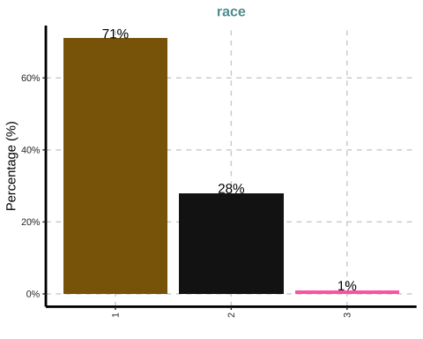

##   
## [[2]]

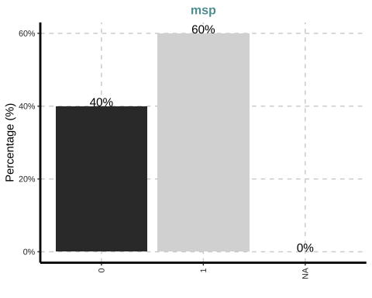

##   
## [[3]]

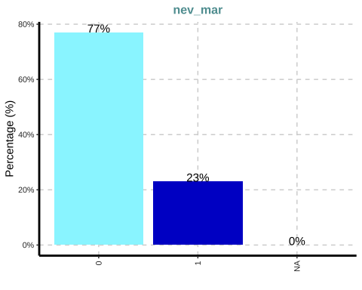

##   
## [[4]]

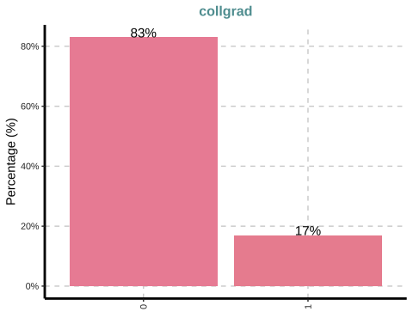

##   
## [[5]]

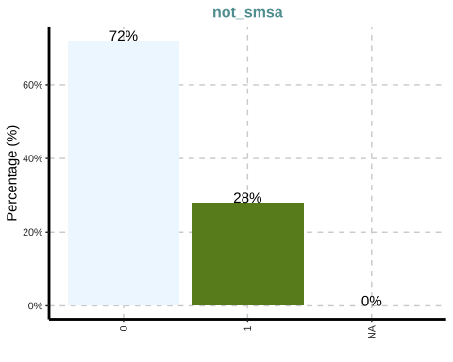

##   
## [[6]]

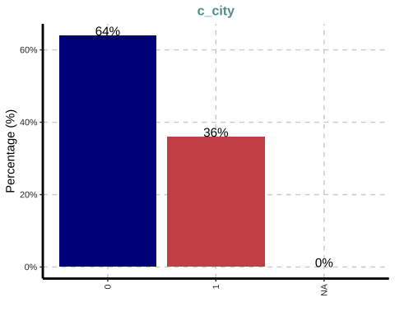

##   
## [[7]]

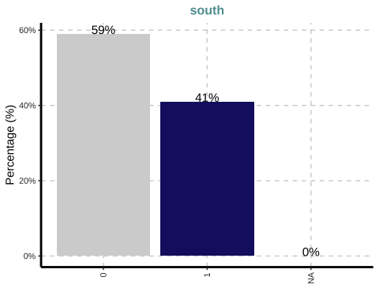

##   
## [[8]]

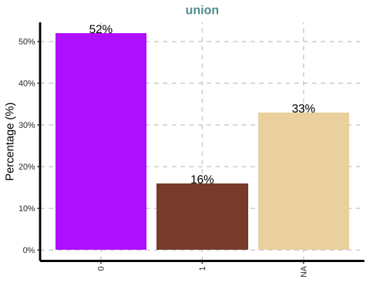

## $`0`

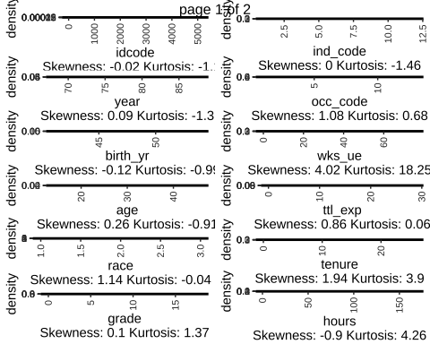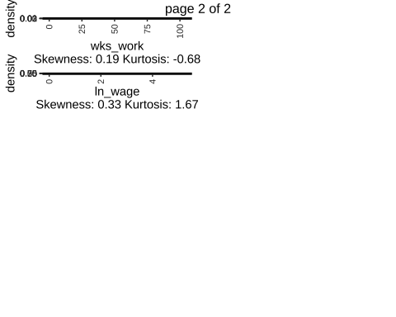

## MISSING VALUES

vis_dat(nlswork)

## Warning: `gather_()` was deprecated in tidyr 1.2.0.  
## ℹ Please use `gather()` instead.  
## ℹ The deprecated feature was likely used in the visdat package.  
## Please report the issue at <]8;;https://github.com/ropensci/visdat/issueshttps://github.com/ropensci/visdat/issues]8;;>.

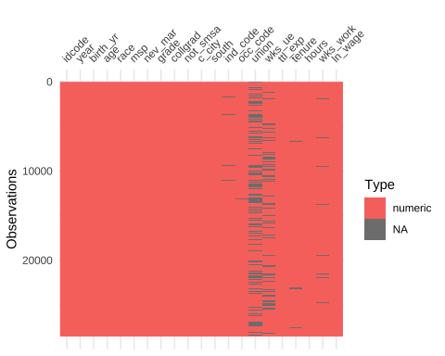

# vis_miss(nlswork) # ALTERNATIVE  
  
 gg_miss_upset(nlswork)

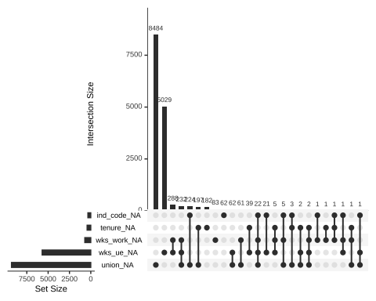

## Add a dataframe

## Export output

stargazer(nls,  
 title = "Summary statistics",  
 label = "tb:statistcis",  
 table.placement = "ht",  
 header=FALSE,type="text")

##   
## Summary statistics  
## =================================================  
## Statistic N Mean St. Dev. Min Max   
## -------------------------------------------------  
## idcode 28,534 2,601.284 1,487.359 1 5,159   
## year 28,534 77.959 6.384 68 88   
## birth_yr 28,534 48.085 3.013 41 54   
## age 28,510 29.045 6.701 14 46   
## race 28,534 1.303 0.482 1 3   
## msp 28,518 0.603 0.489 0 1   
## nev_mar 28,518 0.230 0.421 0 1   
## grade 28,532 12.533 2.324 0 18   
## collgrad 28,534 0.168 0.374 0 1   
## not_smsa 28,526 0.282 0.450 0 1   
## c_city 28,526 0.357 0.479 0 1   
## south 28,526 0.410 0.492 0 1   
## ind_code 28,193 7.693 2.994 1 12   
## occ_code 28,413 4.778 3.065 1 13   
## union 19,238 0.234 0.424 0 1   
## wks_ue 22,830 2.548 7.294 0 76   
## ttl_exp 28,534 6.215 4.652 0.000 28.885  
## tenure 28,101 3.124 3.751 0.000 25.917  
## hours 28,467 36.560 9.870 1 168   
## wks_work 27,831 53.989 29.032 0 104   
## ln_wage 28,534 1.675 0.478 0.000 5.264   
## -------------------------------------------------

## Produce a graph

## Save the graph

## Tabulations and further statistics

## nlswork$race n percent  
## 1 20180 0.70722647  
## 2 8051 0.28215462  
## 3 303 0.01061891

## Frequencies   
## nlswork$year   
## Label: interview year   
## Type: Numeric   
##   
## Freq % Valid % Valid Cum. % Total % Total Cum.  
## ----------- ------- --------- -------------- --------- --------------  
## 88 2272 7.96 7.96 7.96 7.96  
## 77 2171 7.61 15.57 7.61 15.57  
## 87 2164 7.58 23.15 7.58 23.15  
## 75 2141 7.50 30.66 7.50 30.66  
## 82 2085 7.31 37.97 7.31 37.97  
## 85 2085 7.31 45.27 7.31 45.27  
## 83 1987 6.96 52.24 6.96 52.24  
## 73 1981 6.94 59.18 6.94 59.18  
## 78 1964 6.88 66.06 6.88 66.06  
## 71 1851 6.49 72.55 6.49 72.55  
## 80 1847 6.47 79.02 6.47 79.02  
## 72 1693 5.93 84.95 5.93 84.95  
## 70 1686 5.91 90.86 5.91 90.86  
## 68 1375 4.82 95.68 4.82 95.68  
## 69 1232 4.32 100.00 4.32 100.00  
## <NA> 0 0.00 100.00  
## Total 28534 100.00 100.00 100.00 100.00

## Frequencies   
## nlswork$race   
## Label: 1=white, 2=black, 3=other   
## Type: Numeric   
##   
## Freq % Valid % Valid Cum. % Total % Total Cum.  
## ----------- ------- --------- -------------- --------- --------------  
## 1 20180 70.72 70.72 70.72 70.72  
## 2 8051 28.22 98.94 28.22 98.94  
## 3 303 1.06 100.00 1.06 100.00  
## <NA> 0 0.00 100.00  
## Total 28534 100.00 100.00 100.00 100.00

# A new dataset: exclude onservations with missing information in a subset of variables

## Add variable

## Plot variables means

## Warning in arrows(x, li, x, pmax(y - gap, li), col = barcol, lwd = lwd, :  
## zero-length arrow is of indeterminate angle and so skipped

## Warning in arrows(x, ui, x, pmin(y + gap, ui), col = barcol, lwd = lwd, :  
## zero-length arrow is of indeterminate angle and so skipped

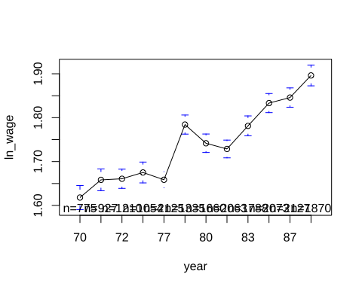

# Regression analysis

* *Estimating a Mincerian Wage Equation*
* *POLS estimator with cluster-robust standard errors*

## *Q1*

### Pooled OLS model

## Export regression output

##   
## Regression analysis  
## =================================================  
## OLS panel   
## linear   
## OLS Pooled   
## -------------------------------------------------  
## Union 0.113*** 0.113***   
## (0.007) (0.007)   
## Collage Graduate 0.351*** 0.351***   
## (0.007) (0.007)   
## Age 0.022*** 0.022***   
## (0.004) (0.004)   
## Age sqrd. -0.0003*** -0.0003***   
## (0.0001) (0.0001)   
## Tenure 0.055*** 0.055***   
## (0.002) (0.002)   
## Tenure sqrd. -0.002*** -0.002***   
## (0.0001) (0.0001)   
## Not SMSA -0.205*** -0.205***   
## (0.007) (0.007)   
## South -0.141*** -0.141***   
## (0.006) (0.006)   
## City -0.032*** -0.032***   
## (0.007) (0.007)   
## N 19,007 19,007   
## R2 0.319 0.319   
## =================================================  
## Notes: Standard errors in parentheses.

* *SMSA*: Standard Metropolitan Statistical Area

# ftable(c_city) # 1 if central city

# CLUSTERED Standard-errors

pols_robust <- coeftest(pols, function(x) vcovHC(x, type = 'sss'))   
   
 stargazer(pols,pols_robust,title = "Regression analysis",   
 model.numbers = FALSE,  
 column.labels = c("Pooled","Pooled (cluster)"),  
 label = "regressions",  
 table.placement = "!ht",  
 notes.append = FALSE,  
 notes.align="l",  
 notes="Standard errors in parentheses.",  
 header = FALSE,  
 no.space = TRUE,  
 covariate.labels = c("Union","Collage graduate","Age","Age sqrd.",  
 "Tenure","Tenure sqrd.","Not SMSA","South","City"),  
 omit = c("Constant"),  
 omit.stat = c("adj.rsq","f","ser"),  
 digits = 6,  
 digits.extra = 7,  
 omit.yes.no = c("Constant",""),  
 dep.var.caption="",  
 dep.var.labels.include = FALSE,  
 style = "qje",  
 type="text")

##   
## Regression analysis  
## =================================================  
## panel coefficient   
## linear test   
## Pooled Pooled (cluster)  
## -------------------------------------------------  
## Union 0.112774*** 0.112774***   
## (0.006774) (0.011731)   
## Collage graduate 0.350946*** 0.350946***   
## (0.007149) (0.014112)   
## Age 0.022481*** 0.022481***   
## (0.004249) (0.005373)   
## Age sqrd. -0.000306*** -0.000306***   
## (0.000068) (0.000088)   
## Tenure 0.054787*** 0.054787***   
## (0.001944) (0.002743)   
## Tenure sqrd. -0.001540*** -0.001540***   
## (0.000125) (0.000180)   
## Not SMSA -0.205457*** -0.205457***   
## (0.007120) (0.013137)   
## South -0.140589*** -0.140589***   
## (0.005850) (0.010964)   
## City -0.031543*** -0.031543***   
## (0.006683) (0.011691)   
## N 19,007   
## R2 0.319459   
## =================================================  
## Notes: Standard errors in parentheses.

## *Q2*

### *Random effects estimator (RE)*

* SEE THE DISCUSSION HERE for the comparison between R and Stata

# <https://stats.stackexchange.com/questions/421374/different-results-from-random-effects-plm-r-and-xtreg-stata>

* R and Stata treat differently unbalanced panels

**for a balanced panel we have**

nlswork_balanced <- read_dta("data/nlswork_balanced.dta")  
   
 re_balanced <- plm(data = nlswork_balanced, ln_wage ~ union +  
 collgrad +age +agesq +tenure +tensq +  
 not_smsa +south +c_city, model="random",  
 index=c("idcode", "year"))  
 summary(re_balanced)

## Oneway (individual) effect Random Effect Model   
## (Swamy-Arora's transformation)  
##   
## Call:  
## plm(formula = ln_wage ~ union + collgrad + age + agesq + tenure +   
## tensq + not_smsa + south + c_city, data = nlswork_balanced,   
## model = "random", index = c("idcode", "year"))  
##   
## Balanced Panel: n = 53, T = 12, N = 636  
##   
## Effects:  
## var std.dev share  
## idiosyncratic 0.03698 0.19230 0.319  
## individual 0.07902 0.28110 0.681  
## theta: 0.8063  
##   
## Residuals:  
## Min. 1st Qu. Median 3rd Qu. Max.   
## -0.904519 -0.104813 0.015673 0.114854 0.658580   
##   
## Coefficients:  
## Estimate Std. Error z-value Pr(>|z|)   
## (Intercept) 1.05650211 0.20514289 5.1501 2.604e-07 ***  
## union 0.06087668 0.02949229 2.0642 0.0390030 *   
## collgrad 0.20128253 0.17651938 1.1403 0.2541673   
## age 0.04592525 0.01334703 3.4409 0.0005799 ***  
## agesq -0.00051693 0.00020986 -2.4632 0.0137701 *   
## tenure 0.00332254 0.00616575 0.5389 0.5899766   
## tensq 0.00011290 0.00028483 0.3964 0.6918193   
## not_smsa -0.29590935 0.07567198 -3.9104 9.214e-05 ***  
## south -0.06346941 0.06258349 -1.0142 0.3105084   
## c_city 0.00068168 0.03609511 0.0189 0.9849322   
## ---  
## Signif. codes: 0 '***' 0.001 '**' 0.01 '*' 0.05 '.' 0.1 ' ' 1  
##   
## Total Sum of Squares: 32.65  
## Residual Sum of Squares: 23.689  
## R-Squared: 0.27447  
## Adj. R-Squared: 0.26404  
## Chisq: 236.819 on 9 DF, p-value: < 2.22e-16

re <- plm(data = nlswork_clean, ln_wage ~ union +  
 collgrad +age +agesq +tenure +tensq +  
 not_smsa +south +c_city, model="random",  
 index=c("idcode", "year"))  
 # summary(re)  
  
 re_robust <- coeftest(re, function(x) vcovHC(x, type = 'sss'))

stargazer(pols,pols_robust,re,re_robust,title = "Regression analysis",   
 model.numbers = FALSE,  
 column.labels = c("Pooled","Pooled (cluster)","RE","RE (cluster"),  
 label = "regressions",  
 table.placement = "!ht",  
 notes.append = FALSE,  
 notes.align="l",  
 notes="Standard errors in parentheses.",  
 header = FALSE,  
 no.space = TRUE,  
 covariate.labels = c("Union","College Graduate","Age","Age sqrd.",  
 "Tenure","Tenure sqrd.","Not SMSA","South","City"),  
 omit = c("Constant"),  
 omit.stat = c("adj.rsq","f","ser"),  
 digits = 3,  
 digits.extra = 5,  
 omit.yes.no = c("Constant",""),  
 dep.var.caption="",  
 dep.var.labels.include = FALSE,  
 style = "qje",  
 type="text")

##   
## Regression analysis  
## ===================================================================  
## panel coefficient panel coefficient  
## linear test linear test   
## Pooled Pooled (cluster) RE RE (cluster  
## -------------------------------------------------------------------  
## Union 0.113*** 0.113*** 0.104*** 0.104***   
## (0.007) (0.012) (0.006) (0.009)   
## College Graduate 0.351*** 0.351*** 0.369*** 0.369***   
## (0.007) (0.014) (0.012) (0.013)   
## Age 0.022*** 0.022*** 0.023*** 0.023***   
## (0.004) (0.005) (0.003) (0.005)   
## Age sqrd. -0.0003*** -0.0003*** -0.0002*** -0.0002***   
## (0.0001) (0.0001) (0.0001) (0.0001)   
## Tenure 0.055*** 0.055*** 0.041*** 0.041***   
## (0.002) (0.003) (0.002) (0.002)   
## Tenure sqrd. -0.002*** -0.002*** -0.001*** -0.001***   
## (0.0001) (0.0002) (0.0001) (0.0001)   
## Not SMSA -0.205*** -0.205*** -0.151*** -0.151***   
## (0.007) (0.013) (0.009) (0.012)   
## South -0.141*** -0.141*** -0.112*** -0.112***   
## (0.006) (0.011) (0.008) (0.011)   
## City -0.032*** -0.032*** 0.0004 0.0004   
## (0.007) (0.012) (0.007) (0.010)   
## N 19,007 19,007   
## R2 0.319 0.349   
## ===================================================================  
## Notes: Standard errors in parentheses.

stargazer(pols,pols_robust,re,re_robust,title = "Regression analysis",   
 model.numbers = FALSE,  
 column.labels = c("Pooled","Pooled (cluster)","RE","RE (cluster"),  
 label = "regressions",  
 table.placement = "!ht",  
 notes.append = FALSE,  
 notes.align="l",  
 notes="Standard errors in parentheses.",  
 header = FALSE,  
 no.space = TRUE,  
 covariate.labels = c("Union","College Graduate","Age","Age sqrd.",  
 "Tenure","Tenure sqrd.","Not SMSA","South","City"),  
 omit = c("Constant"),  
 omit.stat = c("adj.rsq","f","ser"),  
 digits = 3,  
 digits.extra = 5,  
 omit.yes.no = c("Constant",""),  
 dep.var.caption="",  
 dep.var.labels.include = FALSE,  
 style = "qje",  
 type="text")

##   
## Regression analysis  
## ===================================================================  
## panel coefficient panel coefficient  
## linear test linear test   
## Pooled Pooled (cluster) RE RE (cluster  
## -------------------------------------------------------------------  
## Union 0.113*** 0.113*** 0.104*** 0.104***   
## (0.007) (0.012) (0.006) (0.009)   
## College Graduate 0.351*** 0.351*** 0.369*** 0.369***   
## (0.007) (0.014) (0.012) (0.013)   
## Age 0.022*** 0.022*** 0.023*** 0.023***   
## (0.004) (0.005) (0.003) (0.005)   
## Age sqrd. -0.0003*** -0.0003*** -0.0002*** -0.0002***   
## (0.0001) (0.0001) (0.0001) (0.0001)   
## Tenure 0.055*** 0.055*** 0.041*** 0.041***   
## (0.002) (0.003) (0.002) (0.002)   
## Tenure sqrd. -0.002*** -0.002*** -0.001*** -0.001***   
## (0.0001) (0.0002) (0.0001) (0.0001)   
## Not SMSA -0.205*** -0.205*** -0.151*** -0.151***   
## (0.007) (0.013) (0.009) (0.012)   
## South -0.141*** -0.141*** -0.112*** -0.112***   
## (0.006) (0.011) (0.008) (0.011)   
## City -0.032*** -0.032*** 0.0004 0.0004   
## (0.007) (0.012) (0.007) (0.010)   
## N 19,007 19,007   
## R2 0.319 0.349   
## ===================================================================  
## Notes: Standard errors in parentheses.

## LM test for the presence of unobserved effects

plmtest(pols, type=c("bp"))

##   
## Lagrange Multiplier Test - (Breusch-Pagan)  
##   
## data: ln_wage ~ union + collgrad + age + agesq + tenure + tensq + not_smsa + ...  
## chisq = 14041, df = 1, p-value < 2.2e-16  
## alternative hypothesis: significant effects

kable(tidy(plmtest(pols, type=c("bp"))), format = "simple",caption=  
 "LM test for the presence of unobserved effects")

LM test for the presence of unobserved effects

| statistic | p.value | parameter | method | alternative |
| --- | --- | --- | --- | --- |
| 14041.19 | 0 | 1 | Lagrange Multiplier Test - (Breusch-Pagan) | significant effects |

## Fixed effects estimator (FE)

# //Final slide 32  
#   
# *Q3*  
#  
  
 fe <- plm(data = nlswork_clean, ln_wage ~ union +  
 collgrad +age +agesq +tenure +tensq +  
 not_smsa +south +c_city, model="within", index=c("idcode", "year"))  
   
 summary(fe)

## Oneway (individual) effect Within Model  
##   
## Call:  
## plm(formula = ln_wage ~ union + collgrad + age + agesq + tenure +   
## tensq + not_smsa + south + c_city, data = nlswork_clean,   
## model = "within", index = c("idcode", "year"))  
##   
## Unbalanced Panel: n = 4134, T = 1-12, N = 19007  
##   
## Residuals:  
## Min. 1st Qu. Median 3rd Qu. Max.   
## -1.88027 -0.10216 0.00000 0.10774 2.80710   
##   
## Coefficients:  
## Estimate Std. Error t-value Pr(>|t|)   
## union 9.3877e-02 6.9662e-03 13.4761 < 2.2e-16 ***  
## age 2.4259e-02 3.4467e-03 7.0383 2.031e-12 ***  
## agesq -2.2618e-04 5.5316e-05 -4.0890 4.356e-05 ***  
## tenure 3.2966e-02 1.6465e-03 20.0218 < 2.2e-16 ***  
## tensq -1.1002e-03 1.0291e-04 -10.6916 < 2.2e-16 ***  
## not_smsa -9.3105e-02 1.2970e-02 -7.1787 7.372e-13 ***  
## south -6.3222e-02 1.3279e-02 -4.7611 1.944e-06 ***  
## c_city 1.1409e-02 8.8964e-03 1.2824 0.1997   
## ---  
## Signif. codes: 0 '***' 0.001 '**' 0.01 '*' 0.05 '.' 0.1 ' ' 1  
##   
## Total Sum of Squares: 1119.5  
## Residual Sum of Squares: 962.69  
## R-Squared: 0.14005  
## Adj. R-Squared: -0.099505  
## F-statistic: 302.62 on 8 and 14865 DF, p-value: < 2.22e-16

stargazer(pols,re,fe,title = "Regression analysis",   
 model.numbers = FALSE,  
 column.labels = c("Pooled","RE","FE"),  
 label = "regressions",  
 table.placement = "!ht",  
 notes.append = FALSE,  
 notes.align="l",  
 notes="Standard errors in parentheses.",  
 header = FALSE,  
 no.space = TRUE,  
 covariate.labels = c("Union","College","Age","Age sqrd.","Tenure",  
 "Tenure sqrd.","Not SMSA","South","City"),  
 omit = c("Constant"),  
 omit.stat = c("adj.rsq","f","ser"),  
 digits = 6,  
 digits.extra = 7,  
 omit.yes.no = c("Constant",""),  
 dep.var.caption="",  
 dep.var.labels.include = FALSE,  
 style = "qje",  
 type="text")

##   
## Regression analysis  
## ===================================================  
## Pooled RE FE   
## Union 0.112774*** 0.103677*** 0.093877***   
## (0.006774) (0.006447) (0.006966)   
## College 0.350946*** 0.369309***   
## (0.007149) (0.012344)   
## Age 0.022481*** 0.023031*** 0.024259***   
## (0.004249) (0.003317) (0.003447)   
## Age sqrd. -0.000306*** -0.000249*** -0.000226***  
## (0.000068) (0.000053) (0.000055)   
## Tenure 0.054787*** 0.040771*** 0.032966***   
## (0.001944) (0.001583) (0.001646)   
## Tenure sqrd. -0.001540*** -0.001247*** -0.001100***  
## (0.000125) (0.000100) (0.000103)   
## Not SMSA -0.205457*** -0.151136*** -0.093105***  
## (0.007120) (0.009380) (0.012970)   
## South -0.140589*** -0.111567*** -0.063222***  
## (0.005850) (0.008467) (0.013279)   
## City -0.031543*** 0.000397 0.011409   
## (0.006683) (0.007492) (0.008896)   
## N 19,007 19,007 19,007   
## R2 0.319459 0.349029 0.140054   
## ===================================================  
## Notes: Standard errors in parentheses.

# Testing for fixed effects, null: OLS better than fixed  
# 'F test for individual effects' <<==>> 'F test that all u_i=0'  
  
 ols_0 <- lm(data = nlswork_clean, ln_wage ~ union +  
 age +agesq +tenure +tensq +  
 not_smsa +south +c_city)  
 summary(ols_0)

##   
## Call:  
## lm(formula = ln_wage ~ union + age + agesq + tenure + tensq +   
## not_smsa + south + c_city, data = nlswork_clean)  
##   
## Residuals:  
## Min 1Q Median 3Q Max   
## -1.7497 -0.2508 -0.0182 0.2379 3.4100   
##   
## Coefficients:  
## Estimate Std. Error t value Pr(>|t|)   
## (Intercept) 1.008e+00 6.821e-02 14.776 < 2e-16 ***  
## union 1.294e-01 7.181e-03 18.026 < 2e-16 ***  
## age 3.929e-02 4.495e-03 8.740 < 2e-16 ***  
## agesq -5.387e-04 7.175e-05 -7.509 6.24e-14 ***  
## tenure 5.806e-02 2.062e-03 28.158 < 2e-16 ***  
## tensq -1.699e-03 1.331e-04 -12.765 < 2e-16 ***  
## not_smsa -2.311e-01 7.538e-03 -30.657 < 2e-16 ***  
## south -1.475e-01 6.208e-03 -23.762 < 2e-16 ***  
## c_city -3.451e-02 7.094e-03 -4.864 1.16e-06 ***  
## ---  
## Signif. codes: 0 '***' 0.001 '**' 0.01 '*' 0.05 '.' 0.1 ' ' 1  
##   
## Residual standard error: 0.4091 on 18998 degrees of freedom  
## Multiple R-squared: 0.2331, Adjusted R-squared: 0.2328   
## F-statistic: 721.9 on 8 and 18998 DF, p-value: < 2.2e-16

pFtest(fe, ols_0)

##   
## F test for individual effects  
##   
## data: ln_wage ~ union + collgrad + age + agesq + tenure + tensq + not_smsa + ...  
## F = 8.2833, df1 = 4133, df2 = 14865, p-value < 2.2e-16  
## alternative hypothesis: significant effects

# generate fixed-effects  
  
# nlswork_clean$specific_effects <- fixef(fe)  
  
# *Q3.1*  
  
 fe_robust <- coeftest(fe, function(x) vcovHC(x, type = 'sss'))   
  
 stargazer(ols_0,fe,fe_robust,title = "Regression analysis",   
 model.numbers = FALSE,  
 column.labels = c("OLS","FE","FE (cluster)"),  
 label = "regressions",  
 table.placement = "!ht",  
 notes.append = FALSE,  
 notes.align="l",  
 notes="Standard errors in parentheses.",  
 header = FALSE,  
 no.space = TRUE,  
 covariate.labels = c("Union","Age","Age sqrd.","Tenure",  
 "Tenure sqrd.","Not SMSA","South","City"),  
 omit = c("Constant"),  
 omit.stat = c("adj.rsq","f","ser"),  
 digits = 6,  
 digits.extra = 7,  
 omit.yes.no = c("Constant",""),  
 dep.var.caption="",  
 dep.var.labels.include = FALSE,  
 style = "qje",  
 type="text")

##   
## Regression analysis  
## ===================================================  
## OLS panel coefficient   
## linear test   
## OLS FE FE (cluster)  
## ---------------------------------------------------  
## Union 0.129446*** 0.093877*** 0.093877***   
## (0.007181) (0.006966) (0.009565)   
## Age 0.039289*** 0.024259*** 0.024259***   
## (0.004495) (0.003447) (0.005008)   
## Age sqrd. -0.000539*** -0.000226*** -0.000226***  
## (0.000072) (0.000055) (0.000081)   
## Tenure 0.058063*** 0.032966*** 0.032966***   
## (0.002062) (0.001646) (0.002085)   
## Tenure sqrd. -0.001699*** -0.001100*** -0.001100***  
## (0.000133) (0.000103) (0.000126)   
## Not SMSA -0.231095*** -0.093105*** -0.093105***  
## (0.007538) (0.012970) (0.019790)   
## South -0.147518*** -0.063222*** -0.063222***  
## (0.006208) (0.013279) (0.021653)   
## City -0.034506*** 0.011409 0.011409   
## (0.007094) (0.008896) (0.012605)   
## N 19,007 19,007   
## R2 0.233124 0.140054   
## ===================================================  
## Notes: Standard errors in parentheses.

# *Q3.2*  
  
 linearHypothesis(ols,c("age=0","agesq=0"))

## Linear hypothesis test  
##   
## Hypothesis:  
## age = 0  
## agesq = 0  
##   
## Model 1: restricted model  
## Model 2: ln_wage ~ union + collgrad + age + agesq + tenure + tensq + not_smsa +   
## south + c_city  
##   
## Res.Df RSS Df Sum of Sq F Pr(>F)   
## 1 18999 2832.2   
## 2 18997 2821.8 2 10.418 35.066 6.294e-16 ***  
## ---  
## Signif. codes: 0 '***' 0.001 '**' 0.01 '*' 0.05 '.' 0.1 ' ' 1

linearHypothesis(ols,c("age=0","agesq=0"), white.adjust = "hc1")

## Linear hypothesis test  
##   
## Hypothesis:  
## age = 0  
## agesq = 0  
##   
## Model 1: restricted model  
## Model 2: ln_wage ~ union + collgrad + age + agesq + tenure + tensq + not_smsa +   
## south + c_city  
##   
## Note: Coefficient covariance matrix supplied.  
##   
## Res.Df Df F Pr(>F)   
## 1 18999   
## 2 18997 2 40.554 < 2.2e-16 ***  
## ---  
## Signif. codes: 0 '***' 0.001 '**' 0.01 '*' 0.05 '.' 0.1 ' ' 1

Wald_test(fe, vcov = "CR1", cluster = nlswork_clean$idcode,   
 constraints = constrain_zero(c("age","agesq")), test = "Naive-F")

## test Fstat df_num df_denom p_val sig  
## Naive-F 80.4 2 4133 <0.001 ***

## LSDV estimator

# *LSDV Estimator=FE estimator* <<==>> takes too long  
# *using a smaller sample*  
  
nlswork_balanced <- read_dta("data/nlswork_balanced_small.dta")  
  
 LSDV <- lm(data = nlswork_balanced, ln_wage ~ union +  
 age +agesq +tenure +tensq +  
 not_smsa +south +c_city + factor(idcode))  
 summary(LSDV)

##   
## Call:  
## lm(formula = ln_wage ~ union + age + agesq + tenure + tensq +   
## not_smsa + south + c_city + factor(idcode), data = nlswork_balanced)  
##   
## Residuals:  
## Min 1Q Median 3Q Max   
## -0.254362 -0.069457 0.004535 0.078344 0.239917   
##   
## Coefficients: (2 not defined because of singularities)  
## Estimate Std. Error t value Pr(>|t|)   
## (Intercept) 0.5332323 0.4915522 1.085 0.2833   
## union 0.0895838 0.0548743 1.633 0.1090   
## age 0.0758967 0.0334355 2.270 0.0276 *  
## agesq -0.0011959 0.0005405 -2.212 0.0316 *  
## tenure 0.0125105 0.0162130 0.772 0.4440   
## tensq 0.0006329 0.0007176 0.882 0.3821   
## not_smsa NA NA NA NA   
## south NA NA NA NA   
## c_city 0.1164782 0.0875330 1.331 0.1895   
## factor(idcode)20 0.3287869 0.1289784 2.549 0.0140 *  
## factor(idcode)126 -0.0167263 0.0546551 -0.306 0.7609   
## factor(idcode)128 0.0375653 0.0882907 0.425 0.6724   
## factor(idcode)379 -0.1504303 0.1188913 -1.265 0.2118   
## ---  
## Signif. codes: 0 '***' 0.001 '**' 0.01 '*' 0.05 '.' 0.1 ' ' 1  
##   
## Residual standard error: 0.1149 on 49 degrees of freedom  
## Multiple R-squared: 0.8021, Adjusted R-squared: 0.7617   
## F-statistic: 19.86 on 10 and 49 DF, p-value: 5.49e-14

fe_LSDV <- plm(data = nlswork_balanced, ln_wage ~ union +  
 age +agesq +tenure +tensq +  
 not_smsa +south +c_city, model="within", index=c("idcode", "year"))  
 summary(fe_LSDV)

## Oneway (individual) effect Within Model  
##   
## Call:  
## plm(formula = ln_wage ~ union + age + agesq + tenure + tensq +   
## not_smsa + south + c_city, data = nlswork_balanced, model = "within",   
## index = c("idcode", "year"))  
##   
## Balanced Panel: n = 5, T = 12, N = 60  
##   
## Residuals:  
## Min. 1st Qu. Median 3rd Qu. Max.   
## -0.2543619 -0.0694565 0.0045351 0.0783435 0.2399171   
##   
## Coefficients:  
## Estimate Std. Error t-value Pr(>|t|)   
## union 0.08958377 0.05487432 1.6325 0.10898   
## age 0.07589667 0.03343547 2.2699 0.02765 *  
## agesq -0.00119586 0.00054052 -2.2124 0.03163 *  
## tenure 0.01251051 0.01621304 0.7716 0.44404   
## tensq 0.00063295 0.00071759 0.8821 0.38206   
## c_city 0.11647818 0.08753305 1.3307 0.18945   
## ---  
## Signif. codes: 0 '***' 0.001 '**' 0.01 '*' 0.05 '.' 0.1 ' ' 1  
##   
## Total Sum of Squares: 2.3839  
## Residual Sum of Squares: 0.64685  
## R-Squared: 0.72866  
## Adj. R-Squared: 0.67329  
## F-statistic: 21.9312 on 6 and 49 DF, p-value: 2.4403e-12

stargazer(LSDV,fe_LSDV,title = "Regression analysis",   
 model.numbers = FALSE,  
 column.labels = c("LSDV","FE"),  
 label = "regressions",  
 table.placement = "!ht",  
 notes.append = FALSE,  
 notes.align="l",  
 notes="Standard errors in parentheses.",  
 header = FALSE,  
 no.space = TRUE,  
 covariate.labels = c("Union","Age","Age sqrd.","Tenure",  
 "Tenure sqrd.","Not SMSA","South","City"),  
 omit = c("Constant"),  
 omit.stat = c("adj.rsq","f","ser"),  
 digits = 6,  
 digits.extra = 7,  
 omit.yes.no = c("Constant",""),  
 dep.var.caption="",  
 dep.var.labels.include = FALSE,  
 style = "qje",  
 type="text")

##   
## Regression analysis  
## ==================================================  
## OLS panel   
## linear   
## LSDV FE   
## --------------------------------------------------  
## Union 0.089584 0.089584   
## (0.054874) (0.054874)   
## Age 0.075897** 0.075897**   
## (0.033435) (0.033435)   
## Age sqrd. -0.001196** -0.001196**   
## (0.000541) (0.000541)   
## Tenure 0.012511 0.012511   
## (0.016213) (0.016213)   
## Tenure sqrd. 0.000633 0.000633   
## (0.000718) (0.000718)   
## Not SMSA   
##   
## South   
##   
## City 0.116478 0.116478   
## (0.087533) (0.087533)   
## factor(idcode)20 0.328787**   
## (0.128978)   
## factor(idcode)126 -0.016726   
## (0.054655)   
## factor(idcode)128 0.037565   
## (0.088291)   
## factor(idcode)379 -0.150430   
## (0.118891)   
## N 60 60   
## R2 0.802119 0.728663   
## ==================================================  
## Notes: Standard errors in parentheses.

## Hausman test

# //Final slide 35  
#   
# *Q4*  
 fe_0 <- plm(data = nlswork_clean, ln_wage ~ union +  
 age +agesq +tenure +tensq +  
 not_smsa +south +c_city, model="within", index=c("idcode", "year"))  
 re_0 <- plm(data = nlswork_clean, ln_wage ~ union +  
 age +agesq +tenure +tensq +  
 not_smsa +south +c_city, model="random", index=c("idcode", "year"))  
   
 phtest(fe_0, re_0)

##   
## Hausman Test  
##   
## data: ln_wage ~ union + age + agesq + tenure + tensq + not_smsa + south + ...  
## chisq = 607.1, df = 8, p-value < 2.2e-16  
## alternative hypothesis: one model is inconsistent

## BE estimator

# //Final slide 46  
#   
# *Q5*  
  
 be <- plm(data = nlswork_clean, ln_wage ~ union +  
 collgrad +age +agesq +tenure +tensq +  
 not_smsa +south +c_city, model="between",  
 index=c("idcode", "year"))  
   
 summary(be)

## Oneway (individual) effect Between Model  
##   
## Call:  
## plm(formula = ln_wage ~ union + collgrad + age + agesq + tenure +   
## tensq + not_smsa + south + c_city, data = nlswork_clean,   
## model = "between", index = c("idcode", "year"))  
##   
## Unbalanced Panel: n = 4134, T = 1-12, N = 19007  
## Observations used in estimation: 4134  
##   
## Residuals:  
## Min. 1st Qu. Median 3rd Qu. Max.   
## -1.5946586 -0.2004452 -0.0067495 0.1909616 1.8487578   
##   
## Coefficients:  
## Estimate Std. Error t-value Pr(>|t|)   
## (Intercept) 1.19446539 0.15356828 7.7781 9.240e-15 ***  
## union 0.11135322 0.01636297 6.8052 1.154e-11 ***  
## collgrad 0.34850931 0.01308193 26.6405 < 2.2e-16 ***  
## age 0.02113165 0.01022918 2.0658 0.03891 *   
## agesq -0.00034316 0.00016368 -2.0965 0.03610 *   
## tenure 0.09570307 0.00539210 17.7488 < 2.2e-16 ***  
## tensq -0.00343998 0.00036430 -9.4426 < 2.2e-16 ***  
## not_smsa -0.20536231 0.01440760 -14.2537 < 2.2e-16 ***  
## south -0.13058886 0.01145804 -11.3971 < 2.2e-16 ***  
## c_city -0.02215011 0.01385878 -1.5983 0.11006   
## ---  
## Signif. codes: 0 '***' 0.001 '**' 0.01 '*' 0.05 '.' 0.1 ' ' 1  
##   
## Total Sum of Squares: 773.5  
## Residual Sum of Squares: 464.95  
## R-Squared: 0.3989  
## Adj. R-Squared: 0.39759  
## F-statistic: 304.083 on 9 and 4124 DF, p-value: < 2.22e-16

## FD estimator

# //Final slide 53  
#   
# *Q6*  
 fd <- plm(data = nlswork_clean, ln_wage ~ 0 + union +  
 collgrad +age +agesq +tenure +tensq +  
 not_smsa +south +c_city, model="fd",  
 index=c("idcode", "year"))  
   
 summary(fd)

## Oneway (individual) effect First-Difference Model  
##   
## Call:  
## plm(formula = ln_wage ~ 0 + union + collgrad + age + agesq +   
## tenure + tensq + not_smsa + south + c_city, data = nlswork_clean,   
## model = "fd", index = c("idcode", "year"))  
##   
## Unbalanced Panel: n = 4134, T = 1-12, N = 19007  
## Observations used in estimation: 14873  
##   
## Residuals:  
## Min. 1st Qu. Median Mean 3rd Qu. Max.   
## -2.9266 -0.0925 0.0073 0.0156 0.1279 3.3217   
##   
## Coefficients:  
## Estimate Std. Error t-value Pr(>|t|)   
## union 6.9160e-02 6.6336e-03 10.4257 < 2.2e-16 ***  
## age 2.2744e-02 5.5436e-03 4.1027 4.104e-05 ***  
## agesq -2.5853e-04 9.0084e-05 -2.8698 0.004113 **   
## tenure 3.2078e-02 2.1241e-03 15.1024 < 2.2e-16 ***  
## tensq -1.2023e-03 1.7526e-04 -6.8600 7.160e-12 ***  
## not_smsa -7.7277e-02 1.4369e-02 -5.3780 7.645e-08 ***  
## south -4.6889e-02 1.5675e-02 -2.9913 0.002782 **   
## c_city 2.2987e-02 9.9149e-03 2.3185 0.020437 *   
## ---  
## Signif. codes: 0 '***' 0.001 '**' 0.01 '*' 0.05 '.' 0.1 ' ' 1  
##   
## Total Sum of Squares: 1441.5  
## Residual Sum of Squares: 1404.4  
## R-Squared: 0.02879  
## Adj. R-Squared: 0.028332  
## F-statistic: 85.5285 on 8 and 14865 DF, p-value: < 2.22e-16

## Output Table

stargazer(pols,re,fe,be,title = "Regression analysis",   
 model.numbers = FALSE,  
 column.labels = c("OLS","RE","FE","BE"),  
 label = "regressions",  
 table.placement = "!ht",  
 notes.append = FALSE,  
 notes.align="l",  
 notes="Standard errors in parentheses.",  
 header = FALSE,  
 no.space = TRUE,  
 omit = c("Constant"),  
 omit.stat = c("adj.rsq","f","ser"),  
 digits = 6,  
 digits.extra = 7,  
 omit.yes.no = c("Constant",""),  
 dep.var.caption="",  
 dep.var.labels.include = FALSE,  
 style = "qje",  
 type="text")

##   
## Regression analysis  
## ============================================================  
## OLS RE FE BE   
## union 0.112774*** 0.103677*** 0.093877*** 0.111353***   
## (0.006774) (0.006447) (0.006966) (0.016363)   
## collgrad 0.350946*** 0.369309*** 0.348509***   
## (0.007149) (0.012344) (0.013082)   
## age 0.022481*** 0.023031*** 0.024259*** 0.021132**   
## (0.004249) (0.003317) (0.003447) (0.010229)   
## agesq -0.000306*** -0.000249*** -0.000226*** -0.000343**   
## (0.000068) (0.000053) (0.000055) (0.000164)   
## tenure 0.054787*** 0.040771*** 0.032966*** 0.095703***   
## (0.001944) (0.001583) (0.001646) (0.005392)   
## tensq -0.001540*** -0.001247*** -0.001100*** -0.003440***  
## (0.000125) (0.000100) (0.000103) (0.000364)   
## not_smsa -0.205457*** -0.151136*** -0.093105*** -0.205362***  
## (0.007120) (0.009380) (0.012970) (0.014408)   
## south -0.140589*** -0.111567*** -0.063222*** -0.130589***  
## (0.005850) (0.008467) (0.013279) (0.011458)   
## c_city -0.031543*** 0.000397 0.011409 -0.022150   
## (0.006683) (0.007492) (0.008896) (0.013859)   
## N 19,007 19,007 19,007 4,134   
## R2 0.319459 0.349029 0.140054 0.398899   
## ============================================================  
## Notes: Standard errors in parentheses.

# FURTHER SPECIFICATION TESTS FOR PANEL DATA

## Test for heteroskedasticity within panel data

# H0) The null hypothesis for the Breusch-Pagan test is homoskedasticity  
  
# takes too long to compute  
  
# bptest(data = nlswork_clean, ln_wage ~ union +  
# collgrad +age +agesq +tenure +tensq +  
# not_smsa +south +c_city + factor(idcode), studentize=F)  
  
  
 bptest(data = nlswork_balanced, ln_wage ~ union +  
 collgrad +age +agesq +tenure +tensq +  
 not_smsa +south +c_city + factor(idcode), studentize=F)

##   
## Breusch-Pagan test  
##   
## data: ln_wage ~ union + collgrad + age + agesq + tenure + tensq + not_smsa + south + c_city + factor(idcode)  
## BP = 5.2368, df = 10, p-value = 0.8748

## Test of serial correlation within panel data

* Unobserved effects test <<>> Wooldridge’s test for unobserved individual effects <<>>

pwtest(data = nlswork_clean, ln_wage ~ union +  
 collgrad +age +agesq +tenure +tensq +  
 not_smsa +south +c_city)

## Locally robust tests for serial correlation or random effects

* Baltagi and Li AR-RE joint test - balanced panel

pbsytest(data = nlswork_balanced, ln_wage ~ union +  
 collgrad +age +agesq +tenure +tensq +  
 not_smsa +south +c_city, test="j")

##   
## Baltagi and Li AR-RE joint test  
##   
## data: formula  
## chisq = 50.736, df = 2, p-value = 9.612e-12  
## alternative hypothesis: AR(1) errors or random effects

## General serial correlation tests

* Breusch-Godfrey/Wooldridge test for serial correlation in panel models <<>>

pbgtest(fe, order = 2)

##   
## Breusch-Godfrey/Wooldridge test for serial correlation in panel models  
##   
## data: ln_wage ~ union + collgrad + age + agesq + tenure + tensq + not_smsa + ...  
## chisq = 181.23, df = 2, p-value < 2.2e-16  
## alternative hypothesis: serial correlation in idiosyncratic errors

## Wooldridge’s test for serial correlation in FE panels

pwartest(data = nlswork_balanced, ln_wage ~ union +  
 collgrad +age +agesq +tenure +tensq +  
 not_smsa +south +c_city)

##   
## Wooldridge's test for serial correlation in FE panels  
##   
## data: plm.model  
## F = 12.205, df1 = 1, df2 = 53, p-value = 0.0009707  
## alternative hypothesis: serial correlation

## Wooldridge first-difference-based test

pwfdtest(data = nlswork_balanced, ln_wage ~ union +  
 collgrad +age +agesq +tenure +tensq +  
 not_smsa +south +c_city)

##   
## Wooldridge's first-difference test for serial correlation in panels  
##   
## data: plm.model  
## F = 8.5778, df1 = 1, df2 = 48, p-value = 0.005192  
## alternative hypothesis: serial correlation in differenced errors

pwfdtest(data = nlswork_balanced, ln_wage ~ union +  
 collgrad +age +agesq +tenure +tensq +  
 not_smsa +south +c_city, h0="fe")

##   
## Wooldridge's first-difference test for serial correlation in panels  
##   
## data: plm.model  
## F = 2.9964, df1 = 1, df2 = 48, p-value = 0.08988  
## alternative hypothesis: serial correlation in original errors

## Tests for cross-sectional dependence

pcdtest(data = nlswork_balanced, ln_wage ~ union +  
 collgrad +age +agesq +tenure +tensq +  
 not_smsa +south +c_city)

##   
## Pesaran CD test for cross-sectional dependence in panels  
##   
## data: ln_wage ~ union + collgrad + age + agesq + tenure + tensq + not_smsa + south + c_city  
## z = 1.8975, p-value = 0.05776  
## alternative hypothesis: cross-sectional dependence

# HIGH DIMENSIONAL FIXED-EFFECTS

## CHECK: 'lfe' and 'fixest'  
### https://github.com/sgaure/lfe  
### https://github.com/lrberge/fixest  
  
# *including 1 fixed effect*  
  
 HDFE1a <- feols(data = nlswork_clean, ln_wage ~ union +  
 age +agesq +tenure +tensq +  
 not_smsa +south +c_city | idcode)  
   
 summary(HDFE1a)

## OLS estimation, Dep. Var.: ln_wage  
## Observations: 19,007   
## Fixed-effects: idcode: 4,134  
## Standard-errors: Clustered (idcode)   
## Estimate Std. Error t value Pr(>|t|)   
## union 0.093877 0.009566 9.814146 < 2.2e-16 ***  
## age 0.024259 0.005008 4.843618 1.3216e-06 ***  
## agesq -0.000226 0.000081 -2.778359 5.4881e-03 **   
## tenure 0.032966 0.002085 15.807147 < 2.2e-16 ***  
## tensq -0.001100 0.000126 -8.719205 < 2.2e-16 ***  
## not_smsa -0.093105 0.019791 -4.704515 2.6279e-06 ***  
## south -0.063222 0.021654 -2.919622 3.5235e-03 **   
## c_city 0.011409 0.012606 0.905058 3.6549e-01   
## ---  
## Signif. codes: 0 '***' 0.001 '**' 0.01 '*' 0.05 '.' 0.1 ' ' 1  
## RMSE: 0.225053 Adj. R2: 0.703151  
## Within R2: 0.140054

HDFE1b <- felm(data = nlswork_clean, ln_wage ~ union +  
 age +agesq +tenure +tensq +  
 not_smsa +south +c_city | idcode, clustervar=c("idcode"))

## Warning: Argument(s) clustervar are deprecated and will be removed, use  
## multipart formula instead

summary(HDFE1b)

##   
## Call:  
## felm(formula = ln_wage ~ union + age + agesq + tenure + tensq + not_smsa + south + c_city | idcode, data = nlswork_clean, clustervar = c("idcode"))   
##   
## Residuals:  
## Min 1Q Median 3Q Max   
## -1.8803 -0.1022 0.0000 0.1077 2.8071   
##   
## Coefficients:  
## Estimate Cluster s.e. t value Pr(>|t|)   
## union 9.388e-02 9.565e-03 9.814 < 2e-16 ***  
## age 2.426e-02 5.008e-03 4.844 1.32e-06 ***  
## agesq -2.262e-04 8.141e-05 -2.778 0.00549 **   
## tenure 3.297e-02 2.086e-03 15.807 < 2e-16 ***  
## tensq -1.100e-03 1.262e-04 -8.719 < 2e-16 ***  
## not_smsa -9.310e-02 1.979e-02 -4.705 2.63e-06 ***  
## south -6.322e-02 2.165e-02 -2.920 0.00352 **   
## c_city 1.141e-02 1.261e-02 0.905 0.36549   
## ---  
## Signif. codes: 0 '***' 0.001 '**' 0.01 '*' 0.05 '.' 0.1 ' ' 1  
##   
## Residual standard error: 0.2545 on 14865 degrees of freedom  
## Multiple R-squared(full model): 0.7678 Adjusted R-squared: 0.7032   
## Multiple R-squared(proj model): 0.1401 Adjusted R-squared: -0.0995   
## F-statistic(full model, *iid*):11.87 on 4141 and 14865 DF, p-value: < 2.2e-16   
## F-statistic(proj model): 168 on 8 and 4133 DF, p-value: < 2.2e-16

# *including a 2nd fixed effect*  
  
 HDFE2a <- feols(data = nlswork_clean, ln_wage ~ union +  
 age +agesq +tenure +tensq +  
 not_smsa +south +c_city | idcode + year)  
   
 summary(HDFE2a)

## OLS estimation, Dep. Var.: ln_wage  
## Observations: 19,007   
## Fixed-effects: idcode: 4,134, year: 12  
## Standard-errors: Clustered (idcode)   
## Estimate Std. Error t value Pr(>|t|)   
## union 0.095700 0.009523 10.048910 < 2.2e-16 ***  
## age 0.073440 0.013588 5.404711 6.8573e-08 ***  
## agesq -0.000720 0.000116 -6.218794 5.5065e-10 ***  
## tenure 0.032423 0.002104 15.408152 < 2.2e-16 ***  
## tensq -0.001090 0.000129 -8.443532 < 2.2e-16 ***  
## not_smsa -0.090537 0.019619 -4.614644 4.0571e-06 ***  
## south -0.064281 0.021622 -2.972941 2.9666e-03 **   
## c_city 0.010432 0.012668 0.823497 4.1027e-01   
## ---  
## Signif. codes: 0 '***' 0.001 '**' 0.01 '*' 0.05 '.' 0.1 ' ' 1  
## RMSE: 0.223942 Adj. R2: 0.705857  
## Within R2: 0.066421

HDFE2b <- felm(data = nlswork_clean, ln_wage ~ union +  
 age +agesq +tenure +tensq +  
 not_smsa +south +c_city | idcode + year, clustervar=c("idcode"))

## Warning: Argument(s) clustervar are deprecated and will be removed, use  
## multipart formula instead

summary(HDFE2b)

##   
## Call:  
## felm(formula = ln_wage ~ union + age + agesq + tenure + tensq + not_smsa + south + c_city | idcode + year, data = nlswork_clean, clustervar = c("idcode"))   
##   
## Residuals:  
## Min 1Q Median 3Q Max   
## -1.90155 -0.09933 0.00000 0.10738 2.78536   
##   
## Coefficients:  
## Estimate Cluster s.e. t value Pr(>|t|)   
## union 0.0956999 0.0095207 10.052 < 2e-16 ***  
## age 0.0734400 0.0135842 5.406 6.80e-08 ***  
## agesq -0.0007205 0.0001158 -6.221 5.44e-10 ***  
## tenure 0.0324225 0.0021036 15.413 < 2e-16 ***  
## tensq -0.0010902 0.0001291 -8.446 < 2e-16 ***  
## not_smsa -0.0905368 0.0196138 -4.616 4.03e-06 ***  
## south -0.0642811 0.0216158 -2.974 0.00296 **   
## c_city 0.0104319 0.0126641 0.824 0.41014   
## ---  
## Signif. codes: 0 '***' 0.001 '**' 0.01 '*' 0.05 '.' 0.1 ' ' 1  
##   
## Residual standard error: 0.2533 on 14854 degrees of freedom  
## Multiple R-squared(full model): 0.7701 Adjusted R-squared: 0.7059   
## Multiple R-squared(proj model): 0.06642 Adjusted R-squared: -0.1945   
## F-statistic(full model, *iid*):11.98 on 4152 and 14854 DF, p-value: < 2.2e-16   
## F-statistic(proj model): 62.59 on 8 and 4133 DF, p-value: < 2.2e-16

# Exercise with simulated data

See the Stata file ‘stata_do_example.do’ that produces the data in folder tmp_files.

simulated <- read_dta("data/data_simulation.dta")  
  
# names(nlswork)  
# head(nlswork)  
# str(nlswork)

## EDA: Exploratory Data Analysis

# eda_report(simulated,output_dir = "EDA/",output_file = "eda_simulated.pdf")  
  
 ExpData(simulated,type=1)

## Descriptions Value  
## 1 Sample size (nrow) 4950  
## 2 No. of variables (ncol) 22  
## 3 No. of numeric/interger variables 22  
## 4 No. of factor variables 0  
## 5 No. of text variables 0  
## 6 No. of logical variables 0  
## 7 No. of identifier variables 2  
## 8 No. of date variables 0  
## 9 No. of zero variance variables (uniform) 0  
## 10 %. of variables having complete cases 95.45% (21)  
## 11 %. of variables having >0% and <50% missing cases 4.55% (1)  
## 12 %. of variables having >=50% and <90% missing cases 0% (0)  
## 13 %. of variables having >=90% missing cases 0% (0)

ExpData(simulated,type=2)

## Index Variable_Name Variable_Type Sample_n Missing_Count Per_of_Missing  
## 1 1 workerid numeric 4950 0 0.0  
## 2 2 year numeric 4950 0 0.0  
## 3 3 ui numeric 4950 0 0.0  
## 4 4 quarter numeric 4950 0 0.0  
## 5 5 q1 numeric 4950 0 0.0  
## 6 6 wage numeric 4950 0 0.0  
## 7 7 educ numeric 4950 0 0.0  
## 8 8 exper numeric 4950 0 0.0  
## 9 9 union numeric 4950 0 0.0  
## 10 10 exper2 numeric 4950 0 0.0  
## 11 11 lnwage numeric 4950 0 0.0  
## 12 12 yy1 numeric 4950 0 0.0  
## 13 13 yy2 numeric 4950 0 0.0  
## 14 14 yy3 numeric 4950 0 0.0  
## 15 15 yy4 numeric 4950 0 0.0  
## 16 16 yy5 numeric 4950 0 0.0  
## 17 17 yy6 numeric 4950 0 0.0  
## 18 18 yy7 numeric 4950 0 0.0  
## 19 19 yy8 numeric 4950 0 0.0  
## 20 20 yy9 numeric 4950 0 0.0  
## 21 21 yy10 numeric 4950 0 0.0  
## 22 22 lag_lnwage numeric 4455 495 0.1  
## No_of_distinct_values  
## 1 495  
## 2 10  
## 3 495  
## 4 4  
## 5 2  
## 6 4950  
## 7 2469  
## 8 29  
## 9 2  
## 10 29  
## 11 4950  
## 12 2  
## 13 2  
## 14 2  
## 15 2  
## 16 2  
## 17 2  
## 18 2  
## 19 2  
## 20 2  
## 21 2  
## 22 4454

summary(simulated)

## workerid year ui quarter   
## Min. : 1 Min. : 1.0 Min. :0.0004503 Min. :1.000   
## 1st Qu.:124 1st Qu.: 3.0 1st Qu.:0.2438383 1st Qu.:2.000   
## Median :248 Median : 5.5 Median :0.4766747 Median :2.000   
## Mean :248 Mean : 5.5 Mean :0.4879205 Mean :2.517   
## 3rd Qu.:372 3rd Qu.: 8.0 3rd Qu.:0.7447072 3rd Qu.:4.000   
## Max. :495 Max. :10.0 Max. :0.9957856 Max. :4.000   
##   
## q1 wage educ exper   
## Min. :0.0000 Min. : 662.1 Min. : 0.000 Min. : 0.00   
## 1st Qu.:0.0000 1st Qu.:1226.8 1st Qu.: 2.322 1st Qu.: 9.00   
## Median :0.0000 Median :1718.1 Median : 4.646 Median :15.00   
## Mean :0.2404 Mean :1998.8 Mean : 5.226 Mean :14.34   
## 3rd Qu.:0.0000 3rd Qu.:2482.9 3rd Qu.: 7.635 3rd Qu.:19.00   
## Max. :1.0000 Max. :7170.2 Max. :19.446 Max. :28.00   
##   
## union exper2 lnwage yy1 yy2   
## Min. :0.0000 Min. : 0.0 Min. :6.495 Min. :0.0 Min. :0.0   
## 1st Qu.:0.0000 1st Qu.: 81.0 1st Qu.:7.112 1st Qu.:0.0 1st Qu.:0.0   
## Median :0.0000 Median :225.0 Median :7.449 Median :0.0 Median :0.0   
## Mean :0.4863 Mean :247.3 Mean :7.483 Mean :0.1 Mean :0.1   
## 3rd Qu.:1.0000 3rd Qu.:361.0 3rd Qu.:7.817 3rd Qu.:0.0 3rd Qu.:0.0   
## Max. :1.0000 Max. :784.0 Max. :8.878 Max. :1.0 Max. :1.0   
##   
## yy3 yy4 yy5 yy6 yy7   
## Min. :0.0 Min. :0.0 Min. :0.0 Min. :0.0 Min. :0.0   
## 1st Qu.:0.0 1st Qu.:0.0 1st Qu.:0.0 1st Qu.:0.0 1st Qu.:0.0   
## Median :0.0 Median :0.0 Median :0.0 Median :0.0 Median :0.0   
## Mean :0.1 Mean :0.1 Mean :0.1 Mean :0.1 Mean :0.1   
## 3rd Qu.:0.0 3rd Qu.:0.0 3rd Qu.:0.0 3rd Qu.:0.0 3rd Qu.:0.0   
## Max. :1.0 Max. :1.0 Max. :1.0 Max. :1.0 Max. :1.0   
##   
## yy8 yy9 yy10 lag_lnwage   
## Min. :0.0 Min. :0.0 Min. :0.0 Min. :6.495   
## 1st Qu.:0.0 1st Qu.:0.0 1st Qu.:0.0 1st Qu.:7.085   
## Median :0.0 Median :0.0 Median :0.0 Median :7.425   
## Mean :0.1 Mean :0.1 Mean :0.1 Mean :7.455   
## 3rd Qu.:0.0 3rd Qu.:0.0 3rd Qu.:0.0 3rd Qu.:7.784   
## Max. :1.0 Max. :1.0 Max. :1.0 Max. :8.724   
## NA's :495

ftable(simulated$year)

## 1 2 3 4 5 6 7 8 9 10  
##   
## 495 495 495 495 495 495 495 495 495 495

ExpCTable(simulated)

## Variable Valid Frequency Percent CumPercent  
## 1 year 1 495 10.00 10.00  
## 2 year 10 495 10.00 20.00  
## 3 year 2 495 10.00 30.00  
## 4 year 3 495 10.00 40.00  
## 5 year 4 495 10.00 50.00  
## 6 year 5 495 10.00 60.00  
## 7 year 6 495 10.00 70.00  
## 8 year 7 495 10.00 80.00  
## 9 year 8 495 10.00 90.00  
## 10 year 9 495 10.00 100.00  
## 11 year TOTAL 4950 NA NA  
## 12 quarter 1 1190 24.04 24.04  
## 13 quarter 2 1350 27.27 51.31  
## 14 quarter 3 1070 21.62 72.93  
## 15 quarter 4 1340 27.07 100.00  
## 16 quarter TOTAL 4950 NA NA  
## 17 q1 0 3760 75.96 75.96  
## 18 q1 1 1190 24.04 100.00  
## 19 q1 TOTAL 4950 NA NA  
## 20 union 0 2543 51.37 51.37  
## 21 union 1 2407 48.63 100.00  
## 22 union TOTAL 4950 NA NA  
## 23 yy1 0 4455 90.00 90.00  
## 24 yy1 1 495 10.00 100.00  
## 25 yy1 TOTAL 4950 NA NA  
## 26 yy2 0 4455 90.00 90.00  
## 27 yy2 1 495 10.00 100.00  
## 28 yy2 TOTAL 4950 NA NA  
## 29 yy3 0 4455 90.00 90.00  
## 30 yy3 1 495 10.00 100.00  
## 31 yy3 TOTAL 4950 NA NA  
## 32 yy4 0 4455 90.00 90.00  
## 33 yy4 1 495 10.00 100.00  
## 34 yy4 TOTAL 4950 NA NA  
## 35 yy5 0 4455 90.00 90.00  
## 36 yy5 1 495 10.00 100.00  
## 37 yy5 TOTAL 4950 NA NA  
## 38 yy6 0 4455 90.00 90.00  
## 39 yy6 1 495 10.00 100.00  
## 40 yy6 TOTAL 4950 NA NA  
## 41 yy7 0 4455 90.00 90.00  
## 42 yy7 1 495 10.00 100.00  
## 43 yy7 TOTAL 4950 NA NA  
## 44 yy8 0 4455 90.00 90.00  
## 45 yy8 1 495 10.00 100.00  
## 46 yy8 TOTAL 4950 NA NA  
## 47 yy9 0 4455 90.00 90.00  
## 48 yy9 1 495 10.00 100.00  
## 49 yy9 TOTAL 4950 NA NA  
## 50 yy10 0 4455 90.00 90.00  
## 51 yy10 1 495 10.00 100.00  
## 52 yy10 TOTAL 4950 NA NA

ExpCatViz(simulated)

## [[1]]

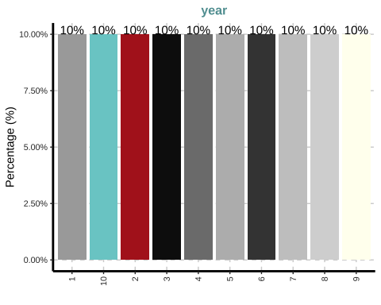

##   
## [[2]]

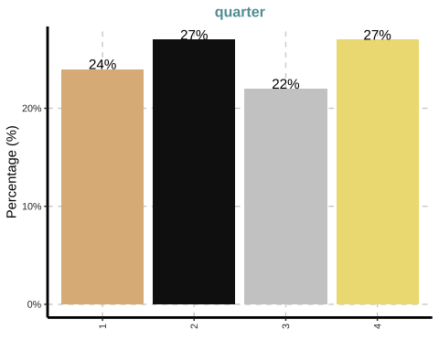

##   
## [[3]]

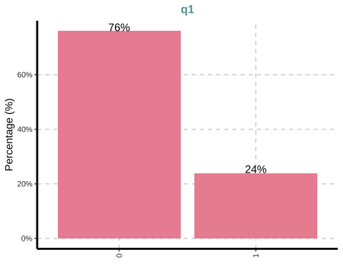

##   
## [[4]]

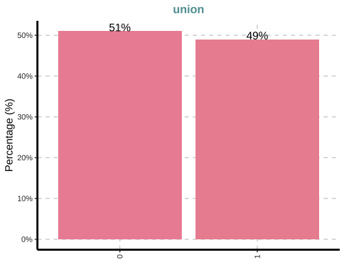

##   
## [[5]]

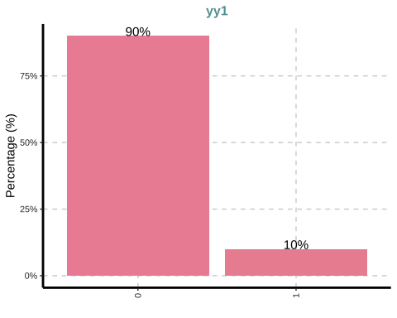

##   
## [[6]]

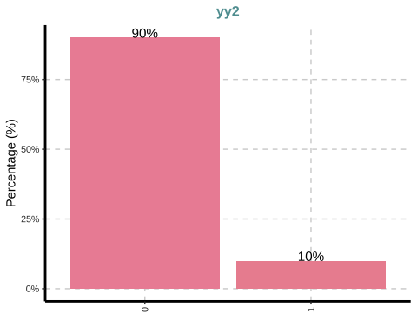

##   
## [[7]]

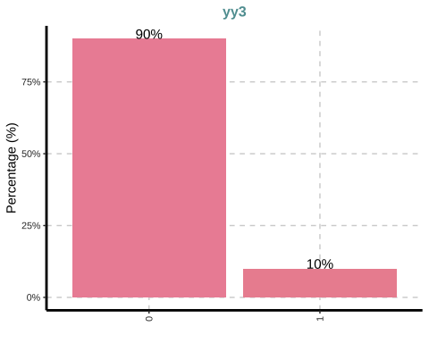

##   
## [[8]]

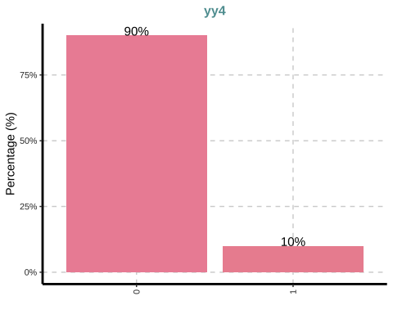

##   
## [[9]]

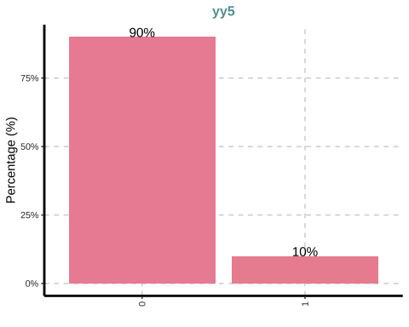

##   
## [[10]]

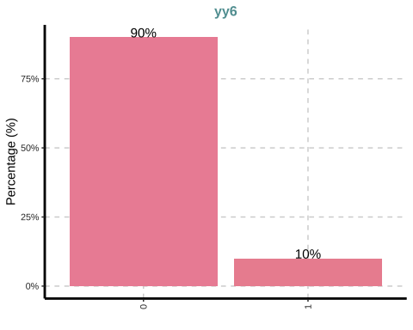

##   
## [[11]]

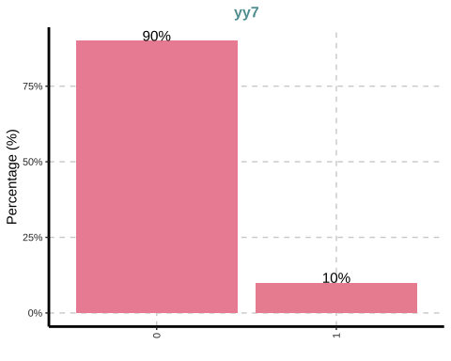

##   
## [[12]]

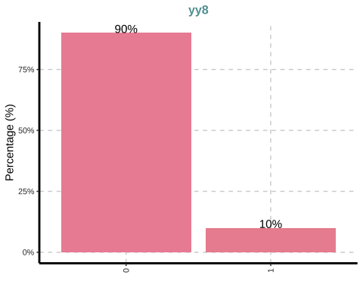

##   
## [[13]]

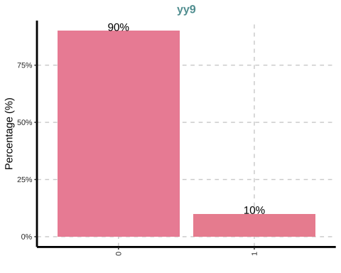

##   
## [[14]]

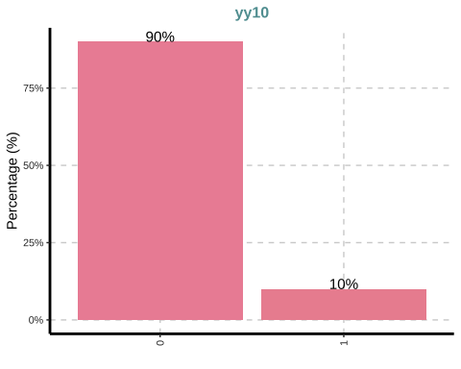

## TRY IN A ‘JUPYTER NOTEBOOK’: ExpNumViz(nlswork)

ExpNumStat(simulated,by="A",Outlier = TRUE,round=2,Qnt=c(0.1,0.25,0.50,0.99))

## Vname Group TN nNeg nZero nPos NegInf PosInf NA_Value Per_of_Missing  
## 5 educ All 4950 0 333 4617 0 0 0 0  
## 6 exper All 4950 0 24 4926 0 0 0 0  
## 7 exper2 All 4950 0 24 4926 0 0 0 0  
## 9 lag_lnwage All 4950 0 0 4455 0 0 495 10  
## 8 lnwage All 4950 0 0 4950 0 0 0 0  
## 3 ui All 4950 0 0 4950 0 0 0 0  
## 4 wage All 4950 0 0 4950 0 0 0 0  
## 1 workerid All 4950 0 0 4950 0 0 0 0  
## 2 year All 4950 0 0 4950 0 0 0 0  
## sum min max mean median SD CV IQR Skewness  
## 5 25870.22 0.00 19.45 5.23 4.65 3.79 0.73 5.31 0.71  
## 6 70965.00 0.00 28.00 14.34 15.00 6.46 0.45 10.00 -0.09  
## 7 1223895.00 0.00 784.00 247.25 225.00 187.13 0.76 280.00 0.66  
## 9 33211.94 6.50 8.72 7.45 7.43 0.47 0.06 0.70 0.29  
## 8 37041.95 6.50 8.88 7.48 7.45 0.48 0.06 0.71 0.28  
## 3 2415.21 0.00 1.00 0.49 0.48 0.29 0.59 0.50 0.05  
## 4 9893953.84 662.08 7170.24 1998.78 1718.12 1032.19 0.52 1256.13 1.36  
## 1 1227600.00 1.00 495.00 248.00 248.00 142.91 0.58 248.00 0.00  
## 2 27225.00 1.00 10.00 5.50 5.50 2.87 0.52 5.00 0.00  
## Kurtosis 10% 25% 50% 99% LB.25% UB.75% nOutliers  
## 5 0.02 0.52 2.32 4.65 15.46 -5.65 15.61 46  
## 6 -0.83 5.00 9.00 15.00 27.00 -6.00 34.00 0  
## 7 -0.41 25.00 81.00 225.00 729.00 -339.00 781.00 19  
## 9 -0.59 6.86 7.08 7.43 8.55 6.04 8.83 0  
## 8 -0.58 6.88 7.11 7.45 8.61 6.05 8.87 1  
## 3 -1.19 0.08 0.24 0.48 0.99 -0.51 1.50 0  
## 4 1.99 969.90 1226.81 1718.12 5468.17 -657.39 4367.13 186  
## 1 -1.20 50.00 124.00 248.00 490.51 -248.00 744.00 0  
## 2 -1.22 1.90 3.00 5.50 10.00 -4.50 15.50 0

ExpNumViz(simulated,Page=c(6,2))

## $`0`

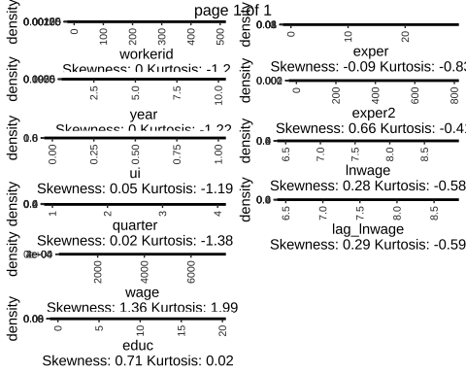

ExpOutliers(simulated,varlist=c("lnwage"))

## $outlier_summary  
## Category lnwage  
## 1 Lower cap : 0.05 6.75808242272123  
## 2 Upper cap : 0.95 8.32169651894011  
## 3 Lower bound 6.05  
## 4 Upper bound 8.87  
## 5 Num of outliers 1  
## 6 Lower outlier case   
## 7 Upper outlier case 210  
## 8 Mean before 7.48  
## 9 Mean after 7.48  
## 10 Median before 7.44898780138622  
## 11 Median after 7.44896911785069  
##   
## $outlier_data  
## workerid year ui quarter q1 wage educ exper union exper2  
## 1: 1 1 0.5734584 2 0 1913.481 6.3080420 17 1 289  
## 2: 1 2 0.5734584 2 0 2065.687 6.3080420 18 1 324  
## 3: 1 3 0.5734584 2 0 2015.642 7.3080420 19 1 361  
## 4: 1 4 0.5734584 2 0 2274.630 8.3080425 20 1 400  
## 5: 1 5 0.5734584 2 0 2576.639 9.3080425 21 1 441  
## ---   
## 4946: 495 6 0.3515452 1 1 1257.155 0.0000000 17 1 289  
## 4947: 495 7 0.3515452 1 1 1170.614 0.3515451 18 1 324  
## 4948: 495 8 0.3515452 1 1 1211.788 0.3515451 19 1 361  
## 4949: 495 9 0.3515452 1 1 1346.442 0.3515451 20 1 400  
## 4950: 495 10 0.3515452 1 1 1279.959 0.3515451 21 0 441  
## lnwage yy1 yy2 yy3 yy4 yy5 yy6 yy7 yy8 yy9 yy10 lag_lnwage  
## 1: 7.556680 1 0 0 0 0 0 0 0 0 0 NA  
## 2: 7.633218 0 1 0 0 0 0 0 0 0 0 7.556680  
## 3: 7.608693 0 0 1 0 0 0 0 0 0 0 7.633218  
## 4: 7.729573 0 0 0 1 0 0 0 0 0 0 7.608693  
## 5: 7.854241 0 0 0 0 1 0 0 0 0 0 7.729573  
## ---   
## 4946: 7.136607 0 0 0 0 0 1 0 0 0 0 6.973784  
## 4947: 7.065284 0 0 0 0 0 0 1 0 0 0 7.136607  
## 4948: 7.099852 0 0 0 0 0 0 0 1 0 0 7.065284  
## 4949: 7.205221 0 0 0 0 0 0 0 0 1 0 7.099852  
## 4950: 7.154584 0 0 0 0 0 0 0 0 0 1 7.205221  
## out_cap_lnwage  
## 1: 7.556680  
## 2: 7.633218  
## 3: 7.608693  
## 4: 7.729573  
## 5: 7.854241  
## ---   
## 4946: 7.136607  
## 4947: 7.065284  
## 4948: 7.099852  
## 4949: 7.205221  
## 4950: 7.154584  
##   
## $outlier_index  
## $outlier_index$upper_out_index  
## $outlier_index$upper_out_index[[1]]  
## [1] 210  
##   
##   
## $outlier_index$lower_out_index  
## $outlier_index$lower_out_index[[1]]  
## numeric(0)

vis_dat(simulated)

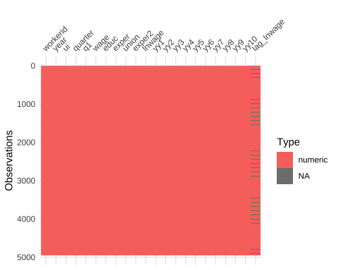

# gg_miss_upset(simulated)  
  
 stargazer(simulated,  
 title = "Summary statistics",  
 label = "tb:statistcis",  
 table.placement = "ht",  
 header=FALSE,type="text")

##   
## Summary statistics  
## ======================================================  
## Statistic N Mean St. Dev. Min Max   
## ------------------------------------------------------  
## workerid 4,950 248.000 142.908 1 495   
## year 4,950 5.500 2.873 1 10   
## ui 4,950 0.488 0.289 0.0005 0.996   
## quarter 4,950 2.517 1.128 1 4   
## q1 4,950 0.240 0.427 0 1   
## wage 4,950 1,998.779 1,032.194 662.083 7,170.242  
## educ 4,950 5.226 3.795 0.000 19.446   
## exper 4,950 14.336 6.460 0 28   
## union 4,950 0.486 0.500 0 1   
## exper2 4,950 247.252 187.126 0 784   
## lnwage 4,950 7.483 0.476 6.495 8.878   
## yy1 4,950 0.100 0.300 0 1   
## yy2 4,950 0.100 0.300 0 1   
## yy3 4,950 0.100 0.300 0 1   
## yy4 4,950 0.100 0.300 0 1   
## yy5 4,950 0.100 0.300 0 1   
## yy6 4,950 0.100 0.300 0 1   
## yy7 4,950 0.100 0.300 0 1   
## yy8 4,950 0.100 0.300 0 1   
## yy9 4,950 0.100 0.300 0 1   
## yy10 4,950 0.100 0.300 0 1   
## lag_lnwage 4,455 7.455 0.470 6.495 8.724   
## ------------------------------------------------------

## DASHBOARD  
  
 ####### ExPanD()

## Regressions

**OBSERVE THE MISTAKE FOLLOWING THE INTRODUCTION OF TIME DUMMIES AND EXPERIENCE IN THE FIXED-EFFECTS MODEL**

pols <- plm(data = simulated, lnwage ~ educ + exper +   
 exper2 + factor(year),   
 model="pooling", index=c("workerid", "year"))  
  
 re <- plm(data = simulated, lnwage ~ educ + exper +   
 exper2 + factor(year),   
 model="random", index=c("workerid", "year"))  
  
 plmtest(pols, type=c("bp"))

##   
## Lagrange Multiplier Test - (Breusch-Pagan)  
##   
## data: lnwage ~ educ + exper + exper2 + factor(year)  
## chisq = 19885, df = 1, p-value < 2.2e-16  
## alternative hypothesis: significant effects

fe <- plm(data = simulated, lnwage ~ educ + exper +   
 exper2 + factor(year),   
 model="within", index=c("workerid", "year"))  
   
 pFtest(fe, pols)

##   
## F test for individual effects  
##   
## data: lnwage ~ educ + exper + exper2 + factor(year)  
## F = 270.97, df1 = 493, df2 = 4444, p-value < 2.2e-16  
## alternative hypothesis: significant effects

phtest(fe, re)

##   
## Hausman Test  
##   
## data: lnwage ~ educ + exper + exper2 + factor(year)  
## chisq = 309.92, df = 11, p-value < 2.2e-16  
## alternative hypothesis: one model is inconsistent

pols_robust <- coeftest(pols, function(x) vcovHC(x, type = 'sss'))   
 re_robust <- coeftest(re, function(x) vcovHC(x, type = 'sss'))   
 fe_robust <- coeftest(fe, function(x) vcovHC(x, type = 'sss'))   
   
 stargazer(pols_robust,re_robust, fe_robust,title = "Regression analysis",   
 model.numbers = FALSE,  
 column.labels = c("Pooled (cluster)","RE (cluster)","FE (cluster"),  
 label = "regressions",  
 table.placement = "!ht",  
 notes.append = FALSE,  
 notes.align="l",  
 notes="Standard errors in parentheses.",  
 header = FALSE,  
 no.space = TRUE,  
 omit = c("Constant"),  
 omit.stat = c("adj.rsq","f","ser"),  
 digits = 4,  
 digits.extra = 5,  
 omit.yes.no = c("Constant",""),  
 dep.var.caption="",  
 dep.var.labels.include = FALSE,  
 style = "qje",  
 type="text")

##   
## Regression analysis  
## ========================================================  
## Pooled (cluster) RE (cluster) FE (cluster  
## educ 0.1072*** 0.0666*** 0.0624***   
## (0.0024) (0.0009) (0.0010)   
## exper 0.0131*** 0.0045** 0.0253***   
## (0.0045) (0.0022) (0.0008)   
## exper2 -0.0003* 0.000004 0.000004   
## (0.0002) (0.00002) (0.00002)   
## factor(year)2 -0.0010 0.0191*** 0.0002   
## (0.0038) (0.0035) (0.0027)   
## factor(year)3 -0.0020 0.0384*** 0.0006   
## (0.0053) (0.0052) (0.0025)   
## factor(year)4 -0.0076 0.0524*** -0.0043*   
## (0.0068) (0.0069) (0.0026)   
## factor(year)5 -0.0041 0.0754*** -0.0002   
## (0.0087) (0.0091) (0.0025)   
## factor(year)6 -0.0049 0.0951*** 0.0008   
## (0.0104) (0.0110) (0.0026)   
## factor(year)7 -0.0090 0.1115*** -0.0014   
## (0.0123) (0.0130) (0.0025)   
## factor(year)8 -0.0109 0.1314*** 0.00004   
## (0.0140) (0.0149) (0.0027)   
## factor(year)9 -0.0133 0.1482*** -0.0019   
## (0.0161) (0.0171) (0.0027)   
## factor(year)10 -0.0109 0.1687***   
## (0.0180) (0.0191)   
## ========================================================  
## Notes: Standard errors in parentheses.

## OBSERVE THE MISTAKE FOLLOWING THE INTRODUCTION OF TIME DUMMIES AND EXPERIENCE IN  
## THE FIXED-EFFECTS MODEL

## Close the log file

end_time <- Sys.time()  
  
end_time - start_time

## Time difference of 18.1791 secs

# sprintf(end_time - start_time,fmt = '%#.1f')

#