WINTER SCHOOL 2019, JAN 2019

FEP - Porto

|  |  |
| --- | --- |
|  | c1 |
| Domestic | 52 |
| Foreign | 22 |

Variable: Price

|  |  |  |  |  |  |  |
| --- | --- | --- | --- | --- | --- | --- |
|  | N | mean | sd | p10 | p50 | p90 |
| Domestic | 22 | 6385 | 2622 | 3895 | 5759 | 9735 |
| Foreign | 52 | 6072 | 3097 | 3955 | 4782 | 11385 |

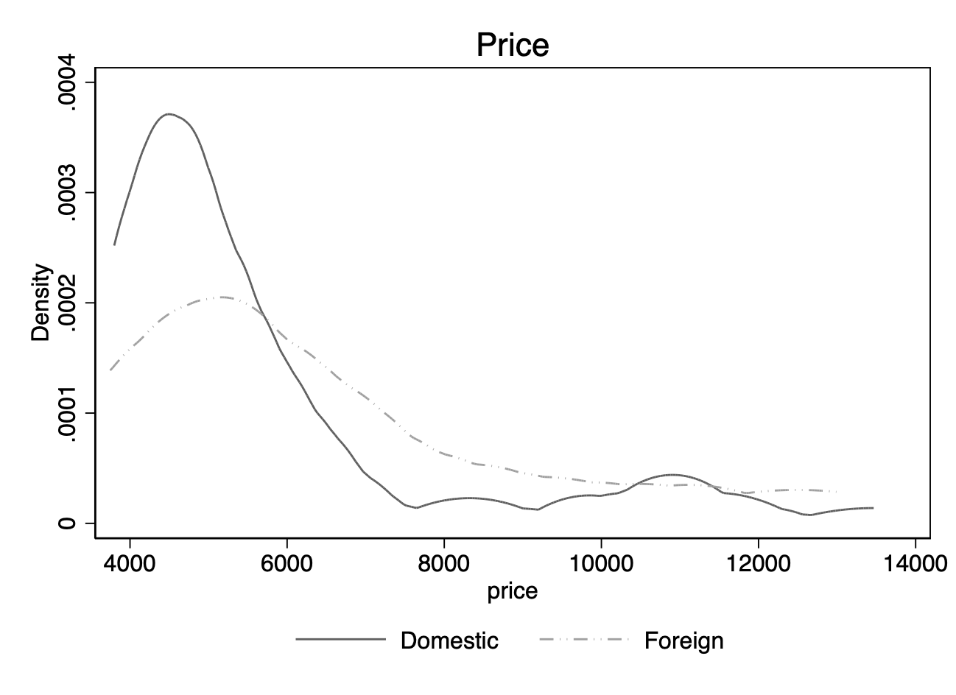

Variable: Mileage (mpg)

|  |  |  |  |  |  |  |
| --- | --- | --- | --- | --- | --- | --- |
|  | N | mean | sd | p10 | p50 | p90 |
| Domestic | 22 | 25 | 7 | 17 | 24 | 35 |
| Foreign | 52 | 20 | 5 | 14 | 19 | 26 |

