*WINTER SCHOOL 2019, JAN 2019*

**FEP - Porto**

Put a table in the docx using information from a tabulation

|  |  |
| --- | --- |
|  | Frequency |
| Domestic | 52 |
| Foreign | 22 |

|  |  |
| --- | --- |
| A | 23.3 |
| BB | 89 |

Variable: Price

|  |  |  |  |  |  |  |
| --- | --- | --- | --- | --- | --- | --- |
|  | N | mean | sd | p10 | p50 | p90 |
| Domestic | 22 | 6385 | 2622 | 3895 | 5759 | 9735 |
| Foreign | 52 | 6072 | 3097 | 3955 | 4782 | 11385 |

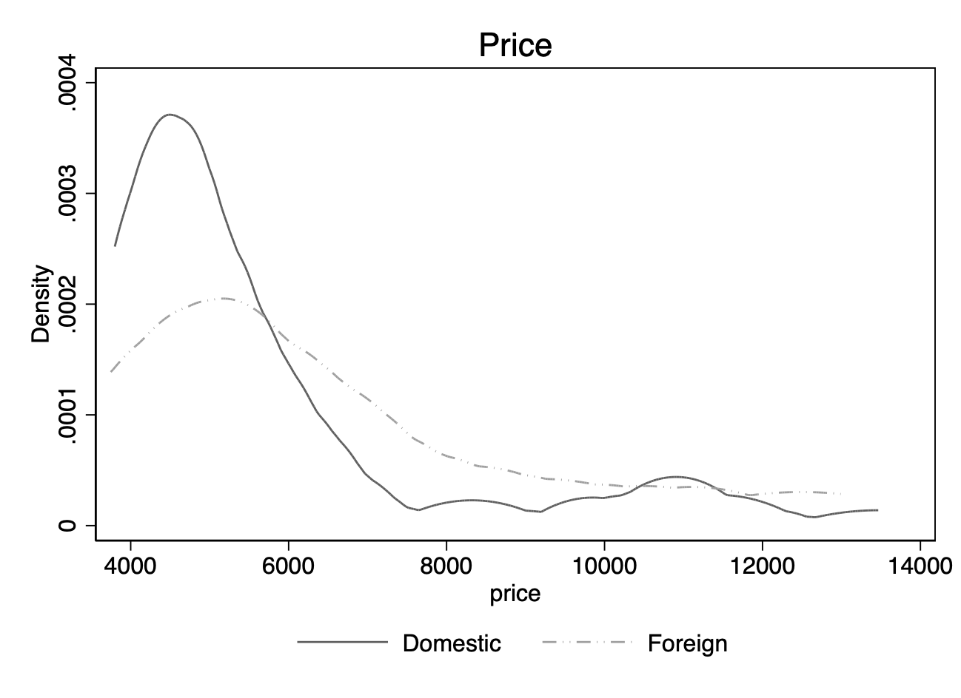

Variable: Mileage (mpg)

|  |  |  |  |  |  |  |
| --- | --- | --- | --- | --- | --- | --- |
|  | N | mean | sd | p10 | p50 | p90 |
| Domestic | 22 | 25 | 7 | 17 | 24 | 35 |
| Foreign | 52 | 20 | 5 | 14 | 19 | 26 |

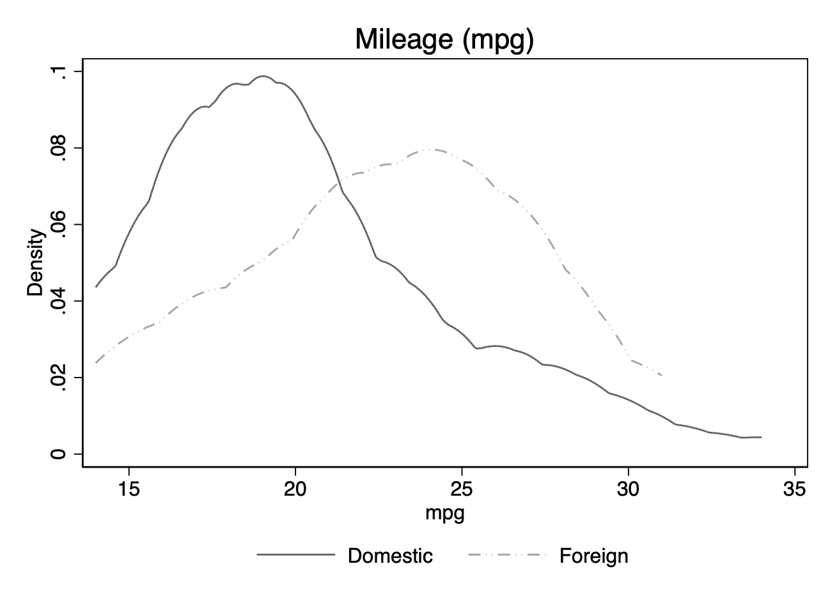

The average price is **6165.3**

|  |  |  |  |  |  |
| --- | --- | --- | --- | --- | --- |
| ln_price | Coef. | Std. Err. | t | [95% Conf. Interval] | |
| ln_mpg | -.826847 | .1484986 | -5.57 | -1.122873 | -.5308204 |