Spinbots
Slots
By Spinbots Games
Version #02

All work Copyright © 2018 by SpinBots Games.
All rights reserved.

Timofei Serebriakov
Andrew Song

May 16th 2018

Table of Contents

- Game Overview
- Game Play Mechanics
- Camera
- Controls
- Interface Sketch
- Game World
- Script
- Scoring
- Bonuses
- Cheat Codes
- Sound Index
- Art / Multimedia Index
- Design Notes
- Future Features
Version History
[This is where you keep track of the detailed changes made to your document throughout the course of development.]
Version 01: Most functionality implemented
Version 02: All assets attached and functionality finished

- Game Overview
The goal of slots is for the player to bet and gamble their money away in attempts to earn more money. This only happens if the slots show multiple of the same amount of image. Players can bet more or less money. There is no way to ultimately win the game. There is however a possibly victory goal of hitting the jackpot. The ultimate goal is that the player should loose all their money as most gambling games are like.
- Game Play Mechanics
The game works by pressing the Spin button to roll the slots, if there are enough matching slots the player will gain an amount based on the type of slot and the amount that the player has bet. If the player does not have enough money to bet, it will not spin. If the player hits the jackpot, the jackpot text will light up and play a sound. When any other combination is hit, only a sound is played based on what was hit.
- Camera
The player is always directly facing the slots machine.
- Controls
This game is touch based with some typing elements.
- Interface Sketch
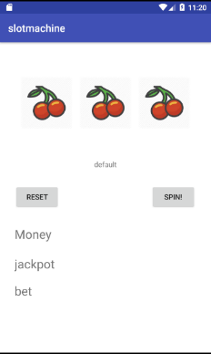

- Game World
The game is a singular slot machine

- Script

- Scoring
The score of the player is the amount of money he has, the more he wins from slots the better his score, the less money he has the worse his score.
- Bonuses
Hitting the jackpot provides a humongous amount of money.
- Cheat Codes
Spinning the slot x amount of times will trigger the jackpot autmatically
- Sound Index
All sound effects taken from starcraft.wikia.com
1. Dropship – Removing overhead luggage.
2. Firebat – Nothing like a good smoke.
3. Marine – Rock and roll.
4. Science Vessel – Excellent.
5. Siege Tank – Humming flight of the valkyries.
6. Vulture – Oh, is that it?
7. Civilian – I need that college money.

- Art / Multimedia Index
Following taken from starcraft.wikia.com:
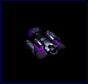
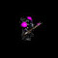
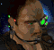
Civilian: Dropship: Marine:

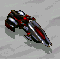
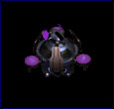
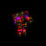
Firebat: Science Vessel: Vulture:

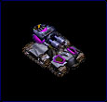
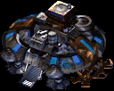
Siege Tank: Command Center:

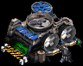
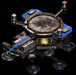
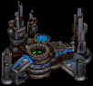
Supply Depot: Starport: Armory:

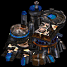
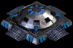
Bunker: Academy:

Following taken from flamingtext.com:


Reset default: Reset hover:
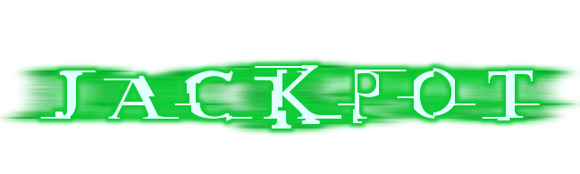

Jackpot default: Jackpot hit:


Money default: Bet default:
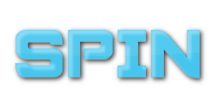

Spin default: Spint hover:
- Design Notes
Initial design included buttons to +- bet amount, and included a handle to pull. It was planned to also have a main menu and a combinations screen but that was removed.

- Future Features
Future features include adding more rows and columns, adding animations, a pulling handle, bet buttons, and balancing changes to % chances of hitting combinations and removing the jackpot after x amount of spins cheat.

