Hi all potential Unscramblers!

I wanted to explore the Scrambling functionality in QV to see if it was reversible, meaning being able to get the original data back. It seems that if you hook into the Qvscrambler.dll (comes with the v10 QVS install), then you actually can reverse the scrambling operation!

One prerequisite for the qvw to work correctly is to register the Qvscrambler.dll on your system with the command “regsvr32 <path>Qvscrambler.dll”.
Note! You need to run the command prompt as an Administrator.

You also need an x86 QV Desktop version to run the .qvw

If you get the below popup after running the command, all is good.
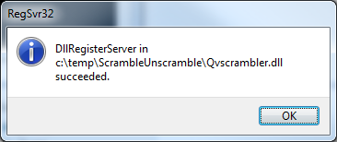

Note that the below setting on the Macro module needs to be set:
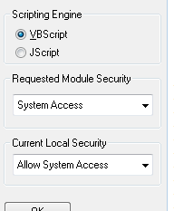

Happy Unscrambling!

Simon Matele
OEM Solutions Architect

