GSO SUPPLIER VISIT REPORT – ODM Activities Doc. EC/EBAS – GSO-2507001x00
Employee: Reinaldo Alves (アルベス レイナルド) Period: July 2025

Guangdong Lingxiao Pump Industry Co.,Ltd

Purpose

Company Information

Company Overview:

Main Products:

Target Products:

Relevant Information:

- Certificates:

- Main Partners/Competitors Reference:

- Conclusion


Reinaldo Viana Alves Filho
Global Sourcing Office
Global Business Strategy Development

Appendix 1 - Pictures

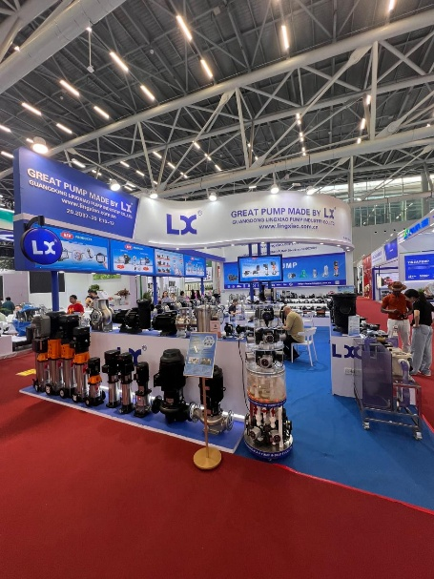 | 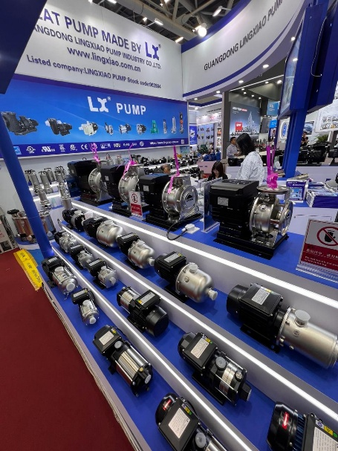
Canton Fair - Lingxiao Booth | Canton Fair - Lingxiao Booth
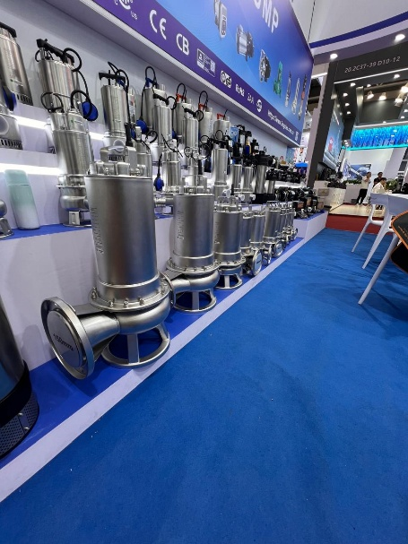 | 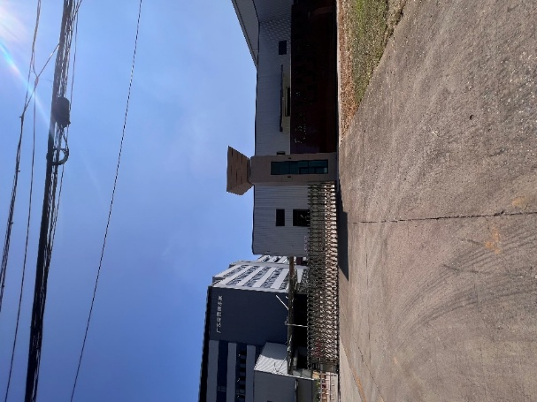
Canton Fair - Lingxiao Booth | Canton Fair – Stainless Steel Factory Entrance
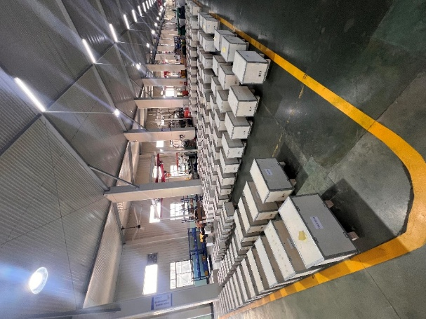 | 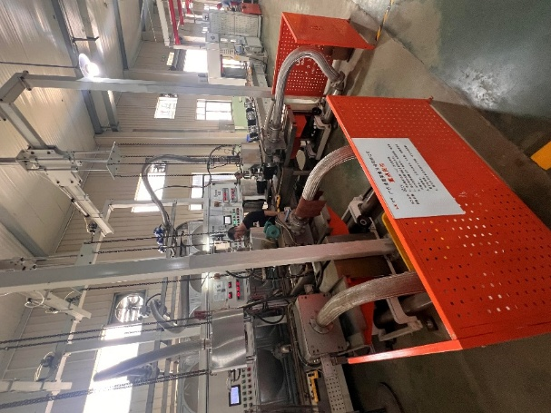
Warehouse – Finish Products | C Line – Test Bench

