Performance comparison of various Models on the Plant Village dataset
Model | Model Size (in  MB) | Total Trainable  parameters | Loss | Accuracy | Precision | Recall | F1-  score | AUC- Score | Kappa  Score | GFLOPS
MobileNet V3 Large

MobileNet V2
Standard VGG16
ResNet50
InceptionV3
Xception
DenseNet121
Phytonet-Lite

Performance comparison of various Models on the Rice dataset.
Model | Model Size (in  MB) | Total Trainable  parameters | Loss | Accuracy | Precision | Recall | F1-  score | AUC- Score | Kappa  Score | GFLOPS
MobileNet V3 Large

MobileNet V2
Standard VGG16
ResNet50
InceptionV3
Xception
DenseNet121
Phytonet-Lite

Performance comparison of various Models on the Mango Leaf
Model | Model Size (in  MB) | Total Trainable  parameters | Loss | Accuracy | Precision | Recall | F1-  score | AUC- Score | Kappa  Score | GFLOPS
MobileNet V3 Large

MobileNet V2
Standard VGG16
ResNet50
InceptionV3
Xception
DenseNet121
Phytonet-Lite

Model Performance Metrics Comparison based on the above table and model

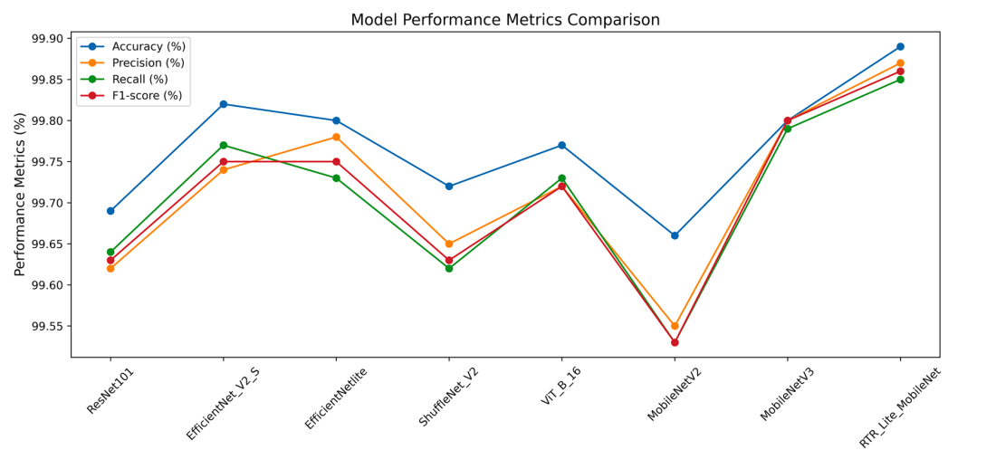

Three Performance matrix for rice ,plant village,cassava dataset
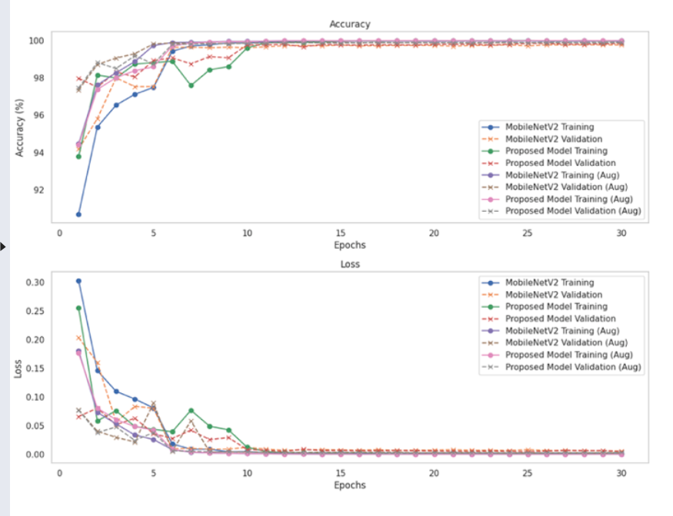

Three separate confusion matrices: Plant Village, rice dataset,later cassava
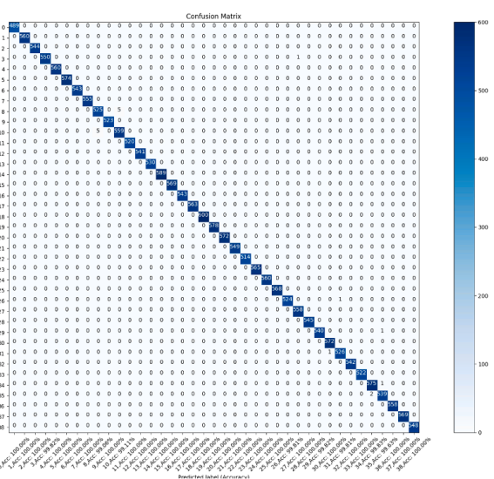
Three separate ROCs: Plant Village, rice dataset,later dicide

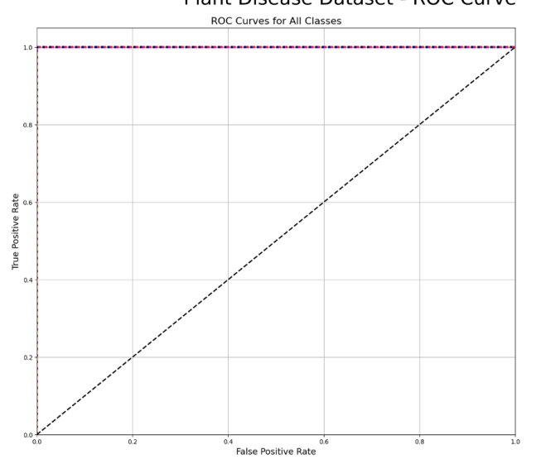
Alation studies on proposed model
