Task 1 – Clone Fahad Jawaid’s open source repo and make it run on your local environment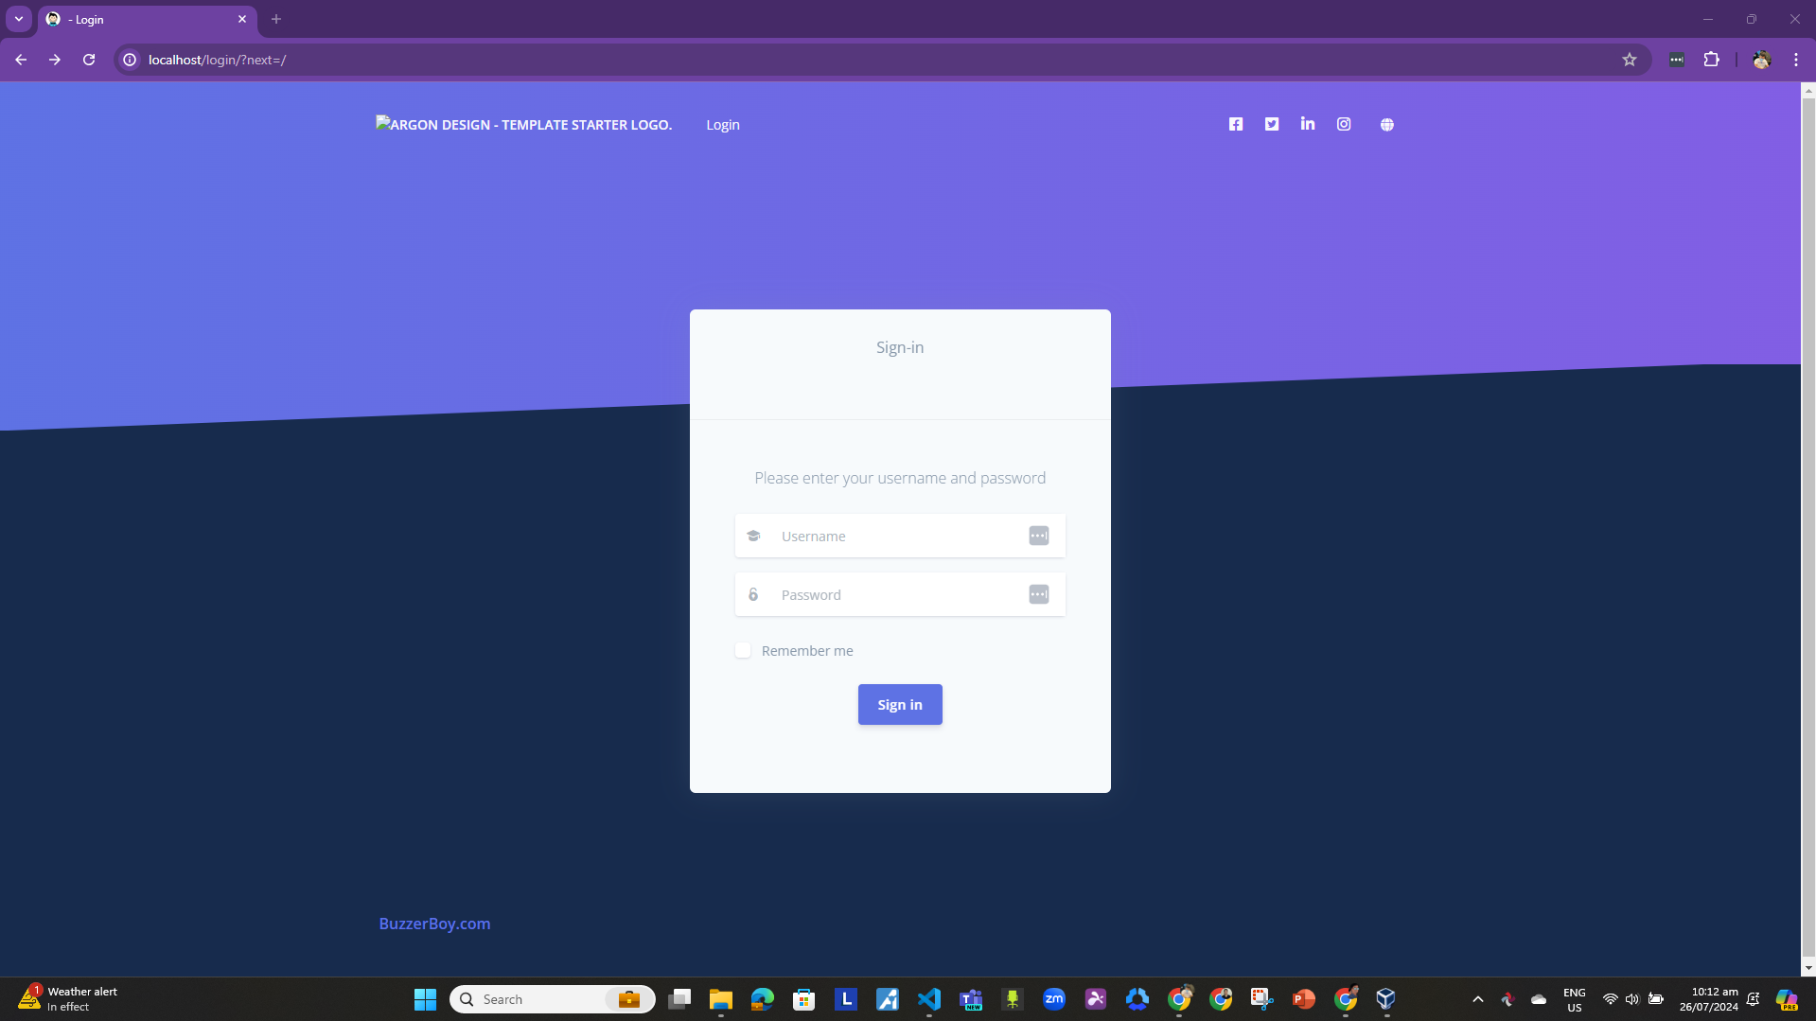

Task 2 – Create a superuser to access the portal in the above cloned repository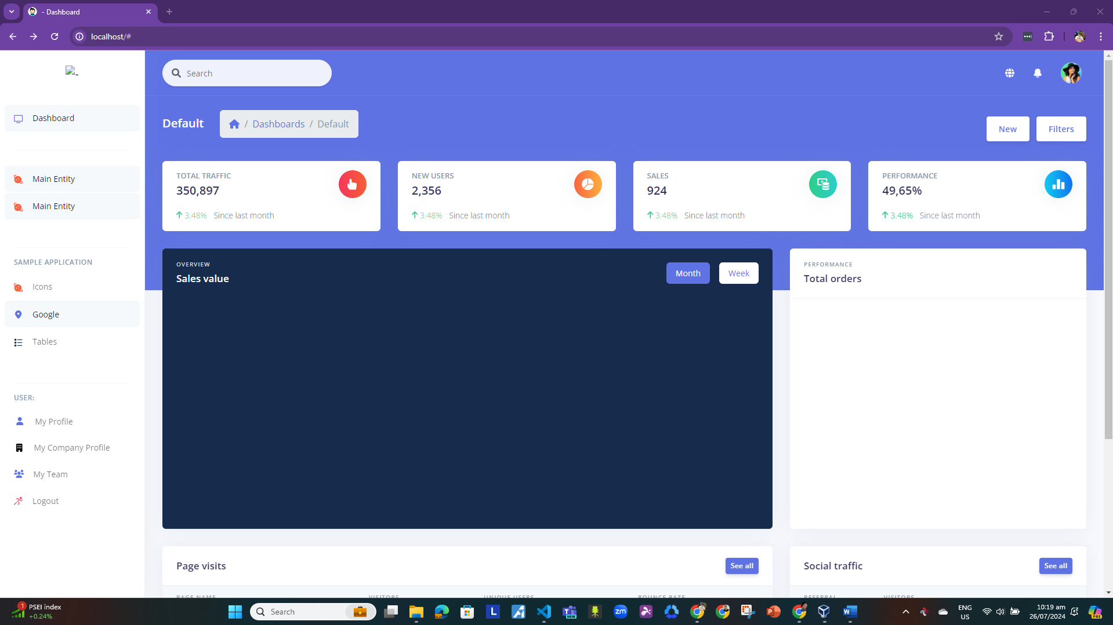

Task 3 – Add “Main Entity” called Restaurant app and build the ability to add, create, view and delete restaurants
in the repo from Task 1

