1. What is a loggerator?
   1. One inlet multiple sinks.
   2. It collect logs from STDOUT/STDERR
   3. A configurable log tool to store logs
2. Which stages a app goes through after cf push
   1. Detect build release
   2. Upload stage run
3. As per 12 factor cloud app development which is the correct scenario.
   1. One code base for all env.
4. As per 12 factor which of the following is true
   1. Explicitly declare and isolate dependencies.
5. Which of the following is an Environment variable
   1. CF_INSTANCE_IP_ADDR
   2. VCAP_APP _PORT
   3. CF_GUID
6. Which of the following is an example of stateful session
   1. Sticky session
7. There is a host name given to an app in manifest.yml. while pushing application hostname is also given via cli. Which will override?
   1. CLI will override YML
8. What is a droplet?
   1. A container in which application is ready to run
9. What is true for services?
   1. It can be attached to multiple application
10. How to resolve unable to resolve application type
    1. Should declare buildpack with cf push using –b
11. How should a developer collect logs.
    1. Write it to log files
    2. Stream logs
12. What role can a space manager perform but a space developer cannot
    1. Create and remove users
13. Where should a developer store MySQL connection variables
    1. Env Variables
14. Output of cf create-service command
    1. It just create a service instance in space
15. What happens when cf stop command is given
    1. It issues SIGTERM signal.
16. What is Application User Security?
17. Which Command is used to access any API in CLI
    1. Cf curl
18. What does application as a deployment unit mean?
    1. A developer only needs to deploy an application. The runtime, dependency etc is taken care by Pivotal Cloud Foundary
19. There are 4 env of an application. Experiment, Development, QA, Prod. How many time a code will be built
    1. 1
    2. 2
    3. 3
    4. 4
20. What are the valid state of application in PCF.
    1. Started, stopped, running, unknown
    2. Started, stopped, crashed, staging
    3. Starting, stopped, crashing, staging
21. Started, Unknown, staging, crashed What is the latest api endpoint of cloud controller api
    1. <https://apidocs.cloudfoundry.org>
    2. <https://www.cloudcontroller.org>
    3. <https://www.cloudcontroller.com>
22. What parameters we can set in manifest but not in cli during cf push?
    1. Stack
    2. Buildpack
    3. host
    4. Environment variables
23. How environment variables is exposed to the application
    1. As a VCAP_application
    2. AS a oprating system variables
24. How can we achieve the zero-down time deployment without degrading the performance
    1. Create new application within the same sapce and same name and use existing url
    2. Create new application in the different space and use the existing url
    3. Create two application with the same name and switch the old route with the new one
    4. Create new application with different name and using existing url
25. What is the good way to inject the APM in pcf
    1. Using stack
    2. Using stemshell
    3. Bosh Deployment
    4. Buildpacks
26. Application security group rules for ip and port consist for
    1. Ingress
    2. Egress
    3. All traffic
    4. none
27. Use case question: Space manager can do but space developer cannot
28. When we bind any application with service what is does?
    1. We can see the service configuration in application environment variables.
29. You push the app and got some error in cli while application is available in space. What can be the possible reason behind it?
30. Which one is the application-specific System Variable
    1. CF_INSTANCE_IP_ADDR
    2. CF_INSTANCE_ID
    3. VCAP_APPLICATION
    4. VACAP_HOME
31. What happened when you scaled your application from 3 to 5?
    1. It will delete 3 instance first and then restart the application with 5 instance
    2. 3 instance will not be affected and application will also run on 2 new instance
32. If a command fails or produces unexpected results, How to enabled to view requests and responses between the cf CLI and the Cloud Controller REST API.
    1. Run cf push with CF_TRACE
33. What you will do if your application is not detected by the any available build packs in pcf.
    1. Use custom buildpack
34. Which route will be created for the following command

cf map-route blueapp shared-domain.example.com --hostname host

* 1. <http://host.shared-domain.example.com>
  2. https:// blueapp.shared-domain.exam.com
  3. https:// shared-domain.exam.com
  4. https:// host.blueapp.shared-domain.exam.com

1. Which route will be created for the following command

cf map-route blueapp shared-domain.example.com --hostname host

* 1. https:// blueappshared-domain.exam.com/foo
  2. https:// shared-domain.exam.com/foo
  3. http://myapp.shared-domain.example.com/foo
  4. https:// host.blueapp.shared-domain.exam.com/blueapp

1. What is the end result of successfully deploying an application using cf push
   1. Running application with no of instance and health
   2. Build pack used
   3. Command to start the app
   4. All
2. What can you provide in User Created Services
   1. URL
   2. Login id
   3. Password
   4. All
   5. None
3. When we bind any application with service what is does?
   1. We can see the service configuration in application environment variables.
4. What does creating a service in pcf
   1. It create a service instance in space and can be bind to multiple application
5. Which Command is used to access any API in CLI
   1. Cf curl
6. What does application as a deployment unit mean?
   1. A developer only needs to deploy an application. The runtime, dependency etc is taken care by Pivotal Cloud Foundary
7. What are the valid state of application in PCF.
   1. Started, stopped, running, unknown
   2. Started, stopped, crashed, staging
   3. Starting, stopped, crashing, staging
   4. Started, Unknown, staging, crashed
8. What is the latest api endpoint of cloud controller api
   1. <https://apidocs.cloudfoundry.org>
   2. <https://www.cloudcontroller.org>
   3. <https://www.cloudcontroller.com>
9. What parameters we can set in manifest but not in cli during cf push?
   1. Stack
   2. Buildpack
   3. host
   4. Environment variables
10. You push the app and got some error in cli while application is available in space. What can be the possible reason behind it?
    1. It had a memory but due to timeout time it was unable to start successfully
    2. application issue
    3. Unable to detect buildpack
    4. Cli error
11. Which one is the application-specific System Variable
    1. CF_INSTANCE_IP_ADDR
    2. CF_INSTANCE_ID
    3. VCAP_APPLICATION
    4. VACAP_HOME
12. When to use custom buildpack?
    1. When installed bulid pack is not able to indentify the type of application have been pushed
13. What are the log type the the cf logs provide ?
    1. API,STG,RTR
14. What does the rabbitMQ does?
15. What is Cf TRACE?
16. What is the command for setting an environment?
17. There is one instance of an application which writes a file to local system. It crashes and restarts again. Other two instance of the application are not impacted. How many instance would be able to access the file?

a.none

1. Which route will be created for the following command
   1. cf create-route my-space shared-domain.example.com -n host
2. What happens when you bind a service?
3. A domain is created. Cf create-domain My-Domain and then u bind a service to the domain. What happens at that situation?
   1. A service is visible to all org and all spaces
   2. A service having that app associated with the domain is available
   3. A service is bound to that particular space
4. In UAA what is sent to Cloud Controller API?
   1. a. token Id
   2. b. token id or Client credentials
   3. c. client credentials.
5. What is the latest api endpoint of cloud controller api
6. <https://apidocs.cloudfoundry.org>
7. <https://www.cloudcontroller.org>
8. <https://www.cloudcontroller.com>
9. What parameters we can set in manifest but not in cli during cf push?

a. Stack

b. Buildpack

c. host

d. Environment variables

1. When will a droplet be created?
   1. restart
   2. restage
   3. create
2. What is the use of Service Broker API?
3. Which of the following is true?
   1. Every application must have one route
   2. Every application may have more than one route
   3. Application may have a route with the existing name.
   4. It is not compulsory to have any routes for the application.
4. When does Cloud Controller makes API Calls?
5. When building a custom buildpack, what is the purpose of the “DETECT” script?
6. Will cf-TRACE logs be given directly to the application or to 3rd party log managers?
7. A question on UAA token.
8. What is a Cell?

Additional Points to Remember

1. Cloud Foundry Architecture

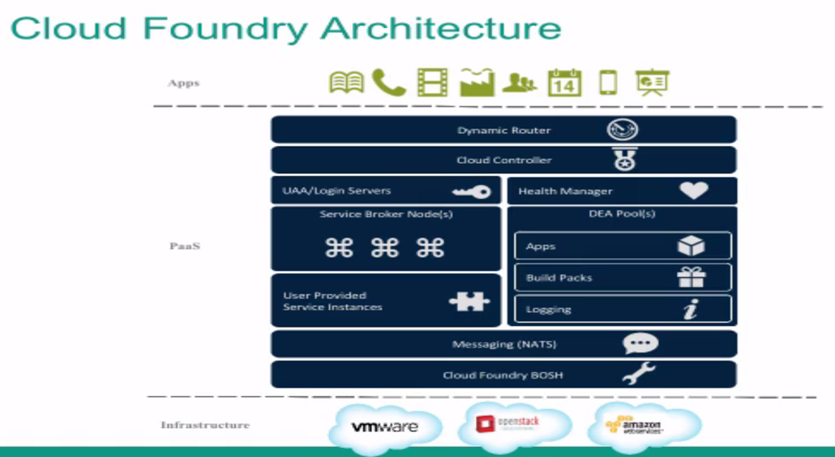

1. CF push has 3 stages
   1. Upload
   2. Staging (It has 3 states)
      1. Detect
      2. Compile
      3. Release
   3. Running

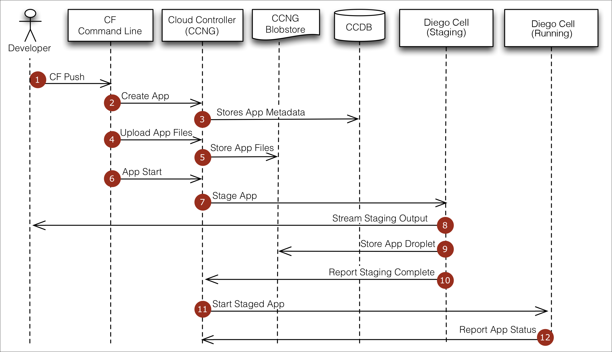

1. Valid CF Logs
   1. AOI
   2. APP
   3. RTR
   4. LGR
   5. STG
   6. DEA
   7. Cell
   8. SSH
2. SF STOP
   1. Sigterm
   2. Sigkill
3. CF Curl: Command to access any API in CLI
4. CF Trace: Track at any component level of CF
5. Logaggregator : STDOUT/STDERROR
6. Org/User/Space/Domain/Route/App/Service Relation

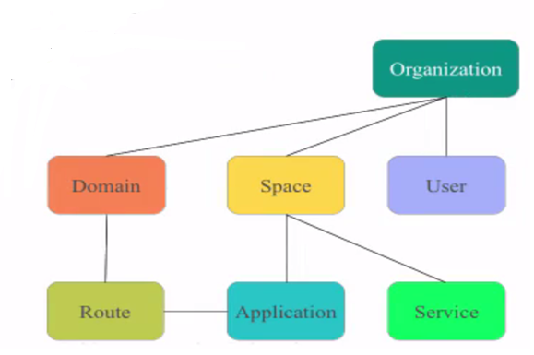

1. Treat Logs as Event Streams
2. Redis or Gemfire for stateless session
3. Read 12/15 Factor App Principles

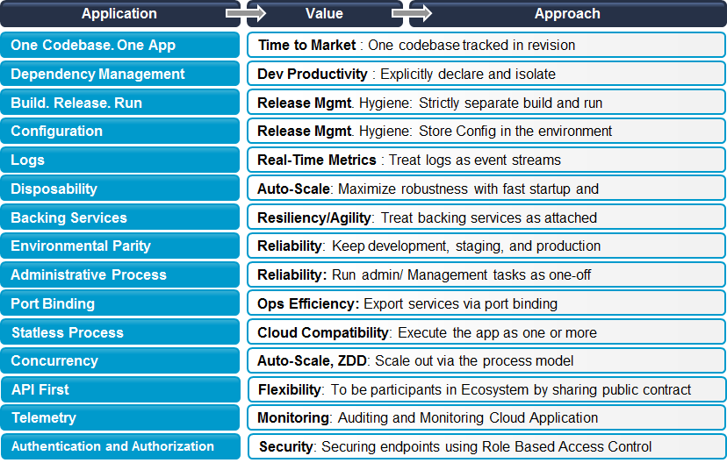

1. RabbitMQ: Asynchronous messaging : Store till recovered: Persisted
2. CF Logs App Name: Streams Loggregator output to the terminal
3. CF Trace: Between CF CLI and Cloud Controller API. Track at Comp oF CF
4. CF SSH: Access the app Container
5. CF Marketplace: All Services, plan and description
6. CF Create Route and CF Map route: Need to do hands-on lab for this command and available options
7. Microservice is Choreography approach while SOA is Orchestration approach
8. Zipkin: Tracing system to troubleshoot failure or latency across distributed system
9. <Https://APIdocs.cloudfoundry.org>
10. <HTTPS://Plugins.cloudfoundry.org>
11. <HTTPs://Docs.cloudfoundry.org>
12. CFapps.IO as extension for any application pushed by default